

|  |
| --- |
| **Capstone Project Document** |
|  |
|  |
| |  |  | | --- | --- | | **The Erudite Guider** | | | Group Members | Nguyen Huu Quyet - SE03119  Phan Van Giang - SE03422  Mong Quoc Toan - SE03369  Nguyen Xuan Tung - SE03325  Khuc Huu Huy - SE03064 | | Supervisor | Mr. Bui Dinh Chien | | Capstone Project code | TEG | |

Table of Contents

1. INTRODUCTION 21

1.1 Project Information 21

1.2 The People 21

1.2.1 Supervisor 21

1.2.2 Team members 21

1.3 Definitions and Acronyms 21

1.4 Problems 22

1.5 Literature Review 23

1.6 Ideas 24

1.7 Proposal of System 25

1.7.1 Our proposal system 25

1.7.2 Introduction about our proposal system 27

1.7.3 Limit of our system 27

2. SOFTWARE PROJECT MANAGEMENT PLAN 27

2.1 Project organization 27

2.1.1 Software Process Model 27

2.1.2 Roles and Responsibilities 29

2.1.1.1 Project Team Member 29

2.1.1.2 Role & Responsibilities 29

2.1.2.3 Tools and Techniques 30

2.2 Project management plan 30

2.2.1 Tasks schedule 30

2.2.2 Meeting Minutes 31

2.2.3 Coding Convention 33

2.2.4 Risks management 33

2.2.5 Communication plan 34

2.2.5.1 Communication between Team Members 34

2.2.5.2 Communication with supervisor 34

2.2.6 Project millstones 35

3. SOFTWARE REQUIREMENT SPECIFICATION 35

3.1 Purpose 37

3.2 Functional Requirements 37

3.2.1 Use Case Diagram 38

3.2.2 Business Rules 39

3.2.3 Use Cases 40

3.2.3.1 Register tower 40

3.2.3.2 Login to subdomain 40

3.2.3.3 Logout of subdomain 41

3.2.3.4 View grounds 42

3.2.3.5 Add ground 43

3.2.3.6 Update ground 44

3.2.3.7 Delete ground 44

3.2.3.8 View citizens 45

3.2.3.9 Add citizen 46

3.2.3.10 Update citizen 47

3.2.3.11 Delete citizen 48

3.2.3.12 View water finance 48

3.2.3.13 Add water finance 49

3.2.3.14 Update water finance 50

3.2.3.15 Delete water finance 50

3.2.3.16 View service finances 51

3.2.3.17 Add service finance 52

3.2.3.18 Update service finance 53

3.2.3.19 Delete service finance 53

3.2.3.20 View history 54

3.2.3.21 View grounds map 54

3.2.3.22 View statistic and report 55

3.2.3.23 Export report 55

3.2.3.24 Create statistic chart 56

3.2.3.25 Payment 56

3.2.3.26 Enter water consumption 57

3.2.3.27 Enter water consumption from excel 57

3.2.3.28 Closing monthly statistic 58

3.2.3.29 Import building database from excel 59

3.2.3.30 See building liabilities 59

3.2.3.31 Add ground picture 60

3.2.3.32 Import ground database from excel 61

3.2.3.33 Change owner 61

3.2.3.34 Import owner database from excel 62

3.2.3.35 Open – Close Service 63

3.2.3.36 See ground liabilities 64

3.2.3.37 Owner history 64

3.2.3.38 Owner history detail 65

3.2.3.39 Import citizen database from excel 66

3.2.3.40 Import citizen card database from excel 67

3.2.3.41 Lock – Lost citizen card 67

3.2.3.42 Import vehicle card database from excel 68

3.2.3.43 Open vehicle card service 69

3.2.3.44 Lock – Lost vehicle card 69

3.2.3.45 Send announcement via email 70

3.2.3.46 Financial setting 71

3.2.3.47 Report setting 71

3.2.3.48 View vehicle finance 72

3.2.3.49 Add vehicle finance 73

3.2.3.50 Delete vehicle finance 73

3.2.3.51 Update vehicle finance 74

3.3 Non – Function Requirements 75

3.3.1 Reliability 75

3.3.2 Availability 75

3.3.3 Security 75

3.3.4 Maintainability 75

3.3.5 Portability 75

3.3.6 Performance 75

3.4 Entity Relationship Diagram or Data Structure 77

4. SOFTWARE DESIGN DESCRIPTION 78

4.1 Design Overview 80

4.2 System Architecture Design 80

4.2.1 System Architecture overview 80

4.2.2 System Architecture Explanation 80

4.2.2.1 Azure Cloud 80

4.2.2.2 HTTPS 81

4.2.2.3 Azure Load Balancer 81

4.2.2.4 Firewall 81

4.2.2.5 Nginx 82

4.2.2.6 Ubuntu Server 82

4.2.2.7 PostgreSQL 82

4.2.3 Application Architecture 82

4.2.3.1 Model-View-Controller Pattern 83

4.2.3.2 Connect and Component View 86

4.2.3.3 Modules View 86

4.3 Database Design 87

4.4 Detail Design 88

4.4.1 Register tower 88

4.4.1.1 Description 88

4.4.1.2 Design 88

4.4.1.3 Class Diagram 89

4.4.1.4 Class Specifications 89

4.4.1.4.1 Function 89

4.4.1.5 Sequence Diagram 90

4.4.2 Login to subdomain 90

4.4.2.1 Description 90

4.4.2.2 Design 91

4.4.2.3 Class Diagram 92

4.4.2.4 Class Specifications 92

4.4.2.4.1 Function 92

4.4.2.5 Sequence Diagram 93

4.4.3 Logout of subdomain 93

4.4.3.1 Description 93

4.4.3.2 Design 94

4.4.3.3 Class Diagram 94

4.4.3.4 Class Specifications 95

4.4.3.4.1 Function 95

4.4.3.5 Sequence Diagram 95

4.4.4 View grounds 96

4.4.4.1 Description 96

4.4.4.2 Design 96

4.4.4.3 Class Diagram 97

4.4.4.4 Class Specifications 97

4.4.4.4.1 Function 97

4.4.4.5 Sequence Diagram 98

4.4.5 Add grounds 99

4.4.5.1 Description 99

4.4.5.2 Design 99

4.4.5.3 Class Diagram 100

4.4.5.4 Class Specifications 100

4.4.5.4.1 Function 100

4.4.5.5 Sequence Diagram 101

4.4.6 Update ground 102

4.4.6.1 Description 102

4.4.6.2 Design 102

4.4.6.3 Class Diagram 103

4.4.6.4 Class Specifications 103

4.4.6.4.1 Function 103

4.4.6.5 Sequence Diagram 104

4.4.7 Delete ground 105

4.4.7.1 Description 105

4.4.7.2 Design 105

4.4.7.3 Class Diagram 105

4.4.7.4 Class Specifications 105

4.4.7.4.1 Function 105

4.4.7.5 Sequence Diagram 106

4.4.8 View citizens 107

4.4.8.1 Description 107

4.4.8.2 Design 107

4.4.8.3 Class Diagram 108

4.4.8.4 Class Specifications 108

4.4.8.4.1 Function 108

4.4.8.5 Sequence Diagram 109

4.4.9 Add citizens 110

4.4.9.1 Description 110

4.4.9.2 Design 110

4.4.9.3 Class Diagram 111

4.4.9.4 Class Specifications 111

4.4.9.4.1 Function 111

4.4.9.5 Sequence Diagram 112

4.4.10 Update citizen 113

4.4.10.1 Description 113

4.4.10.2 Design 113

4.4.10.3 Class Diagram 114

4.4.10.4 Class Specifications 114

4.4.10.4.1 Function 114

4.4.10.5 Sequence Diagram 115

4.4.11 Delete citizen 115

4.4.11.1 Description 115

4.4.11.2 Design 116

4.4.11.3 Class Diagram 116

4.4.11.4 Class Specifications 116

4.4.11.4.1 Function 116

4.4.11.5 Sequence Diagram 117

4.4.12 View water finance 118

4.4.12.1 Description 118

4.4.12.2 Design 118

4.4.12.3 Class Diagram 119

4.4.12.4 Class Specifications 119

4.4.12.4.1 Function 119

4.4.12.5 Sequence Diagram 120

4.4.13 Add water finance 120

4.4.13.1 Description 120

4.4.13.2 Design 121

4.4.13.3 Class Diagram 121

4.4.13.4 Class Specifications 121

4.4.13.4.1 Function 121

4.4.13.5 Sequence Diagram 122

4.4.14 Update water finance 122

4.4.14.1 Description 122

4.4.14.2 Design 123

4.4.14.3 Class Diagram 124

4.4.14.4 Class Specifications 124

4.4.14.4.1 Function 124

4.4.14.5 Sequence Diagram 125

4.4.15 Delete water finance 125

4.4.15.1 Description 125

4.4.15.2 Design 126

4.4.15.3 Class Diagram 126

4.4.15.4 Class Specifications 126

4.4.15.4.1 Function 126

4.4.15.5 Sequence Diagram 127

4.4.16 View service finances 127

4.4.16.1 Description 127

4.4.16.2 Design 127

4.4.16.3 Class Diagram 128

4.4.16.4 Class Specifications 128

4.4.16.4.1 Function 128

4.4.16.5 Sequence Diagram 129

4.4.17 Add service finance 130

4.4.17.1 Description 130

4.4.17.2 Design 130

4.4.17.3 Class Diagram 130

4.4.17.4 Class Specifications 130

4.4.17.4.1 Function 130

4.4.17.5 Sequence Diagram 131

4.4.18 Update service finances 131

4.4.18.1 Description 131

4.4.18.2 Design 132

4.4.18.3 Class Diagram 132

4.4.18.4 Class Specifications 132

4.4.18.4.1 Function 132

4.4.18.5 Sequence Diagram 133

4.4.19 Delete service finance 134

4.4.19.1 Description 134

4.4.19.2 Design 134

4.4.19.3 Class Diagram 134

4.4.19.4 Class Specifications 135

4.4.19.4.1 Function 135

4.4.19.5 Sequence Diagram 135

4.4.20 View history 136

4.4.20.1 Description 136

4.4.20.2 Design 136

4.4.20.3 Class Diagram 137

4.4.20.4 Class Specifications 137

4.4.20.4.1 Function 137

4.4.20.5 Sequence Diagram 138

4.4.21 View grounds map 139

4.4.21.1 Description 139

4.4.21.2 Design 139

4.4.21.3 Class Diagram 139

4.4.21.4 Class Specifications 140

4.4.21.4.1 Function 140

4.4.21.5 Sequence Diagram 140

4.4.22 View statistic and report 141

4.4.22.1 Description 141

4.4.22.2 Design 141

4.4.22.3 Class Diagram 142

4.4.22.4 Class Specifications 142

4.4.22.4.1 Function 142

4.4.22.5 Sequence Diagram 143

4.4.23 Export Report 144

4.4.23.1 Description 144

4.4.23.2 Design 144

4.4.23.3 Class Diagram 145

4.4.23.4 Class Specifications 146

4.4.23.4.1 Function 146

4.4.23.5 Sequence Diagram 147

4.4.24 Create Statistic Chart 147

4.4.24.1 Description 147

4.4.24.2 Design 148

4.4.24.3 Class Diagram 149

4.4.24.4 Class Specifications 150

4.4.24.4.1 Function 150

4.4.24.5 Sequence Diagram 150

4.4.25 Payment 151

4.4.25.1 Description 151

4.4.25.2 Design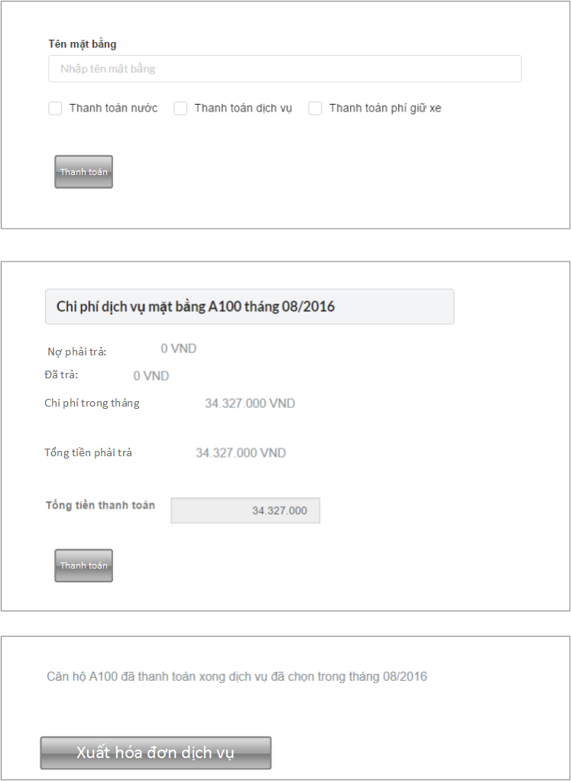 151

4.4.25.3 Class Diagram 152

4.4.25.4 Class Specifications 153

4.4.25.4.1 Function 153

4.4.25.5 Sequence Diagram 154

4.4.26 Enter Water Consumption 154

4.4.26.1 Description 154

4.4.26.2 Design 155

4.4.26.3 Class Diagram 155

4.4.26.4 Class Specifications 156

4.4.26.4.1 Function 156

4.4.26.5 Sequence Diagram 156

4.4.27 Enter water consumption from excel 157

4.4.27.1 Description 157

4.4.27.2 Design 157

4.4.27.3 Class Diagram 157

4.4.27.4 Class Specifications 157

4.4.27.4.1 Function 157

4.4.27.5 Sequence Diagram 158

4.4.28 Closing monthly statistic 159

4.4.28.1 Description 159

4.4.28.2 Design 159

4.4.28.3 Class Diagram 160

4.4.28.4 Class Specifications 161

4.4.28.4.1 Function 161

4.4.28.5 Sequence Diagram 161

4.4.29 Import building database from excel 162

4.4.29.1 Description 162

4.4.29.2 Design 162

4.4.29.3 Class Diagram 162

4.4.29.4 Class Specifications 163

4.4.29.4.1 Function 163

4.4.29.5 Sequence Diagram 164

4.4.30 See building liabilities 165

4.4.30.1 Description 165

4.4.30.2 Design 165

4.4.30.3 Class Diagram 166

4.4.30.4 Class Specifications 167

4.4.30.4.1 Function 167

4.4.30.5 Sequence Diagram 168

4.4.31 Add ground picture 169

4.4.31.1 Description 169

4.4.31.2 Design 169

4.4.31.3 Class Diagram 170

4.4.31.4 Class Specifications 170

4.4.31.4.1 Function 170

4.4.31.5 Sequence Diagram 171

4.4.32 Import ground database from excel 172

4.4.32.1 Description 172

4.4.32.2 Design 172

4.4.32.3 Class Diagram 172

4.4.32.4 Class Specifications 172

4.4.32.4.1 Function 172

4.4.32.5 Sequence Diagram 173

4.4.33 Change owner 174

4.4.33.1 Description 174

4.4.33.2 Design 174

4.4.33.3 Class Specifications 174

4.4.33.3.1 Function 174

4.4.33.4 Class Diagram 175

4.4.33.5 Sequence Diagram 176

4.4.34 Import owner database from excel 177

4.4.34.1 Description 177

4.4.34.2 Design 177

4.4.34.3 Class Diagram 177

4.4.34.4 Class Specifications 177

4.4.34.4.1 Function 177

4.4.34.5 Sequence Diagram 178

4.4.35 Open – Close service 179

4.4.35.1 Description 179

4.4.35.2 Design 179

4.4.35.3 Class Diagram 179

4.4.35.4 Class Specifications 180

4.4.35.4.1 Function 180

4.4.35.5 Sequence Diagram 180

4.4.36 See ground liabilities 181

4.4.36.1 Description 181

4.4.36.2 Design 181

4.4.36.3 Class Specifications 181

4.4.36.3.1 Function 181

4.4.36.4 Class Diagram 182

4.4.36.5 Sequence Diagram 183

4.4.37 Owner history 184

4.4.37.1 Description 184

4.4.37.2 Design 184

4.4.37.3 Class Diagram 185

4.4.37.4 Class Specifications 185

4.4.37.4.1 Function 185

4.4.37.5 Sequence Diagram 186

4.4.38 Owner history detail 186

4.4.38.1 Description 186

4.4.38.2 Design 186

4.4.38.3 Class Diagram 187

4.4.38.4 Class Specifications 187

4.4.38.4.1 Function 187

4.4.38.5 Sequence Diagram 188

4.4.39 Import citizen database from excel 189

4.4.39.1 Description 189

4.4.39.2 Design 189

4.4.39.3 Class Diagram 190

4.4.39.4 Class Specifications 190

4.4.39.4.1 Function 190

4.4.39.5 Sequence Diagram 191

4.4.40 Import citizen card database from excel 192

4.4.40.1 Description 192

4.4.40.2 Design 192

4.4.40.3 Class Diagram 193

4.4.40.4 Class Specifications 193

4.4.40.4.1 Function 193

4.4.40.5 Sequence Diagram 194

4.4.41 Lock – Lost citizen card 195

4.4.41.1 Description 195

4.4.41.2 Design 195

4.4.41.3 Class Diagram 196

4.4.41.4 Class Specifications 197

4.4.41.4.1 Function 197

4.4.41.5 Sequence Diagram 198

4.4.42 Import Vehicle Card database from excel 199

4.4.42.1 Description 199

4.4.42.2 Design 199

4.4.42.3 Class Diagram 199

4.4.42.4 Class Specifications 200

4.4.42.4.1 Function 200

4.4.42.5 Sequence Diagram 201

4.4.43 Open vehicle card service 202

4.4.43.1 Description 202

4.4.43.2 Design 202

4.4.43.3 Class Diagram 203

4.4.43.4 Class Specifications 203

4.4.43.4.1 Function 203

4.4.43.5 Sequence Diagram 204

4.4.44 Lock – Lost vehicle card 205

4.4.44.1 Description 205

4.4.44.2 Design 205

4.4.44.3 Class Diagram 206

4.4.44.4 Class Specifications 207

4.4.44.4.1 Function 207

4.4.44.5 Sequence Diagram 208

4.4.45 Send announcement via email 209

4.4.45.1 Description 209

4.4.45.2 Design 209

4.4.45.3 Class Diagram 210

4.4.45.4 Class Specifications 210

4.4.45.4.1 Function 210

4.4.45.5 Sequence Diagram 211

4.4.46 Financial Setting 211

4.4.46.1 Description 211

4.4.46.2 Design 212

4.4.46.3 Class Diagram 213

4.4.46.4 Class Specifications 214

4.4.46.4.1 Function 214

4.4.46.5 Sequence Diagram 214

4.4.47 Report Setting 215

4.4.47.1 Description 215

4.4.47.2 Design 215

4.4.47.3 Class Diagram 215

4.4.47.4 Class Specifications 215

4.4.47.4.1 Function 215

4.4.47.5 Sequence Diagram 216

4.4.48 View vehicle finance 217

4.4.48.1 Description 217

4.4.48.2 Design 217

4.4.48.3 Class Diagram 218

4.4.48.4 Class Specifications 218

4.4.48.4.1 Function 218

4.4.48.5 Sequence Diagram 219

4.4.49 Add vehicle finance 220

4.4.49.1 Description 220

4.4.49.2 Design 220

4.4.49.3 Class Diagram 220

4.4.49.4 Class Specifications 220

4.4.49.4.1 Function 220

4.4.49.5 Sequence Diagram 221

4.4.50 Update vehicle finance 221

4.4.50.1 Description 221

4.4.50.2 Design 222

4.4.50.3 Class Diagram 222

4.4.50.4 Class Specifications 222

4.4.50.4.1 Function 222

4.4.50.5 Sequence Diagram 223

4.4.51 Delete vehicle finance 223

4.4.51.1 Description 223

4.4.51.2 Design 224

4.4.51.3 Class Diagram 224

4.4.51.4 Class Specifications 224

4.4.51.4.1 Function 224

4.4.51.5 Sequence Diagram 225

5. SOFTWARE TEST DOCUMENTATION 226

5.1 Introduction 226

5.1.1 System Overview 226

5.1.2 Scope of testing: 226

5.1.2.1 Stage of testing: 226

5.1.2.2 Type of testing: 227

5.1.2.3 Scope of testing: 227

5.2 Test Plan: 228

5.2.1 Testing tools and environment: 228

5.2.1.1 Testing tools: 228

5.2.1.2 Testing environment: 228

5.2.2 Resources and responsibilities: 229

5.2.3 Test strategy: 229

5.2.3.1 Test Model: 229

5.2.3.2 Test type: 231

5.2.3.3 Test Stage: 232

5.2.3.4 Test Schedule: 233

5.2.3.5 Deliverables: 234

Table below are the Deliverables for MANAPART Project: 234

5.2.4 Feature to be tested: 234

5.2.5 Feature not to be tested: 234

5.3 Test Approach: 235

5.3.1 Integration and System Test: 235

5.3.2 Acceptance Test: 239

5.3.3 Defect Log: 240

5.4 Test Report: 241

5.4.1 Test case 241

5.4.2 Bug list report: 244

6. USER MANUAL 245

1.1 User Guidelines 245

1.1.1 Register 245

1.1.2 Login 246

1.1.3 Dashboard 250

1.1.3.1 Overview 250

1.1.3.2 Payment 252

1.1.3.3 Building 255

1.1.3.4 Ground 259

1.1.3.5 Citizen 265

1.1.3.6 Announcement 270

1.1.3.7 Facility 272

1.1.3.8 Maintain 274

1.1.3.9 Setting 275

# INTRODUCTION

## Project Information

* Project name : **The Erudite Guider**
* Project code : **TEG**
* Project group name: **ISE0801**
* Product type :**Website and Android Mobile Application**
* Timeline : **From 5 th September 2016 to 12 th December 2016**

## The People

### Supervisor

|  |  |  |  |  |
| --- | --- | --- | --- | --- |
|  | **Full name** | **Phone** | **E-Mail** | **Title** |
| Supervisor | Mr. Bui Dinh Chien | +84 904232472 | [chienbd@fpt.edu.vn](mailto:chienbd@fpt.edu.vn) | Lecturer |

*Table 1.1: Supervisor information*

### Team members

|  |  |  |  |  |  |
| --- | --- | --- | --- | --- | --- |
|  | **Full name** | **Student code** | **Phone** | **E-mail** | **Role in Group** |
| 1 | Nguyen Huu Quyet | SE03119 | +84 1646093888 | [quyetnhse03119@fpt.edu.vn](mailto:quyetnhse03119@fpt.edu.vn) | Team Leader |
| 2 | Nguyen Xuan Tung | SE03325 | +84 974800599 | [tungnxse03325@fpt.edu.vn](mailto:tungnxse03325@fpt.edu.vn) | Member |
| 3 | Mông Quốc Toàn | SE03369 | +84 947595595 | [toanmq03369@fpt.edu.vn](mailto:toanmq03369@fpt.edu.vn) | Member |
| 4 | Khuc Huu Huy | SE03064 | +84 868448682 | [huykhse03064@fpt.edu.vn](mailto:huykhse03064@fpt.edu.vn) | Member |
| 5 | Phan Van Giang | SE03422 | +84 1692685219 | [giangpvse03422@fpt.edu.vn](mailto:giangpvse03422@fpt.edu.vn) | Member |

*Table 1.2: Team member’s information*

## Definitions and Acronyms

|  |  |  |
| --- | --- | --- |
| **Acronym** | **Definition** | **Note** |
| TEG | The Erudite Guider |  |
| PMP | Project Management Plan |  |
| RUP | Rational Unified Process |  |
| PM | Project Manager |  |
| SRS | Software Requirement Specification |  |
| QA | Quality Assurance |  |
| DB | Database |  |
| SC | Screen |  |
| UC | Use Case |  |
| N/A | Not Available |  |
| No. | Number |  |
| GUI | Graphic User Interface |  |
| Admin | Administrator |  |
|  |  |  |
|  |  |  |
|  |  |  |
|  |  |  |
|  |  |  |
|  |  |  |
|  |  |  |

*Table 1.3: Definitions and Acronyms*

## Problems

Generally, museums and exhibitions are established for saving and exhibiting histories, chronicles and all categories of art. However, even though visitors come to the museums and exhibitions by individuals or groups at various time, tour guides in each exhibition room are limited in numbers of speakers and presentation time.

In case of FPT University museum where exhibits hundreds of artifacts that relate to history of formation and development path of FPT University through 10 years from establishing day. Each artifact represents a long story behind as well as photos, cups, student cards. Groups of visitors from countries, corporations and universities also have certain timeline for their tours.

Hence, there is a problem comes out is how all the artifacts completely convey theirs significance to viewers while both visitors and guides have limited time and opportunities to visit all of them.

## Literature Review

After conducting research, we found some kinds of technology can apply to museums to help digitization their artifacts and why “The Erudite Guider” will create revolution about the tourism industry in general and museum sector in Vietnam in particular.

[**vnmh.egal.vn**](http://vnmh.egal.vn/)

Egal is a website run as a 3D virtual museum. This website draws on the characteristics of a museum, in order to complement, enhance, or augment the museum experience through personalization, interactivity and richness of content. The 3D interactive virtual museum solutions allow visitors access and discover easily the interested objects, topics…that can be found in a real museum. Angel provides the entire exhibition space, the actual architectural space realistic simulated in 3D. Visitors can move, sightseeing, interact with virtual 3D space by play audio guide of corresponding artifacts. Location, artifacts are digitization detailed by laser scanning technology, 3D scanning. Each location, objects are then accurately reproduce the position in 3D space virtual and can interact visually.

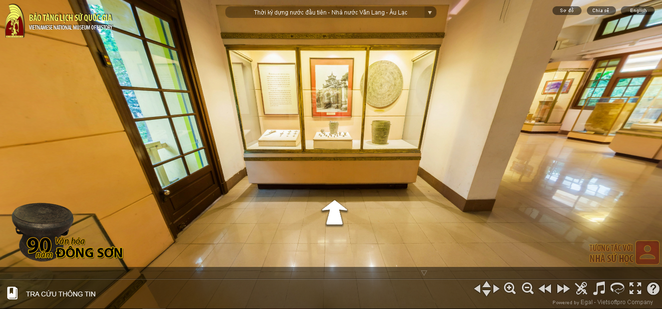

At the present time, vnmh.egal.vn is running in Vietnam national museum of history.

Although apply advanced technology, egal system also show their limitation. Because egal is a web application, visitors like to use it when they are not in museum. When visitors are in museum, they do not need to use this website anymore. Moreover, information of artifacts is not diverse (Read illustrated mainly through audio files).

**Orpheo Mikro – audio guide device**

The Orpheo Mikro is a well-known audio guide device which is used in museums around the world. It delivers quality audio, and is conveniently compact and lightweight - similar in size to a mobile phone. The Mikro device will allow visitors to actively guide themselves around the museum according to their interests. It provides an enhanced museum visit, with additional historical and cultural information, interviews and music associated with the museum’s objects.

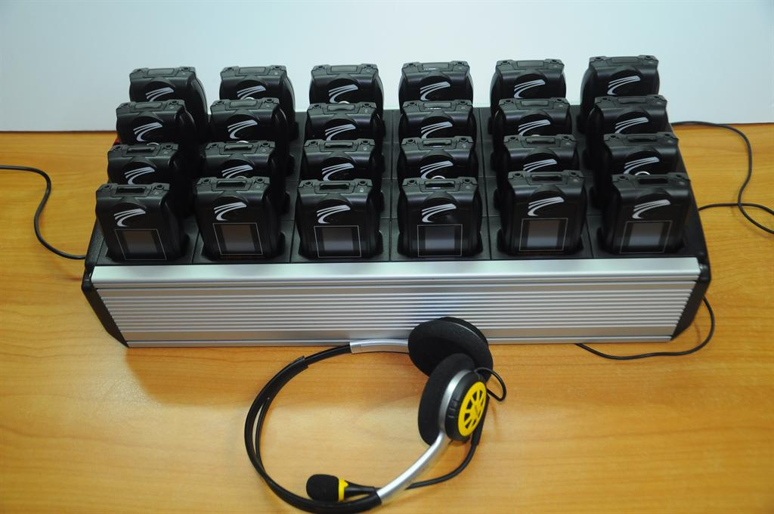

This device lets users start the story in two ways: automatically at the start of the tour or by clicking the keyboard of the device, volume is customized. However, device only interacts with user through audio.

Summary, the existing systems are only audio guide and do not have good interaction with visitor. Therefore, this is cause to make visitor feel boring when they are using them.

## Ideas

Like we mentioned above, have a lot of limitation interm of applying new technology into museum industry. Therefore, after researching and studying, we find out a solution called “The Erudite Guide”. This solution could help visitors completely understand the meaning of artifacts when they come to museum without museum’s guider. Artifact’s information can be present under audio, video to bring multiple perspectives and lively approach to visitors.

“The Erudite Guide” expected to include of three parts:

* Client: This part will be an Android application installed on user’s devices (Smartphone, tablet, etc). The application takes responsibility for artifact detection and sending the corresponding target ID to Server.
* Server: This is Vuforia Cloud. Server stores target Image or marker of Artifact to identify when artifact is tracked.
* Customize service backend to manage Database and content. Those are videos, audios and information in text format of corresponding artifacts.

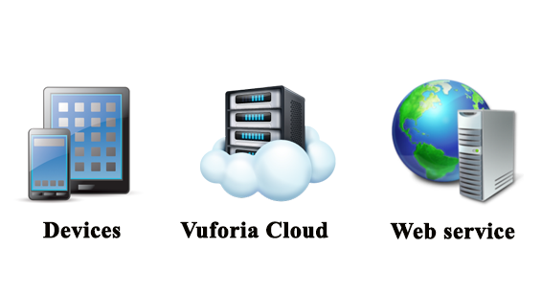

## Proposal of System

### Our proposal system

For the above reasons, “The Erudite Guider” is created and developed on augmented reality platform could be seen as an effective apps in order to solve all of the above problems.

“The Erudite Guide” application aims to promptly present meaning of artifacts with their initial information, story behind and even turn their artifacts’ pictures into audio, video and even 3D models (out standing feature in the future) after recognizing the artifacts by camera.

Using “The Erudite Guide” could help visitors completely understand the meaning of artifacts when they go to exhibition room.

“The Erudite Guide” not only is android application, but it also has a web system to store and manage artifact’s information (text descriptions, audios, videos and images) of museums who are our customer. This backend component ensures android application can accept data from cloud therefor avoid heavy capacity of application on device. More important, web system can help museum manage and interact with their artifact very easy and flexible.

BASIC FUNCTIONS:

* Web application:
* Allows administrator manage all museum and account register in the system.
* Allows administrator view all museum’s account in the system.
* Allows administrator create new admin account to assign task in the system.
* Allows administrator manage all museum’s artifacts in the system.
* Allows customer view object of each member museum in the system.
* Allows administrator manage request form guest(free museum) and customer(member museum)
* Allows administrator view all request from guest (request to register new account) in the system.
* Allows administrator accept or reject all request from guest (request to register new account) in the system.
* Allows administrator view all request from customer (request to change object’s status, request to delete object) in the system.
* Allows administrator accept or reject all request from customer (request to change object’s status, request to delete object) in the system.
* Allows customer manage all museum’s artifacts in the system
* Allows customer upload new object in the system.
* Allows customer view internal object in the system.
* Allows customer manage all museum’s request in the system
* Allows customer create new request (request to change object’s status, request to delete object) in the system.
* Allows customer view all created request (request to change object’s status, request to delete object) in the system.
* Mobile application:
* Allows visitor scan artifact have Active status in the system to get corresponding information.
* Play artifact’s video
* Play artifact’s audio

OUT OF SCOPE FUNCTIONS:

* Image/ Object recognization

### Introduction about our proposal system

Once again, “The Erudite Guider” application aims to promptly present meaning of artifacts with their initial information, story behind and even turn their artifacts’ pictures into audio, video and even 3D models (out standing feature in the future) after recognizing the artifacts by camera.

Using “The Erudite Guider” could help visitors completely understand the meaning of artifacts when they go to exhibition room.

The Erudite Guider is change the way of visiting museum behavior at present. Let imagine, only with a mobile device (smartphone, tablet, etc) and The Erudite Guider mobile application, visitor can enjoy museum without traditional guider.

### Limit of our system

Beside advanatage above, our system also face to some limitation:

* “The Erudite Guide” is using Vuforia cloud to detect target that is advantage but also a limitation of knowledge and ability.
* Besides that, how to obtain contents of artifact also is a challenge for us.
* One more factor, our system require user’s devices to be connected to the internet to use the service.

# SOFTWARE PROJECT MANAGEMENT PLAN

In this section, we will describe our organization and plan of project (work schedule from start to the end of project), project risk management plan and communication plan. In addition, we introduce our team and overview about project. Meeting minutes also present in this section. Each member of team must use this section as a guideline tracking assigned tasks and deadlines. Furthermore, this will be used by project manager to manage and control work of all team. The supervisor can use this to track progress of the project team.

## 2.1 Project organi**z**ation

### 2.1.1 Software Process Model

In this project, we apply Rational Unified Process (RUP) model as development process model.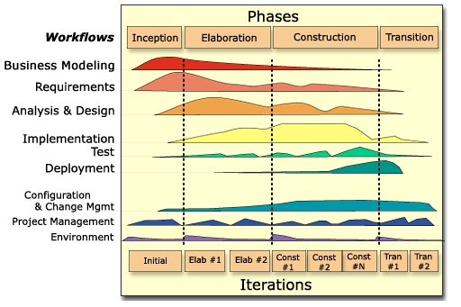

*Figure 2-1-1 Rational Unified Process*

The RUP has determined a project life-cycle consisting of four phases. These phases allow the process to be presented at a high level in a similar way to how a 'waterfall'-styled project might be presented, although in essence the key to the process lies in the iterations of development that lie within all of the phases. Also, each phase has one key objective and milestone at the end that denotes the objective being accomplished. The visualization of RUP phases and disciplines over time is referred to as the RUP hump chart.

### 2.1.2 Project lifecycle

Base on RUP model above, this project is divided into 4 phases: Inception, Elaboration, Construction, and Transition. Each phase goes through requirements, analysis and design, implementation and testing. Every phase has a specific set of goals, which are addressed within the iterations of the phase, so that the phase milestone may be met.

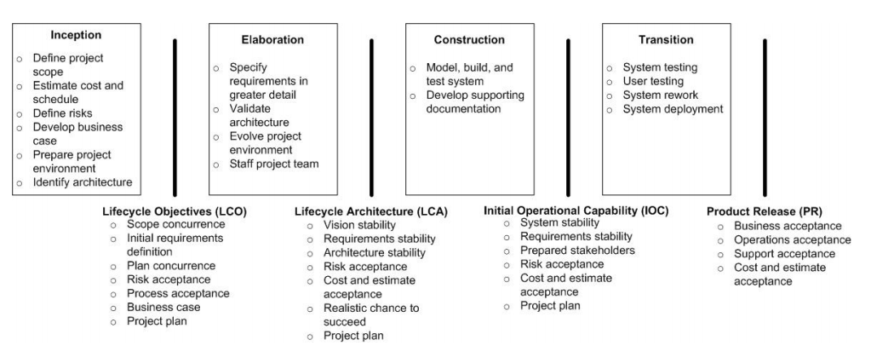

*Figure 2-1-2 The RUP phases and their milestone*

### 2.1.3 Roles and Responsibilities



#### Project Team Member

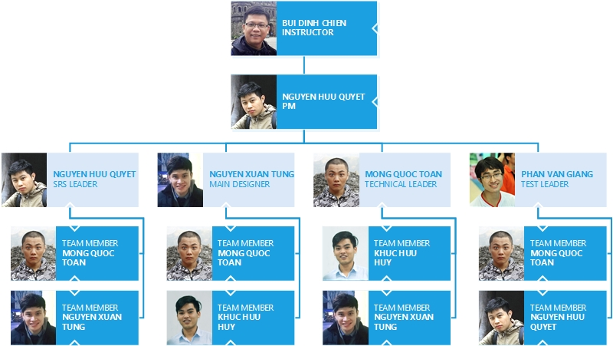

*Figure 2-1-3 Organization structure*

#### Role & Responsibilities

|  |  |  |
| --- | --- | --- |
| **Member** | **Role** | **Responsibilities** |
| Instructor | Mr. Bui Dinh Chien | * Give instruction for project team * Resolve escalated issues * Supervise project team’s status   Verify deliverables |
| PM | Nguyen Huu Quyet | Have overall responsibility of the project:   * Create project plan * Create software requirements specification * Assign task to team members * Manage project stakeholders, project team and resolve conflicts. * Tracking team member’s work * Report work status to the instructor * Communication with members and instructor, include weekly plan, weekly status report, hold meetings and assure to submit reports and work status to the instructor on schedule |
| Requirement analysis team | | |
| SRS leader | Nguyen Huu Quyet | Complete SRS document and submit to instructor |
| Member #1 | Mong Quoc Toan | Create user case and review document |
| Member #2 | Nguyen Xuan Tung | Create database requirements |
| Design team | | |
| Main designer | Nguyen Xuan Tung | Design interface for web application |
| Designer #1 | Mong Quoc Toan | Design for mobile application |
| Designer #2 | Khuc Huu Huy | Support in design for web application |
| Development team | | |
| Technical leader | Mong Quoc Toan | * Decide technique and tools to be used * Develop and coding for mobile application |
| Developer #1 | Nguyen Xuan Tung | * Train other member of web development * Create coding convention * Develop web application * Coding for web service |
| Developer #2 | Khuc Huu Huy | Coding for web service |
| Test team | | |
| Test leader | Phan Van Giang | * Create test plan * Create test case * Report test result |
| Tester #1 | Mong Quoc Toan | Implement test case |
| Tester #2 | Nguyen Huu Quyet | Implement test case |

*Table 2.1: Project roles and member’s responsibilities*

### Tools and Infrastructure

#### Hardwares

* Personal computer for developing and testing with the minimum configuration: 4GB RAM, 500GB of hard disk, Intel Core i3.
* Internet network connection.
* Smart phone run on Android operating system.

#### Softwares

|  |  |  |
| --- | --- | --- |
| **Category** | **Software name** | **Version** |
| **Operating system** | Microsoft Windows 7 | Professional |
| **Office tools** | Microsoft Word | 2010 |
| Microsoft Excel | 2010 |
| Microsoft Power point | 2010 |
| **Management tool** | Microsoft Project | 2016 |
| Google Driver |  |
| **Design tool** | Astah Professional | 7.1.0 |
| [www.draw.io](http://www.draw.io) |  |
| Adobe Photoshop | CS6 |
| Microsoft Power point | 2010 |
| **Development tool** | Android Studio | 2.2.2 |
| Sublime Text | 3.0 |
| phpStrom | 2016.3 |
| **Database tool** | phpMySQL |  |
| Navicat |  |
| Xampp | 7.0.9.1 |
| **Source code**  **management tool** | GitHub Desktop | 3.3.3 |
| github.com |  |
| **Communication tools** | Google Mail Group |  |

*Table 2.2: Software is used in project*

## Project management plan

### 2.2.1 Tasks schedule

Inception: Start Monday 05th – Sep -2016 to Monday 19th – Sep– 2016.

Elaboration: Monday 19th – Sep– 2016 to Friday 14th – Oct– 2016.

Construction: Friday 14th – Oct– 2016 to Thursday 08th – Dec– 2016.

Elaboration: Thursday 08th – Dec– 2016 to Monday 12th – Dec– 2016.

Below are the images of work schedule for this project. Refer to *TEG_ProjectManagementPlan.mpp* for detail.

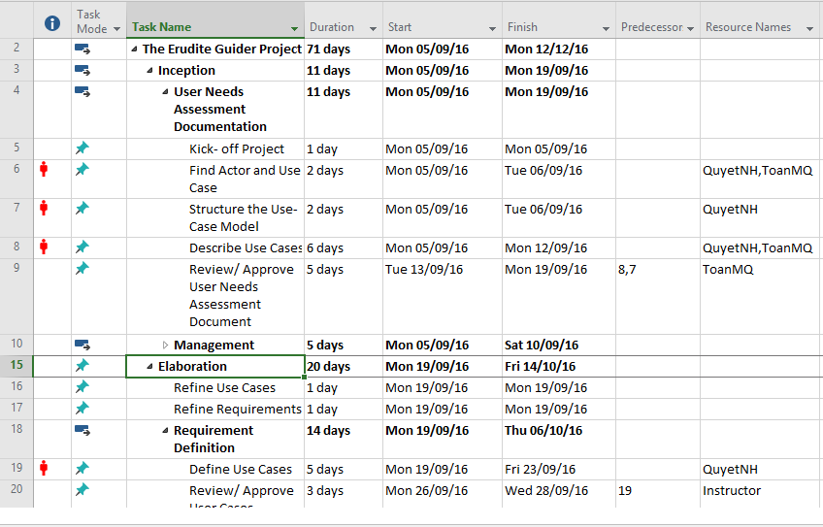

*Figure 2-2-1 Work Breakdown Structure*

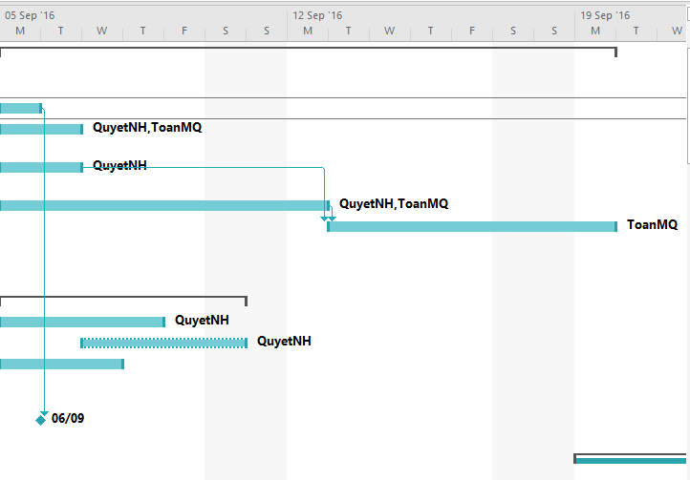

*Figure 2-2-2 Grantt chart*

### 2.2.2 Meeting Minutes

In all meeting minutes will be written follow this template:

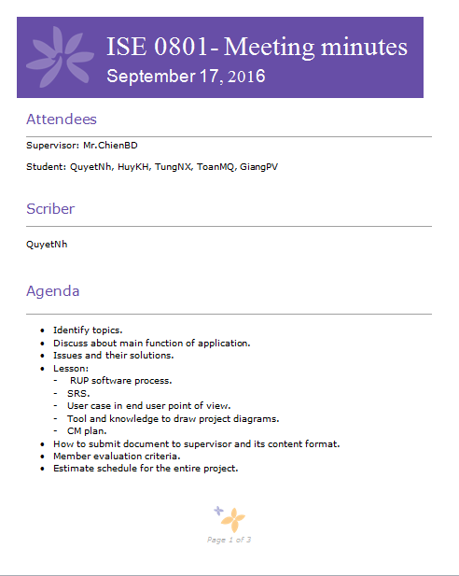

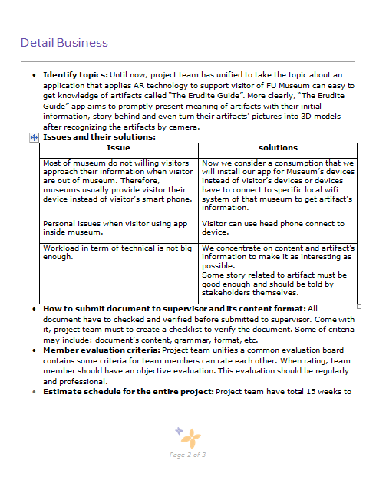

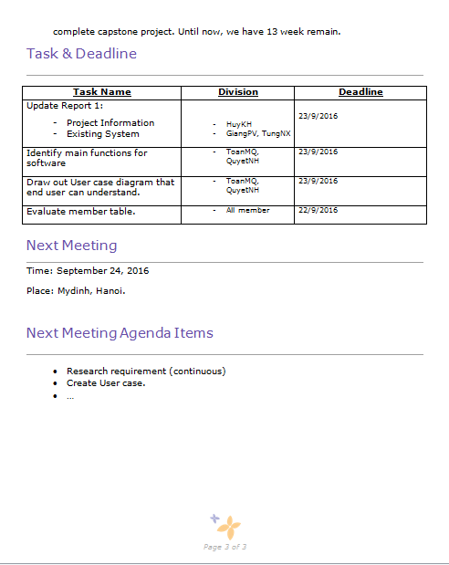

### 2.2.3 Coding Convention

Coding convention for this project will follow the “Code Style for Contributors” for Android developer.

For more details, visit the following link: <https://source.android.com/source/code-style.html>

### 2.2.4 Risks management

|  |  |  |
| --- | --- | --- |
| **Category** | **Sub-category** | **Acronym & Abbreviation** |
| **Technical** | Requirement Definition | T-RD |
| Technology | T-T |
| Complexity and Interfaces | T-CI |
| Performance and Reliability | T-PR |
| Quality | T-Q |
| **Management** | Estimating | M-E |
| Human Resources | M-HR |
| Communication | M-Cm |
| Source | M-S |
| Controlling | M-Cl |
| **External** | Weather | E-W |

*Table 2.3: Risk categories*

|  |  |  |  |  |  |  |  |
| --- | --- | --- | --- | --- | --- | --- | --- |
| **ID** | **Description**  **of risk** | **Cat** | **Impact** | **Root Cause** | **Avoidance Plan** | **Contingency Plan** | **Fallback Plan** |
| 1 | The processes does not meet their deadline | M-Cl | Delay task and negative affect the attitude of team member | Poor control and estimation | Research carefully about how to control team and assign task clearly | Increase work performance | Operate more work and task at the same time |
| Low technical skills of team members | Stepping up training and learning technique |
| 2 | A team member’s absence | M-HR | Bad affect to project schedule and project quality | Health reason | Motivate member and create positive work environment | Other members replace that  member’s work |  |
| 3 | Low team member’s motivation | M-Cm | Delay task and negative affect the attitude of team member | Personal morale | Organize team building so that team member can get well to each other | Conduct a meeting so that the team members can express their opinions and find out solutions | Take responsibility in front of the team/ apply team punishment rules |
| 4 | Training process is not effective | M-HR | Bad affect to project schedule and project quality | Each member needs to do research by themselves and consult experts (active to learn) | Create more team meeting to training and share resource and knowledge as well |  | Contact someone to help with technical training |
| 5 | Poor unit test and test case | T-Q | Bad affect to project schedule and project quality | Team member does not clearly understand about system | Each member needs to do research and work carefully | Increase work performance | Ask for other people’s help to test |
| 6 | Low processing speed | T-T | Bad affect to project quality | Third-party service package selection is poor | Select high service from third-party by pay money | Decrease redundant data on transmission line |  |

*Table 2.4: Risk register*

**Risk probability and impact**

The probability and impact of occurrence for each identified risk will be assessed by the project manager, with input from the project team using the following approach:

* **Probability**
* High – Greater than <70%> probability of occurrence
* Medium – Between <30%> and <70%> probability of occurrence
* Low – Below <30%> probability of occurrence
* **Impact**
* High – Risk that has the potential to greatly impact project cost, project schedule or performance
* Medium – Risk that has the potential to slightly impact project cost, project schedule or performance
* Low – Risk that has relatively little impact on cost, schedule or performance

|  |  |  |  |  |
| --- | --- | --- | --- | --- |
| **Probability** | High |  | Risk 5 | Risk 1 |
| Medium |  | Risk 3  Risk 6 | Risk 4  Risk 2 |
| Low |  |  |  |
|  | Low | Medium | High |
|  | **Impact** | | | |

*Table 2.5: Probability/Impact matrix*

**Closing a Risk**

A risk will be considered closed when it meets the following criteria:

* Risk is no longer valid.
* Risk Event has occurred.
* Risk is no longer considered a risk.
* Risk closure at the direction of the Project Manager.

### 2.2.5 Communication plan

Within 15 weeks from 9/5/2016 to 12/12/2016, project team had meeting with Instructor on every Monday. Moreover, in the implementation process if get any issue need instructor ‘consultation, we will proactively arrange meetings.

For each meeting with Instructor, documents and meeting minutes will be kept under internal server directory of Github and email group.

With team member, we arrange 3 days and all night of the week to discuss and work together.

All document is stored in server directory of Github in folder that corresponding with member who is assigned. Those are public for all team members. For each delivery milestone in this project, those reports required stored in document directory and we try to limit to modify them.

|  |  |  |  |
| --- | --- | --- | --- |
| **No** | **Name** | **Responsibilities** | **Telephone, Address, Email** |
| 1 | Mr. Bui Dinh Chien | Instructor | My Dinh, Ha Noi  Tel: +84 904232472  Email: [chienbd@fpt.edu.vn](mailto:chienbd@fpt.edu.vn) |
| 2 | Nguyen Huu Quyet | Project Manager | Hoa Lac, Thach That, Ha Noi  Tel: +84 1646093888  Email: [quyetnhse03119@fpt.edu.vn](mailto:quyetnhse03119@fpt.edu.vn) |
| 3 | Nguyen Xuan Tung | Main Designer | Hoa Lac, Thach That, Ha Noi  Tel: +84 974800599  Email: [tungnxse03325@fpt.edu.vn](mailto:tungnxse03325@fpt.edu.vn) |
| 4 | Phan Van Giang | Test Leader | Hoa Lac, Thach That, Ha Noi  Tel: +84 1692685219  Email: [giangpvse03422@fpt.edu.vn](mailto:giangpvse03422@fpt.edu.vn) |
| 5 | Mong Quoc Toan | Technical Leader | Hoa Lac, Thach That, Ha Noi  Tel: +84 947595595  Email: [toanmq03369@fpt.edu.vn](mailto:toanmq03369@fpt.edu.vn) |
| 6 | Khuc Huu Huy | Member | Hoa Lac, Thach That, Ha Noi  Tel: +84 868448682  Email:  [huykhse03064@fpt.edu.vn](mailto:toanmq03369@fpt.edu.vn) |

*Table 2.6: Project team member’s contact*

|  |  |  |
| --- | --- | --- |
| **Technologies or access method** | **Tool Name** | **Purpose** |
| Email and message | Gmail | Contact with Instructor or Customer |
| Skype/ Facebook | Contact with team member |
| Mobile phone call | Cellphone | Contact directly with other stakeholders in an emergency situation |
| Video call | Skype/ Facebook | Online meeting |
| Collaboration tool | Github Desktop | Managing source code and document |

*Table 2.7: Technologies or access method use for communications*

### 2.2.6 Project millstones

|  |  |  |  |  |
| --- | --- | --- | --- | --- |
| **No** | **Milestones** | **Delivery Date** | **Delivery Location** | **Delivery Type** |
| 1 | Project registration | 13/08/2016 | University | Hard and soft  copy |
| 2 | Kick off project | 5/09/2016 | Supervisor | Soft copy |
| 3 | Report No.1: Introduction | 12/09/2016 | Supervisor | Soft copy |
| 4 | Report No.2: Software Project Management Plan (SPMP) | 19/09/2016 | Supervisor | Soft copy |
| 5 | Report No.3: Software Requirements Specifications (SRS) | 30/09/2016 | Supervisor | Soft copy |
| 6 | Report No.4: Software Design Description (SDD) | 14/10/2016 | Supervisor | Soft copy |
| 7 | Report No.5: Software Test Documentation (STD) | 11/11/2016 | Supervisor | Soft copy |
| 8 | Report No.6: Software User’s Manual (SUM) | 5/12/2016 | Supervisor | Soft copy |
| 9 | Final Report | 14/12/2014 | Supervisor | Soft copy |
| 10 | All project resource | 14/12/2014 | University | Hard and soft  copy |
| 11 | Project defense | 22/12/2016 | University | Hard and soft  copy |

Table 2.7: Project milestones and deliverables

# SOFTWARE REQUIREMENT SPECIFICATION

Use Case List

|  |  |  |
| --- | --- | --- |
| **Primary Actor** | **Use Cases** | **Reference** |
| Manager | UC - 01: Register tower |  |
| Manager | UC - 02: Login to subdomain |  |
| Manager | UC - 03: Logout of subdomain |  |
| Manager | UC - 04: View grounds |  |
| Manager | UC - 05: Add ground |  |
| Manager | UC - 06: Update ground |  |
| Manager | UC - 07: Delete ground |  |
| Manager | UC - 08: View citizens |  |
| Manager | UC - 09: Add citizens |  |
| Manager | UC - 10: Update citizen |  |
| Manager | UC - 11: Delete citizen |  |
| Manager | UC - 12: View water finance |  |
| Manager | UC - 13: Add water finance |  |
| Manager | UC – 14: Update water finance |  |
| Manager | UC - 15: Delete water finance |  |
| Manager | UC - 16: View service finance |  |
| Manager | UC - 17: Add service finance |  |
| Manager | UC - 18: Update service finance |  |
| Manager | UC - 19: Delete service finance |  |
| Manager | UC - 20: View history |  |
| Manager | UC - 21: View grounds map |  |
| Manager | UC - 22: View statistic and report |  |
| Manager | UC - 23: Export report |  |
| Manager | UC - 24: Create Statistic Chart |  |
| Manager | UC - 25: Payment |  |
| Manager | UC - 26: Enter water consumption |  |
| Manager | UC - 27: Enter water consumption from excel |  |
| Manager | UC - 28: Closing monthly statistic |  |
| Manager | UC - 29: Import building database from excel |  |
| Manager | UC - 30: See building liabilities |  |
| Manager | UC - 31: Add ground picture |  |
| Manager | UC - 32: Import ground database from excel |  |
| Manager | UC - 33: Change owner |  |
| Manager | UC - 34: Import owner database from excel |  |
| Manager | UC - 35: Open – Close service |  |
| Manager | UC - 36: See ground liabilities |  |
| Manager | UC – 37: Owner history |  |
| Manager | UC – 38: Owner history detail |  |
| Manager | UC – 39: Import citizen database from excel |  |
| Manager | UC – 40: Import citizen card database from excel |  |
| Manager | UC – 41: Lock – lost citizen card |  |
| Manager | UC – 42: Import Vehicle Card database from excel |  |
| Manager | UC – 43: Open vehicle card service |  |
| Manager | UC – 44: Lock – Lost vehicle card |  |
| Manager | UC – 45: Send announcement via email |  |
| Manager | UC – 46: Financial Setting |  |
| Manager | UC – 47: Report Setting |  |
| Manager | UC – 48: View vehicle finance |  |
| Manager | UC – 49: Add vehicle finance |  |
| Manager | UC – 50: Update vehicle finance |  |
| Manager | UC – 51: Delete vehicle finance |  |
| Administrator | UC – 52: Login to main domain | Appendix Section 1.1.1 |
| Administrator | UC – 53: Logout of main domain | Appendix Section 1.1.2 |
| Administrator | UC – 54: Change password | Appendix Section 1.1.3 |
| Administrator | UC – 55: View all towers | Appendix Section 1.1.4 |
| Administrator | UC – 56: Update tower | Appendix Section 1.1.5 |
| Administrator | UC – 57: Delete tower | Appendix Section 1.1.6 |
| Manager | UC – 58: View account manager | Appendix Section 1.1.7 |
| Manager | UC – 59: Add account manager | Appendix Section 1.1.8 |
| Manager | UC – 60: Update account manager | Appendix Section 1.1.9 |
| Manager | UC – 61: Deactive account manager | Appendix Section 1.1.10 |
| Manager | UC – 62: View buildings | Appendix Section 1.1.11 |
| Manager | UC – 63: Add building | Appendix Section 1.1.12 |
| Manager | UC – 64: Update building | Appendix Section 1.1.13 |
| Manager | UC – 65: Delete building | Appendix Section 1.1.14 |
| Manager | UC – 66: View citizen cards | Appendix Section 1.1.15 |
| Manager | UC – 67: Add citizen card | Appendix Section 1.1.16 |
| Manager | UC – 68: Update citizen card | Appendix Section 1.1.17 |
| Manager | UC – 69: Delete citizen card | Appendix Section 1.1.18 |
| Manager | UC – 70: View facilities | Appendix Section 1.1.19 |
| Manager | UC – 71: Add facilities | Appendix Section 1.1.20 |
| Manager | UC – 72: Update facility | Appendix Section 1.1.21 |
| Manager | UC – 73: Delete facility | Appendix Section 1.1.22 |
| Manager | UC – 74: View maintenance schedule | Appendix Section 1.1.23 |
| Manager | UC – 75: Add maintenance schedule | Appendix Section 1.1.24 |
| Manager | UC – 76: Update maintenance schedule | Appendix Section 1.1.25 |
| Manager | UC – 77: Delete maintenance schedule | Appendix Section 1.1.26 |
| Manager | UC – 78: View vehicle cards | Appendix Section 1.1.27 |
| Manager | UC – 79: Update vehicle cards | Appendix Section 1.1.28 |
| User | UC – 80: View post | Appendix Section 1.1.29 |
| Manager | UC – 81: Add post | Appendix Section 1.1.30 |
| Manager | UC – 82: Update post | Appendix Section 1.1.31 |
| Manager | UC – 83: Delete post | Appendix Section 1.1.32 |

## Purpose

This chapter outlines functional and non-functional requirements of our website. It also provides some format constraints in common requirements and project success criteria. All members will work (design, code, test) based on the information provided in this chapter.

## Functional Requirements

### Use Case Diagram

Figure 3.1 Use Case Diagram

### Business Rules

This is the business rules table for system’s use case

|  |  |
| --- | --- |
| **No** | **Description** |
| **B01** | The deactive account cannot log in the system. |
| **B02** | After manager clicks the “Ngừng hoạt động” button in “Danh sách tài khoản” tab, Manapart replaces it with the “Mở hoạt động” button. |
| **B03** | Owner have to pay all the debt before they want to leave out ground |
| **B04** | Citizens have to be removed out ground before the manager want to delete them |
| **B05** | All action interact with the system is logged |
| **B06** | History change owner is logged individually |
| **B07** | Format of image to upload is png, jpg, gif |
| **B08** | Images size must be less than 5MB |
| **B09** | Homepage of subdomain display all news for citizen. With the manager, homepage show more two button “Sửa” and “Xóa” to edit or delete quickly the new |
| **B10** | Field “Mặt bằng” to search information of ground which is alreaydy in the system, is autocomplete |
| **B11** | Field “Mặt bằng” to search information of citizen which is alreaydy in the system, is autocomplete |
| **B12** | Autocomplete citizen have to with information about date of birth to distinguish |
| **B13** | When the manager want to delete ground, Manapart have to check debt of this ground |
| **B14** | Pagination of table have to change when the number of result is changed by searching |
| **B15** | When searching or filtering, the page doesn’t reload all only reload the table display result |
| **B16** | The require field is marked by “*” |
| **B17** | The manager access to the system through the link subdomain when register |
| **B18** | The Manapart don’t allow detroy record in the system, only delete logical |
| **B19** | The bussines in “Bàn làm việc” and “Quản lý chung” is same although they have different operations |
| **B20** | Validation message displays under each field when inputs are invalid |
| **B21** | If manager want to edit or show , a modal showing a full detail information appears |
|  |  |
|  |  |
|  |  |
|  |  |
|  |  |
|  |  |
|  |  |
|  |  |
|  |  |

### Use Cases



#### Register tower

|  |  |  |  |  |
| --- | --- | --- | --- | --- |
| **Use Case ID** | | UC - 01 | **Version** | 1.0 |
| **Use Case Name** | | Register tower | | |
| **Actor** | | User | | |
| **Description** | | User access MANAPART homepage on browser via Internet and register apartment tower | | |
| **Precondition** | | User is welcome page of MANAPART | | |
| **Trigger** | | Input all mandatory fields and choose price package | | |
| **Post-condition** | | User register tower successfully | | |
| **Main flows** | | | | |
| **Step** | **Actor** | **Action** | | |
| 1 | User | Access to MANAPART homepage | | |
| 2 | System | Display homepage | | |
| 3 | User | Click “Đăng kí” button Navigation Bar | | |
| 4 | System | Display “Đăng kí” screen | | |
| 5 | User | Fill all mandatory fields and choose price package | | |
| 6 | System | Display message notify that register successfully | | |
| **Alternative flows** | | | | |
| **AT1** | At step 5 in main flows, if user don’t fill all mandatory fields | | | |
| **Step** | **Actor** | **Action** | | |
| 5.1 | System | Display message “{Texbox name} không được để trống” | | |
| **Business Rules** | | | | |
|  | | | | |

#### Login to subdomain

|  |  |  |  |  |
| --- | --- | --- | --- | --- |
| **Use Case ID** | | UC - 02 | **Version** | 1.0 |
| **Use Case Name** | | Login to subdomain | | |
| **Actor** | | Manager | | |
| **Description** | | Manager access manage page on browser via Internet and input account and password to login. When login successfully, manager can access full function in the website. | | |
| **Precondition** | | Manager has account to login | | |
| **Trigger** | | Input “Tài khoản”, “Mật khẩu” in the textbox, and click “Đăng nhập” button | | |
| **Post-condition** | | Display manage page with this account, login successfully | | |
| **Main flows** | | | | |
| **Step** | **Actor** | **Action** | | |
| 1 | User | Access to the subdomain website of apartment | | |
| 2 | System | Display login page | | |
| 3 | User | Input “Tài khoản”, “Mật khẩu” in the textbox, and click Login button | | |
| 4 | System | Display manage page with this account, login successfully | | |
| **Alternative flows** | | | | |
| **AT1** | At step 3 in main flows if do not input “Tài khoản” textbox. | | | |
| **Step** | **Actor** | **Action** | | |
| 3.1 | System | Display message “Tài khoản không được để trống” under textbox. | | |
| **AT2** | At step 3 in main flows, if do not input “Mật khẩu” textbox. | | | |
| **Step** | **Actor** | **Action** | | |
| 3.2 | System | Display message “Mật khẩu không được để trống” under textbox. | | |
| **AT3** | At step 3 in main flows, if input wrong “Mật khẩu” or “Tài khoản” or both of them. | | | |
| **Step** | **Actor** | **Action** | | |
| 3.3 | System | Display message “Tài khoản hoặc mật khẩu không chính xác” under textbox. | | |
| **Business Rules** | | | | |
|  | | | | |

#### Logout of subdomain

|  |  |  |  |  |
| --- | --- | --- | --- | --- |
| **Use Case ID** | | UC - 03 | **Version** | 1.0 |
| **Use Case Name** | | Logout of subdomain | | |
| **Actor** | | Manager | | |
| **Description** | | When login successfully into the system, manager can logout to the system. | | |
| **Precondition** | | Manager logged into the system | | |
| **Trigger** | | Click “Đăng xuất” link in top-right corner of website | | |
| **Post-condition** | | Logout successfully | | |
| **Main flows** | | | | |
| **Step** | **Actor** | **Action** | | |
| 1 | User | Access to the manager website | | |
| 2 | System | Display manager Screen | | |
| 3 | User | Click login’s account on Navigation Bar | | |
| 4 | System | Display list link menu | | |
| 5 | User | Click logout on link list | | |
| 6 | System | Logout successfully | | |
| **Alternative flows** | | | | |
| N/A | | | | |
| **Business Rules** | | | | |
| N/A | | | | |

#### View grounds

|  |  |  |  |  |
| --- | --- | --- | --- | --- |
| **Use Case ID** | | UC - 04 | **Version** | 1.0 |
| **Use Case Name** | | View grounds | | |
| **Actor** | | The manager use management system | | |
| **Description** | | The manager can access the management system page. When login successfully, they can view all grounds in their tower. | | |
| **Precondition** | | The manager has an account to login. | | |
| **Trigger** | | N/A | | |
| **Post-condition** | | The ground list is showed | | |
| **Main flows** | | | | |
| **Step** | **Actor** | **Action** | | |
| 1 | User | Access to the Management Page of their subdomain website | | |
| 2 | System | Display Management Page Screen | | |
| 3 | User | Click “Quản Lý Chung” tab in Navigation bar | | |
| 4 | System | Display list link menu | | |
| 5 | User | Click “Mặt Bằng” link | | |
| 6 | System | Display “Mặt Bằng” Screen. All the grounds are showed | | |
| **Alternative flows** | | | | |
| **AT1** | At step 6 in main flows, user click “Chi tiết” icon in the column “Hành động” | | | |
| **Step** | **Actor** | **Action** | | |
| 6.1 | System | Display details information of the ground | | |
| **AT2** | At step 6 in main flows, user click “Export” button | | | |
| **Step** | **Actor** | **Action** | | |
| 6.2 | System | Display dialog box to save file | | |
| 6.3 | User | Choose the location to store file , input file name and click button “Save” | | |
| 6.4 | System | Export excel with name in store in user computer. | | |
| **AT3** | At step 6, in main flows, input to search box | | | |
| **Step** | **Actor** | **Action** | | |
| 6.5 | System | Display list all grounds have information relate to text is input | | |
| **Business Rules** | | | | |
|  | | | | |

#### Add ground

|  |  |  |  |  |
| --- | --- | --- | --- | --- |
| **Use Case ID** | | UC - 05 | **Version** | 1.0 |
| **Use Case Name** | | Add ground | | |
| **Actor** | | The manager use management system | | |
| **Description** | | The manager can access the management system page. When login successfully, they add a ground in their tower. | | |
| **Precondition** | | The manager has an account to login. | | |
| **Trigger** | | N/A | | |
| **Post-condition** | | The ground is added successfully | | |
| **Main flows** | | | | |
| **Step** | **Actor** | **Action** | | |
| 1 | User | Access to the Management Page of their subdomain website | | |
| 2 | System | Display Management Page Screen | | |
| 3 | User | Click “Quản Lý Chung” tab in Navigation bar | | |
| 4 | System | Display list link menu | | |
| 5 | User | Click “Mặt Bằng” icon | | |
| 6 | System | Display “Mặt Bằng” Screen. All the apartments is showed | | |
| 7 | User | Click on “Thêm mặt bằng” icon | | |
| 8 | System | Display “Tạo Mặt Bằng” Screen | | |
| 9 | User | Input all textbox mandatory, after that click “Tạo Mới” Button | | |
| 10 | System | Show success message “Mặt Bằng đã được tạo thành công.” | | |
| **Alternative flows** | | | | |
| **AT1** | At step 7, user click “Import ” button | | | |
| **Step** | **Actor** | **Action** | | |
| 7.1 | System | Display dialog box to choose the file (*.csv, *.xls) to import | | |
| 7.2 | User | Choose the file to import and click button “OK” | | |
| 7.3 | System | Read file , validated and import to the system | | |
| 7.3.1 | System | If successful, display message “Nhập mặt bằng thành công” | | |
| 7.3.2 | System | If fail, display message “Nhập mặt bằng không thành công. Hãy kiểm tra lại file” | | |
| **AT2** | At step 9, user don’t input to mandatory textbox | | | |
| **Step** | **Actor** | **Action** | | |
| 9.1 | System | Display message error ”Xin hãy nhập vào (textbox name) “ under textbox | | |
| **Business Rules** | | | | |
|  | | | | |

#### Update ground

|  |  |  |  |  |
| --- | --- | --- | --- | --- |
| **Use Case ID** | | UC - 06 | **Version** | 1.0 |
| **Use Case Name** | | Update ground | | |
| **Actor** | | The manager use management system | | |
| **Description** | | The manager can access the management system page. When login successfully, they update all ground in their tower. | | |
| **Precondition** | | The manager has an account to login. | | |
| **Trigger** | | N/A | | |
| **Post-condition** | | The ground is update successfully | | |
| **Main flows** | | | | |
| **Step** | **Actor** | **Action** | | |
| 1 | User | Access to the Management Page of their subdomain website | | |
| 2 | System | Display Management Page Screen | | |
| 3 | User | Click “Quản Lý Chung” tab in Navigation bar | | |
| 4 | System | Display list link menu | | |
| 5 | User | Click “Mặt Bằng” icon | | |
| 6 | System | Display “Mặt Bằng” Screen. All the apartments is showed | | |
| 7 | User | Click on “Sửa” icon at the ground that you want to update | | |
| 8 | System | Display “Sửa Mặt Bằng” modal | | |
| 9 | User | Change information if necessary, after that click “Lưu” Button | | |
| 10 | System | Show success message “Mặt Bằng đã được sửa đổi thành công.” | | |
| **Alternative flows** | | | | |
| **AT1** | At step 9, user don’t input to mandatory textbox | | | |
| **Step** | **Actor** | **Action** | | |
| 9.1 | System | Display message error ”Xin hãy nhập vào (textbox name) “ under textbox | | |
| **Business Rules** | | | | |
|  | | | | |

#### Delete ground

|  |  |  |  |  |
| --- | --- | --- | --- | --- |
| **Use Case ID** | | UC - 07 | **Version** | 1.0 |
| **Use Case Name** | | Delete ground | | |
| **Actor** | | The manager use management system | | |
| **Description** | | The manager can access the management system page. When login successfully, they can delete ground in their tower. | | |
| **Precondition** | | The manager has an account to login. | | |
| **Trigger** | | N/A | | |
| **Post-condition** | | The ground is deactive in the system | | |
| **Main flows** | | | | |
| **Step** | **Actor** | **Action** | | |
| 1 | User | Access to the Management Page of their subdomain website | | |
| 2 | System | Display Management Page Screen | | |
| 3 | User | Click “Quản Lý Chung” tab in Navigation bar | | |
| 4 | System | Display list link menu | | |
| 5 | User | Click “Mặt Bằng” link | | |
| 6 | System | Display “Mặt Bằng” Screen. All the apartments is showed | | |
| 7 | User | User click “Xóa” icon at the ground that you want to delete | | |
| 8 | System | Display message confirm”Bạn có chắc là muốn xóa mặt bằng không“ | | |
| 9 | User | Click button “Đồng ý” | | |
| 10 | System | Check validate in system, if successful display message “Đã xóa thành công”. The apartment is deactive in the system | | |
| **Alternative flows** | | | | |
| **AT1** | At step 9 in main flows, user click button “Không” | | | |
| **Step** | **Actor** | **Action** | | |
| 9.1 | System | Do nothing, return to “Mặt Bằng ” | | |
| **AT2** | At step 10 in main flows, check validate in system fail | | | |
| **Step** | **Actor** | **Action** | | |
| 10.1 | System | Display message “Không thể xóa được mặt bằng”. | | |
| **Business Rules** | | | | |
|  | | | | |

#### View citizens

|  |  |  |  |  |
| --- | --- | --- | --- | --- |
| **Use Case ID** | | UC - 08 | **Version** | 1.0 |
| **Use Case Name** | | View citizens | | |
| **Actor** | | The manager use management system | | |
| **Description** | | The manager can access the management system page. When login successfully, they can view all citizens in the system. | | |
| **Precondition** | | The manager has an account to login. | | |
| **Trigger** | | N/A | | |
| **Post-condition** | | The citizens list is showed | | |
| **Main flows** | | | | |
| **Step** | **Actor** | **Action** | | |
| 1 | User | Access to the Management Page of their subdomain website | | |
| 2 | System | Display Management Page Screen | | |
| 3 | User | Click “Quản Lý Chung” tab in Navigation bar | | |
| 4 | System | Display list link menu | | |
| 5 | User | Click “Cư Dân” link | | |
| 6 | System | Display “Cư Dân” Screen. All citizens are showed | | |
| **Alternative flows** | | | | |
| **AT1** | At step 6 in main flows, user clicks “Chi tiết” icon in the column “Hành động” | | | |
| **Step** | **Actor** | **Action** | | |
| 6.1 | System | Display details information of the citizen | | |
| **AT2** | At step 6 in main flows, user click “Export” button | | | |
| **Step** | **Actor** | **Action** | | |
| 6.2 | System | Display dialog box to save file | | |
| 6.3 | User | Choose the location to store file , input file name and click button “Save” | | |
| 6.4 | System | Export excel with name in store in user computer | | |
| **AL3** | At step 6 in main flows, user input key word to search citizen | | | |
| **Step** | **Actor** | **Action** | | |
| 6.5 | System | Display list all citizens have information relate to text is input | | |
| **Business Rules** | | | | |
|  | | | | |

#### Add citizen

|  |  |  |  |  |
| --- | --- | --- | --- | --- |
| **Use Case ID** | | UC - 09 | **Version** | 1.0 |
| **Use Case Name** | | Add citizen | | |
| **Actor** | | The manager use management system | | |
| **Description** | | The manager can access the management system page. When login successfully, they add all citizen in their tower. | | |
| **Precondition** | | The manager has an account to login. | | |
| **Trigger** | | N/A | | |
| **Post-condition** | | The citizen is added successfully | | |
| **Main flows** | | | | |
| **Step** | **Actor** | **Action** | | |
| 1 | User | Access to the Management Page of their subdomain website | | |
| 2 | System | Display Management Page Screen | | |
| 3 | User | Click “Quản Lý Chung” tab in Navigation bar | | |
| 4 | System | Display list link menu | | |
| 5 | User | Click “Cư Dân” icon | | |
| 6 | System | Display “Cư Dân” Screen. All the citizen is showed | | |
| 7 | User | Click on “Thêm” button | | |
| 8 | System | Display “Tạo Cư Dân” Screen | | |
| 9 | User | Input all textbox mandatory, after that click “Tạo” Button | | |
| 10 | System | Show success message “Cư dân đã được tạo thành công.” | | |
| **Alternative flows** | | | | |
| **AT1** | At step 7, user click “Import” button | | | |
| **Step** | **Actor** | **Action** | | |
| 7.1 | System | Display dialog box to choose the file (*.csv, *.xls) to import | | |
| 7.2 | User | Choose the file to import and click button “OK” | | |
| 7.3 | System | Read file , validated and import to the system | | |
| 7.3.1 | System | If successful, display message “Nhập cư dân thành công” | | |
| 7.3.2 | System | If fail, display message “Nhập cư dân không thành công. Hãy kiểm tra lại file” | | |
| **AT2** | At step 9, user don’t input to mandatory textbox | | | |
| **Step** | **Actor** | **Action** | | |
| 9.1 | System | Display message error ”Xin hãy nhập vào (textbox name) “ under textbox | | |
| **Business Rules** | | | | |
|  | | | | |

#### Update citizen

|  |  |  |  |  |
| --- | --- | --- | --- | --- |
| **Use Case ID** | | UC - 10 | **Version** | 1.0 |
| **Use Case Name** | | Update citizen | | |
| **Actor** | | The manager use management system | | |
| **Description** | | The manager can access the management system page. When login successfully, they update all citizen in their tower. | | |
| **Precondition** | | The manager has an account to login. | | |
| **Trigger** | | N/A | | |
| **Post-condition** | | The citizen is updated successfully | | |
| **Main flows** | | | | |
| **Step** | **Actor** | **Action** | | |
| 1 | User | Access to the Management Page of their subdomain website | | |
| 2 | System | Display Management Page Screen | | |
| 3 | User | Click “Quản Lý Chung” tab in Navigation bar | | |
| 4 | System | Display list link menu | | |
| 5 | User | Click “Cư Dân” icon | | |
| 6 | System | Display “Cư Dân” Screen. All the citizen is showed | | |
| 7 | User | Click on “Sửa” icon at the citizen that you want to update | | |
| 8 | System | Display “Thay Đổi Thông Tin Cư Dân” Screen | | |
| 9 | User | Change information if necessary, after that click “Lưu” Button | | |
| 10 | System | Show success message “Cư dân đã được sửa đổi thành công.” | | |
| **Alternative flows** | | | | |
| **AT1** | At step 9, user don’t input to mandatory textbox | | | |
| **Step** | **Actor** | **Action** | | |
| 9.1 | System | Display message error ”Xin hãy nhập vào (textbox name) “ under textbox | | |
| **Business Rules** | | | | |
|  | | | | |

#### Delete citizen

|  |  |  |  |  |
| --- | --- | --- | --- | --- |
| **Use Case ID** | | UC - 11 | **Version** | 1.0 |
| **Use Case Name** | | Delete citizen | | |
| **Actor** | | The manager use management system | | |
| **Description** | | The manager can access the management system page. When login successfully, they can delete citizen in their tower. | | |
| **Precondition** | | The manager has an account to login. | | |
| **Trigger** | | N/A | | |
| **Post-condition** | | The citizen list is deleted | | |
| **Main flows** | | | | |
| **Step** | **Actor** | **Action** | | |
| 1 | User | Access to the Management Page of their subdomain website | | |
| 2 | System | Display Management Page Screen | | |
| 3 | User | Click “Quản Lý Chung” tab in Navigation bar | | |
| 4 | System | Display list link menu | | |
| 5 | User | Click “Cư Dân” link | | |
| 6 | System | Display “Cư Dân” Screen. All the citizen is showed | | |
| 7 | User | Click “Xóa thẻ cư dân” icon | | |
| 8 | System | Display message confirm”Bạn có chắc là muốn xóa cư dân không?” | | |
| 9 | User | Click “Đồng ý” button | | |
| 10 | System | Check validate in system, if successful display message “Đã xóa thành công”. The citizen is deactive in the system | | |
| **Alternative flows** | | | | |
| **AT1** | At step 9 in main flows, user click button “Không” | | | |
| **Step** | **Actor** | **Action** | | |
| 9.1 | System | Do nothing, return to “Cư Dân ” | | |
| **AT2** | At step 10 in main flows, check validate in system fail | | | |
| 10.1 | System | Display message “Không thể xóa được cư dân”. | | |
| **Business Rules** | | | | |
|  | | | | |

#### View water finance

|  |  |  |  |  |
| --- | --- | --- | --- | --- |
| **Use Case ID** | | UC - 12 | **Version** | 1.0 |
| **Use Case Name** | | View water finance | | |
| **Actor** | | The manager uses management system | | |
| **Description** | | The manager can access the management system page. When login successfully, they can view all water finance in the system. | | |
| **Precondition** | | The manager has an account to login. | | |
| **Trigger** | | N/A | | |
| **Post-condition** | | The water finance list are showed | | |
| **Main flows** | | | | |
| **Step** | **Actor** | **Action** | | |
| 1 | User | Access to the Management Page of their subdomain website | | |
| 2 | System | Display Management Page Screen | | |
| 3 | User | Click “Quản Lý Chung” tab in Navigation bar | | |
| 4 | System | Display list link menu | | |
| 5 | User | Click “Phí nước” tab | | |
| 6 | System | Display “Phí nước” Screen. All the water finance are showed | | |
| **Alternative flows** | | | | |
| **AT1** | At step 6 in main flows, user clicks “Chi tiết” icon in the column “Hành động” | | | |
| **Step** | **Actor** | **Action** | | |
| 6.1 | System | Display details information of the water service | | |
| **AT2** | At step 6 in main flows, user click “Export” button | | | |
| **Step** | **Actor** | **Action** | | |
| 6.2 | System | Display dialog box to save file | | |
| 6.3 | User | Choose the location to store file, input file name and click button “Save” | | |
| 6.4 | System | Export excel with name in store in user computer | | |
| **AL3** | At step 6 in main flows, user input key word to search water | | | |
| **Step** | **Actor** | **Action** | | |
| 6.5 | System | Display list all water have information relate to text is input | | |
| **Business Rules** | | | | |
|  | | | | |

#### Add water finance

|  |  |  |  |  |
| --- | --- | --- | --- | --- |
| **Use Case ID** | | UC - 13 | **Version** | 1.0 |
| **Use Case Name** | | Add water finance | | |
| **Actor** | | Manager | | |
| **Description** | | Manager delete fee | | |
| **Precondition** | | Manager go to “Phí nước” in “Quản lý chung” | | |
| **Trigger** | | N/A | | |
| **Post-condition** | | N/A | | |
| **Main flows** | | | | |
| **Step** | **Actor** | **Action** | | |
| 1 | User | Click “Phí nước” tab in “Quản lý chung” tab | | |
| 2 | System | Display “Phí nước” Screen. All the water finance are showed | | |
| 3 | User | Click “Thêm” button | | |
| 4 | System | Display New service screen | | |
| 5 | User | Input “Mặt bằng”, “Chỉ số nước” and “Nợ”, “Đã trả”, “Tháng tính phí”. After that clicking “Tạo” button | | |
| 6 | System | Return successful message. | | |
| **Alternative flows** | | | | |
| **AT1** | At step 5 in main flows, if do not input into textbox. | | | |
| **Step** | **Actor** | **Action** | | |
| 5.1 | System | Display error message in “Nợ”, “Đã trả”, “Tháng tính phí” “Chỉ số nước” under textbox. | | |
| **AT2** | At step 5 in main flows, if user choose the month paid before | | | |
| **Step** | **Actor** | **Action** | | |
| 5.2 | System | Display message alert user that month paid before and change another month | | |
| **Business Rules** | | | | |

#### Update water finance

|  |  |  |  |  |
| --- | --- | --- | --- | --- |
| **Use Case ID** | | UC- 14 | **Version** | 1.0 |
| **Use Case Name** | | Update water service | | |
| **Actor** | | Manager | | |
| **Description** | | Manager will update water, status or field | | |
| **Precondition** | | The facility user wants to update must have in system Manager access “Phí nước” on Navigation Bar | | |
| **Trigger** | | N/A | | |
| **Post-condition** | | N/A | | |
| **Main flows** | | | | |
| **Step** | **Actor** | **Action** | | |
| 1 | User | Click “Phí nước” tab in “Quản lý chung” tab | | |
| 2 | System | Display “Phí nước” Screen. All the water finance are showed | | |
| 3 | User | Click “Sửa” icon at the water finance that you want to update | | |
| 4 | System | Display “Sửa phí nước” modal | | |
| 5 | User | Update service information and click “Lưu” button | | |
| 6 | System | Display message “Sửa phí nước thành công” | | |
| **Alternative flows** | | | | |
| **AT1** | At step 5 in main flows, if user don’t enter any manatory field. | | | |
| **Step** | **Actor** | **Action** | | |
| 5.1 | System | Display message “Không được để trống” under textbox. | | |
| **Business Rules** | | | | |
|  | | | | |
|  | | | | |

#### Delete water finance

|  |  |  |  |  |
| --- | --- | --- | --- | --- |
| **Use Case ID** | | UC- 15 | **Version** | 1.0 |
| **Use Case Name** | | Delete water finance | | |
| **Actor** | | Manager | | |
| **Description** | | Manager deletes a water finance | | |
| **Precondition** | | Manager go to “Phí nước” in “Quản lý chung” | | |
| **Trigger** | | N/A | | |
| **Post-condition** | | N/A | | |
| **Main flows** | | | | |
| **Step** | **Actor** | **Action** | | |
| 1 | User | Click “x” button in record want to delete | | |
| 2 | System | Display confirmation dialog | | |
| 3 | User | Click “Đồng ý” | | |
| 4 | System | Delete record and display successful message. | | |
| **Alternative flows** | | | | |
| **AT1** | At step 3 in main flows, click “Không”. | | | |
| **Step** | **Actor** | **Action** | | |
| 3.1 | System | Return to “Phí nước” screen | | |
| **Business Rules** | | | | |

#### View service finances

|  |  |  |  |  |
| --- | --- | --- | --- | --- |
| **Use Case ID** | | UC - 16 | **Version** | 1.0 |
| **Use Case Name** | | View service finances information | | |
| **Actor** | | The manager uses management system | | |
| **Description** | | The manager can access the management system page. When login successfully, they can view all service finances in the system. | | |
| **Precondition** | | The manager has an account to login. | | |
| **Trigger** | | N/A | | |
| **Post-condition** | | The service finances list are showed | | |
| **Main flows** | | | | |
| **Step** | **Actor** | **Action** | | |
| 1 | User | Access to the Management Page of their subdomain website | | |
| 2 | System | Display Management Page Screen | | |
| 3 | User | Click “Quản Lý Chung” tab in Navigation bar | | |
| 4 | System | Display list link menu | | |
| 5 | User | Click “Phí Chung” link | | |
| 6 | System | Display “Phí Chung” Screen. All the service finances are showed | | |
| **Alternative flows** | | | | |
| **AT1** | At step 6 in main flows, user clicks “Chi tiết” icon in the column “Hành động” | | | |
| **Step** | **Actor** | **Action** | | |
| 6.1 | System | Display details information of the service finances | | |
| **AT2** | At step 6 in main flows, user click “Export” button | | | |
| **Step** | **Actor** | **Action** | | |
| 6.2 | System | Display dialog box to save file | | |
| 6.3 | User | Choose the location to store file, input file name and click button “Save” | | |
| 6.4 | System | Export excel with name in store in user computer | | |
| **AL3** | At step 6 in main flows, user input key word to search service finances | | | |
| **Step** | **Actor** | **Action** | | |
| 6.5 | System | Display list all service finances have information relate to text is input | | |
| **Business Rules** | | | | |
|  | | | | |

#### Add service finance

|  |  |  |  |  |
| --- | --- | --- | --- | --- |
| **Use Case ID** | | UC - 17 | **Version** | 1.0 |
| **Use Case Name** | | Add service finance | | |
| **Actor** | | Manager | | |
| **Description** | | Manager create new service finance | | |
| **Precondition** | | Manager go to “Phí Chung” in “Quản lý chung” | | |
| **Trigger** | | N/A | | |
| **Post-condition** | | N/A | | |
| **Main flows** | | | | |
| **Step** | **Actor** | **Action** | | |
| 1 | User | Click “Thêm” button | | |
| 2 | System | Display New service screen | | |
| 3 | User | Input “Mặt bằng” and “Nợ”, “Đã trả”, “Tháng tính phí”. After that clicking “Tạo” button | | |
| 4 | System | Return successful message. | | |
| **Alternative flows** | | | | |
| **AT1** | At step 3 in main flows, if do not input into textbox. | | | |
| **Step** | **Actor** | **Action** | | |
| 3.1 | System | Display error message in “Nợ”, “Đã trả”, “Tháng tính phí” under textbox. | | |
| **AT2** | At step 3 in main flows, if user choose the month paid before | | | |
| **Step** | **Actor** | **Action** | | |
| 3.2 | System | Display message alert user that month paid before and change another month | | |
| **Business Rules** | | | | |

#### Update service finance

|  |  |  |  |  |
| --- | --- | --- | --- | --- |
| **Use Case ID** | | UC – 18 | **Version** | 1.0 |
| **Use Case Name** | | Update service finance | | |
| **Actor** | | Manager | | |
| **Description** | | Manager can update finance service. | | |
| **Precondition** | | The manager has logged in. | | |
| **Trigger** | | N/A | | |
| **Post-condition** | | Display finance updated service page which will list all finance of service. | | |
| **Main flows** | | | | |
| **Step** | **Actor** | **Action** | | |
| 1 | User | Access to the Management Page of their subdomain website | | |
| 2 | System | Display Management Page Screen | | |
| 3 | User | Click “Quản Lý Chung” tab in Navigation bar | | |
| 4 | System | Display list link menu | | |
| 5 | User | Click on tab “Phí chung” | | |
| 6 | System | Display tab “Phí chung” and list all service | | |
| 7 | User | Click “Sửa” button | | |
| 8 | System | Display page with editable field | | |
| 9 | User | Edit then click “Lưu thay đổi” button | | |
| 10 | System | Validate input then process the update and display successful message | | |
| **Alternative flows** | | | | |
| **AT1** | At step 9, If user don’t fill all mandatory fields | | | |
| **Step** | **Actor** | **Action** | | |
| **9.1** | System | Display error message | | |
| **Business Rules** | | | | |
| N/A | | | | |

#### Delete service finance

|  |  |  |  |  |
| --- | --- | --- | --- | --- |
| **Use Case ID** | | UC – 19 | **Version** | 1.0 |
| **Use Case Name** | | Delete service finance | | |
| **Actor** | | Manager | | |
| **Description** | | Manager delete service finance | | |
| **Precondition** | | Manager go to “Phí Chung” in “Quản lý chung” | | |
| **Trigger** | | N/A | | |
| **Post-condition** | | N/A | | |
| **Main flows** | | | | |
| **Step** | **Actor** | **Action** | | |
| 1 | User | Click “x” button in record want to delete | | |
| 2 | System | Display confirmation screen | | |
| 3 | User | Click “Đồng ý” | | |
| 4 | System | Delete record and display successful message | | |
| **Alternative flows** | | | | |
| **AT1** | At step 3 in main flows, click “No”. | | | |
| **Step** | **Actor** | **Action** | | |
| 3.1 | System | Return to “Phí chung” screen | | |
| **Business Rules** | | | | |

#### View history

|  |  |  |  |  |
| --- | --- | --- | --- | --- |
| **Use Case ID** | | UC – 20 | **Version** | 1.0 |
| **Use Case Name** | | View history | | |
| **Actor** | | Manager | | |
| **Description** | | Manager can view all transaction history of tower. | | |
| **Precondition** | | The manager has logged in. | | |
| **Trigger** | | N/A | | |
| **Post-condition** | | Display all history transaction of tower | | |
| **Main flows** | | | | |
| **Step** | **Actor** | **Action** | | |
| 1 | User | Click “Lịch sử” tab in “Quản lý chung” tab | | |
| 2 | System | Display “Lịch sử” Screen. All the history is showed | | |
| Alternative flows | | | | |
| **AT1** | If user click “Chi tiết” icon beside the transaction history of tower | | | |
| **Step** | **Actor** | **Action** | | |
| 3.1 | System | Display detail information of a transaction history | | |

#### View grounds map

|  |  |  |  |  |
| --- | --- | --- | --- | --- |
| **Use Case ID** | | UC – 21 | **Version** | 1.0 |
| **Use Case Name** | | View grounds map | | |
| **Actor** | | Manager | | |
| **Description** | | Manager can view all ground of tower. | | |
| **Precondition** | | The manager has logged in. | | |
| **Trigger** | | N/A | | |
| **Post-condition** | | N/A | | |
| **Main flows** | | | | |
| **Step** | **Actor** | **Action** | | |
| 1 | User | Click “Chọn tòa nhà” drop down box and then click Submit | | |
| 2 | System | Display “Sơ đồ mặt bằng” Screen. All ground is showed | | |
| **Alternative flows** | | | | |
| **AT1** | If user hover icon ground | | | |
| **Step** | **Actor** | **Action** | | |
| **3.1** | System | Display detail ground information | | |

#### View statistic and report

|  |  |  |  |  |
| --- | --- | --- | --- | --- |
| **Use Case ID** | | UC – 22 | **Version** | 1.0 |
| **Use Case Name** | | View statistic and report | | |
| **Actor** | | Manager | | |
| **Description** | | Manager can view all ground of tower. | | |
| **Precondition** | | The manager has logged in. | | |
| **Trigger** | | N/A | | |
| **Post-condition** | | N/A | | |
| **Main flows** | | | | |
| **Step** | **Actor** | **Action** | | |
| 1 | User | Click “Báo cáo thống kê” subtab in “Tổng quan” tab | | |
| 2 | System | Display “Báo cáo thống kê” Screen. All statistic is showed | | |
| **Alternative flows** | | | | |
| **AT1** | If user hover chart | | | |
| **Step** | **Actor** | **Action** | | |
| 3.1 | System | Display detail information | | |

#### Export report

|  |  |  |  |  |
| --- | --- | --- | --- | --- |
| **Use Case ID** | | UC – 23 | **Version** | 1.0 |
| **Use Case Name** | | Export report | | |
| **Actor** | | Manager | | |
| **Description** | | Manager can export report. | | |
| **Precondition** | | The manager has logged in. | | |
| **Trigger** | | N/A | | |
| **Post-condition** | | N/A | | |
| **Main flows** | | | | |
| **Step** | **Actor** | **Action** | | |
| 1 | User | Click “Xuất báo xáo” subtab in “Tổng quan” tab | | |
| 2 | System | Display “Xuất báo cáo” Screen. There are 4 type of report | | |
| 3 | User | Choose report that you want to export | | |
| 4 | System | Download file to this local | | |

#### Create statistic chart

|  |  |  |  |  |
| --- | --- | --- | --- | --- |
| **Use Case ID** | | UC – 24 | **Version** | 1.0 |
| **Use Case Name** | | Create statistic chart | | |
| **Actor** | | Manager | | |
| **Description** | | Manager can create a statistic chart | | |
| **Precondition** | | The manager has logged in. | | |
| **Trigger** | | N/A | | |
| **Post-condition** | | N/A | | |
| **Main flows** | | | | |
| **Step** | **Actor** | **Action** | | |
| 1 | User | Click “Vẽ biểu đồ” subtab in “Tổng quan” tab | | |
| 2 | System | Display “Vẽ biểu đồ” Screen. All statistic is showed | | |
| 3 | User | Choose option in 4 drop-down box “Biểu đồ”, “Đối tượng”, “Thống kê”, “Loại”, “Nhóm chọn” and then click “Vẽ biểu đồ” | | |
| 4 | System | Display result chart. | | |

#### Payment

|  |  |  |  |  |
| --- | --- | --- | --- | --- |
| **Use Case ID** | | UC – 25 | **Version** | 1.0 |
| **Use Case Name** | | Payment | | |
| **Actor** | | Manager | | |
| **Description** | | Manager can create payment. | | |
| **Precondition** | | The manager has logged in. | | |
| **Trigger** | | N/A | | |
| **Post-condition** | | N/A | | |
| **Main flows** | | | | |
| **Step** | **Actor** | **Action** | | |
| 1 | User | Click “Thanh toán” tab | | |
| 2 | System | Display “Thanh toán” Screen. All statistic is showed | | |
| 3 | User | Enter “Tên mặt bằng”, and choose the service “Thanh toán nước”, “Thanh toán dịch vụ”, “Thanh toán phí giữ xe” and Click “Thanh toán” | | |
| 4 | System | Show “Chi phí trong tháng” dialog | | |
| 5 | User | Click “Thanh toán” | | |
| 6 | System | Show “Xuất hóa đơn” buttons | | |
| 7 | User | Click “Xuất hóa đơn” | | |
| 8 | System | Show report | | |

#### Enter water consumption

|  |  |  |  |  |
| --- | --- | --- | --- | --- |
| **Use Case ID** | | UC – 26 | **Version** | 1.0 |
| **Use Case Name** | | Enter water consumption | | |
| **Actor** | | Manager | | |
| **Description** | | Manager can enter number of water consumption | | |
| **Precondition** | | The manager has logged in | | |
| **Trigger** | | N/A | | |
| **Post-condition** | | Click “Cảm ơn” button | | |
| **Main flows** | | | | |
| **Step** | **Actor** | **Action** | | |
| 1 | User | Click “Thanh toán” tab | | |
| 2 | System | Display “Thanh toán” Screen. All statistic is showed | | |
| 3 | User | Click “Nhập số nước” Subtab | | |
| 4 | System | Display “Nhập số nước” Screen. All statistic is showed | | |
| 5 | User | Enter “Tên mặt bằng” and “Số nước tiêu thụ” and click “Đồng ý” | | |
| 6 | System | Show “Thêm số nước thành công” dialog | | |
| **Alternative flows** | | | | |
| **AT1** | If user click “Đồng ý” without enter information | | | |
| **Step** | **Actor** | **Action** | | |
| **5.1** | System | Display an red alert in text box | | |
| **AT2** | If user click “Đồng ý” without enter “mặt bằng” information | | | |
| **Step** | **Actor** | **Action** | | |
| **5.1** | System | Display an red alert in text box | | |
| **AT3** | If user click “Đồng ý” without enter “Số nươc tiêu thụ” information | | | |
| **Step** | **Actor** | **Action** | | |
| **3.1** | System | Display an red alert in text box | | |

#### Enter water consumption from excel

|  |  |  |  |  |
| --- | --- | --- | --- | --- |
| **Use Case ID** | | UC - 27 | **Version** | 1.0 |
| **Use Case Name** | | Enter water consumption from excel | | |
| **Actor** | | Manager | | |
| **Description** | | Manager import water consumption from excel | | |
| **Precondition** | | Manager account is signed in | | |
| **Trigger** | | N/A | | |
| **Post-condition** | | N/A | | |
| **Main flows** | | | | |
| **Step** | **Actor** | **Action** | | |
| 1 | User | Click “Thanh toán” tab | | |
| 2 | System | Display “Thanh toán” Screen. All statistic is showed | | |
| 3 | User | Click “Nhập số nước từ excel” Subtab | | |
| 4 | System | Display “Nhập số nước từ excel” Screen. | | |
| 5 | User | Click “Nhập số nước từ file” | | |
| 6 | System | Show “Choose file” dialog | | |
| 7 | User | Click “Choose file” button | | |
| 8 | System | Show “Open” dialog | | |
| 9 | User | Choose import file and click Open | | |
| 10 | System | Show file path in “Choose file” dialog | | |
| 11 | User | Click “Import” button | | |
| 12 | System | Return successful message | | |
| **Alternative flows** | | | | |
| **AT1** | At step 9 in main flows, user do not choose excel file. | | | |
| **Step** | **Actor** | **Action** | | |
| 9.1 | System | Display Error “Wrong path file”. | | |
| **AT2** | At step 5 in main flows, user choose “Tải file mẫu nhập số nước”. | | | |
| **Step** | **Actor** | **Action** | | |
| 5.1 | System | Download template into user computer | | |
| **AT2** | At step 9 in main flows, user choose excel but do not use template. | | | |
| **Step** | **Actor** | **Action** | | |
| 9.1 | System | Display Error “Wrong template”. | | |
| **Business Rules** | | | | |
|  | | | | |

#### Closing monthly statistic

|  |  |  |  |  |
| --- | --- | --- | --- | --- |
| **Use Case ID** | | UC - 28 | **Version** | 1.0 |
| **Use Case Name** | | Closing monthly statistic | | |
| **Actor** | | Manager | | |
| **Description** | | Manager close water consumption monthly | | |
| **Precondition** | | Manager account is signed in | | |
| **Trigger** | | N/A | | |
| **Post-condition** | | N/A | | |
| **Main flows** | | | | |
| **Step** | **Actor** | **Action** | | |
| 1 | User | Click “Thanh toán” tab | | |
| 2 | System | Display “Thanh toán” Screen. All statistic is showed | | |
| 3 | User | Click “Chốt sổ” Subtab | | |
| 4 | System | Display “Chốt sổ” Screen. | | |
| 5 | User | Click “Chốt sổ tháng” | | |
| 6 | System | Return successful message | | |
| **Business Rules** | | | | |

#### Import building database from excel

|  |  |  |  |  |
| --- | --- | --- | --- | --- |
| **Use Case ID** | | UC - 29 | **Version** | 1.0 |
| **Use Case Name** | | Import building database from excel | | |
| **Actor** | | Manager | | |
| **Description** | | Import information from excel template file | | |
| **Precondition** | | Manager account is signed in | | |
| **Trigger** | | N/A | | |
| **Post-condition** | | N/A | | |
| **Main flows** | | | | |
| **Step** | **Actor** | **Action** | | |
| 1 | User | Click “Tòa nhà” tab | | |
| 2 | System | Display “Tòa nhà” Screen. | | |
| 3 | User | Click “Nhập từ excel” Subtab | | |
| 4 | System | Display “Nhập từ excel” Screen. | | |
| 5 | User | Click “Nhập tòa nhà từ excel” button | | |
| 6 | System | Open import dialog | | |
| 7 | User | Click “Choose file” button | | |
| 8 | System | Choose file and click Import | | |
| **Alternative flows** | | | | |
| AT1 | At step 8 in main flows, User choose wrong file extension | | | |
| **Step** | **Actor** | **Action** | | |
| **8.1** | **System** | Return error message | | |
| AT2 | At step 8 in main flows, User import file with wrong template | | | |
| **Step** | **Actor** | **Action** | | |
| **8.1** | **System** | Return error message | | |
| AT3 | At step 8 in main flows, User click “Tải mẫu file danh sách mặt bằng” | | | |
| **Step** | **Actor** | **Action** | | |
| **8.1** | **System** | Download template automatically | | |
| **Business Rules** | | | | |

#### See building liabilities

|  |  |  |  |  |
| --- | --- | --- | --- | --- |
| **Use Case ID** | | UC - 30 | **Version** | 1.0 |
| **Use Case Name** | | See building liabilities | | |
| **Actor** | | Manager | | |
| **Description** | | See building liabilities | | |
| **Precondition** | | Manager account is signed in | | |
| **Trigger** | | N/A | | |
| **Post-condition** | | N/A | | |
| **Main flows** | | | | |
| **Step** | **Actor** | **Action** | | |
| 1 | User | Click “Tòa nhà” tab | | |
| 2 | System | Display “Tòa nhà” Screen. | | |
| 3 | User | Click “Công nợ tòa nhà” Subtab | | |
| 4 | System | Display “Công nợ toà nhà” Screen. | | |
| 5 | User | Choose “Chọn toàn nhà” drop-down, enter “Ngày bắt đầu” and “Ngày kết thúc”. After that click Xem công nợ | | |
| 6 | System | Show “Công nợ” statistic | | |
| **Alternative flows** | | | | |
| **AT1** | At step 6 in main flows, user click “Xuất báo cáo công nợ toà nhà”. | | | |
| **Step** | **Actor** | **Action** | | |
| 6.1 | System | Download Pdf file about statistic | | |
| **Business Rules** | | | | |
|  | | | | |

#### Add ground picture

|  |  |  |  |  |
| --- | --- | --- | --- | --- |
| **Use Case ID** | | UC - 31 | **Version** | 1.0 |
| **Use Case Name** | | Add ground picture | | |
| **Actor** | | Manager | | |
| **Description** | | Manager add picture ground manually | | |
| **Precondition** | | Manager account is signed in | | |
| **Trigger** | | N/A | | |
| **Post-condition** | | N/A | | |
| **Main flows** | | | | |
| **Step** | **Actor** | **Action** | | |
| 1 | User | Click “Mặt bằng” tab | | |
| 2 | System | Display “Nhập thủ công” subscreen | | |
| 3 | User | Enter “Tên mặt bằng” field | | |
| 4 | System | Display “Nhập hình ảnh” and Upload button. | | |
| 5 | User | Click “Choose file” and choose file | | |
| 6 | System | Upload file and return message | | |
| **Alternative flows** | | | | |
| **AT1** | At step 2 in main flows, “tên mặt bằng” not match does not exsit | | | |
| **Step** | **Actor** | **Action** | | |
| 3.1 | System | Display error “Không có mặt bằng” | | |
| **AT2** | At step 6 in main flows, user upload wrong file extension | | | |
| **Step** | **Actor** | **Action** | | |
| 6.1 | System | Display return error “Sai định dạng” | | |
| **Business Rules** | | | | |

#### Import ground database from excel

|  |  |  |  |  |
| --- | --- | --- | --- | --- |
| **Use Case ID** | | UC - 32 | **Version** | 1.0 |
| **Use Case Name** | | Import ground database from excel | | |
| **Actor** | | Manager | | |
| **Description** | | Import information from excel template file | | |
| **Precondition** | | Manager account is signed in | | |
| **Trigger** | | N/A | | |
| **Post-condition** | | N/A | | |
| **Main flows** | | | | |
| **Step** | **Actor** | **Action** | | |
| 1 | User | Click “Mặt bằng” tab | | |
| 2 | System | Display “Nhập thủ công” Screen. | | |
| 3 | User | Click “Nhập mặt bằng từ excel” Subtab | | |
| 4 | System | Display “Nhập mặt từ excel” Screen. | | |
| 5 | User | Click “Nhập mặt bằng từ file” button | | |
| 6 | System | Open import dialog | | |
| 7 | User | Click “Choose file” button and click Import | | |
| 8 | System | Import file and return message | | |
| 9 | User | Choose import file and click open | | |
| Alternative flows | | | | |
| AT1 | At step 9 in main flows, User choose wrong file extension | | | |
| Step | Actor | Action | | |
| 9.1 | System | Return error message | | |
| AT2 | At step 9 in main flows, User import file with wrong template | | | |
| Step | Actor | Action | | |
| 9.1 | System | Return error message | | |
| AT3 | At step 9 in main flows, User click “Tải mẫu file danh sách mặt bằng” | | | |
| Step | Actor | Action | | |
| 9.1 | System | Download template automatically | | |
| **Business Rules** | | | | |

#### Change owner

|  |  |  |  |  |
| --- | --- | --- | --- | --- |
| **Use Case ID** | | UC - 33 | **Version** | 1.0 |
| **Use Case Name** | | Change owner | | |
| **Actor** | | Manager | | |
| **Description** | | Manager change owner | | |
| **Precondition** | | Manager account is signed in | | |
| **Trigger** | | N/A | | |
| **Post-condition** | | N/A | | |
| **Main flows** | | | | |
| **Step** | **Actor** | **Action** | | |
| 1 | User | Click “Mặt bằng” tab | | |
| 2 | System | Display “Nhập thủ công” subscreen | | |
| 3 | User | Click “Đổi chủ hộ” subtab | | |
| 4 | System | Display “Đổi chủ hộ” screen. | | |
| 5 | User | Enter or choose in suggestion at “tên mặt bằng” and “Chủ mặt bằng” field and then press “Đổi chủ hộ” button | | |
| 6 | System | Return message | | |
| **Alternative flows** | | | | |
| **AT1** | At step 5 in main flows, “tên mặt bằng” not match does not exsit | | | |
| **Step** | **Actor** | **Action** | | |
| 5.1 | System | Display error “Không có mặt bằng” | | |
| **AT2** | At step 5 in main flows, “Chủ mặt bằng” not match does not exsit | | | |
| **Step** | **Actor** | **Action** | | |
| 5.1 | System | Display return error “Không có chủ mặt bằng” | | |
| **AT3** | At step 5 in main flows, user click “Thêm cư dân” button | | | |
| **Step** | **Actor** | **Action** | | |
| 5.1 | System | System open Thêm cư dân dialog | | |
| **AT4** | At step 5 in main flows, change user was owner another ground | | | |
| **Step** | **Actor** | **Action** | | |
| 5.1 | System | System return alert | | |
| **Business Rules** | | | | |

#### Import owner database from excel

|  |  |  |  |  |
| --- | --- | --- | --- | --- |
| **Use Case ID** | | UC - 34 | **Version** | 1.0 |
| **Use Case Name** | | Import owner database from excel | | |
| **Actor** | | Manager | | |
| **Description** | | Import information from excel template file | | |
| **Precondition** | | Manager account is signed in | | |
| **Trigger** | | N/A | | |
| **Post-condition** | | N/A | | |
| **Main flows** | | | | |
| **Step** | **Actor** | **Action** | | |
| 1 | User | Click “Mặt bằng” tab | | |
| 2 | System | Display “Nhập thủ công” Screen. | | |
| 3 | User | Click “Nhập chủ hộ từ excel” Subtab | | |
| 4 | System | Display “Nhập chủ hộ từ excel” Screen. | | |
| 5 | User | Click “Nhập chủ hộ từ file” button | | |
| 6 | System | Open import dialog | | |
| 7 | User | Click “Choose file” button and click Import | | |
| 8 | System | Import file and return message | | |
| Alternative flows | | | | |
| AT1 | At step 8 in main flows, User choose wrong file extension | | | |
| Step | Actor | Action | | |
| 8.1 | System | Return error message | | |
| AT2 | At step 8 in main flows, User import file with wrong template | | | |
| Step | Actor | Action | | |
| 8.1 | System | Return error message | | |
| AT3 | At step 8 in main flows, User click “Tải mẫu file danh sách chủ hộ” | | | |
| Step | Actor | Action | | |
| 8.1 | System | Download template automatically | | |
| **Business Rules** | | | | |

#### Open – Close Service

|  |  |  |  |  |
| --- | --- | --- | --- | --- |
| **Use Case ID** | | UC - 35 | **Version** | 1.0 |
| **Use Case Name** | | Open – Close Service | | |
| **Actor** | | Manager | | |
| **Description** | | Manager open – close service | | |
| **Precondition** | | Manager account is signed in | | |
| **Trigger** | | N/A | | |
| **Post-condition** | | N/A | | |
| **Main flows** | | | | |
| **Step** | **Actor** | **Action** | | |
| 1 | User | Click “Mặt bằng” tab | | |
| 2 | System | Display “Nhập thủ công” Screen. | | |
| 3 | User | Click “Mở - Đóng dịch vụ” Subtab | | |
| 4 | System | Display “Mở - Đóng dịch vụ” Screen. | | |
| 5 | User | Enter “Tên mặt bằng” and choose “Mở đóng dịch vụ” status using drop-down list, and then click “Thực hiện” | | |
| 6 | System | Open or Close Service depend on status option | | |
| **Alternative flows** | | | | |
| **AT1** | At step 5 in main flows, “tên mặt bằng” not match does not exsit | | | |
| **Step** | **Actor** | **Action** | | |
| 5.1 | System | Display error “Không có mặt bằng” | | |
| **Business Rules** | | | | |

#### See ground liabilities

|  |  |  |  |  |
| --- | --- | --- | --- | --- |
| **Use Case ID** | | UC - 36 | **Version** | 1.0 |
| **Use Case Name** | | See ground liabilities | | |
| **Actor** | | Manager | | |
| **Description** | | See ground liabilities | | |
| **Precondition** | | Manager account is signed in | | |
| **Trigger** | | N/A | | |
| **Post-condition** | | N/A | | |
| **Main flows** | | | | |
| **Step** | **Actor** | **Action** | | |
| 1 | User | Click “Mặt bằng” tab | | |
| 2 | System | Display “Nhập thủ công” Screen. | | |
| 3 | User | Click “Công nợ mặt bằng” Subtab | | |
| 4 | System | Display “Công nợ mặt bằng” Screen. | | |
| 5 | User | Enter “Nhập tên mặt bằng” “Ngày bắt đầu” and “Ngày kết thúc”. After that click Xem công nợ | | |
| 6 | System | Show “Công nợ” statistic | | |
| **Alternative flows** | | | | |
| **AT1** | At step 6 in main flows, user click “Xuất báo cáo công nợ toà nhà”. | | | |
| **Step** | **Actor** | **Action** | | |
| 6.1 | System | Download Pdf file about statistic | | |
| **AT2** | At step 5 in main flows, user enter ground does not exsit in database | | | |
| **Step** | **Actor** | **Action** | | |
| 5.1 | System | Return error message | | |
| **Business Rules** | | | | |

#### Owner history

|  |  |  |  |  |
| --- | --- | --- | --- | --- |
| **Use Case ID** | | UC - 37 | **Version** | 1.0 |
| **Use Case Name** | | Owner history | | |
| **Actor** | | Manager | | |
| **Description** | | Manager see the owner history | | |
| **Precondition** | | Manager account is signed in | | |
| **Trigger** | | N/A | | |
| **Post-condition** | | N/A | | |
| **Main flows** | | | | |
| **Step** | **Actor** | **Action** | | |
| 1 | User | Click “Mặt bằng” tab | | |
| 2 | System | Display “Nhập thủ công” Screen. | | |
| 3 | User | Click “Lịch sử đổi chủ” Subtab | | |
| 4 | System | Display “Lịch sử đổi chủ” Screen. | | |
| 5 | User | See information about owner history | | |
| **Business Rules** | | | | |

#### Owner history detail

|  |  |  |  |  |
| --- | --- | --- | --- | --- |
| **Use Case ID** | | UC - 38 | **Version** | 1.0 |
| **Use Case Name** | | Owner history detail | | |
| **Actor** | | Manager | | |
| **Description** | | Manager see the owner history detail | | |
| **Precondition** | | Manager account go to “Lịch sử đổi chủ” in “Mặt bằng tab” | | |
| **Trigger** | | N/A | | |
| **Post-condition** | | N/A | | |
| **Main flows** | | | | |
| **Step** | **Actor** | **Action** | | |
| 1 | User | Click “Xem them chi tiết tại đây” | | |
| 2 | System | Display “Chi tiết mặt bằng” Screen. | | |
| 3 | User | Click “i” button in each record | | |
| 4 | System | Display detail information | | |
| **Alternative flows** | | | | |
| **AT1** | At step 2 in main flows, user click “Lọc theo tháng đi”. | | | |
| **Step** | **Actor** | **Action** | | |
| 2.1 | System | Filter from user request | | |
| **AT2** | At step 2 in main flows, user click “Lọc theo tháng đến”. | | | |
| **Step** | **Actor** | **Action** | | |
| 2.1 | System | Filter from user request | | |
| **AT3** | At step 2 in main flows, user click “Export” | | | |
| **Step** | **Actor** | **Action** | | |
| 2.1 | System | Open “Save as” dialog | | |
| 2.2 | User | Choose save location and click Save | | |
| 2.3 | System | Save file | | |
| **AT4** | At step 2 in main flows, user enter in search dialog | | | |
| **Step** | **Actor** | **Action** | | |
| 2.1 | User | Enter keyword and press Search | | |
| 2.2 | System | Choose save location and click Save | | |
| 2.3 | System | Save file | | |
| **Business Rules** | | | | |

#### Import citizen database from excel

|  |  |  |  |  |
| --- | --- | --- | --- | --- |
| **Use Case ID** | | UC - 39 | **Version** | 1.0 |
| **Use Case Name** | | Import citizen database from excel | | |
| **Actor** | | Manager | | |
| **Description** | | Import information from excel template file | | |
| **Precondition** | | Manager account is signed in | | |
| **Trigger** | | N/A | | |
| **Post-condition** | | N/A | | |
| **Main flows** | | | | |
| **Step** | **Actor** | **Action** | | |
| 1 | User | Click “Cư dân” tab | | |
| 2 | System | Display “Tạo cư dân” Screen. | | |
| 3 | User | Click “Nhập cư dân từ excel” Subtab | | |
| 4 | System | Display “Nhập cư dân từ excel” Screen. | | |
| 5 | User | Click “Nhập cư dân từ file” button | | |
| 6 | System | Open import dialog | | |
| 7 | User | Click “Choose file” button, after choose file click Import | | |
| 8 | System | Import file and return message | | |
| Alternative flows | | | | |
| AT1 | At step 8 in main flows, User choose wrong file extension | | | |
| Step | Actor | Action | | |
| 8.1 | System | Return error message | | |
| AT2 | At step 8 in main flows, User import file with wrong template | | | |
| Step | Actor | Action | | |
| 8.1 | System | Return error message | | |
| AT3 | At step 8 in main flows, User click “Tải mẫu file danh sách cư dân” | | | |
| Step | Actor | Action | | |
| 8.1 | System | Download template automatically | | |
| **Business Rules** | | | | |

#### Import citizen card database from excel

|  |  |  |  |  |
| --- | --- | --- | --- | --- |
| **Use Case ID** | | UC - 40 | **Version** | 1.0 |
| **Use Case Name** | | Import citizen card database from excel | | |
| **Actor** | | Manager | | |
| **Description** | | Import information from excel template file | | |
| **Precondition** | | Manager account is signed in | | |
| **Trigger** | | N/A | | |
| **Post-condition** | | N/A | | |
| **Main flows** | | | | |
| **Step** | **Actor** | **Action** | | |
| 1 | User | Click “Cư dân” tab | | |
| 2 | System | Display “Tạo cư dân” Screen. | | |
| 3 | User | Click “Nhập thẻ cư dân từ excel” Subtab | | |
| 4 | System | Display “Nhập thẻ cư dân từ excel” Screen. | | |
| 5 | User | Click “Nhập thẻ cư dân từ file” button | | |
| 6 | System | Open import dialog | | |
| 7 | User | Click “Choose file” button, after choose file click Import | | |
| 8 | System | Import file and return message | | |
| Alternative flows | | | | |
| AT1 | At step 8 in main flows, User choose wrong file extension | | | |
| Step | Actor | Action | | |
| 8.1 | System | Return error message | | |
| AT2 | At step 8 in main flows, User import file with wrong template | | | |
| Step | Actor | Action | | |
| 8.1 | System | Return error message | | |
| AT3 | At step 8 in main flows, User click “Tải mẫu file danh sách thẻ cư dân” | | | |
| Step | Actor | Action | | |
| 8.1 | System | Download template automatically | | |
| **Business Rules** | | | | |

#### Lock – Lost citizen card

|  |  |  |  |  |
| --- | --- | --- | --- | --- |
| **Use Case ID** | | UC - 41 | **Version** | 1.0 |
| **Use Case Name** | | Lock – lost citizen card | | |
| **Actor** | | Manager | | |
| **Description** | | Manager lock or lost citizen card | | |
| **Precondition** | | Manager account is signed in | | |
| **Trigger** | | N/A | | |
| **Post-condition** | | N/A | | |
| **Main flows** | | | | |
| **Step** | **Actor** | **Action** | | |
| 1 | User | Click “Cư dân” tab | | |
| 2 | System | Display “Tạo cư dân” Screen. | | |
| 3 | User | Click “Khóa – Báo mất thẻ” subtab | | |
| 4 | System | Display “Khóa – Báo mất thẻ” subtab | | |
| 3 | User | Enter information in “Tên mặt bằng”, field and then click “Thực hiện” button | | |
| 4 | System | System return successful message. | | |
| **Alternative flows** | | | | |
| **AT1** | At step 3 in main flows, user do not enter information into field. | | | |
| **Step** | **Actor** | **Action** | | |
| 3.1 | System | Return error message “Không được để trống” in Tên mặt bằng” field | | |
| **Business Rules** | | | | |

#### Import vehicle card database from excel

|  |  |  |  |  |
| --- | --- | --- | --- | --- |
| **Use Case ID** | | UC - 42 | **Version** | 1.0 |
| **Use Case Name** | | Import vehicle card database from excel | | |
| **Actor** | | Manager | | |
| **Description** | | Import information from excel template file | | |
| **Precondition** | | Manager account is signed in | | |
| **Trigger** | | N/A | | |
| **Post-condition** | | N/A | | |
| **Main flows** | | | | |
| **Step** | **Actor** | **Action** | | |
| 1 | User | Click “Thẻ xe” tab | | |
| 2 | System | Display “Tạo thẻ xe” Screen. | | |
| 3 | User | Click “Nhập thẻ xe từ excel” Subtab | | |
| 4 | System | Display “Nhập thẻ xe từ excel” Screen. | | |
| 5 | User | Click “Nhập thẻ xe từ file” button | | |
| 6 | System | Open import dialog | | |
| 7 | User | Click “Choose file” button, after choose file click Import | | |
| 8 | System | Import file and return message | | |
| Alternative flows | | | | |
| AT1 | At step 8 in main flows, User choose wrong file extension | | | |
| Step | Actor | Action | | |
| 8.1 | System | Return error message | | |
| AT2 | At step 8 in main flows, User import file with wrong template | | | |
| Step | Actor | Action | | |
| 8.1 | System | Return error message | | |
| AT3 | At step 8 in main flows, User click “Tải mẫu file danh sách thẻ xe” | | | |
| Step | Actor | Action | | |
| 8.1 | System | Download template automatically | | |
| **Business Rules** | | | | |

#### Open vehicle card service

|  |  |  |  |  |
| --- | --- | --- | --- | --- |
| **Use Case ID** | | UC - 43 | **Version** | 1.0 |
| **Use Case Name** | | Open vehicle card service | | |
| **Actor** | | Manager | | |
| **Description** | | Manager open vehicle card service | | |
| **Precondition** | | Manager account is signed in | | |
| **Trigger** | | N/A | | |
| **Post-condition** | | N/A | | |
| **Main flows** | | | | |
| **Step** | **Actor** | **Action** | | |
| 1 | User | Click “Thẻ xe” tab | | |
| 2 | System | Display “Tạo thẻ xe” Screen. | | |
| 3 | User | Click “Mở dịch vụ thẻ xe” Subtab | | |
| 4 | System | Display “Mở dịch vụ thẻ xe” Screen. | | |
| 3 | User | Enter information in “Tên mặt bằng”, field and then click “Thực hiện” button | | |
| 4 | System | System return successful message. | | |
| **Alternative flows** | | | | |
| **AT1** | At step 3 in main flows, user do not enter information into field. | | | |
| **Step** | **Actor** | **Action** | | |
| 3.1 | System | Return error message “Không được để trống” in Tên mặt bằng” field | | |
| **Business Rules** | | | | |

#### Lock – Lost vehicle card

|  |  |  |  |  |
| --- | --- | --- | --- | --- |
| **Use Case ID** | | UC - 44 | **Version** | 1.0 |
| **Use Case Name** | | Lock – lost vehicle card | | |
| **Actor** | | Manager | | |
| **Description** | | Manager lock or lost citizen card | | |
| **Precondition** | | Manager account is signed in | | |
| **Trigger** | | N/A | | |
| **Post-condition** | | N/A | | |
| **Main flows** | | | | |
| **Step** | **Actor** | **Action** | | |
| 1 | User | Click “Thẻ xe” tab | | |
| 2 | System | Display “Tạo thẻ xe” Screen. | | |
| 3 | User | Click “Khóa – Báo mất thẻ” Subtab | | |
| 4 | System | Display “Khóa – Báo mất thẻ” Screen. | | |
| 3 | User | Enter information in “Tên mặt bằng”, field and then click “Thực hiện” button | | |
| 4 | System | System return successful message. | | |
| **Alternative flows** | | | | |
| **Business Rules** | | | | |

#### Send announcement via email

|  |  |  |  |  |
| --- | --- | --- | --- | --- |
| **Use Case ID** | | UC - 45 | **Version** | 1.0 |
| **Use Case Name** | | Send announcement via email | | |
| **Actor** | | Manager | | |
| **Description** | | Manager create new announcement for citizen | | |
| **Precondition** | | Manager account is signed in | | |
| **Trigger** | | N/A | | |
| **Post-condition** | | N/A | | |
| **Main flows** | | | | |
| **Step** | **Actor** | **Action** | | |
| 1 | User | Click “Thông báo” tab | | |
| 2 | System | Display “Tạo thông báo toàn bộ” Screen. | | |
| 3 | User | Click “Gửi thông báo” subtab | | |
| 4 | System | Display “Gửi thông báo” screen | | |
| 3 | User | Enter information in “Gửi đến cư dân”, “Tiêu đề” field, enter “Nội dung” what you want to annouce and then click “Gửi” button | | |
| 4 | System | System return successful message. | | |
| **Alternative flows** | | | | |
| **AT1** | At step 3 in main flows, user do not enter information into field. | | | |
| **Step** | **Actor** | **Action** | | |
| 3.1 | System | Return error message “Không được để trống” in “Tiêu đề” and “Gửi đến cư dân” field | | |
| **Business Rules** | | | | |

#### Financial setting

|  |  |  |  |  |
| --- | --- | --- | --- | --- |
| **Use Case ID** | | UC - 46 | **Version** | 1.0 |
| **Use Case Name** | | Financial setting | | |
| **Actor** | | Manager | | |
| **Description** | | Manager change financial setting | | |
| **Precondition** | | Manager account is signed in | | |
| **Trigger** | | N/A | | |
| **Post-condition** | | N/A | | |
| **Main flows** | | | | |
| **Step** | **Actor** | **Action** | | |
| 1 | User | Click “Cài đặt” tab | | |
| 2 | System | Display “Thiết lập tài chính” Screen. | | |
| 3 | User | Change information in “Ngày chốt sổ hàng tháng”, “Giá dịch vụ (theo diện tích m2) (Đơn vị: VND)”, “Giá vệ sinh”, “Mức giá nước ưu đãi 1 (4 mét khối đầu)”, “Mức giá nước ưu đãi 2 (từ 4-6 mét khối)”, “Mức giá nước”, “Giá giữ xe đạp”, “Giá giữ xe đạp điện”, “Giá giữ xe máy”, “Giá giữ ô tô (4 chỗ)”, “Giá giữ ô tô (7 chỗ)”, “Phí làm lại thẻ xe”, “Phí làm lại thẻ cư dân” field if user want, and then click “Lưu” button | | |
| 4 | System | System return successful message. | | |
| **Alternative flows** | | | | |
| **AT1** | At step 3 in main flows, user do not enter information into field. | | | |
| **Step** | **Actor** | **Action** | | |
| 3.1 | System | Return error message “Phải là một số lớn hơn 0” in all field | | |
| **Business Rules** | | | | |

#### Report setting

|  |  |  |  |  |
| --- | --- | --- | --- | --- |
| **Use Case ID** | | UC - 47 | **Version** | 1.0 |
| **Use Case Name** | | Report setting | | |
| **Actor** | | Manager | | |
| **Description** | | Manager change report setting | | |
| **Precondition** | | Manager account is signed in | | |
| **Trigger** | | N/A | | |
| **Post-condition** | | N/A | | |
| **Main flows** | | | | |
| **Step** | **Actor** | **Action** | | |
| 1 | User | Click “Cài đặt” tab | | |
| 2 | System | Display “Thiết lập tài chính” Screen. | | |
| 3 | User | Click “Thiết lập báo cáo” | | |
| 4 | System | Display “Thiết lập báo cáo” screen | | |
| 3 | User | Change information in “Tên chủ sở hữu”, “Ban quản lý”, “Giá vệ sinh”, “Số tài khoản ngân hàng”, “Tên người nhận”, “Tên ngân hàng”, “Tên ngân hàng (tiếng anh)”, “Hình đại diện”, field if user want, and then click “Lưu” button | | |
| 4 | System | System return successful message. | | |
| **Alternative flows** | | | | |
| **AT1** | At step 3 in main flows, user do not enter information into field. | | | |
| **Step** | **Actor** | **Action** | | |
| 3.1 | System | Return error message “Không được để trống” in all field | | |
| **Business Rules** | | | | |

#### View vehicle finance

|  |  |  |  |  |
| --- | --- | --- | --- | --- |
| **Use Case ID** | | UC - 48 | **Version** | 1.0 |
| **Use Case Name** | | View vehicle finance | | |
| **Actor** | | Manager | | |
| **Description** | | Manager view vehicle finance | | |
| **Precondition** | | Manager log in system | | |
| **Trigger** | | N/A | | |
| **Post-condition** | | N/A | | |
| **Main flows** | | | | |
| **Step** | **Actor** | **Action** | | |
| 1 | User | Click “Quản lý chung” and then choose “Phí xe” | | |
| 2 | System | Display “Phí Chung” screen | | |
| 3 | User | User can see all record in this screen | | |
| **Alternative flows** | | | | |
| **AT1** | At step 3 in main flows, if user click “Export” | | | |
| **Step** | **Actor** | **Action** | | |
| 3.1 | System | Display “Save as” dialog to choose save export file location. | | |
| 3.2 | User | Choose location and click Save | | |
| 3.3 | System | Download file into save location | | |
| **AT2** | At step 3 in main flows, if user enter keyword into search bar | | | |
| **Step** | **Actor** | **Action** | | |
| 3.1 | System | Return result | | |
| **AT3** | At step 3 in main flows, if user click “Lọc” drop-down-list | | | |
| **Step** | **Actor** | **Action** | | |
| 3.1 | System | Return result from user choose | | |
| **Business Rules** | | | | |

#### Add vehicle finance

|  |  |  |  |  |
| --- | --- | --- | --- | --- |
| **Use Case ID** | | UC - 49 | **Version** | 1.0 |
| **Use Case Name** | | Add vehicle finance | | |
| **Actor** | | Manager | | |
| **Description** | | Manager create new vehicle finance | | |
| **Precondition** | | Manager go to “Phí xe” in “Quản lý chung” | | |
| **Trigger** | | N/A | | |
| **Post-condition** | | N/A | | |
| **Main flows** | | | | |
| **Step** | **Actor** | **Action** | | |
| 1 | User | Click “Quản lý chung” and then choose “Phí xe” | | |
| 2 | System | Display “Phí xe” screen | | |
| 3 | User | Click “Thêm” button | | |
| 4 | System | Display New service screen | | |
| 5 | User | Input “Thẻ xe” and “Nợ”, “Đã trả”, “Tháng tính phí”. After that clicking “Tạo” button | | |
| 6 | System | Return successful message. | | |
| **Alternative flows** | | | | |
| **AT1** | At step 5 in main flows, if do not input into textbox. | | | |
| **Step** | **Actor** | **Action** | | |
| 5.1 | System | Display error message in “Nợ”, “Đã trả”, “Tháng tính phí” under textbox. | | |
| **AT2** | At step 5 in main flows, if user choose the month paid before | | | |
| **Step** | **Actor** | **Action** | | |
| 5.2 | System | Display message alert user that month paid before and change another month | | |
| **Business Rules** | | | | |

#### Delete vehicle finance

|  |  |  |  |  |
| --- | --- | --- | --- | --- |
| **Use Case ID** | | UC - 50 | **Version** | 1.0 |
| **Use Case Name** | | Delete vehicle finance | | |
| **Actor** | | Manager | | |
| **Description** | | Manager delete vehicle finance | | |
| **Precondition** | | Manager go to “Phí xe” in “Quản lý chung” | | |
| **Trigger** | | N/A | | |
| **Post-condition** | | N/A | | |
| **Main flows** | | | | |
| **Step** | **Actor** | **Action** | | |
| 1 | User | Click “Quản lý chung” and then choose “Phí xe” | | |
| 2 | System | Display “Phí xe” screen | | |
| 3 | User | Click “x” button in record want to delete | | |
| 4 | System | Display confirmation screen | | |
| 5 | User | Click “Đồng ý” | | |
| 6 | System | Delete record | | |
| **Alternative flows** | | | | |
| **AT1** | At step 3 in main flows, click “No”. | | | |
| **Step** | **Actor** | **Action** | | |
| 3.1 | System | Return to “Phí xe” screen | | |
| **Business Rules** | | | | |
| N/A | | | | |

#### Update vehicle finance

|  |  |  |  |  |
| --- | --- | --- | --- | --- |
| **Use Case ID** | | UC - 51 | **Version** | 1.0 |
| **Use Case Name** | | Update vehicle finance | | |
| **Actor** | | Manager | | |
| **Description** | | Manager create new vehicle finance | | |
| **Precondition** | | Manager go to “Phí xe” in “Quản lý chung” | | |
| **Trigger** | | N/A | | |
| **Post-condition** | | N/A | | |
| **Main flows** | | | | |
| **Step** | **Actor** | **Action** | | |
| 1 | User | Click “Quản lý chung” and then choose “Phí xe” | | |
| 2 | System | Display “Phí xe” screen | | |
| 3 | User | Click edit icon button | | |
| 4 | System | Display Update service screen | | |
| 5 | User | Edit “Thẻ xe” and “Nợ”, “Đã trả”. After that clicking “Lưu” button | | |
| 6 | System | Return successful message. | | |
| **Alternative flows** | | | | |
| **AT1** | At step 3 in main flows, if do not input into textbox. | | | |
| **Step** | **Actor** | **Action** | | |
| 3.1 | System | Display error message in “Nợ”, “Đã trả”, “Thẻ xe” under textbox. | | |
| **AT2** | At step 3 in main flows, if user click “Đóng” | | | |
| **Step** | **Actor** | **Action** | | |
| 3.2 | System | Return to “Phí xe” screen | | |
| **Business Rules** | | | | |

## Non – Function Requirements

### 3.3.1 Reliability

* Initial data must be collected carefully and correctly.
* The database must be backed up regularly and can be recovered if necessary.
* Rating system must be reliable.
* The system’s reliability will be considered in every phase of the design and development. The system’s interface lets the user know what is happening inside the system via timely and relevant response.

### 3.3.2 Availability

* The system should be available anytime users want to use it. In case of internal server down, backups of the previous tasks should be retrieved and re-establish when system re-run.
* Level of availability: 24 * 7
* Usage frequency: Daily

### 3.3.3 Security

* The password will be encrypted by bcrypt [1]method

### 3.3.4 Maintainability

* Output of the project must include coding standards and naming conventions documentations. Implementation code must be easy to maintain.
* All code must be clearly commented, including class, method documentations.
* If some components are reused, the documentations of those components must also be included.
* The system must provide an email address to receive customer feedback or send emails.
* Data in database is classified by update time and can be recovered when any problem happens.
* All actions in system are logged and can be traced back to actor if necessary.

### 3.3.5 Portability

* Website can be used by any people with a browser, an Internet connection

### 3.3.6 Performance

Load time

* Every page should be completely displayed within: average 1.5 second and maximum 5 seconds.
* Searching should return and display the result within 2 seconds.

Mailing system

* Mail server should send emails within 1 minute after associated events happen.

Compatibility

* The system should provide elegant response for screen resolutions: 1366x768 and 1024x768
* The output must be compatible with a common browser: Google Chrome.

## Entity Relationship Diagram or Data Structure

# SOFTWARE DESIGN DESCRIPTION

**Detail Design List**

|  |  |  |
| --- | --- | --- |
| **Primary Actor** | **Use Cases** | **Reference** |
| Manager | UC - 01: Register tower |  |
| Manager | UC - 02: Login to subdomain |  |
| Manager | UC - 03: Logout of subdomain |  |
| Manager | UC - 04: View grounds |  |
| Manager | UC - 05: Add ground |  |
| Manager | UC - 06: Update ground |  |
| Manager | UC - 07: Delete ground |  |
| Manager | UC - 08: View citizens |  |
| Manager | UC - 09: Add citizens |  |
| Manager | UC - 10: Update citizen |  |
| Manager | UC - 11: Delete citizen |  |
| Manager | UC - 12: View water finance |  |
| Manager | UC - 13: Add water finance |  |
| Manager | UC – 14: Update water finance |  |
| Manager | UC - 15: Delete water finance |  |
| Manager | UC - 16: View service finance |  |
| Manager | UC - 17: Add service finance |  |
| Manager | UC - 18: Update service finance |  |
| Manager | UC - 19: Delete service finance |  |
| Manager | UC - 20: View history |  |
| Manager | UC - 21: View grounds map |  |
| Manager | UC - 22: View statistic and report |  |
| Manager | UC - 23: Export report |  |
| Manager | UC - 24: Create Statistic Chart |  |
| Manager | UC - 25: Payment |  |
| Manager | UC - 26: Enter water consumption |  |
| Manager | UC - 27: Enter water consumption from excel |  |
| Manager | UC - 28: Closing monthly statistic |  |
| Manager | UC - 29: Import building database from excel |  |
| Manager | UC - 30: See building liabilities |  |
| Manager | UC - 31: Add ground picture |  |
| Manager | UC - 32: Import ground database from excel |  |
| Manager | UC - 33: Change owner |  |
| Manager | UC - 34: Import owner database from excel |  |
| Manager | UC - 35: Open – Close service |  |
| Manager | UC - 36: See ground liabilities |  |
| Manager | UC – 37: Owner history |  |
| Manager | UC – 38: Owner history detail |  |
| Manager | UC – 39: Import citizen database from excel |  |
| Manager | UC – 40: Import citizen card database from excel |  |
| Manager | UC – 41: Lock – lost citizen card |  |
| Manager | UC – 42: Import Vehicle Card database from excel |  |
| Manager | UC – 43: Open vehicle card service |  |
| Manager | UC – 44: Lock – Lost vehicle card |  |
| Manager | UC – 45: Send announcement via email |  |
| Manager | UC – 46: Financial Setting |  |
| Manager | UC – 47: Report Setting |  |
| Manager | UC – 48: View vehicle finance |  |
| Manager | UC – 49: Add vehicle finance |  |
| Manager | UC – 50: Update vehicle finance |  |
| Manager | UC – 51: Delete vehicle finance |  |
| Administrator | UC – 52: Login to main domain | Appendix Section 2.1.1 |
| Administrator | UC – 53: Logout of main domain | Appendix Section 2.1.2 |
| Administrator | UC – 54: Change password | Appendix Section 2.1.3 |
| Administrator | UC – 55: View all towers | Appendix Section 2.1.4 |
| Administrator | UC – 56: Update tower | Appendix Section 2.1.5 |
| Administrator | UC – 57: Delete tower | Appendix Section 2.1.6 |
| Manager | UC – 58: View account manager | Appendix Section 2.1.7 |
| Manager | UC – 59: Add account manager | Appendix Section 2.1.8 |
| Manager | UC – 60: Update account manager | Appendix Section 2.1.9 |
| Manager | UC – 61: Deactive account manager | Appendix Section 2.1.10 |
| Manager | UC – 62: View buildings | Appendix Section 2.1.11 |
| Manager | UC – 63: Add building | Appendix Section 2.1.12 |
| Manager | UC – 64: Update building | Appendix Section 2.1.13 |
| Manager | UC – 65: Delete building | Appendix Section 2.1.14 |
| Manager | UC – 66: View citizen cards | Appendix Section 2.1.15 |
| Manager | UC – 67: Add citizen card | Appendix Section 2.1.16 |
| Manager | UC – 68: Update citizen card | Appendix Section 2.1.17 |
| Manager | UC – 69: Delete citizen card | Appendix Section 2.1.18 |
| Manager | UC – 70: View facilities | Appendix Section 2.1.19 |
| Manager | UC – 71: Add facilities | Appendix Section 2.1.20 |
| Manager | UC – 72: Update facility | Appendix Section 2.1.21 |
| Manager | UC – 73: Delete facility | Appendix Section 2.1.22 |
| Manager | UC – 74: View maintenance schedule | Appendix Section 2.1.23 |
| Manager | UC – 75: Add maintenance schedule | Appendix Section 2.1.24 |
| Manager | UC – 76: Update maintenance schedule | Appendix Section 2.1.25 |
| Manager | UC – 77: Delete maintenance schedule | Appendix Section 2.1.26 |
| Manager | UC – 78: View vehicle cards | Appendix Section 2.1.27 |
| Manager | UC – 79: Update vehicle cards | Appendix Section 2.1.28 |
| User | UC – 80: View post | Appendix Section 2.1.29 |
| Manager | UC – 81: Add post | Appendix Section 2.1.30 |
| Manager | UC – 82: Update post | Appendix Section 2.1.31 |
| Manager | UC – 83: Delete post | Appendix Section 2.1.32 |

## Design Overview

This document describes the technical design of Manapart System. The purpose of this section is to give the developer team the overview of the system’s architecture so they can understand how the system work and how they should be implemented. This chapter consists of:

* System architecture design
* Detail Design

## System Architecture Design

### System Architecture overview

### System Architecture Explanation

#### Azure Cloud

As the best cloud service from Microsoft, Azure runs on a worldwide net work of Microsoft-managed datacenters across 26 regions—more countries and regions than Amazon Web Services and Google Cloud combined. This fast-growing global footprint gives you lots of options for running applications and ensuring great performance.

Azure supports the broadest selection of operating systems, programming languages, frameworks, tools, databases and devices. Run Linux containers with Docker integration; build apps with Ruby, JavaScript, Python, .NET, PHP, Java and Node.js; build back-ends for iOS, Android and Windows devices.

#### HTTPS

Hyper Text Transfer Protocol Secure (HTTPS) is the secure version of HTTP, the protocol which data is sent between your browser and the website that you are connected to. The 'S' at the end of HTTPS stands for 'Secure'. It means all communications between your browser and the website are encrypted. HTTPS is often used to protect highly confidential online transactions like online banking and online shopping order forms.

HTTPS pages typically use one of two secure protocols to encrypt communications - SSL (Secure Sockets Layer) or TLS (Transport Layer Security). Both the TLS and SSL protocols use what is known as an 'asymmetric' Public Key Infrastructure (PKI) system. An asymmetric system uses two 'keys' to encrypt communications, a 'public' key and a 'private' key. Anything is encrypted with the public key can only be decrypted by the private key and vice-versa.

#### Azure Load Balancer

The Azure Load Balancer delivers high availability and network performance to our applications. It is a Layer 4 (TCP, UDP) load balancer that distributes incoming traffic among healthy service instances in cloud services or virtual machines defined in a load-balanced set.

The load balancer uses a hash-based distribution algorithm. By default, it uses a 5-tuple (source IP, source port, destination IP, destination port, and protocol type) hash to map traffic to available servers. It provides stickiness only within a transport session. Packets in the same TCP or UDP session will be directed to the same datacenter IP instance behind the load-balanced endpoint. When the client closes and reopens the connection or starts a new session from the same source IP, the source port changes. This may cause the traffic to go to a different datacenter IP endpoint.

#### Firewall

Firewall inspects inbound web traffic and blocks SQL injections, Cross-Site Scripting, malware uploads & application DDoS and other attacks targeted at our web applications. It also inspects the responses from the back-end web servers for Data Loss Prevention (DLP). The integrated access control engine enables administrators to create granular access control policies for Authentication, Authorization & Accounting (AAA), which gives organizations strong authentication and user control. The onboard L4/L7 Load Balancing capabilities enable organizations to quickly add back-end servers to scale deployments. Application acceleration capabilities including SSL Offloading, caching, compression, and connection pooling, ensure faster application delivery of web application content.

#### Nginx

NGINX is the all-in-one application delivery platform for the modern web. NGINX adds enterprise-ready features for [HTTP, TCP, and UDP load balancing](https://www.nginx.com/products/application-load-balancing/), such as[session persistence](https://www.nginx.com/products/session-persistence/), [health checks](https://www.nginx.com/products/application-health-checks/), [advanced monitoring](https://www.nginx.com/products/live-activity-monitoring/), and management to give us the freedom to innovate without being constrained by infrastructure.

#### Ubuntu Server

Ubuntu Server brings economic and technical scalability to our application, public or private. Ubuntu has the performance and versatility our need. With no licence fees or subscription costs, Ubuntu Server can help us scale our application. Subscriptions to Ubuntu Advantage, Canonical’s management programme, include support for unlimited virtualisation.

Use Ubuntu Server in the public cloud. Ubuntu cloud guest offers all the benefits of Ubuntu Server, specially tailored for public cloud infrastructures and without any licence restrictions.

#### PostgreSQL

PostgreSQL is a powerful, open source object-relational database system. It runs on all major operating systems, including Linux, UNIX (AIX, BSD, HP-UX, SGI IRIX, Mac OS X, Solaris, Tru64), and Windows. It is fully ACID compliant, has full support for foreign keys, joins, views, triggers, and stored procedures (in multiple languages). It includes most SQL 2008 data types, including INTEGER, NUMERIC, BOOLEAN, CHAR, VARCHAR, DATE, INTERVAL, and TIMESTAMP. It also supports storage of binary large objects, including pictures, sounds, or video. It has native programming interfaces for C/C++, Java, .Net, Perl, Python, Ruby, Tcl, ODBC, among others.

PostgreSQL prides itself in standards compliance. Its SQL implementation strongly conforms to the ANSI-SQL 2008 standard. It has full support for subqueries (including subselects in the FROM clause), read-committed and serializable transaction isolation levels. And while PostgreSQL has a fully relational system catalog which itself supports multiple schemas per database, its catalog is also accessible through the Information Schema as defined in the SQL standard.

Data integrity features include (compound) primary keys, foreign keys with restricting and cascading updates/deletes, check constraints, unique constraints, and not null constraints.

It also has a host of extensions and advanced features. Among the conveniences are auto-increment columns through sequences, and LIMIT/OFFSET allowing the return of partial result sets. PostgreSQL supports compound, unique, partial, and functional indexes which can use any of its B-tree, R-tree, hash, or GiST storage methods.

### Application Architecture

#### Model-View-Controller Pattern

**Directory Structure**

* **app** − It organizes your application components. It's got subdirectories that hold the view (views and helpers), controller (controllers), and the backend business logic (models).
* **app/controllers** − The controllers subdirectory is where Rails looks to find the controller classes. A controller handles a web request from the user.
* **app/helpers** − The helpers subdirectory holds any helper classes used to assist the model, view, and controller classes. This helps to keep the model, view, and controller code small, focused, and uncluttered.
* **app/models** − The models subdirectory holds the classes that model and wrap the data stored in our application's database. In most frameworks, this part of the application can grow pretty messy, tedious, verbose, and error-prone. Rails makes it dead simple!
* **app/view** − The views subdirectory holds the display templates to fill in with data from our application, convert to HTML, and return to the user's browser.
* **app/view/layouts** − Holds the template files for layouts to be used with views. This models the common header/footer method of wrapping views. In your views, define a layout using the <tt>layout:default</tt> and create a file named default.html.erb. Inside default.html.erb, call <% yield %> to render the view using this layout.
* **components** − This directory holds components, tiny self-contained applications that bundle model, view, and controller.
* **config** − This directory contains the small amount of configuration code that your application will need, including your database configuration (in database.yml), your Rails environment structure (environment.rb), and routing of incoming web requests (routes.rb). You can also tailor the behavior of the three Rails environments for test, development, and deployment with files found in the environments directory.
* **db** − Usually, your Rails application will have model objects that access relational database tables. You can manage the relational database with scripts you create and place in this directory.
* **doc** − Ruby has a framework, called RubyDoc, that can automatically generate documentation for code you create. You can assist RubyDoc with comments in your code. This directory holds all the RubyDoc-generated Rails and application documentation.
* **lib** − You'll put libraries here, unless they explicitly belong elsewhere (such as vendor libraries).
* **log** − Error logs go here. Rails creates scripts that help you manage various error logs. You'll find separate logs for the server (server.log) and each Rails environment (development.log, test.log, and production.log).
* **public** − Like the public directory for a web server, this directory has web files that don't change, such as JavaScript files (public/javascripts), graphics (public/images), stylesheets (public/stylesheets), and HTML files (public).
* **script** − This directory holds scripts to launch and manage the various tools that you'll use with Rails. For example, there are scripts to generate code (generate) and launch the web server (server).
* **test** − The tests you write and those that Rails creates for you, all goes here. You'll see a subdirectory for mocks (mocks), unit tests (unit), fixtures (fixtures), and functional tests (functional).
* **tmp** − Rails uses this directory to hold temporary files for intermediate processing.
* **vendor** − Libraries provided by third-party vendors (such as security libraries or database utilities beyond the basic Rails distribution) go here.

#### Connect and Component View

#### Modules View

## C:\Users\admin\Desktop\db.pngDatabase Design

*Figure 4-3 Database of Manapart website*

Refer to Appendix Section 3 DATABASE DICTIONARY to view details

## Detail Design

### Register tower

#### Description

User registers tower to the system. The system will create a sub domain and account to each tower.

#### Design

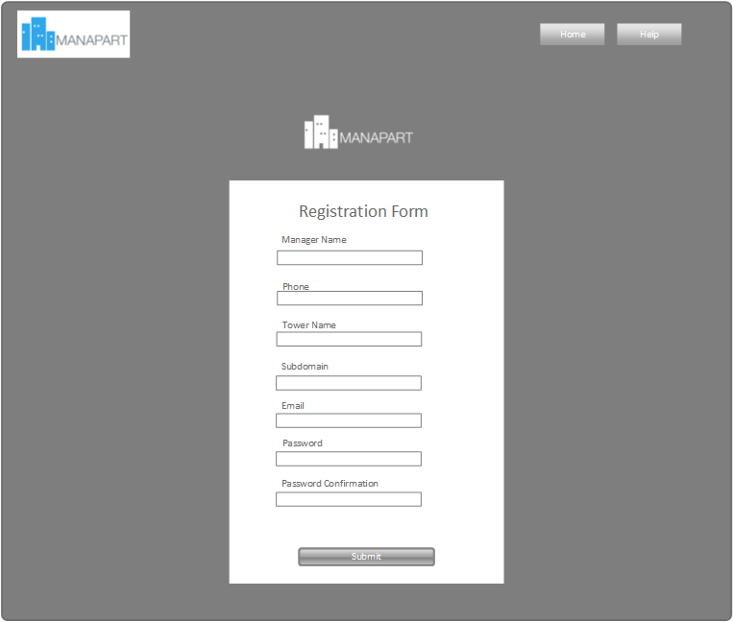

|  |  |  |
| --- | --- | --- |
| **Element** | **Type** | **Description** |
| Manager name | Textbox | Name of manager |
| Phone | Textbox | Phone number of manager |
| Tower name | Textbox | Name of tower |
| Subdomain | Textbox | Name of subdomain |
| Email | Textbox | Email to login to system |
| Password | Textbox | Password to login to system |
| Password confirm | Textbox | Confirm this above password |
| Submit | Button | Button to complete form |

#### Class Diagram

*Refer to class diagram of view all towers in 1.3.4 View all tower*

#### Class Specifications

##### Function

|  |  |  |  |  |
| --- | --- | --- | --- | --- |
| **Class** | **RegisterController** | | | |
| **Description** | Register and create susdomain | | | |
| **Base Class** | ApplicationController | | | |
| **Source File** | Register_controller.rb | | | |
| **Namespace** | app/controllers/ | | | |
| **Attributes** | **N/A** | | | |
| **Methods** | **Name** | **Input** | **Output** | **Description** |
| create | Information input | void | Register new tower and create new subdomain |

#### Sequence Diagram

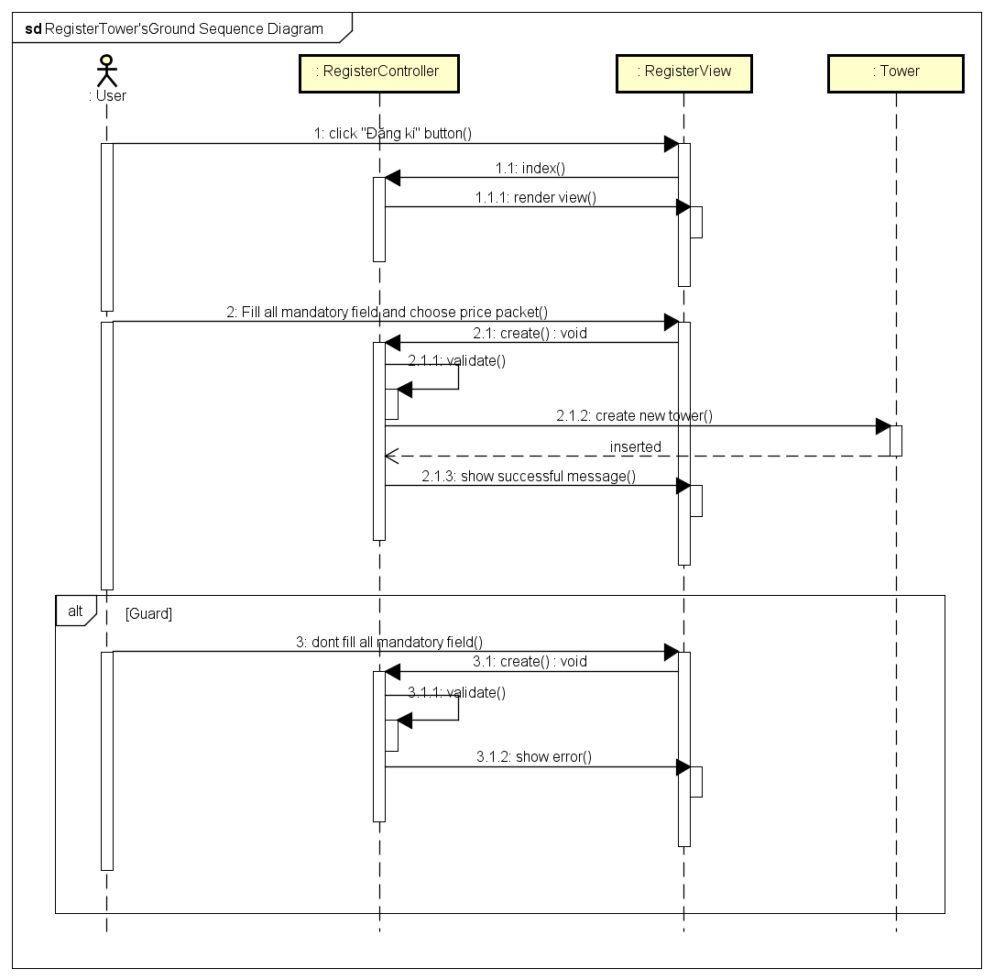

### Login to subdomain

#### Description

Manager login to subdomain. After login, manager can user all function of system.

#### Design

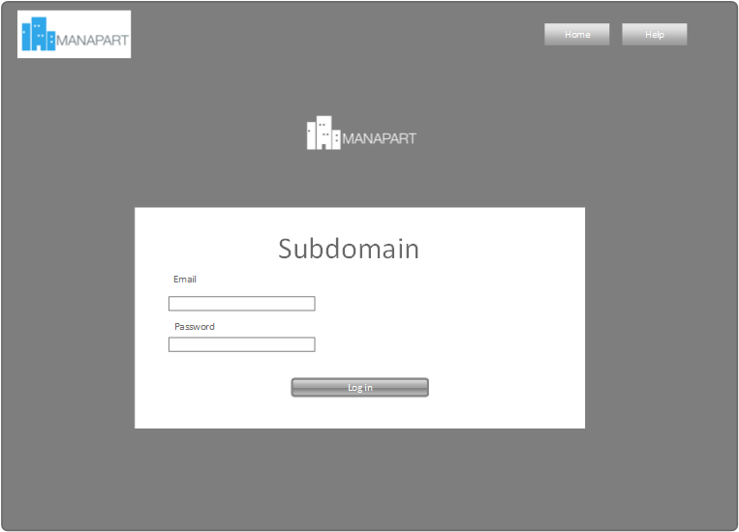

|  |  |  |
| --- | --- | --- |
| **Element** | **Type** | **Description** |
| Email | Textbox | Email to login this subdomain |
| Password | textbox | Password to login this subdomain |
| Log in | Button | Button to submit form |

#### Class Diagram

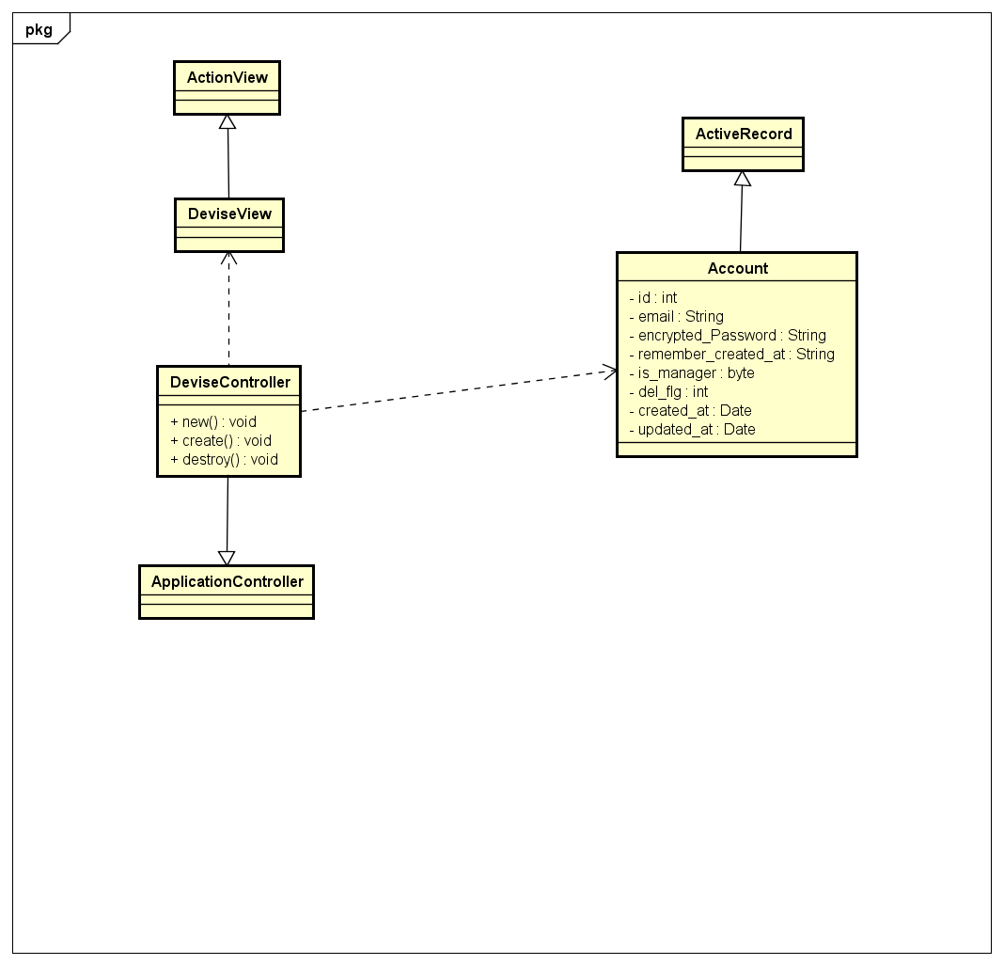

#### Class Specifications

##### Function

|  |  |  |  |  |
| --- | --- | --- | --- | --- |
| **Class** | **DeviseController** | | | |
| **Description** | Control login and Logout of subdomain | | | |
| **Base Class** | ApplicationController | | | |
| **Source File** | devise_controller.rb | | | |
| **Namespace** | app/controllers/ | | | |
| **Attributes** | **N/A** | | | |
| **Methods** | **Name** | **Input** | **Output** | **Description** |
| create | Information input | void | Login to subdomain |

#### Sequence Diagram

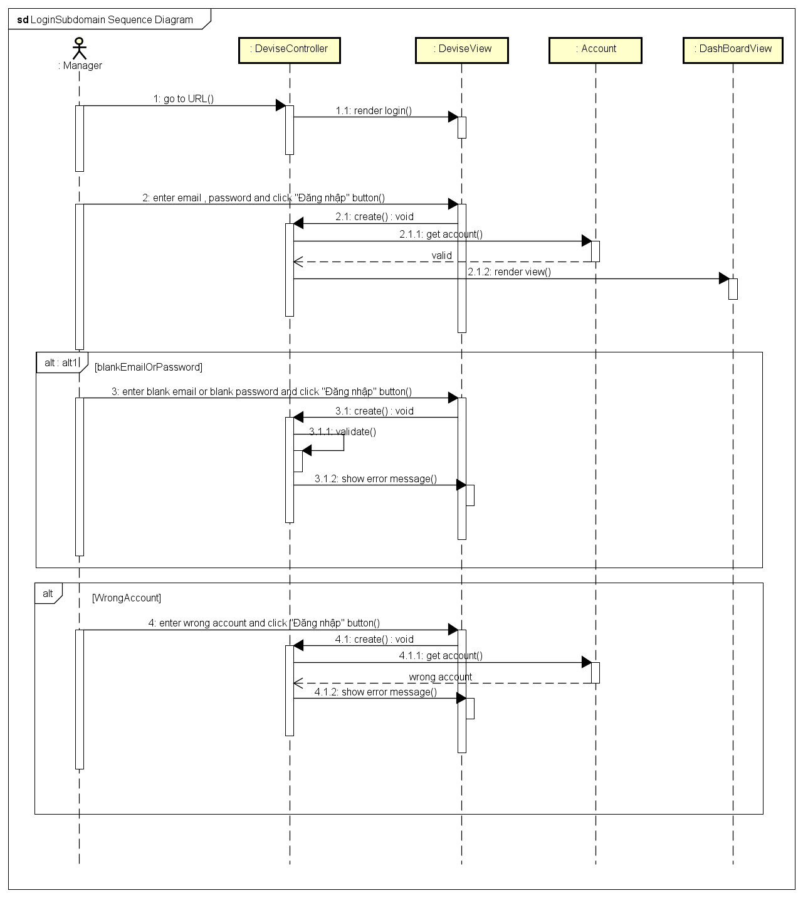

### Logout of subdomain

#### Description

User logout from subdomain. After that, back to login page.

#### Design

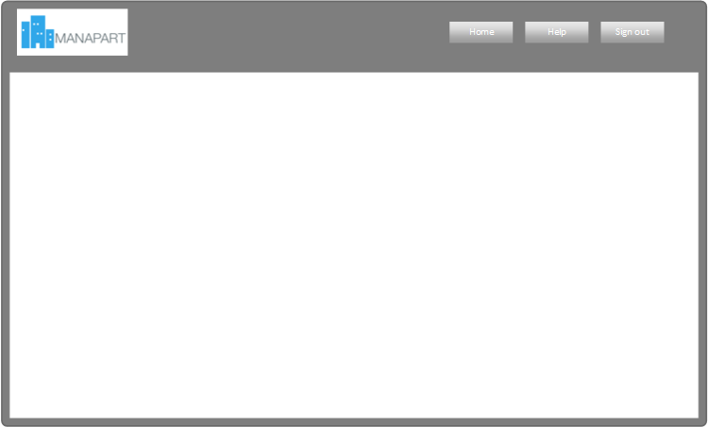

|  |  |  |
| --- | --- | --- |
| **Element** | **Type** | **Description** |
| Sign out | Button | Button to log out |

#### Class Diagram

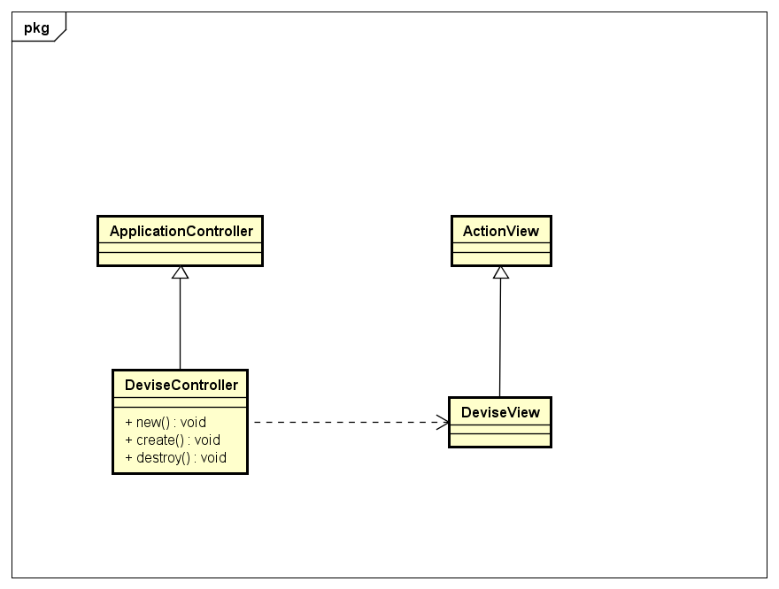

#### Class Specifications

##### Function

|  |  |  |  |  |
| --- | --- | --- | --- | --- |
| **Class** | **DeviseController** | | | |
| **Description** | Control login and logout of subdomain | | | |
| **Base Class** | ApplicationController | | | |
| **Source File** | devise_controller.rb | | | |
| **Namespace** | app/controllers/ | | | |
| **Attributes** | **N/A** | | | |
| **Methods** | **Name** | **Input** | **Output** | **Description** |
| destroy | Information input | void | Logout from subdomain |

#### Sequence Diagram

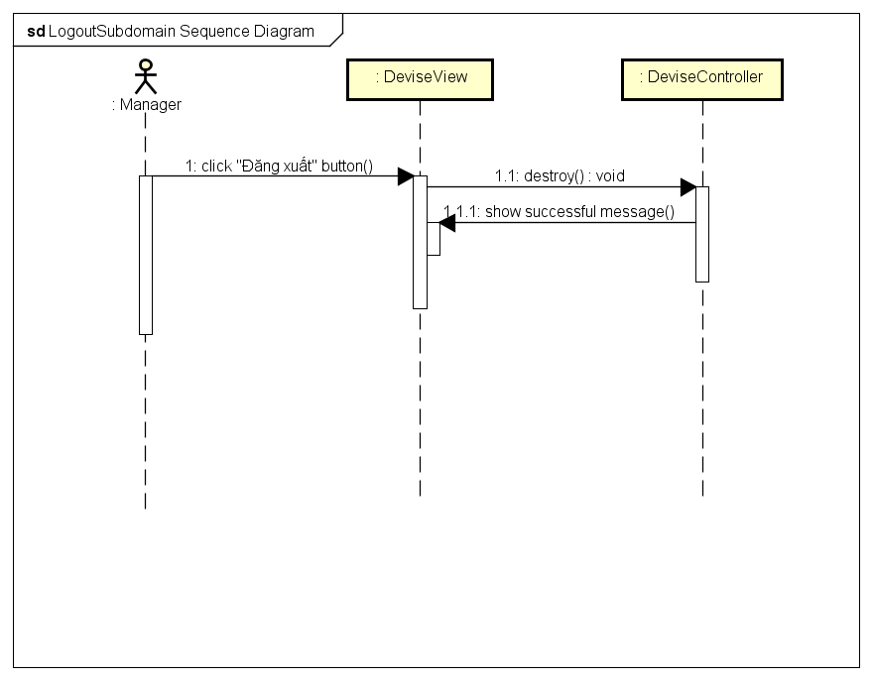

### View grounds

#### Description

Manager views all ground of tower. Other, manager can also view detail information of each ground or search ground that they want to see or export to CSV or Excel file.

#### Design

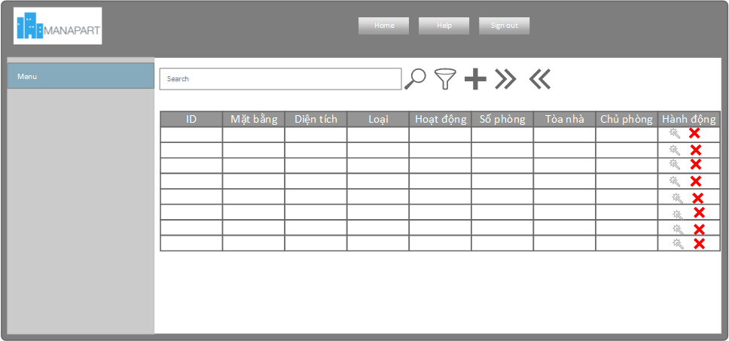

|  |  |  |
| --- | --- | --- |
| **Element** | **Type** | **Description** |
| id | Textbox | Id of ground |
| Mặt bằng | Texbox | Name of ground |
| Diện tích | Textbox | Area of ground |
| Loại | Texbox | Type of ground |
| Hoạt động | Textbox | Status of groud (active, deactive,...) |
| Số phòng | texbox | Number room of ground |
| Tòa nhà | Texbox | Building that include this ground |
| Chủ phòng | Textbox | Ower of ground |
| Hành động | Textbox | Action that manager can do with ground |

#### Class Diagram

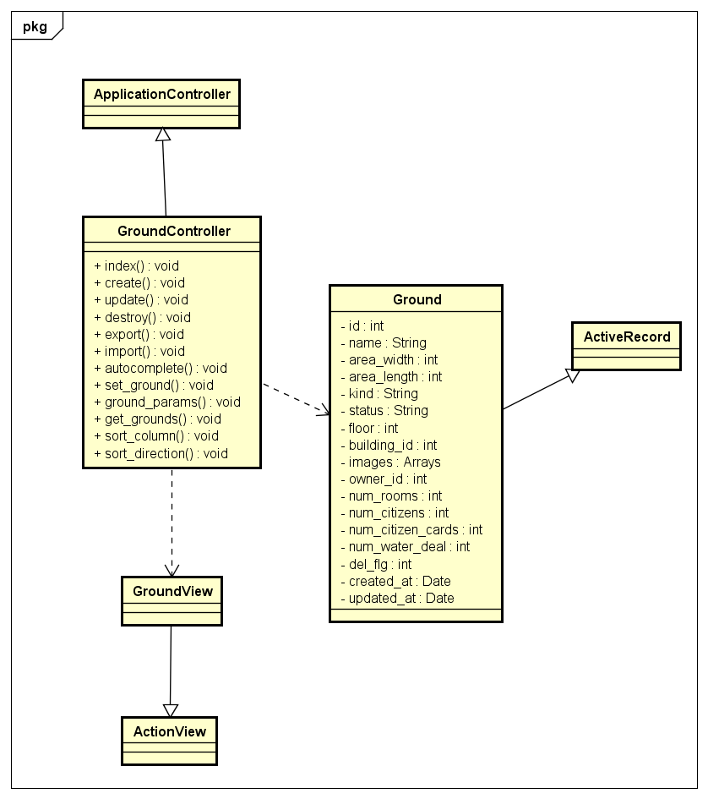

#### Class Specifications

##### Function

|  |  |  |  |  |
| --- | --- | --- | --- | --- |
| **Class** | **GroundController** | | | |
| **Description** | Control and do business relate to ground | | | |
| **Base Class** | ApplicationController | | | |
| **Source File** | ground_controller.rb | | | |
| **Namespace** | app/controllers/ | | | |
| **Attributes** | **N/A** | | | |
| **Methods** | **Name** | **Input** | **Output** | **Description** |
| index | Information input | void | Get all ground information and render view |

#### Sequence Diagram

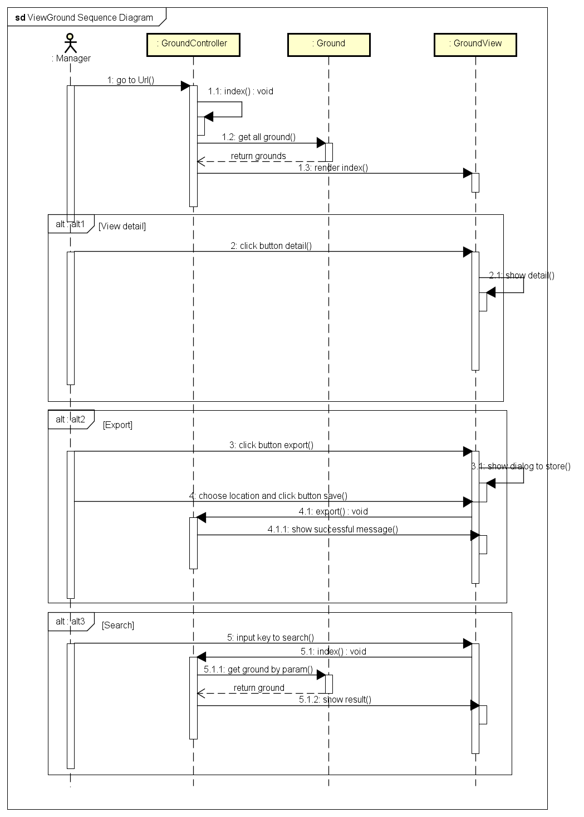

### Add grounds

#### Description

Manager adds ground to the building. Manager also add ground by import CSV or Excel file.

#### Design

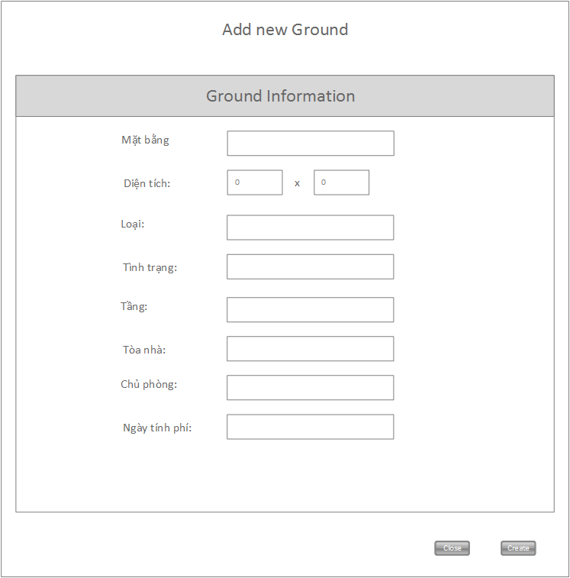

|  |  |  |
| --- | --- | --- |
| **Element** | **Type** | **Description** |
| Mặt bằng | Textbox | Name of ground |
| Diện tích | Textbox | Area of ground |
| Loại | Textbox | Type of ground |
| Tình trạng | Textbox | Status of ground (active, deactive,…) |
| Tầng | Texbox | Floor that includes this ground |
| Tòa nhà | textbox | building that includes this ground |
| Chủ phòng | Textbox | Owner of ground |
| Ngày tính phí | Textbox | day charge of ground |
| Close | Button | Button to Close form |
| Create | Button | Button to submit form |

#### Class Diagram

*Refer to class diagram of view grounds in 1.3.18 View grounds*

#### Class Specifications

##### Function

|  |  |  |  |  |
| --- | --- | --- | --- | --- |
| **Class** | **GroundController** | | | |
| **Description** | Control and do business relate to ground | | | |
| **Base Class** | ApplicationController | | | |
| **Source File** | ground_controller.rb | | | |
| **Namespace** | app/controllers/ | | | |
| **Attributes** | **N/A** | | | |
| **Methods** | **Name** | **Input** | **Output** | **Description** |
| create | Information input | void | Create new ground and add to the subdomain system |

#### Sequence Diagram

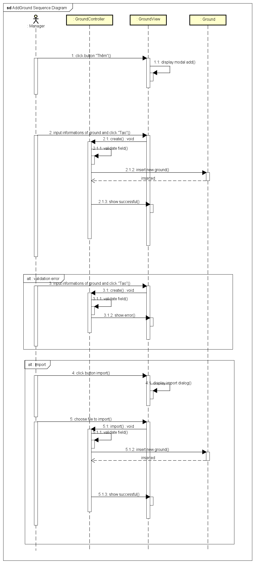

### Update ground

#### Description

Manager updates ground information.

#### Design

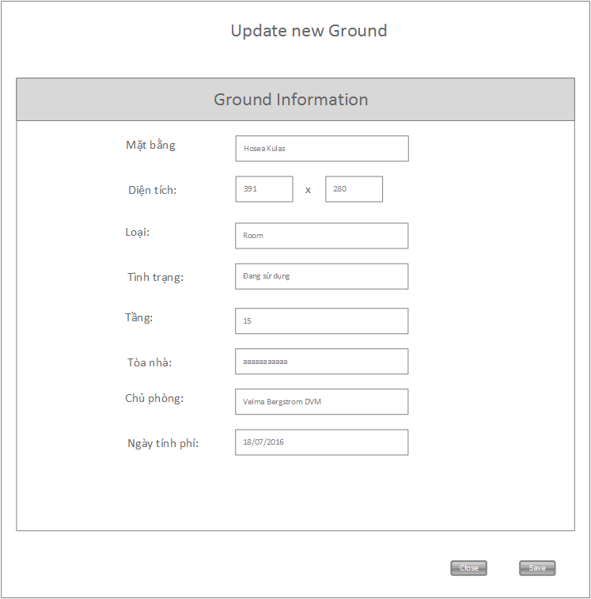

|  |  |  |
| --- | --- | --- |
| **Element** | **Type** | **Description** |
| Mặt bằng | Textbox | Name of ground |
| Diện tích | Textbox | Area of ground |
| Loại | Textbox | Type of ground |
| Tình trạng | Textbox | Status of ground (active, deactive,…) |
| Tầng | Texbox | Floor that includes this ground |
| Tòa nhà | textbox | building that includes this ground |
| Chủ phòng | Textbox | Owner of ground |
| Ngày tính phí | Textbox | day charge of ground |
| Close | Button | Button to Close form |
| Save | Button | Button to submit form |

#### Class Diagram

*Refer to class diagram of view grounds in 1.3.18 View grounds*

#### Class Specifications

##### Function

|  |  |  |  |  |
| --- | --- | --- | --- | --- |
| **Class** | **GroundController** | | | |
| **Description** | Control and do business relate to ground | | | |
| **Base Class** | ApplicationController | | | |
| **Source File** | ground_controller.rb | | | |
| **Namespace** | app/controllers/ | | | |
| **Attributes** | **N/A** | | | |
| **Methods** | **Name** | **Input** | **Output** | **Description** |
| update | Information input | void | Update ground information |

#### Sequence Diagram

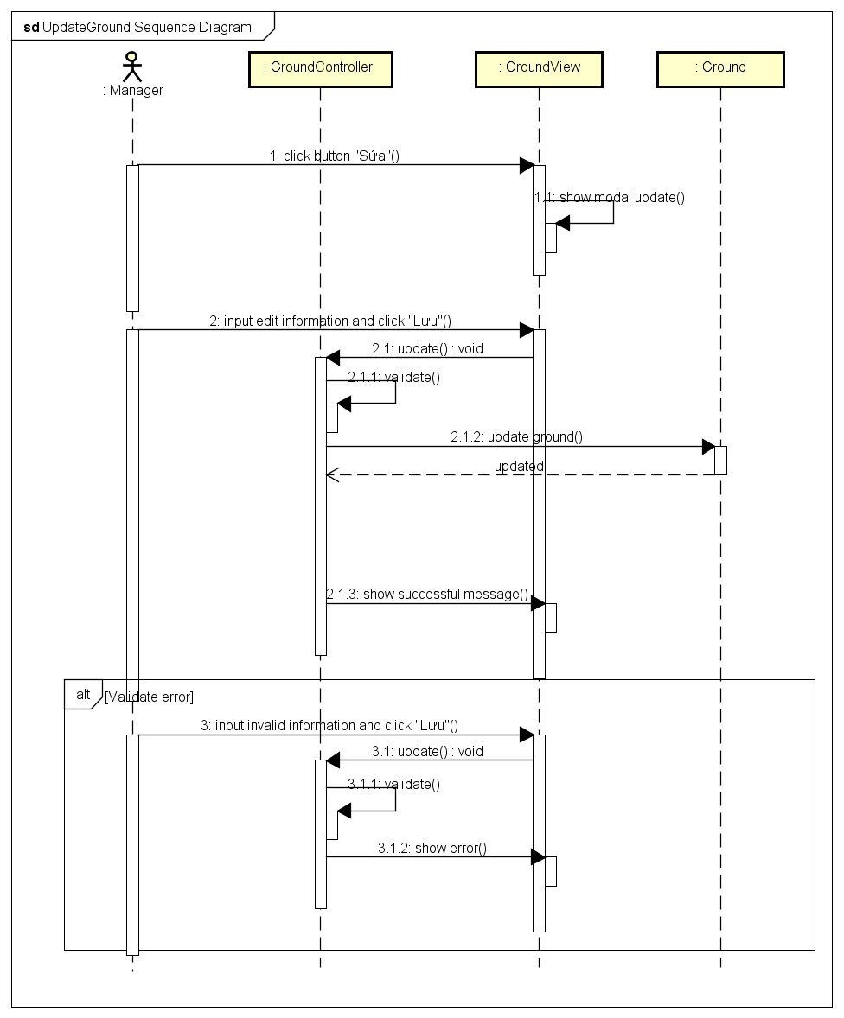

### Delete ground

#### Description

Manager deletes ground information.

#### Design

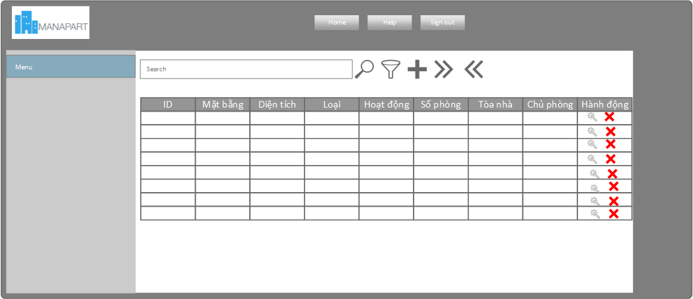

|  |  |  |
| --- | --- | --- |
| **Element** | **Type** | **Description** |
| Delete icon | Icon | Click to icon to delete ground |

#### Class Diagram

*Refer to class diagram of view grounds in 1.3.18 View grounds*

#### Class Specifications

##### Function

|  |  |  |  |  |
| --- | --- | --- | --- | --- |
| **Class** | **GroundController** | | | |
| **Description** | Control and do business relate to ground | | | |
| **Base Class** | ApplicationController | | | |
| **Source File** | ground_controller.rb | | | |
| **Namespace** | app/controllers/ | | | |
| **Attributes** | **N/A** | | | |
| **Methods** | **Name** | **Input** | **Output** | **Description** |
| destroy | Information input | void | Delete ground from subdomain system |

#### Sequence Diagram

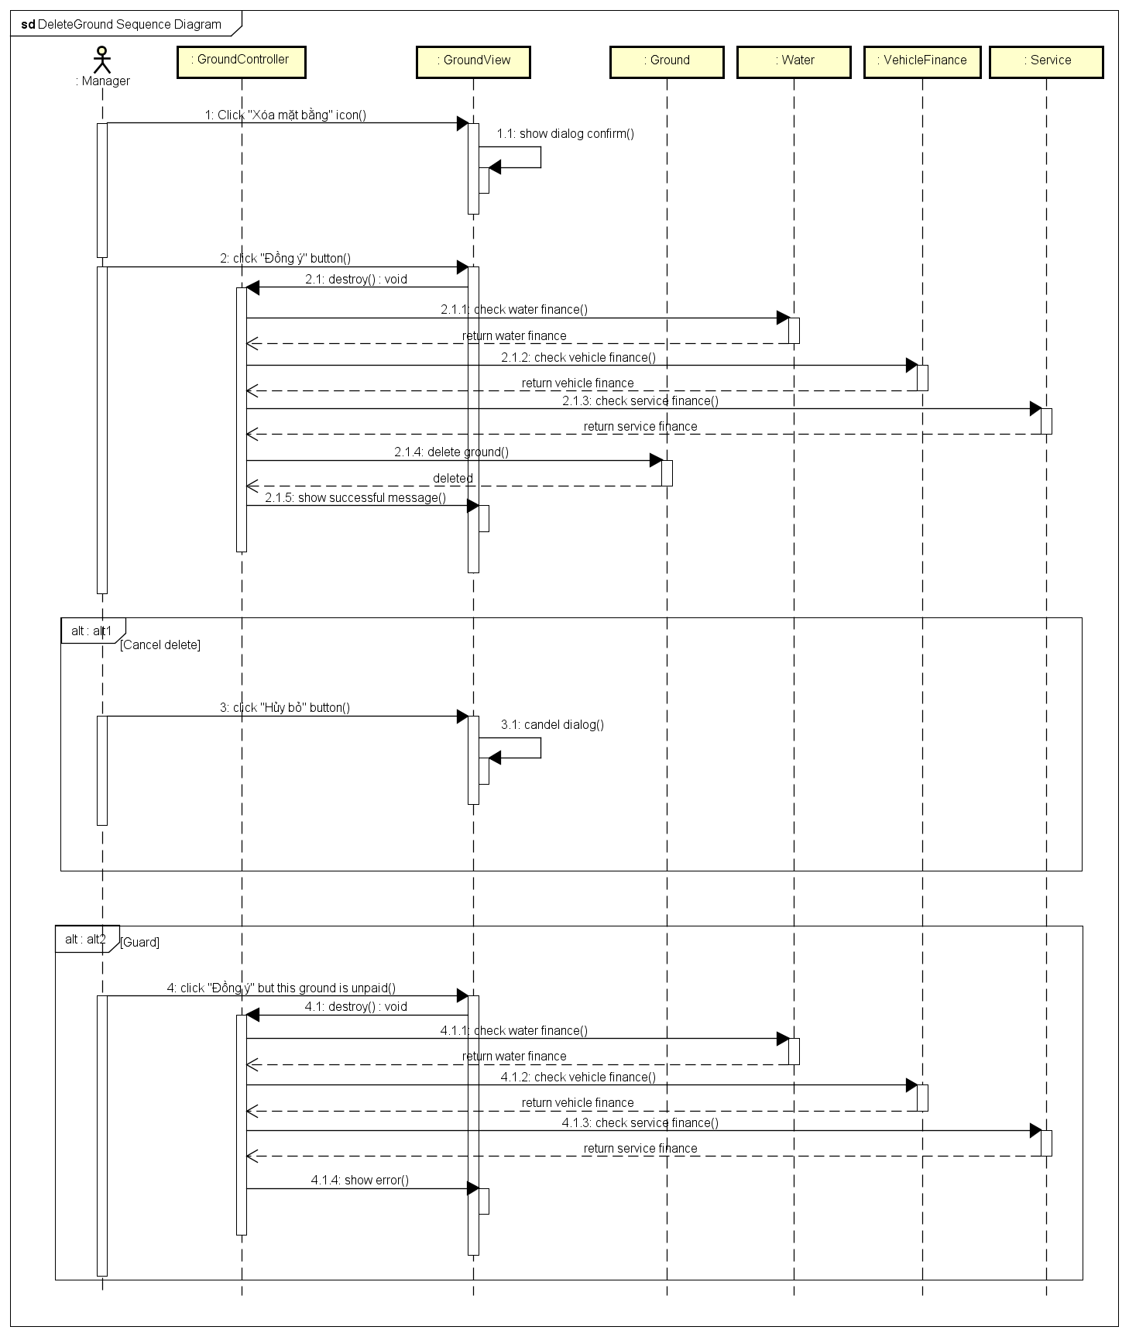

### View citizens

#### Description

Manager view all citizens of tower. Other, manager can view detail information of each citizen or export to CSV or Excel file.

#### Design

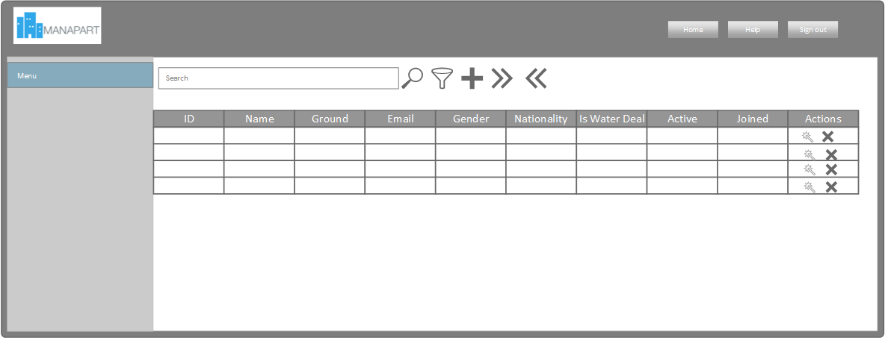

|  |  |  |
| --- | --- | --- |
| **Element** | **Type** | **Description** |
| Id | Textbox | Id of citizen |
| Name | Textbox | Name of citizen |
| Ground | Textbox | Ground that citizen lives in |
| Email | Textbox | Email of citizen |
| Gender | Textbox | Gender of citizen |
| Nationality | Textbox | Nationality of citizen |
| Is water deal | Checbox | Citizen has water deal or not |
| Active | Checkbox | Citizen active or not |
| Joined | Textbox | Joined date |
| Actions | Textbox | Action that manager can do with this citizen. |

#### Class Diagram

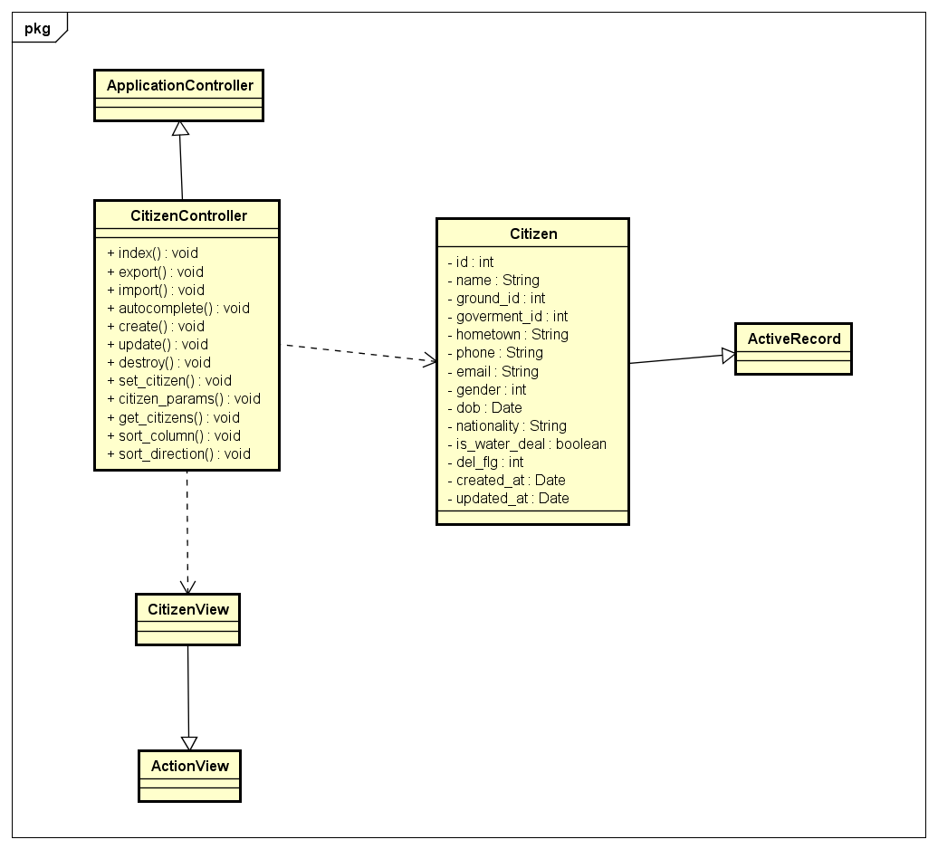

#### Class Specifications

##### Function

|  |  |  |  |  |
| --- | --- | --- | --- | --- |
| **Class** | **CitizenController** | | | |
| **Description** | Control and do business relate to citizen | | | |
| **Base Class** | ApplicationController | | | |
| **Source File** | citizens_controller.rb | | | |
| **Namespace** | app/controllers/ | | | |
| **Attributes** | **N/A** | | | |
| **Methods** | **Name** | **Input** | **Output** | **Description** |
| index | Information input | void | Get all citizen information and render view |

#### Sequence Diagram

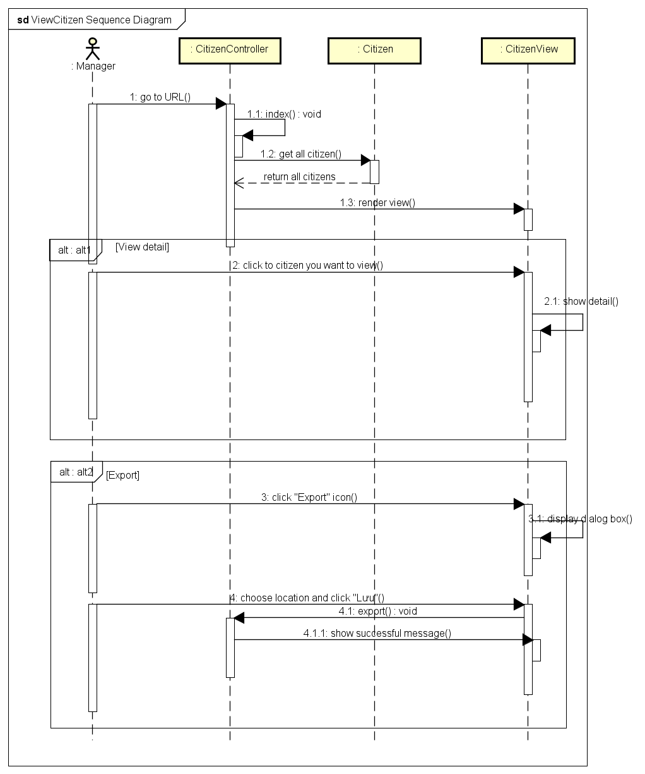

### Add citizens

#### Description

Manager adds information of new citizen to the subdomain system. They also add many citizen by import CSV or Excel file.

#### Design

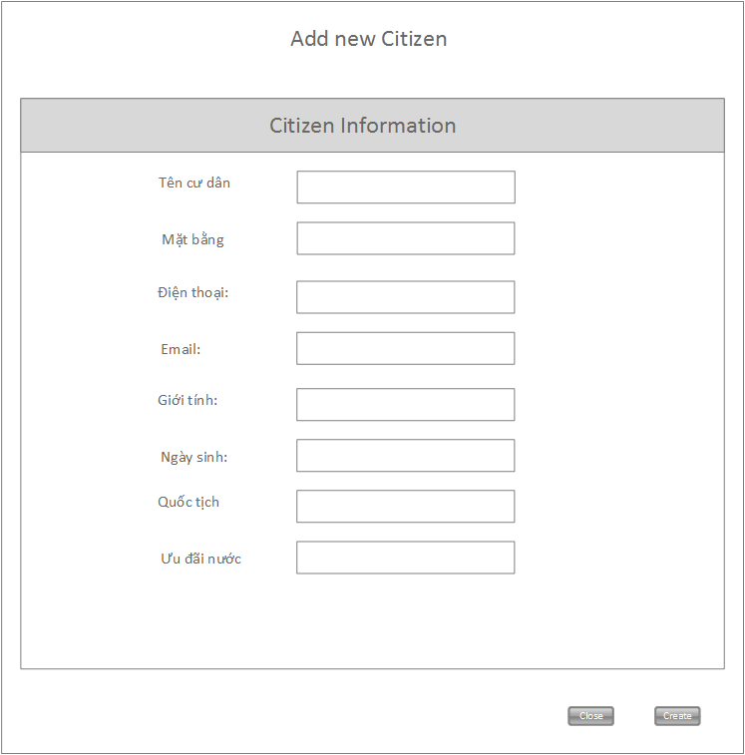

|  |  |  |
| --- | --- | --- |
| **Element** | **Type** | **Description** |
| Tên cư dân | Textbox | Name of citizen |
| Mặt bằng | Textbox | Ground that citizen lives in |
| Điện thoại | Textbox | Phone number of citizen |
| Email | Textbox | Email of citizen |
| Giới tính | Checkbox | Gender of citizen |
| Ngày sinh | Textbox | Date of birth of citizen |
| Quốc tịch | Textbox | Nationality of citizen |
| Ưu đãi nước | checkbox | Citizen has water deal or not |
| Close | Textbox | Button to close form |
| create | Textbox | Button to submit form |

#### Class Diagram

*Refer to class diagram of view citizens in 1.3.26 View citizens*

#### Class Specifications

##### Function

|  |  |  |  |  |
| --- | --- | --- | --- | --- |
| **Class** | **CitizenController** | | | |
| **Description** | Control and do business relate to citizen | | | |
| **Base Class** | ApplicationController | | | |
| **Source File** | citizens_controller.rb | | | |
| **Namespace** | app/controllers/ | | | |
| **Attributes** | **N/A** | | | |
| **Methods** | **Name** | **Input** | **Output** | **Description** |
| create | Information input | void | Create a new citizen and add to subdomain system |

#### Sequence Diagram

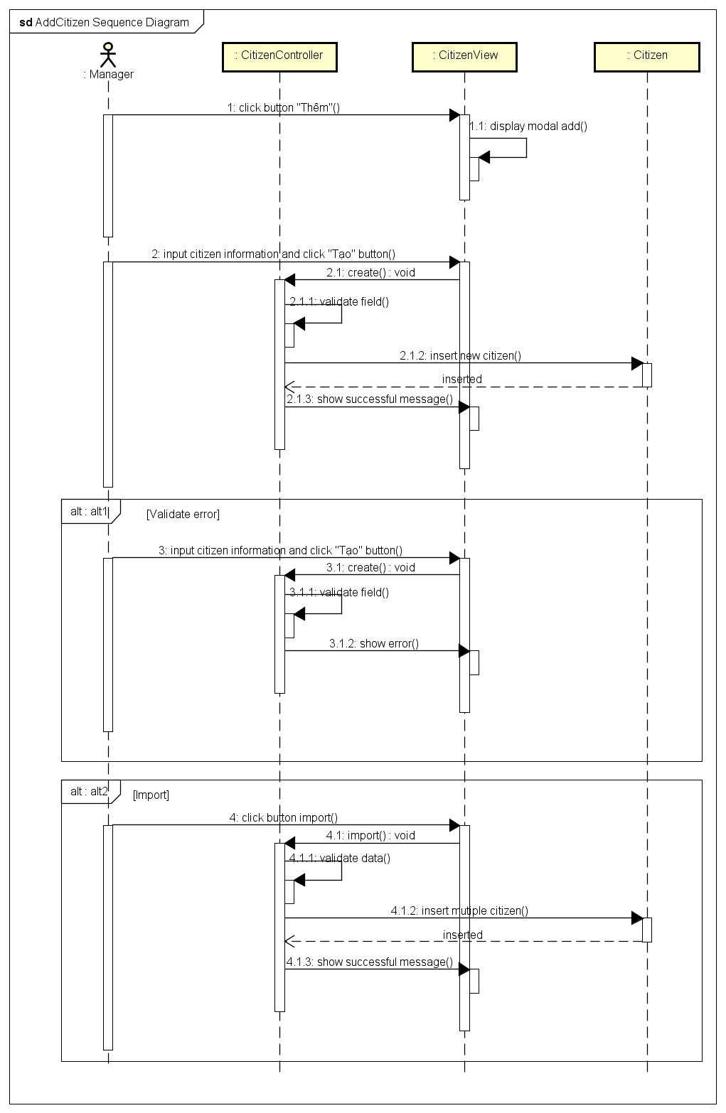

### Update citizen

#### Description

Manager updates citizen information in the system.

#### Design



|  |  |  |
| --- | --- | --- |
| **Element** | **Type** | **Description** |
| Tên cư dân | Textbox | Name of citizen |
| Mặt bằng | Textbox | Ground that citizen lives in |
| Điện thoại | Textbox | Phone number of citizen |
| Email | Textbox | Email of citizen |
| Giới tính | Checkbox | Gender of citizen |
| Ngày sinh | Textbox | Date of birth of citizen |
| Quốc tịch | Textbox | Nationality of citizen |
| Ưu đãi nước | checkbox | Citizen has water deal or not |
| Close | Textbox | Button to close form |
| Save | Textbox | Button to submit form |

#### Class Diagram

*Refer to class diagram of view citizens in 1.3.26 View citizens*

#### Class Specifications

##### Function

|  |  |  |  |  |
| --- | --- | --- | --- | --- |
| **Class** | **CitizenController** | | | |
| **Description** | Control and do business relate to citizen | | | |
| **Base Class** | ApplicationController | | | |
| **Source File** | citizens_controller.rb | | | |
| **Namespace** | app/controllers/ | | | |
| **Attributes** | **N/A** | | | |
| **Methods** | **Name** | **Input** | **Output** | **Description** |
| update | Information input | void | Update citizen information |

#### Sequence Diagram

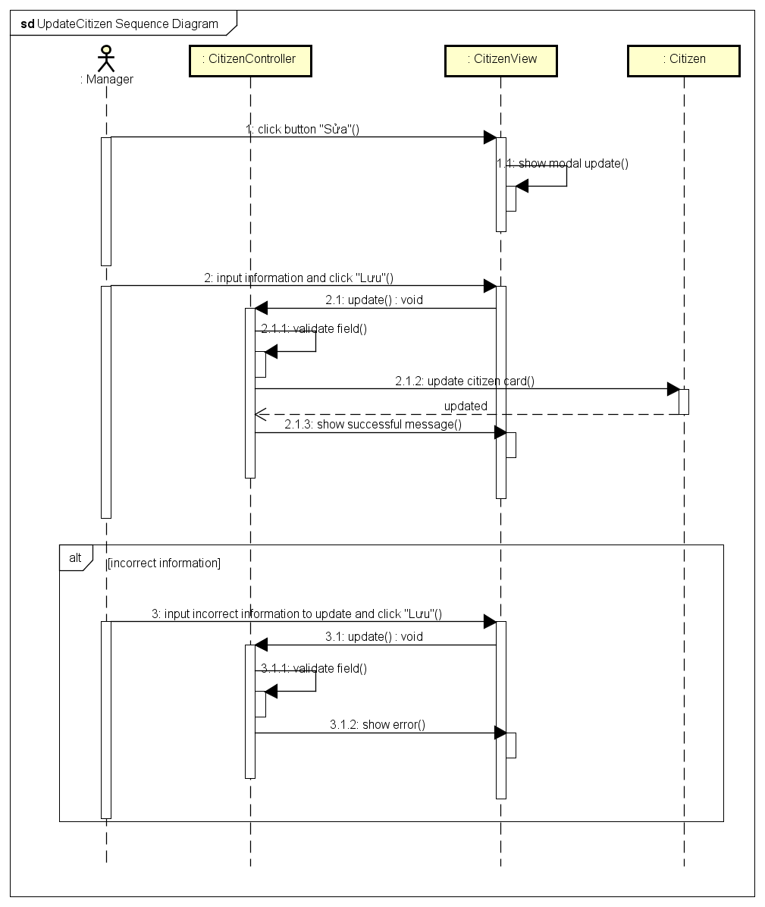

### Delete citizen

#### Description

Manager deletes citizen information from the subdomain system.

#### Design

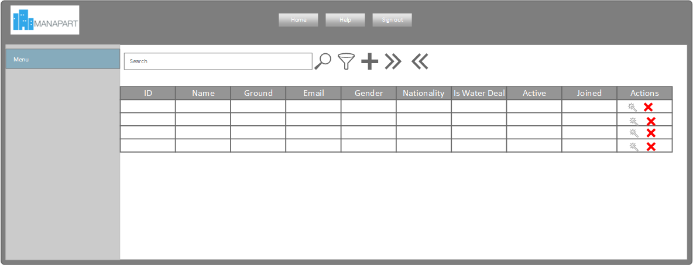

|  |  |  |
| --- | --- | --- |
| **Element** | **Type** | **Description** |
| Delete icon | Icon | Click icon to delete citizen information |

#### Class Diagram

*Refer to class diagram of view citizens in 1.3.26 View citizens*

#### Class Specifications

##### Function

|  |  |  |  |  |
| --- | --- | --- | --- | --- |
| **Class** | **CitizenController** | | | |
| **Description** | Control and do business relate to citizen | | | |
| **Base Class** | ApplicationController | | | |
| **Source File** | citizens_controller.rb | | | |
| **Namespace** | app/controllers/ | | | |
| **Attributes** | **N/A** | | | |
| **Methods** | **Name** | **Input** | **Output** | **Description** |
| destroy | Information input | void | Delete citizen from subdomain system |

#### Sequence Diagram

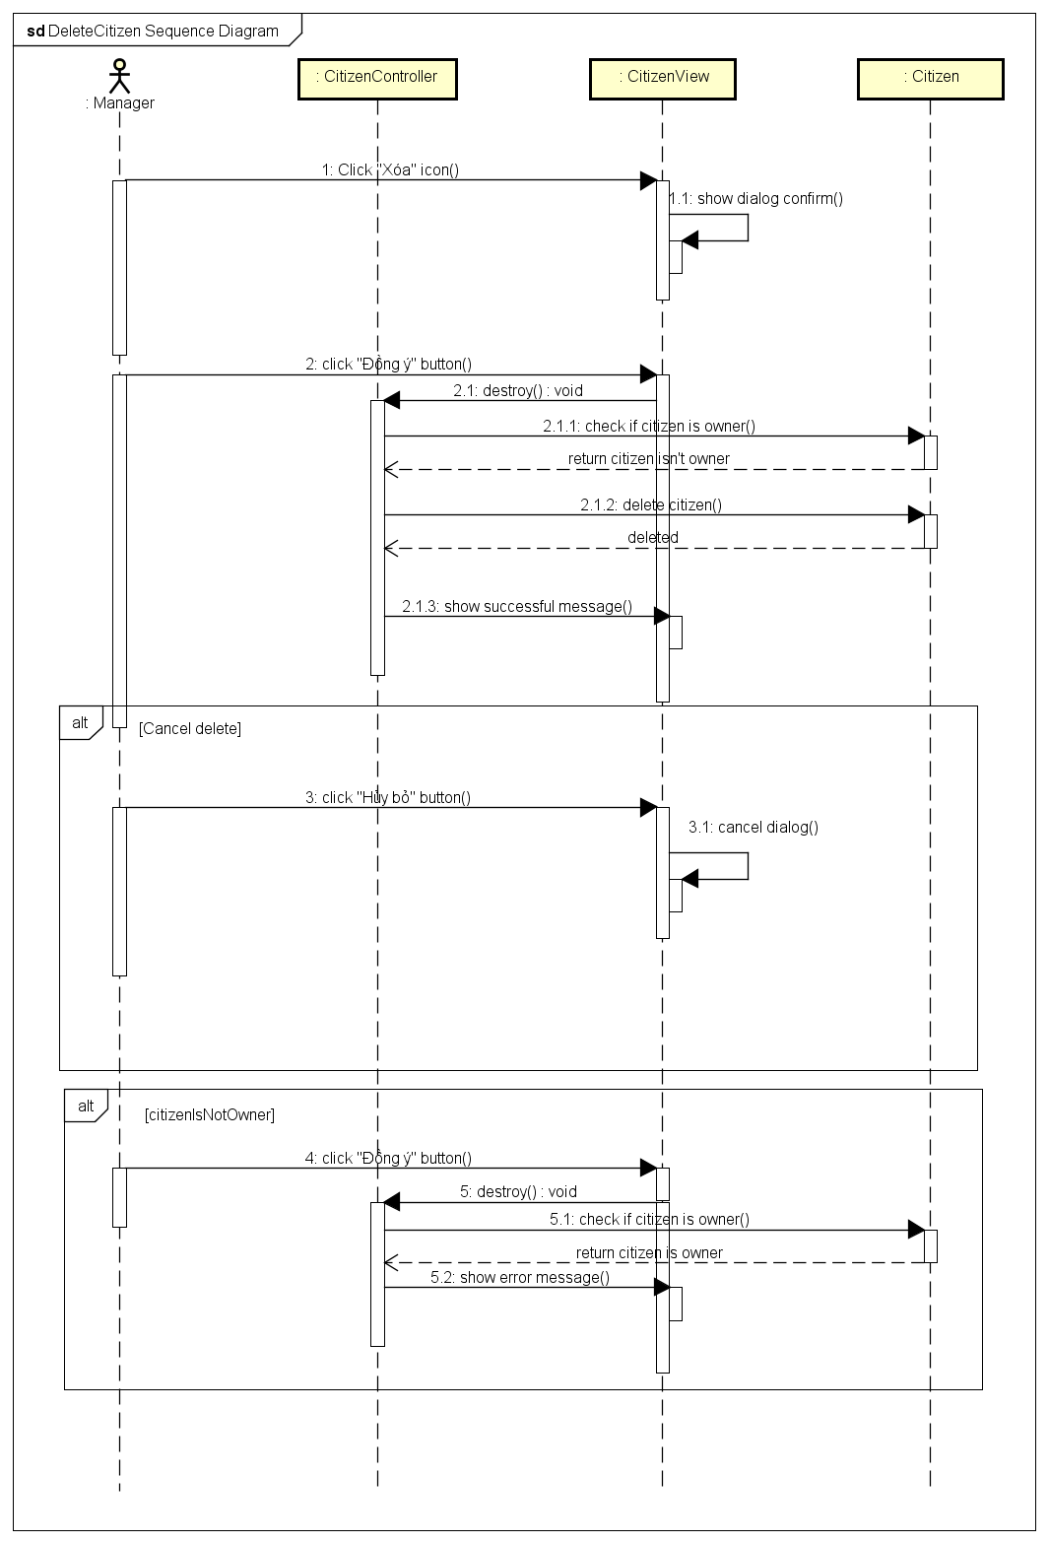

### View water finance

#### Description

Manager views all water finances in the subdomain system. They also view detail of each water finance of the citizen or export to CSV or Excel file

#### Design

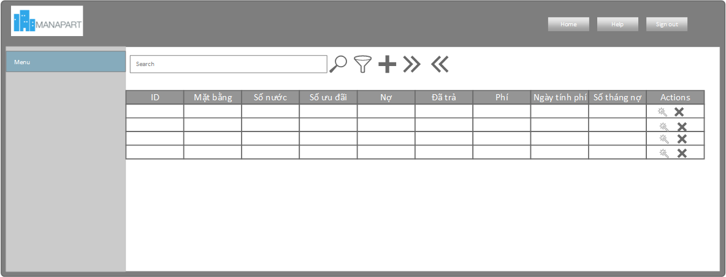

|  |  |  |
| --- | --- | --- |
| **Element** | **Type** | **Description** |
| Id | Textbox | Id of water service |
| Mặt bằng | Textbox | Ground that has water service |
| Số nước | Textbox | Water number of this month |
| Số ưu đãi | Textbox | Deal number that is discounted |
| Nợ | Textbox | Water fee Debt of this ground |
| Đã trả | Textbox | Water Paid fee of this ground |
| Phí | Textbox | Water fee of this month |
| Ngày tính phí | Textbox | Date charge of water service |
| Số tháng nợ | Textbox | Number month that didn’t paid for water fee |
| actions | Textbox | Action that manager can do with this water service. |

#### Class Diagram

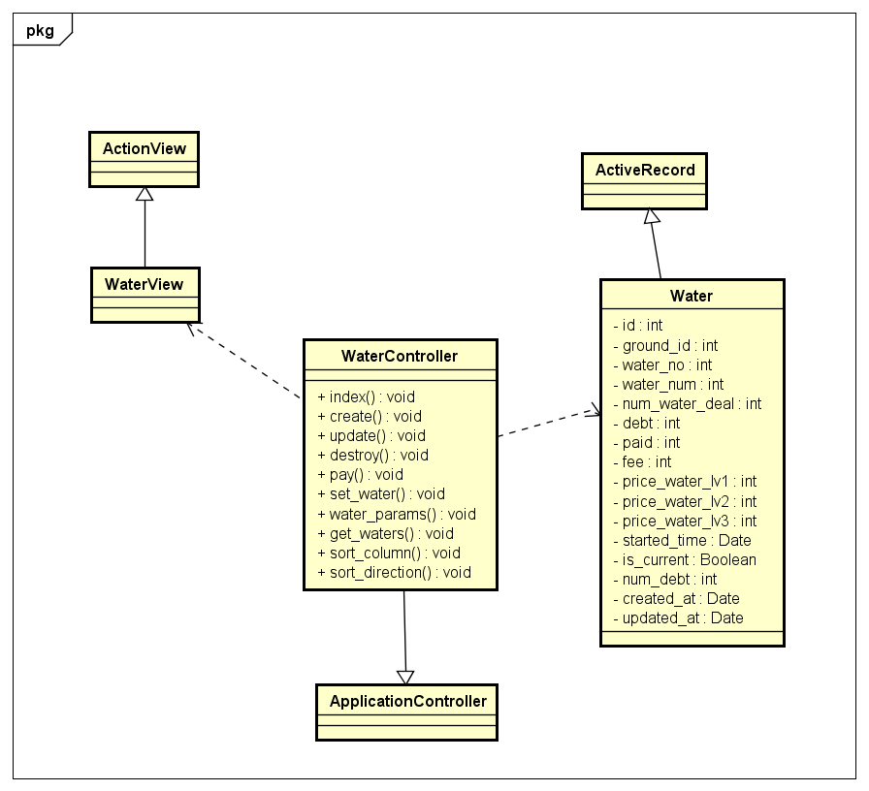

#### Class Specifications

##### Function

|  |  |  |  |  |
| --- | --- | --- | --- | --- |
| **Class** | **WaterController** | | | |
| **Description** | Control and do business relate to water service of tower | | | |
| **Base Class** | ApplicationController | | | |
| **Source File** | waters_controller.rb | | | |
| **Namespace** | app/controllers/ | | | |
| **Attributes** | **N/A** | | | |
| **Methods** | **Name** | **Input** | **Output** | **Description** |
| index | Information input | void | Get all water service information and render view |

#### Sequence Diagram

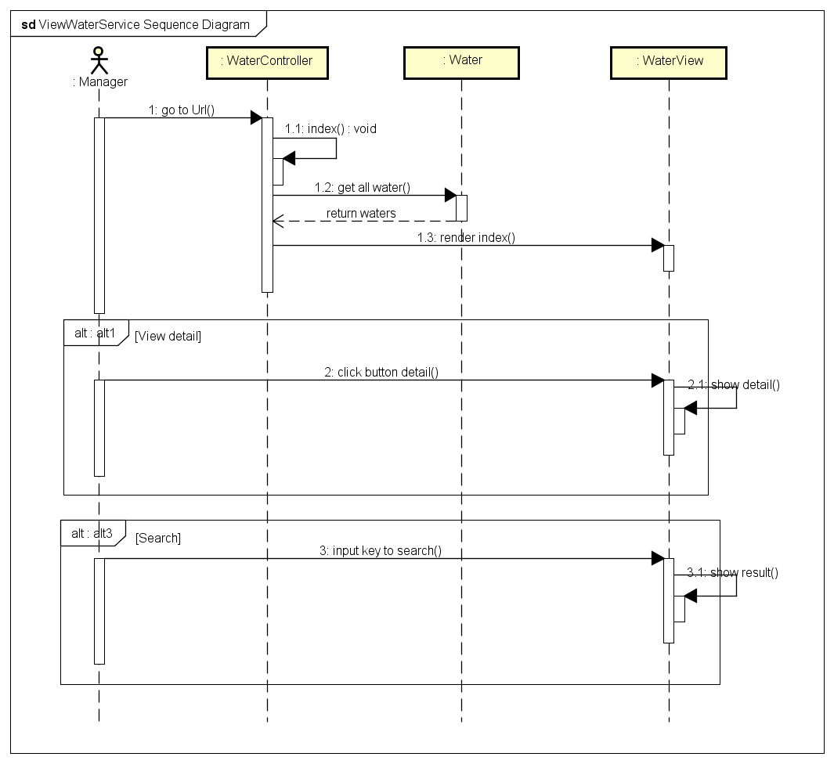

### Add water finance

#### Description

Manager add new water finance of a ground.

#### Design

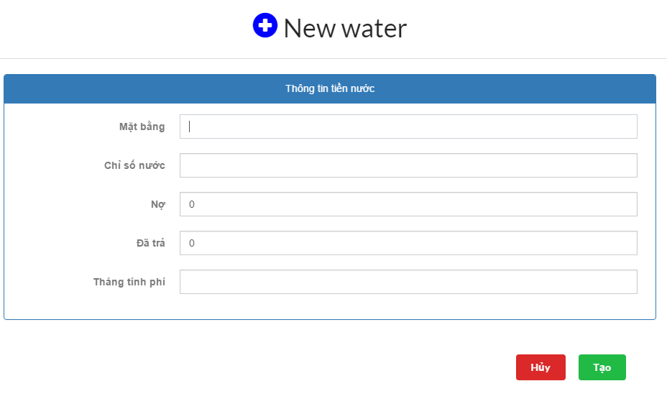

|  |  |  |
| --- | --- | --- |
| **Element** | **Type** | **Description** |
| Mặt bằng | Textbox | Ground name |
| Chỉ số nước | Textbox | Water number |
| Nợ | Textbox | water Debt of ground |
| Đã trả | Textbox | water Paid of ground |
| Tháng tính phí | Textbox | Month that charge |
| Hủy | Button | Button to dismiss form |
| Tạo | Button | Button to submit form |

#### Class Diagram

*Refer to class diagram of view water finance in 1.3.38 View water finance*

#### Class Specifications

##### Function

|  |  |  |  |  |
| --- | --- | --- | --- | --- |
| **Class** | **WaterController** | | | |
| **Description** | Control and do business relate to water of tower | | | |
| **Base Class** | ApplicationController | | | |
| **Source File** | waters_controller.rb | | | |
| **Namespace** | app/controllers/ | | | |
| **Attributes** | **N/A** | | | |
| **Methods** | **Name** | **Input** | **Output** | **Description** |
| create | Information input | void | creates a new water finance of a ground |

#### Sequence Diagram

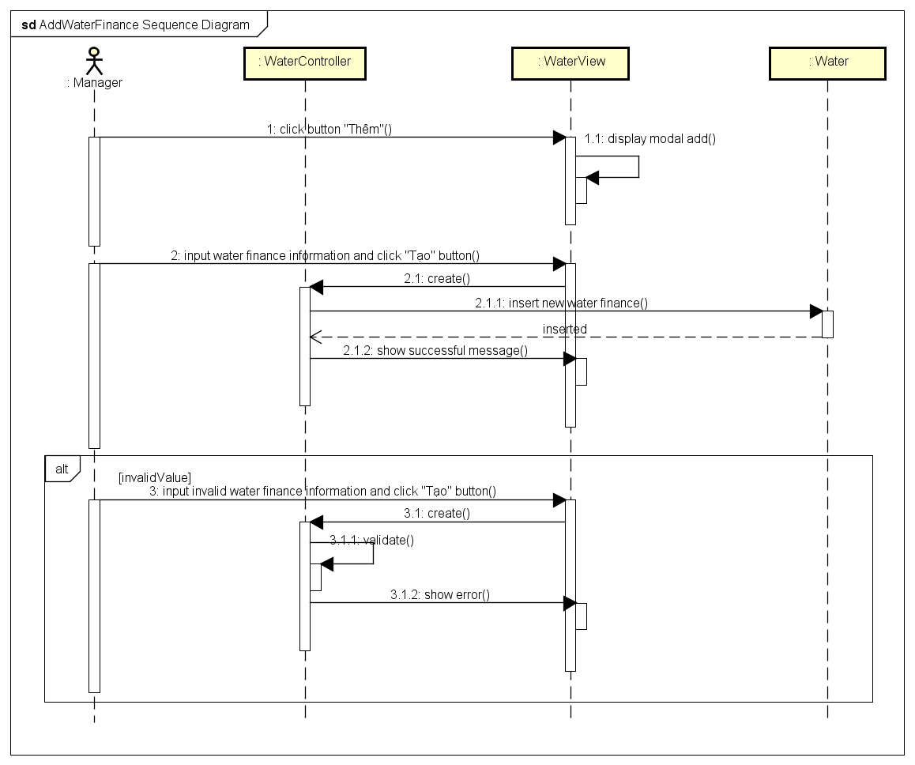

### Update water finance

#### Description

Manager update water finance information in the subdomain system.

#### Design

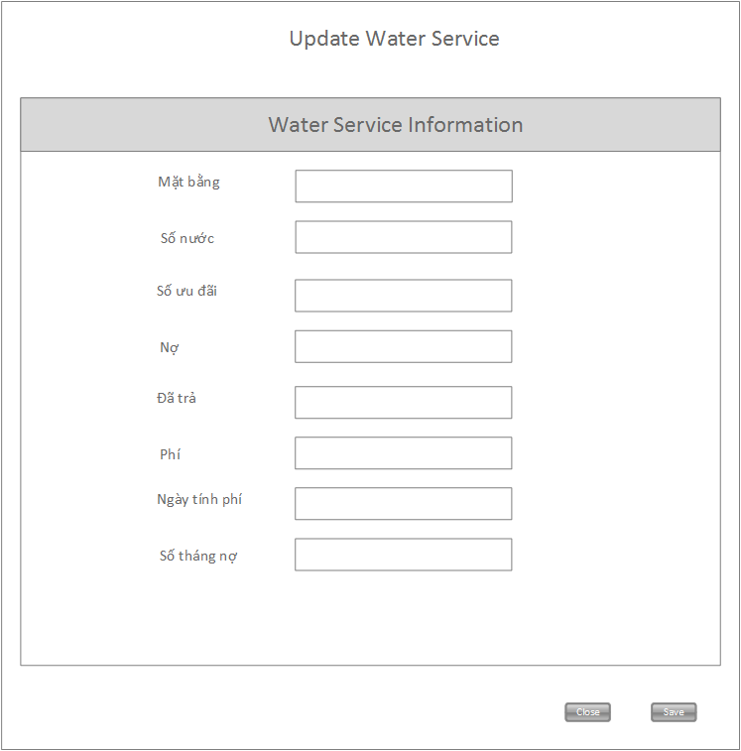

|  |  |  |
| --- | --- | --- |
| **Element** | **Type** | **Description** |
| Mặt bằng | Textbox | Ground that has water service |
| Số nước | Textbox | Water number of this month |
| Số ưu đãi | Textbox | Deal number that is discounted |
| Nợ | Textbox | Water fee Debt of this ground |
| Đã trả | Textbox | Water Paid fee of this ground |
| phí | Textbox | Water fee of this month |
| Ngày tính phí | Textbox | Date charge of water service |
| Số tháng nợ | Textbox | Number month that didn’t paid for water fee |
| Close | Button | Button to close form |
| Save | Button | Button to submit form |

#### Class Diagram

*Refer to class diagram of view water finance in 1.3.38 View water finance*

#### Class Specifications

##### Function

|  |  |  |  |  |
| --- | --- | --- | --- | --- |
| **Class** | **WaterController** | | | |
| **Description** | Control and do business relate to water service of tower | | | |
| **Base Class** | ApplicationController | | | |
| **Source File** | waters_controller.rb | | | |
| **Namespace** | app/controllers/ | | | |
| **Attributes** | **N/A** | | | |
| **Methods** | **Name** | **Input** | **Output** | **Description** |
| update | Information input | void | Update water service information |

#### Sequence Diagram

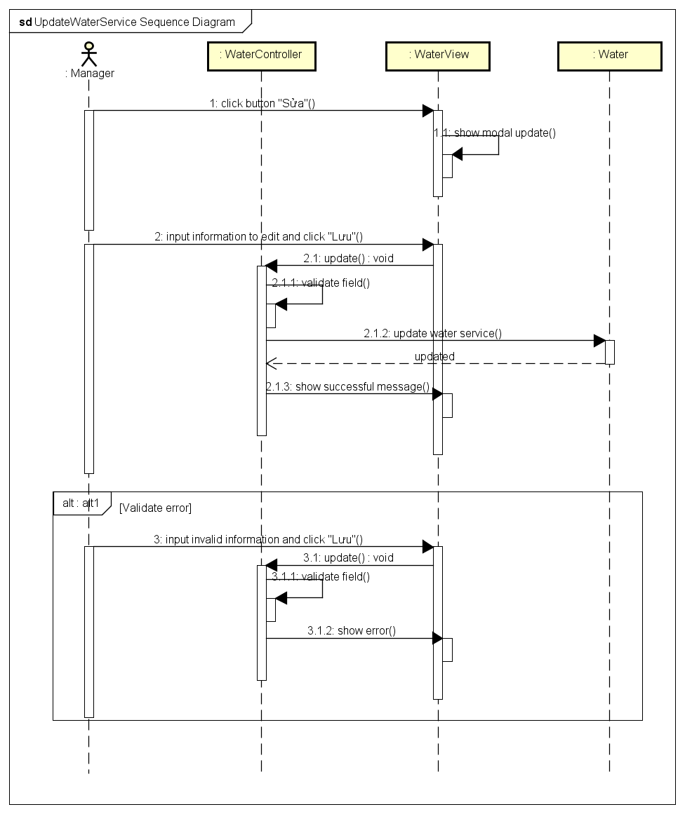

### Delete water finance

#### Description

Manager deletes water finance of a ground

#### Design

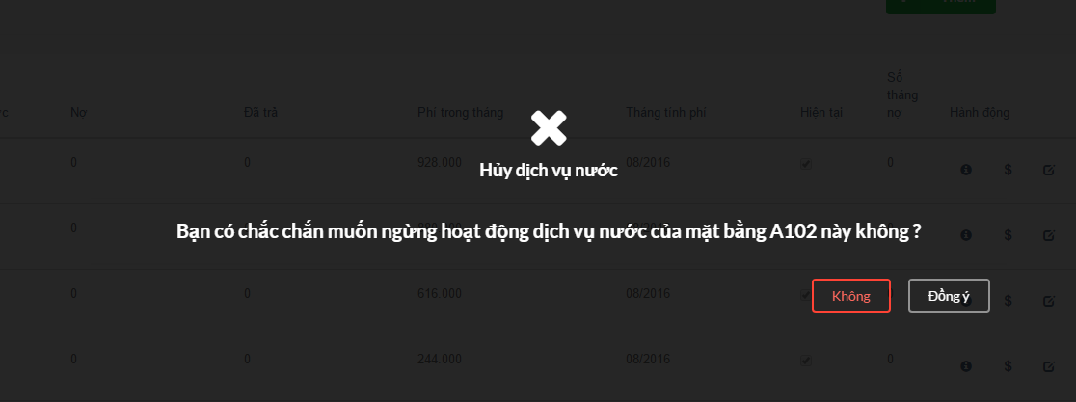

|  |  |  |
| --- | --- | --- |
| **Element** | **Type** | **Description** |
| Không | Button | Button to cancel delete |
| có | Button | Button to submit delete |

#### Class Diagram

*Refer to class diagram of view water finance in 1.3.38 View water finance*

#### Class Specifications

##### Function

|  |  |  |  |  |
| --- | --- | --- | --- | --- |
| **Class** | **WaterController** | | | |
| **Description** | Control and do business relate to water of tower | | | |
| **Base Class** | ApplicationController | | | |
| **Source File** | waters_controller.rb | | | |
| **Namespace** | app/controllers/ | | | |
| **Attributes** | **N/A** | | | |
| **Methods** | **Name** | **Input** | **Output** | **Description** |
| destroy | Information input | void | Delete water finance of a ground |

#### Sequence Diagram

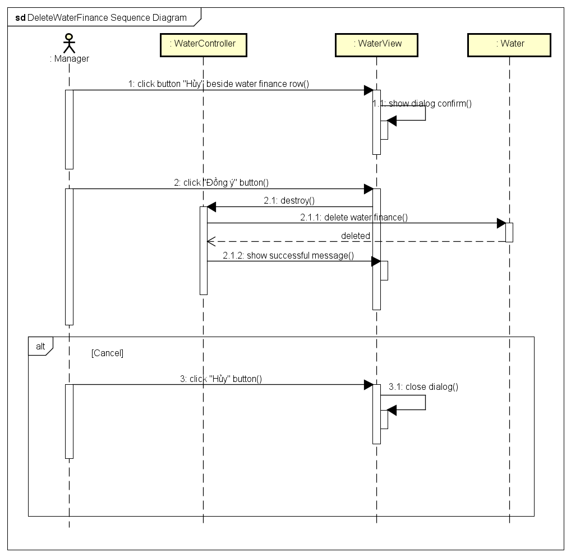

### View service finances

#### Description

Manager views all service finances of tower. Other, he also view detail information of one service finance, search service finance of a ground or export all to excel file.

#### Design

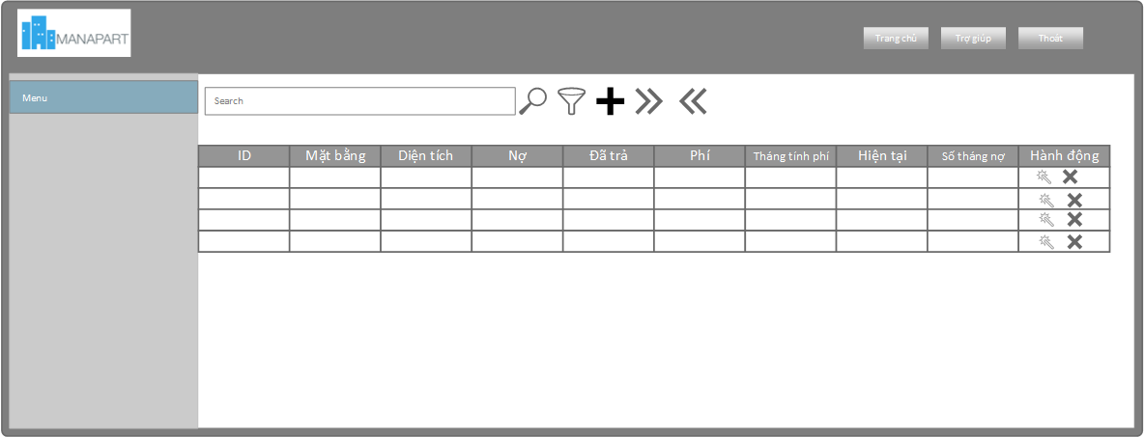

|  |  |  |
| --- | --- | --- |
| **Element** | **Type** | **Description** |
| Id | Textbox | Id of service |
| Mặt bằng | Textbox | Ground name |
| Diện tích | Textbox | Area of ground |
| Nợ | Textbox | Service debt |
| Đã trả | Textbox | Paid service fee |
| Phí trong tháng | Textbox | Fee in month |
| Tháng tính phí | Textbox | Month that charge |
| Hiện tại | Checkbox | Is current or not |
| Số tháng nợ | Textbox | Number of debt month |
| Hành động | Textbox | Actions that manager can do |

#### Class Diagram

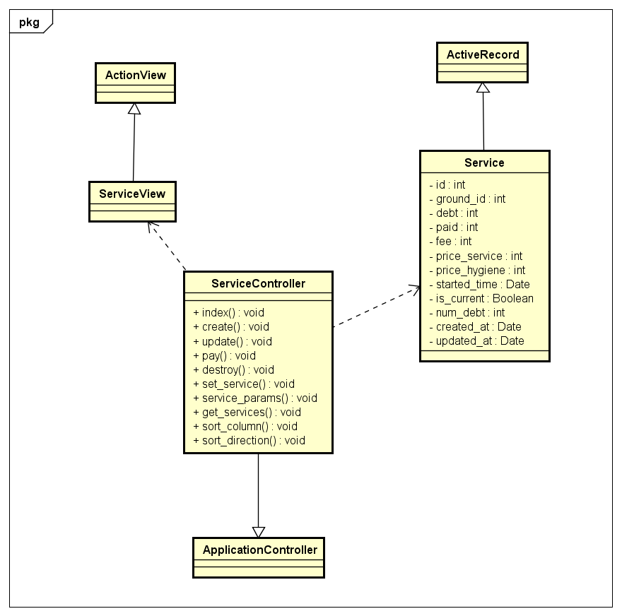

#### Class Specifications

##### Function

|  |  |  |  |  |
| --- | --- | --- | --- | --- |
| **Class** | **ServiceController** | | | |
| **Description** | Control and do business relate to service of tower | | | |
| **Base Class** | ApplicationController | | | |
| **Source File** | services_controller.rb | | | |
| **Namespace** | app/controllers/ | | | |
| **Attributes** | **N/A** | | | |
| **Methods** | **Name** | **Input** | **Output** | **Description** |
| index | Information input | void | Get all service finanaces information and render view |

#### Sequence Diagram

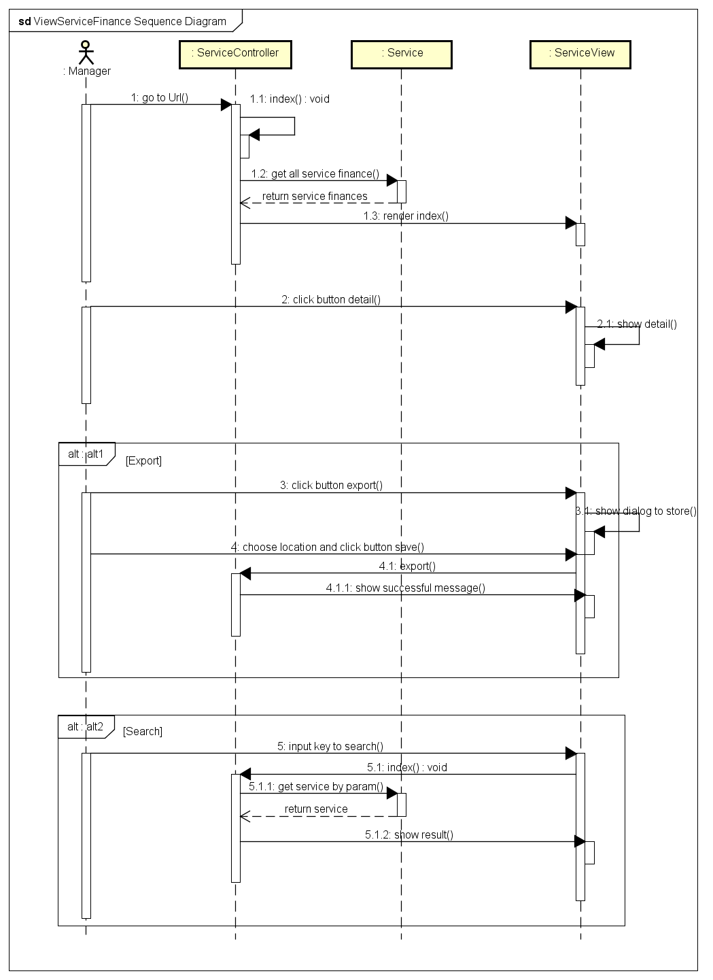

### Add service finance

#### Description

Manager adds new service finance.

#### Design

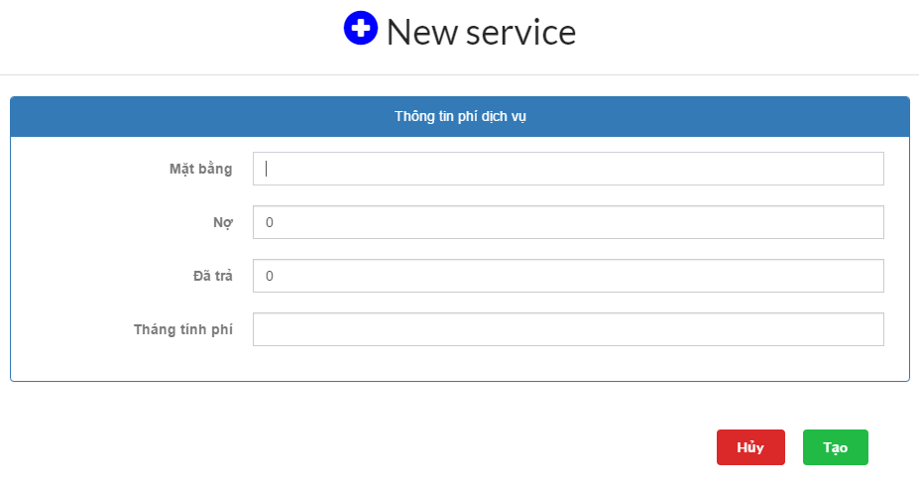

|  |  |  |
| --- | --- | --- |
| **Element** | **Type** | **Description** |
| Mặt bằng | Textbox | Ground name |
| Nợ | Textbox | Service Debt of ground |
| Đã trả | Textbox | Service Paid of ground |
| Tháng tính phí | Textbox | Month that charge |
| Hủy | Button | Button to dismiss form |
| Tạo | Button | Button to submit form |

#### Class Diagram

*Refer to class diagram of view service finance in 1.3.44 View service finance*

#### Class Specifications

##### Function

|  |  |  |  |  |
| --- | --- | --- | --- | --- |
| **Class** | **ServiceController** | | | |
| **Description** | Control and do business relate to service of tower | | | |
| **Base Class** | ApplicationController | | | |
| **Source File** | service_controller.rb | | | |
| **Namespace** | app/controllers/ | | | |
| **Attributes** | **N/A** | | | |
| **Methods** | **Name** | **Input** | **Output** | **Description** |
| create | Information input | void | creates a new service finance |

#### Sequence Diagram

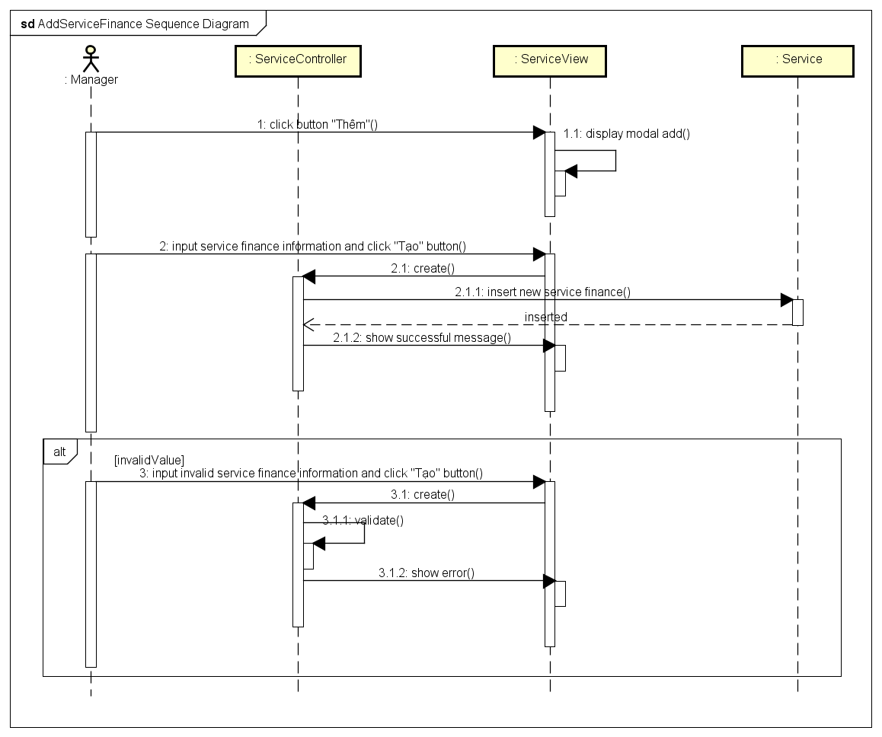

### Update service finances

#### Description

Manager updates service finance of a ground.

#### Design

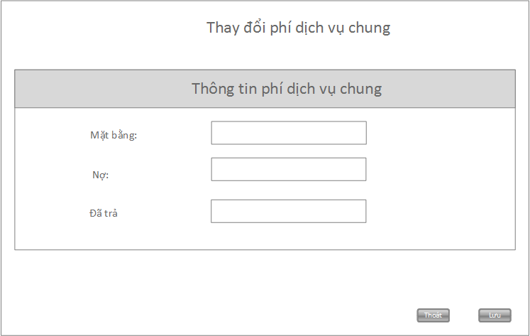

|  |  |  |
| --- | --- | --- |
| **Element** | **Type** | **Description** |
| Mặt bằng | Textbox | Ground name |
| Nợ | Textbox | Debt of this ground |
| Đã trả | Textbox | Paid of this ground |
| Hủy | Button | Button to dimiss form |
| Lưu | button | Button to submit form |

#### Class Diagram

*Refer to class diagram of view service finance in 1.3.44 View service finance*

#### Class Specifications

##### Function

|  |  |  |  |  |
| --- | --- | --- | --- | --- |
| **Class** | **ServiceController** | | | |
| **Description** | Control and do business relate to service of tower | | | |
| **Base Class** | ApplicationController | | | |
| **Source File** | services_controller.rb | | | |
| **Namespace** | app/controllers/ | | | |
| **Attributes** | **N/A** | | | |
| **Methods** | **Name** | **Input** | **Output** | **Description** |
| update | Information input | void | Update service finance information of a ground |

#### Sequence Diagram

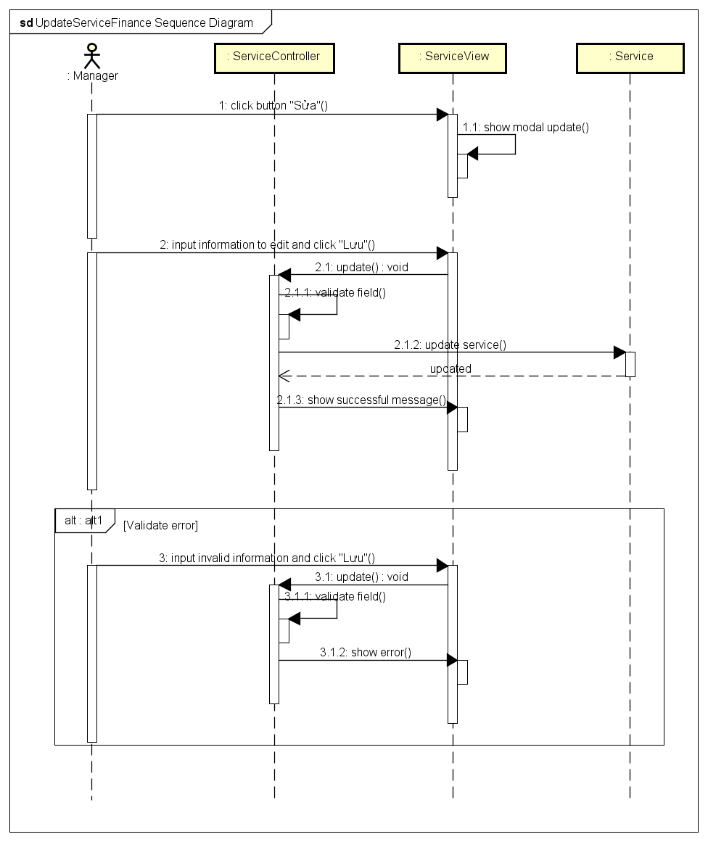

### Delete service finance

#### Description

Manager deletes a service finance of a ground.

#### Design

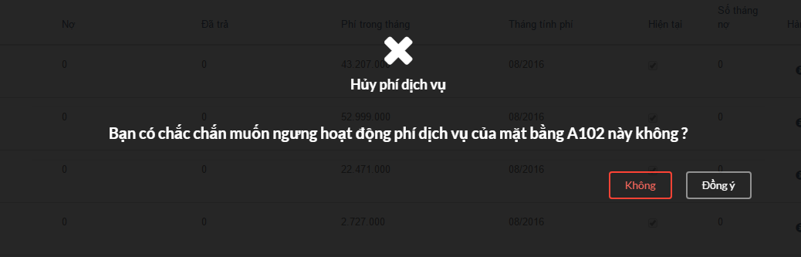

|  |  |  |
| --- | --- | --- |
| **Element** | **Type** | **Description** |
| Không | Button | Button to cancel delete |
| có | Button | Button to submit delete |

#### Class Diagram

*Refer to class diagram of view service finance in 1.3.44 View service finance*

#### Class Specifications

##### Function

|  |  |  |  |  |
| --- | --- | --- | --- | --- |
| **Class** | **ServiceController** | | | |
| **Description** | Control and do business relate to service of tower | | | |
| **Base Class** | ApplicationController | | | |
| **Source File** | Apartments_controller.rb | | | |
| **Namespace** | app/controllers/ | | | |
| **Attributes** | **N/A** | | | |
| **Methods** | **Name** | **Input** | **Output** | **Description** |
| destroy | Information input | void | Delete a service finance |

#### Sequence Diagram

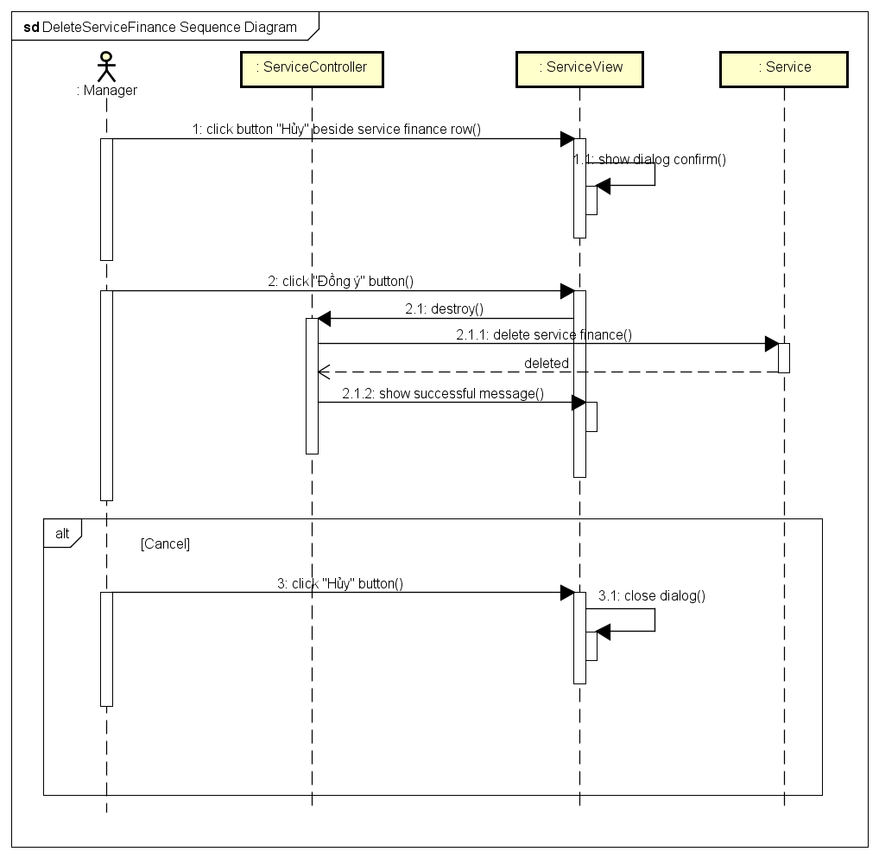

### View history

#### Description

Manager views all history transaction of tower.

#### Design

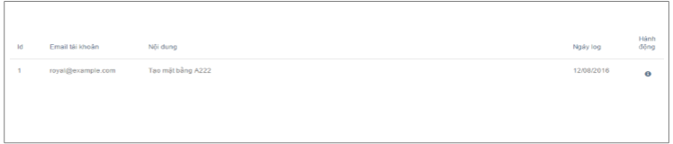

|  |  |  |
| --- | --- | --- |
| **Element** | **Type** | **Description** |
| Id | Textbox | Id of history |
| Email tài khoản | Textbox | Manager account that do this action |
| Nội dung | Textbox | Content of history |
| Ngày kig | Textbox | Date that occur this action |
| Hành động | Button | View detail |

#### Class Diagram

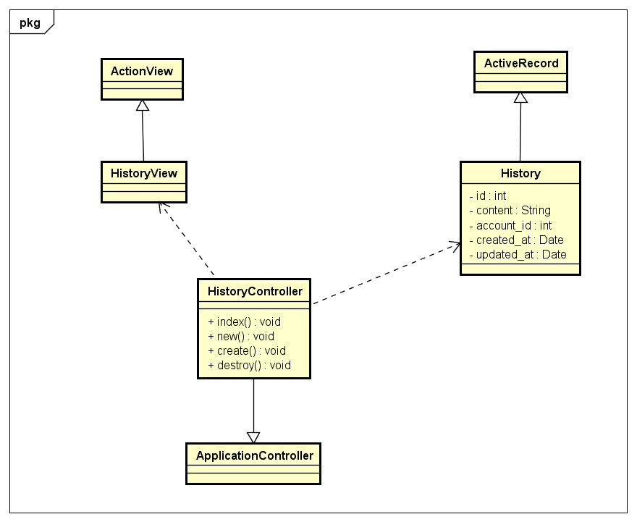

#### Class Specifications

##### Function

|  |  |  |  |  |
| --- | --- | --- | --- | --- |
| **Class** | **HistoryController** | | | |
| **Description** | Record all transaction of tower. | | | |
| **Base Class** | ApplicationController | | | |
| **Source File** | histories_controller.rb | | | |
| **Namespace** | app/controllers/ | | | |
| **Attributes** | **N/A** | | | |
| **Methods** | **Name** | **Input** | **Output** | **Description** |
| index | Information input | void | Get all history transaction of tower and render view |

#### Sequence Diagram

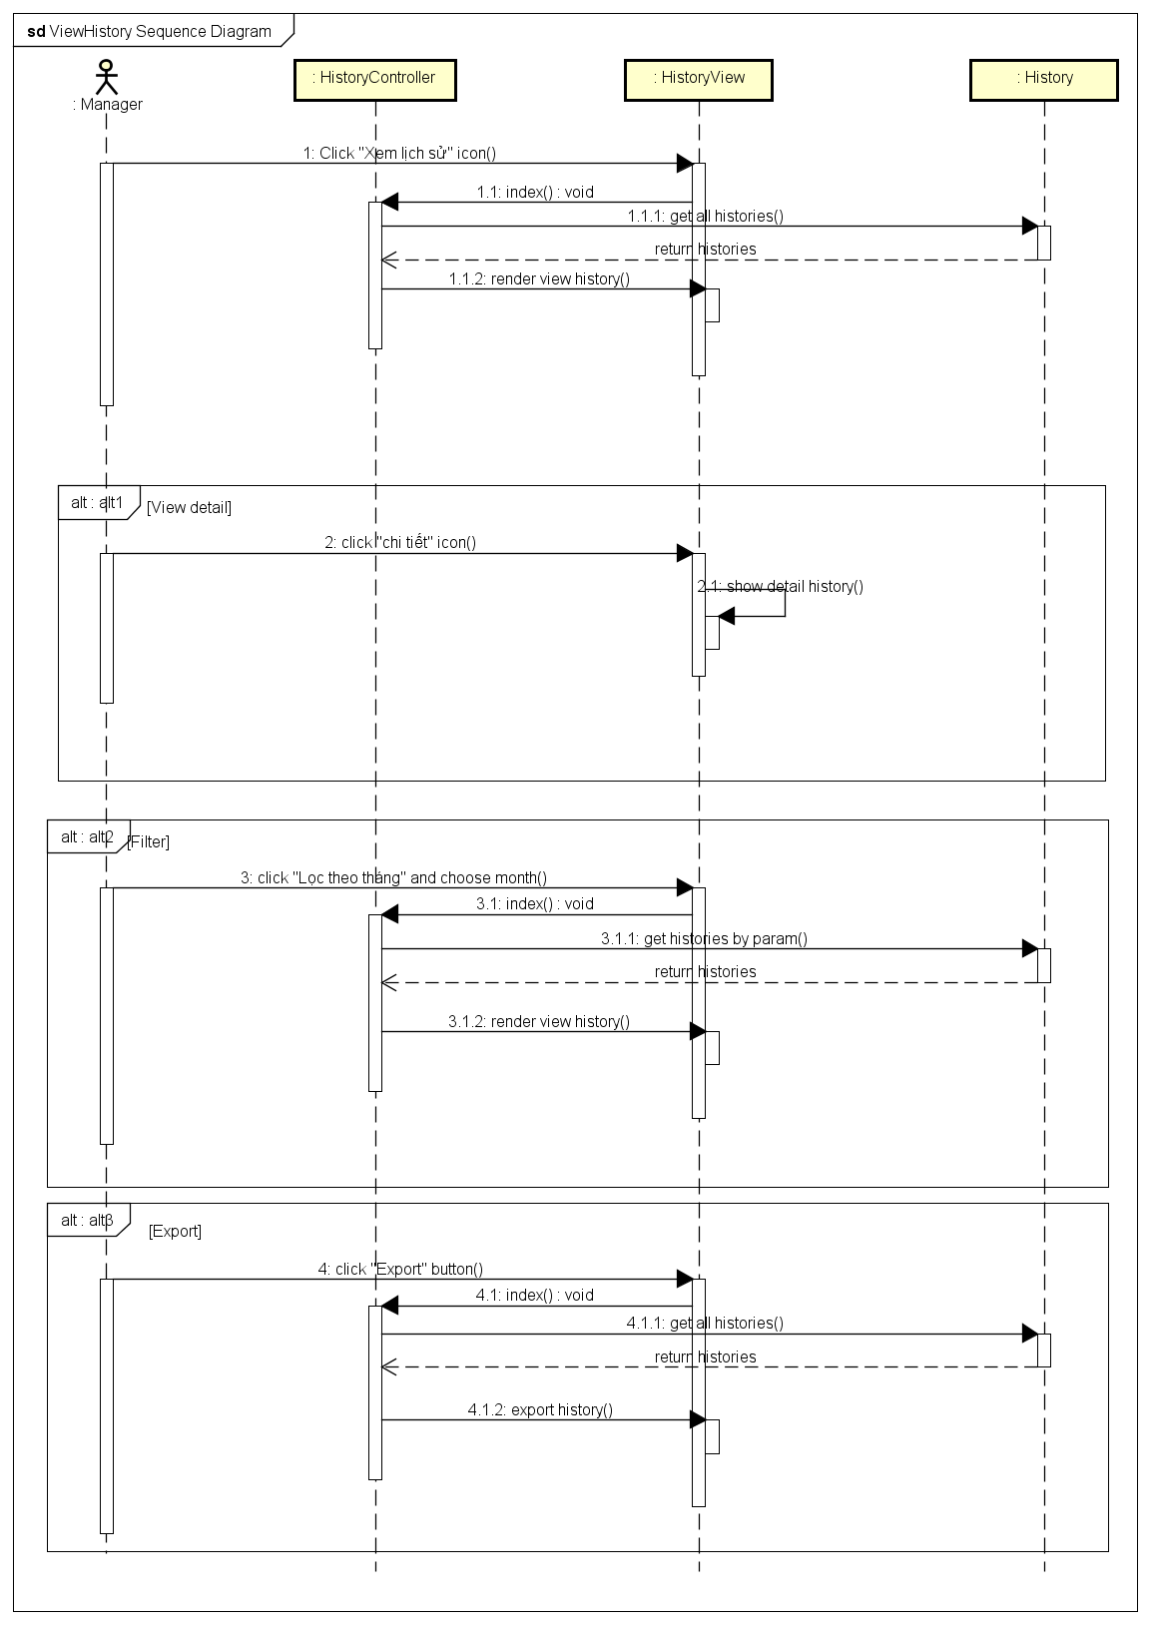

### View grounds map

#### Description

Manager views ground chart of the building.

#### Design

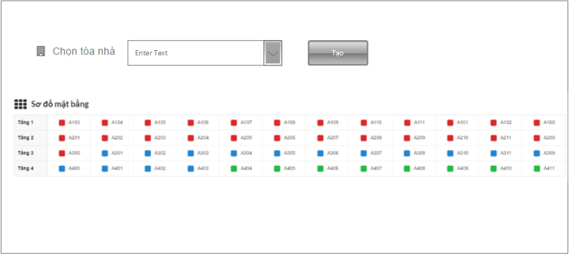

|  |  |  |
| --- | --- | --- |
| **Element** | **Type** | **Description** |
| Dropbox | dropbox | Dropbox to choose building |
| Tạo | Button | Button to create chart |
| Chart | Chart | Ground chart |

#### Class Diagram

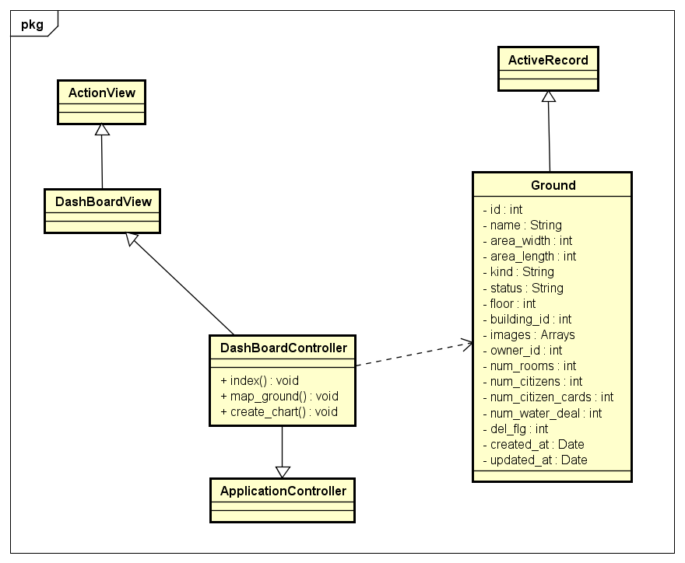

#### Class Specifications

##### Function

|  |  |  |  |  |
| --- | --- | --- | --- | --- |
| **Class** | **DashBoardController** | | | |
| **Description** | Control all action relate to chart and report of building and tower | | | |
| **Base Class** | DashBoardController | | | |
| **Source File** | Apartments_controller.rb | | | |
| **Namespace** | app/controllers/ | | | |
| **Attributes** | **N/A** | | | |
| **Methods** | **Name** | **Input** | **Output** | **Description** |
| map_ground | Information input | void | Get all grounds information and render a chart |

#### Sequence Diagram

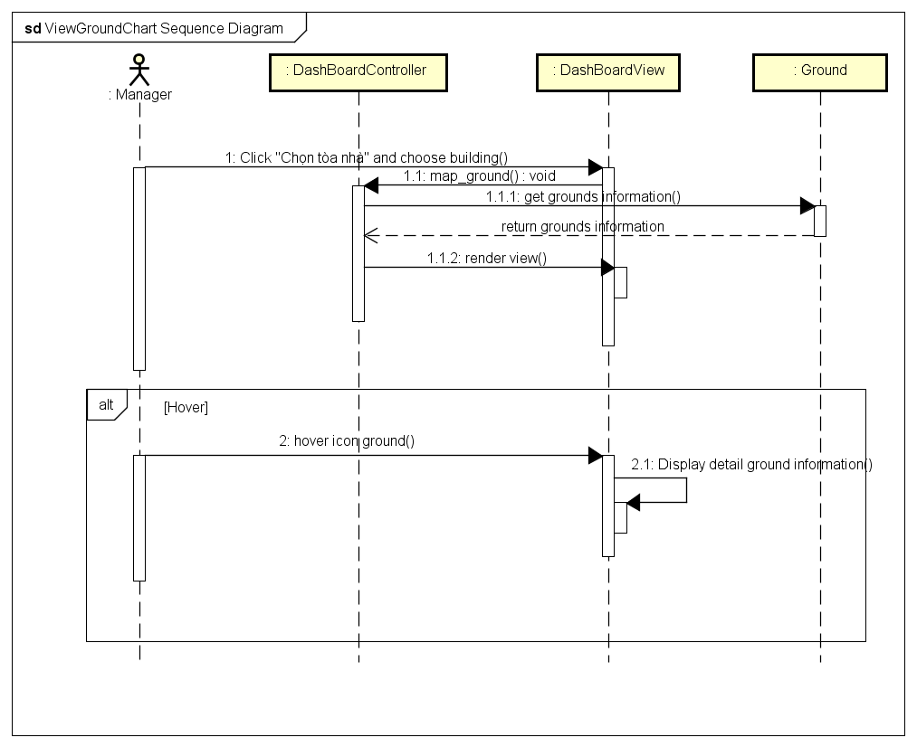

### View statistic and report

#### Description

Manager views building statistic: type of grounds, type of vehicle, revenue of water, service, vehicle, etc

#### Design

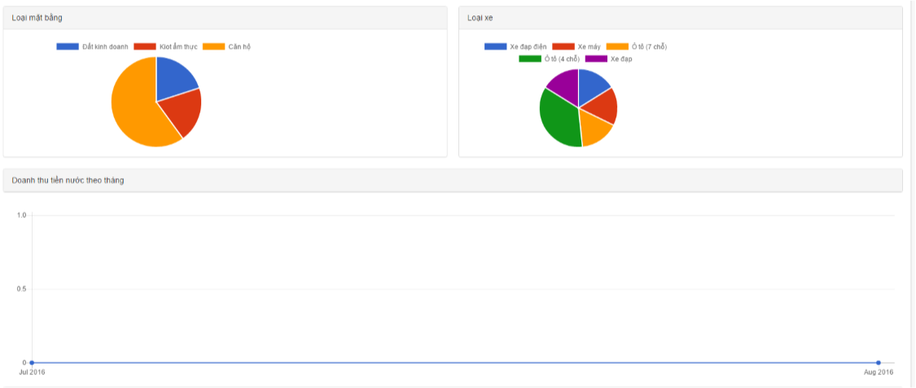

|  |  |  |
| --- | --- | --- |
| **Element** | **Type** | **Description** |
| Loại mặt bằng | Chart | Ground chart |
| Loại xe | Chart | Vehicle chart |
| Doanh thu theo xxx | Chart | Revenue chart |

#### Class Diagram

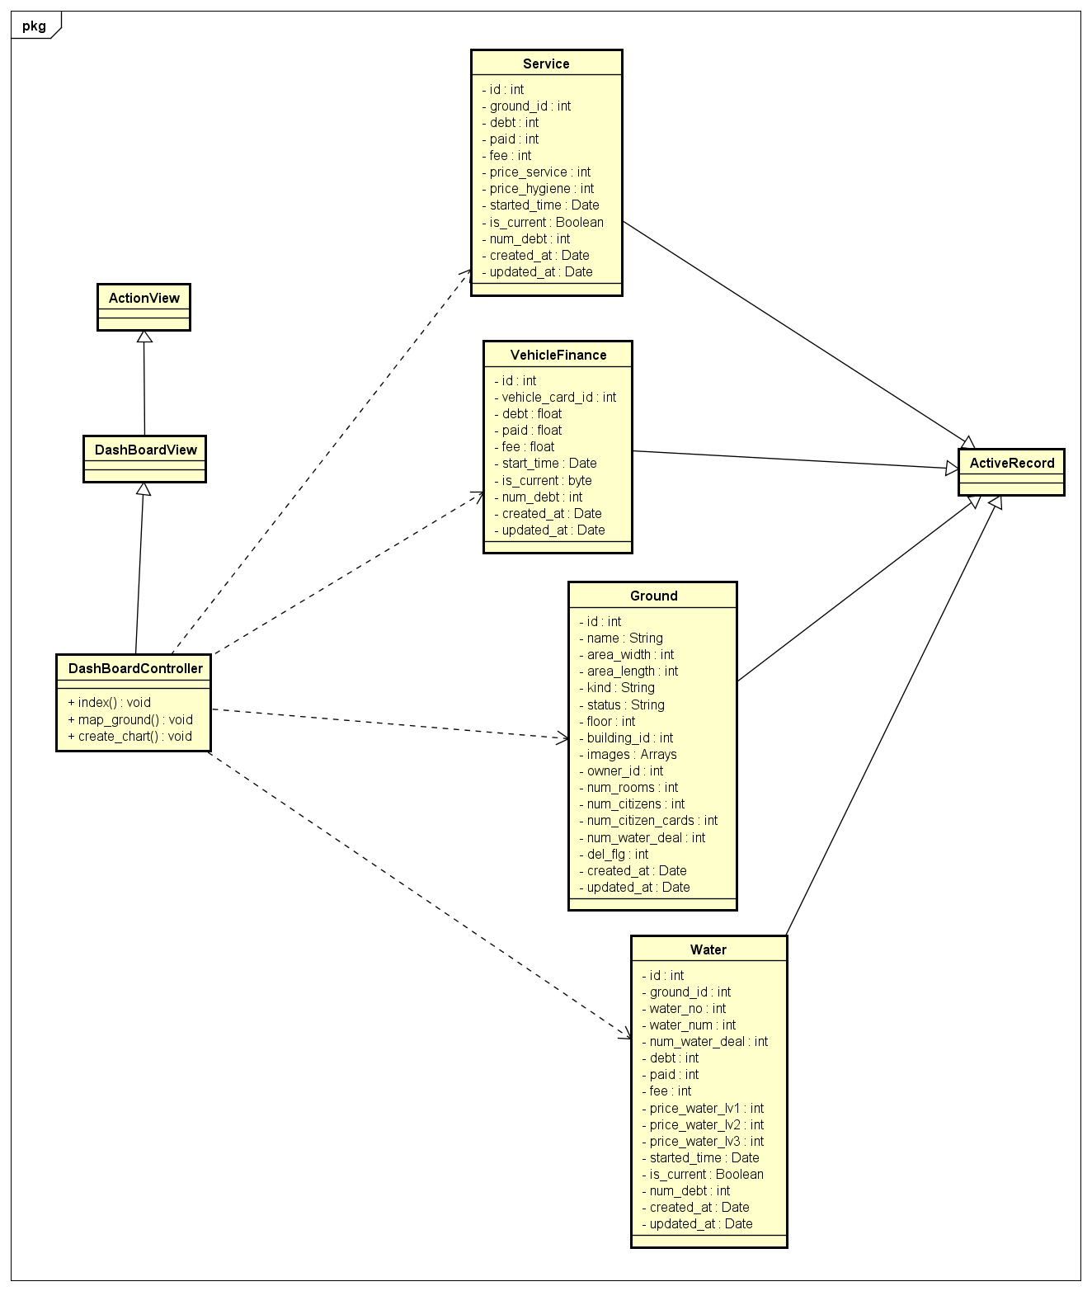

#### Class Specifications

##### Function

|  |  |  |  |  |
| --- | --- | --- | --- | --- |
| **Class** | **DashBoardController** | | | |
| **Description** | Control all action relate to chart and report of building and tower | | | |
| **Base Class** | ApplicationController | | | |
| **Source File** | dashboard_controller.rb | | | |
| **Namespace** | app/controllers/ | | | |
| **Attributes** | **N/A** | | | |
| **Methods** | **Name** | **Input** | **Output** | **Description** |
| index | Information input | void | Get ground, service, vehicle finance and water information and render view statistic. |

#### Sequence Diagram

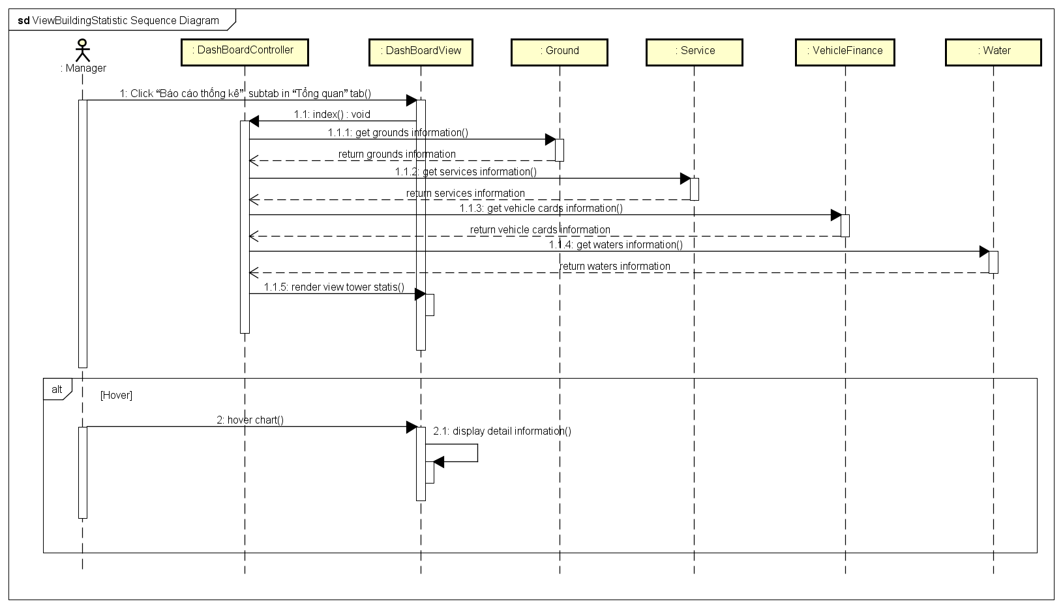

### Export Report

#### Description

Manager exports reports: list of citizens, list of grounds, list of vehicle holders, list of facilities.

#### Design

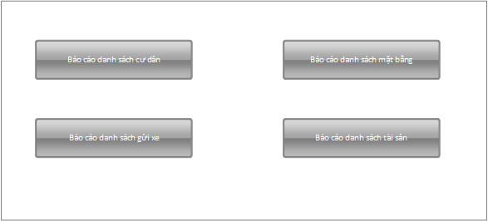

|  |  |  |
| --- | --- | --- |
| **Element** | **Type** | **Description** |
| Báo cáo danh sách cư dân | Button | Button to export citizen list |
| Báo cáo danh sách gửi xe | Button | Button to export vehicle list |
| Báo cáo danh sách mặt bằng | Button | Button to export ground list |
| Báo cáo danh sách tài sản | Button | Button to export facility list |

#### Class Diagram

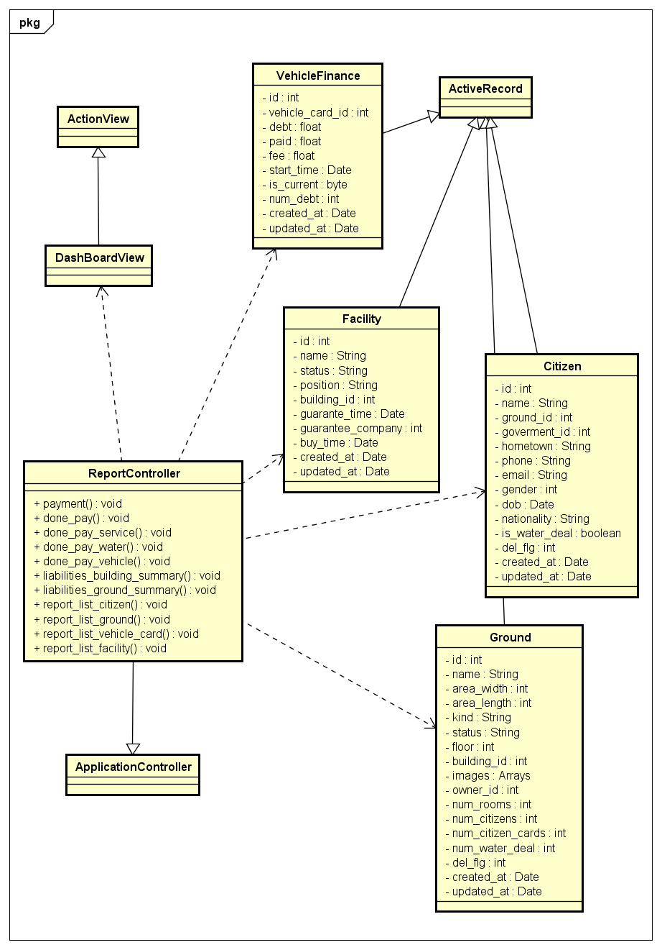

#### Class Specifications

##### Function

|  |  |  |  |  |
| --- | --- | --- | --- | --- |
| **Class** | **ReportController** | | | |
| **Description** | Control all action relate to report of tower. | | | |
| **Base Class** | ApplicationController | | | |
| **Source File** | report_controller.rb | | | |
| **Namespace** | app/controllers/ | | | |
| **Attributes** | **N/A** | | | |
| **Methods** | **Name** | **Input** | **Output** | **Description** |
| Report_list_citizen | N/A | void | Get all citizens information and export report |
| Report_list_ground | N/A | Void | Get all grounds information and export report |
| Report_list_vehicle_card | N/A | Void | Get all vehicle cards information and export report |
| Report_list_facility | N/A | void | Get all facilities information and export report |

#### Sequence Diagram

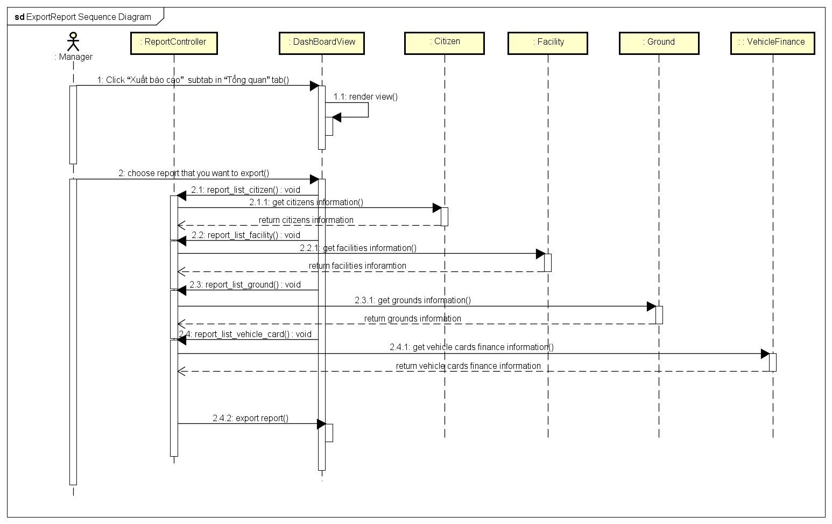

### Create Statistic Chart

#### Description

Systems will draw statistic chart of tower base on the input that manager chosen.

#### Design

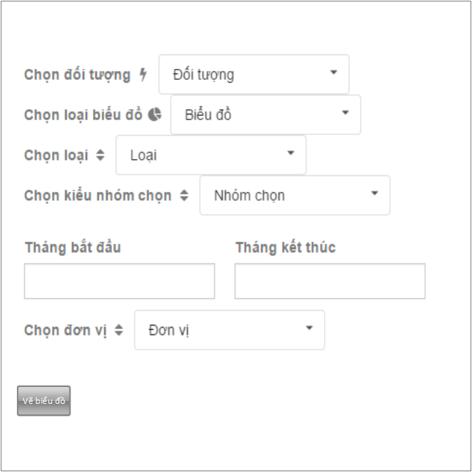

|  |  |  |
| --- | --- | --- |
| **Element** | **Type** | **Description** |
| Chọn đối tượng | Dropbox | Choose object to draw chart |
| Chọn loại biểu đồ | Dropbox | Choose type of chart |
| Chọn loại | Dropbox | Choose type of fee |
| Chọn kiểu nhóm chọn | Dropbox | Choose type of unit to count |
| Tháng bắt đầu | Textbox | Start month |
| Tháng kết thúc | Textbox | End month |
| Đơn vị | Dropbox | Unit |
| Vẽ biểu đồ | Button | Button to draw chart |

#### Class Diagram

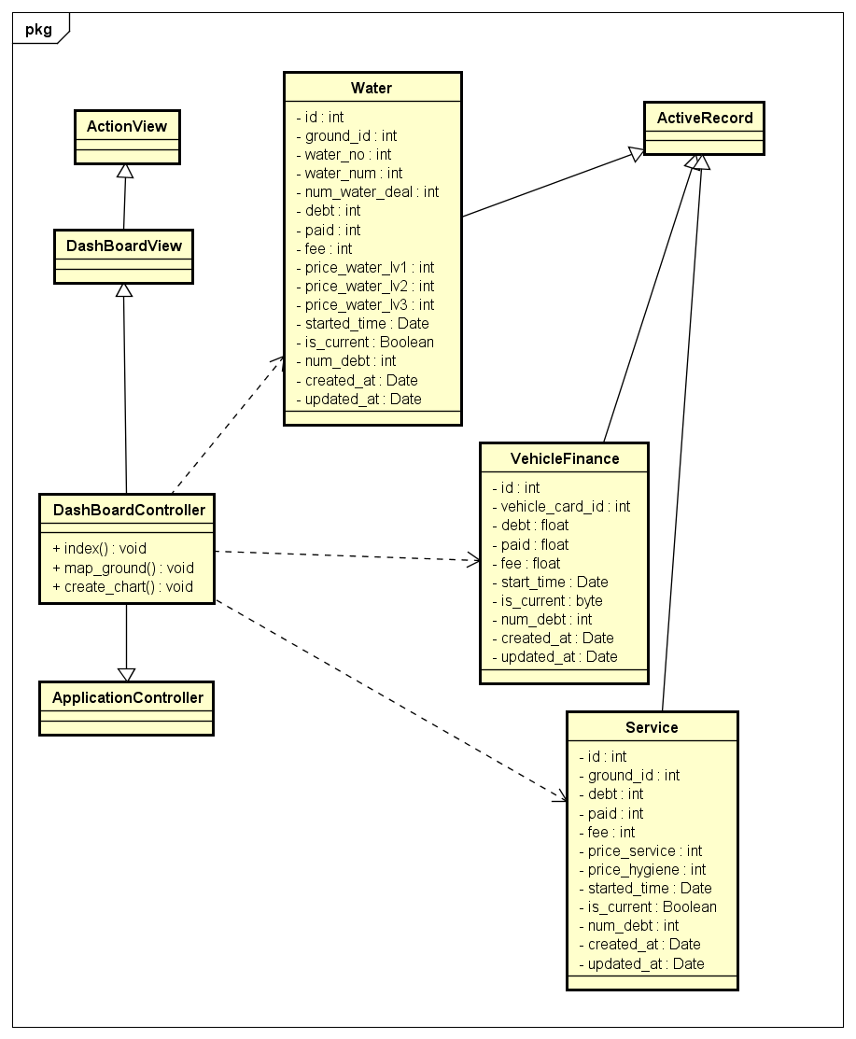

#### Class Specifications

##### Function

|  |  |  |  |  |
| --- | --- | --- | --- | --- |
| **Class** | **DashBoardController** | | | |
| **Description** | Control all action relate to chart and report of building and tower | | | |
| **Base Class** | ApplicationController | | | |
| **Source File** | dashboard_controller.rb | | | |
| **Namespace** | app/controllers/ | | | |
| **Attributes** | **N/A** | | | |
| **Methods** | **Name** | **Input** | **Output** | **Description** |
| Create_chart | Information input | void | Create a chart base on the input that manager chosen. |

#### Sequence Diagram

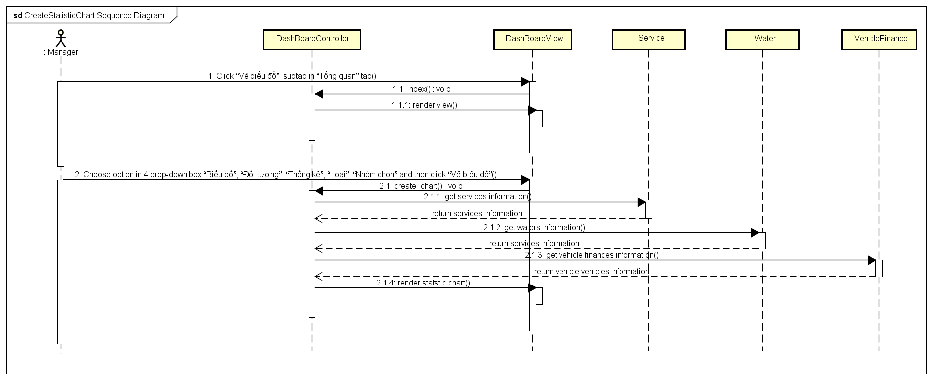

### Payment

#### Description

Manager completes payment of a ground.

#### Design

|  |  |  |
| --- | --- | --- |
| **Element** | **Type** | **Description** |
| Tên mặt bằng | Textbox | Ground name |
| Choose type of service | Checkbox | Choose type service to pay |
| Thanh toán | Button | Button to pay |
| Detail payment | Table | Detail service payment of this ground |
| Xuất hóa đơn dịch vụ | button | Button to export invoice |

#### Class Diagram

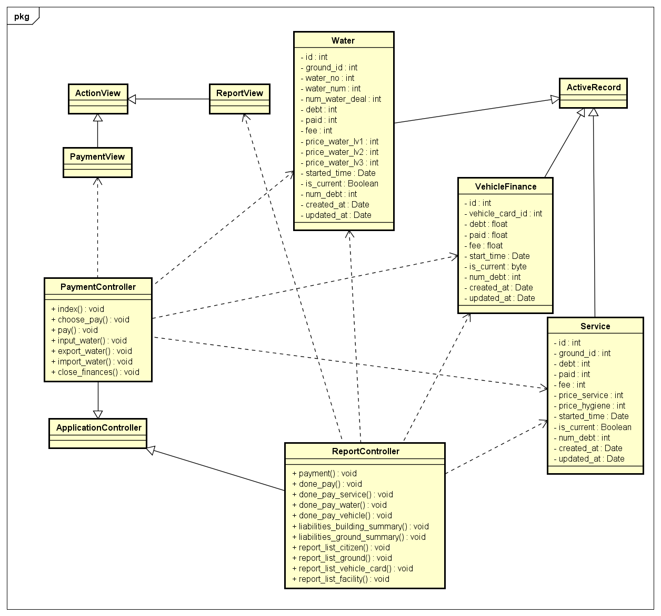

#### Class Specifications

##### Function

|  |  |  |  |  |
| --- | --- | --- | --- | --- |
| **Class** | **PaymentController** | | | |
| **Description** | Control all action relate to payment of a ground | | | |
| **Base Class** | ApplicationController | | | |
| **Source File** | Payment_controller.rb | | | |
| **Namespace** | app/controllers/ | | | |
| **Attributes** | **N/A** | | | |
| **Methods** | **Name** | **Input** | **Output** | **Description** |
| index | Information input | void | Render payment view |
| Choose_pay | Information input | Void | Choose service to pay |
| pay | Information input | Void | Pay for service of ground |
| Done_pay_service | Information input | Void | Done pay service and export invoice |
| Done_pay_vehicle | Information input | Void | Done pay vehicle and export invoice |
| Done_pay_water | Information input | void | Done pay water and export invoice |

#### Sequence Diagram

### Enter Water Consumption

#### Description

Manager enters water consumption of a ground

#### Design

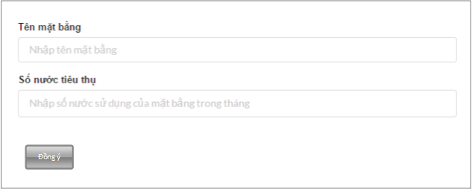

|  |  |  |
| --- | --- | --- |
| **Element** | **Type** | **Description** |
| Tên mặt bằng | Textbox | Ground name |
| Số nước tiêu thụ | Textbox | Number of water |
| Đồng ý | Button | Button to submit |

#### Class Diagram

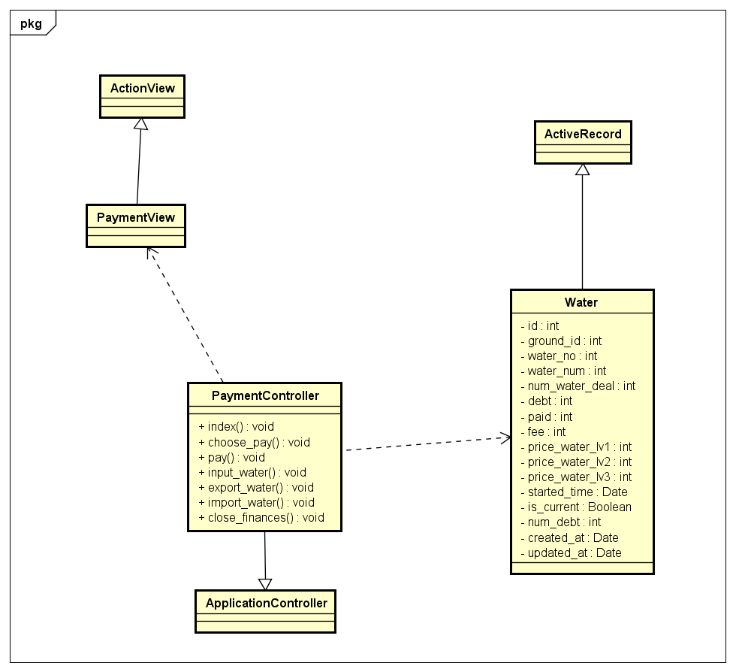

#### Class Specifications

##### Function

|  |  |  |  |  |
| --- | --- | --- | --- | --- |
| **Class** | **PaymentController** | | | |
| **Description** | Control all action relate to payment of a ground | | | |
| **Base Class** | ApplicationController | | | |
| **Source File** | payment_controller.rb | | | |
| **Namespace** | app/controllers/ | | | |
| **Attributes** | **N/A** | | | |
| **Methods** | **Name** | **Input** | **Output** | **Description** |
| index | Information input | void | Render ivew |
| Import_water | Information input | void | Import water consumption of a ground |

#### Sequence Diagram

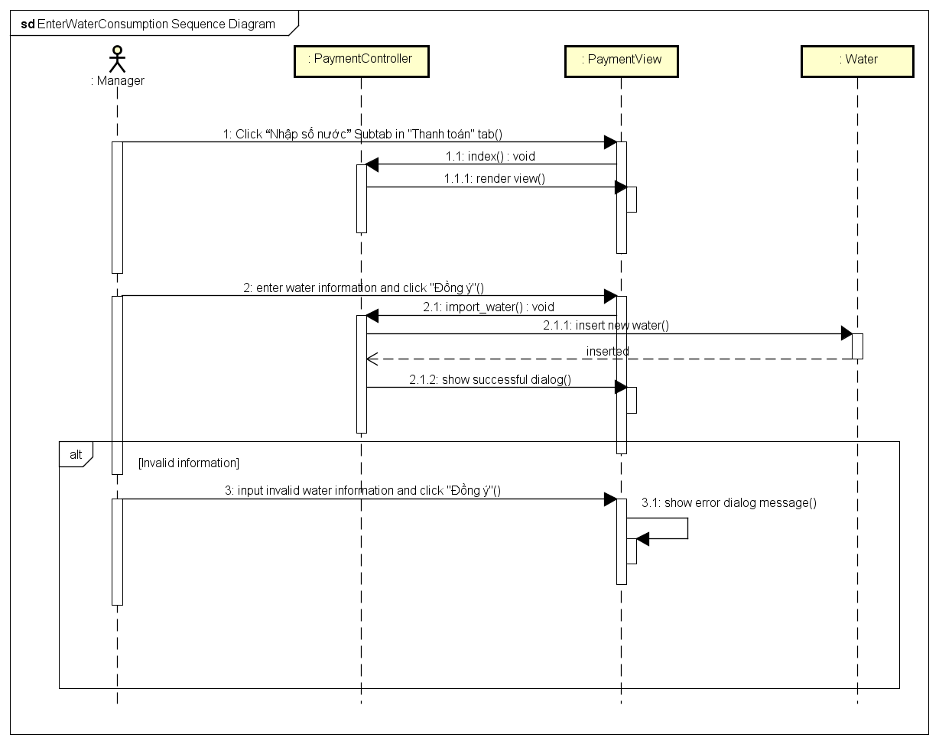

### Enter water consumption from excel

#### Description

Manager enter water consumption of a building from excel file.

#### Design

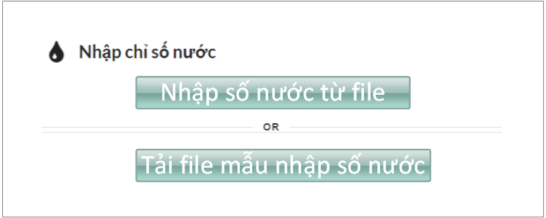

|  |  |  |
| --- | --- | --- |
| **Element** | **Type** | **Description** |
| Nhập số nước từ file | Button | Button to import file |
| Tải file mẫu nhập số nước | button | Button to download template |

#### Class Diagram

*Refer to class diagram of Enter water consumption in 1.3.59 Enter water consumption*

#### Class Specifications

##### Function

|  |  |  |  |  |
| --- | --- | --- | --- | --- |
| **Class** | **PaymentController** | | | |
| **Description** | Control all action relate to payment of a ground | | | |
| **Base Class** | ApplicationController | | | |
| **Source File** | payment_controller.rb | | | |
| **Namespace** | app/controllers/ | | | |
| **Attributes** | **N/A** | | | |
| **Methods** | **Name** | **Input** | **Output** | **Description** |
| index | Information input | void | Render ivew |
| Import_water | Information input | void | Import water consumption of a ground |

#### Sequence Diagram

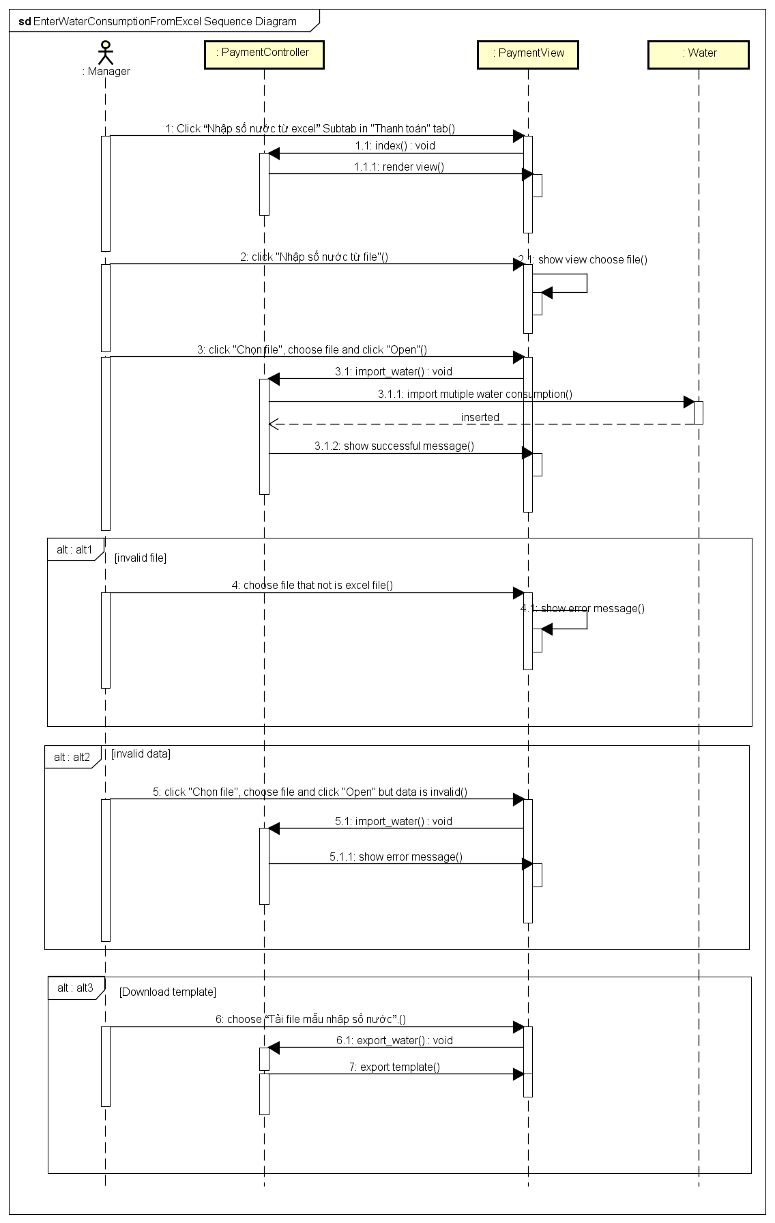

### Closing monthly statistic

#### Description

Manager closes payment of all grounds in tower

#### Design

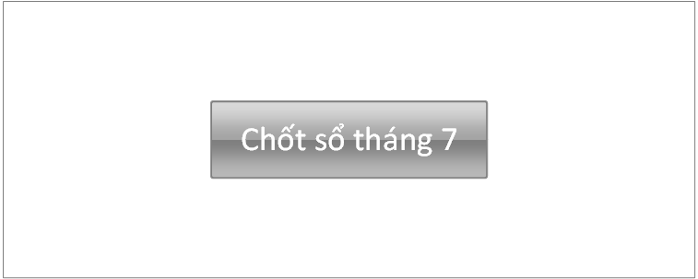

|  |  |  |
| --- | --- | --- |
| **Element** | **Type** | **Description** |
| Chốt sổ | Button | Button to Close monthy |

#### Class Diagram

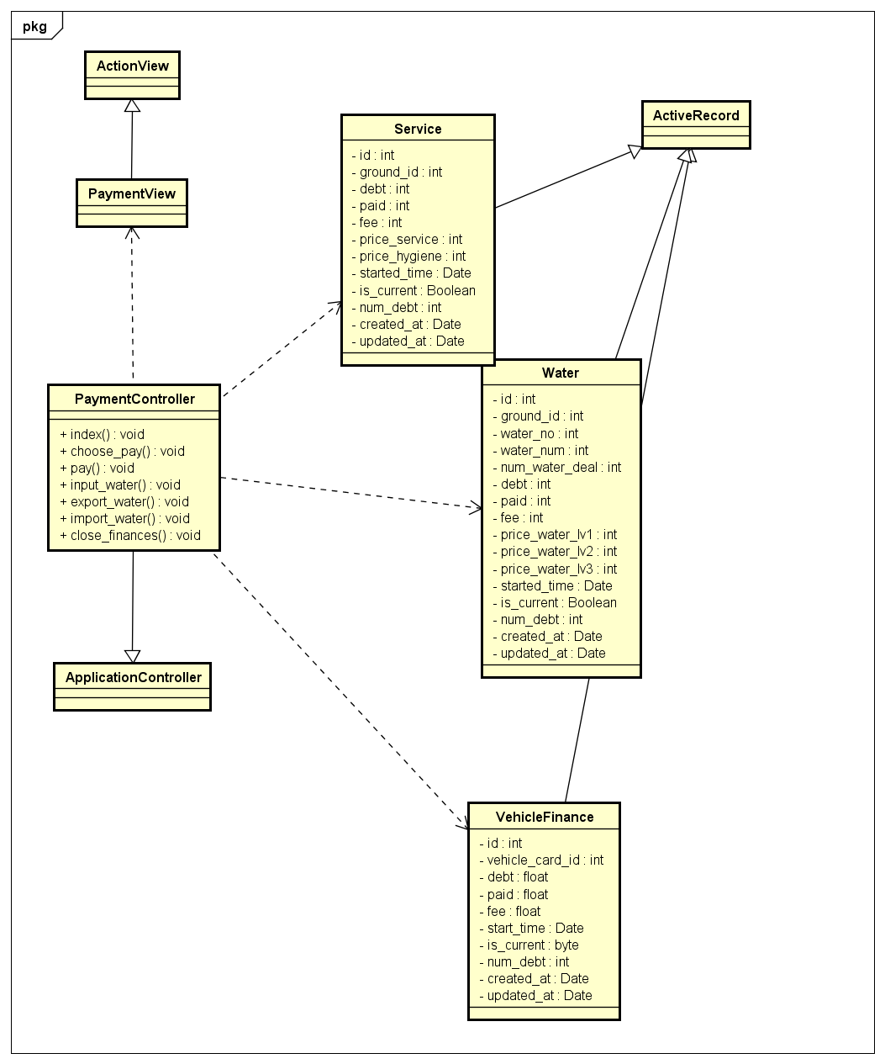

#### Class Specifications

##### Function

|  |  |  |  |  |
| --- | --- | --- | --- | --- |
| **Class** | **PaymentController** | | | |
| **Description** | Control all action relate to payment of a ground | | | |
| **Base Class** | ApplicationController | | | |
| **Source File** | payment_controller.rb | | | |
| **Namespace** | app/controllers/ | | | |
| **Attributes** | **N/A** | | | |
| **Methods** | **Name** | **Input** | **Output** | **Description** |
| index | Information input | void | Render view |
| Close_finance | Information input | Void | Close finance of all grounds in tower |

#### Sequence Diagram

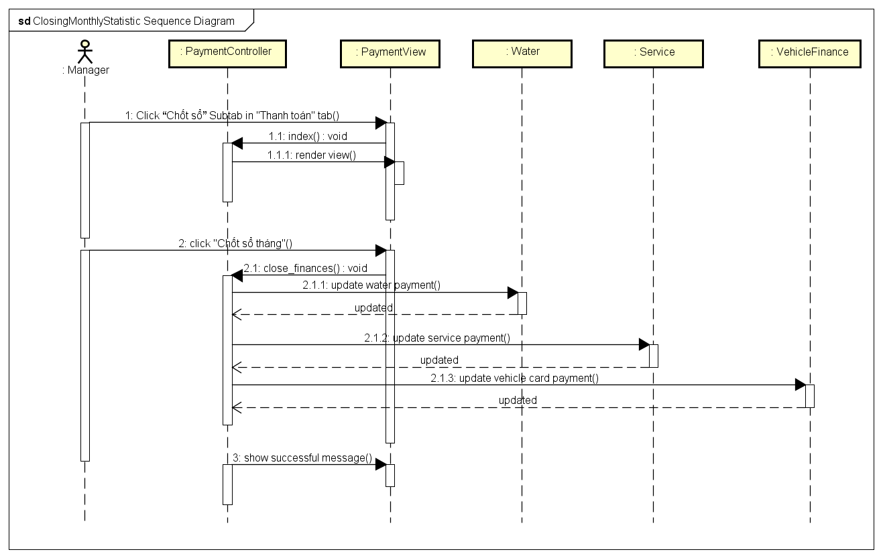

### Import building database from excel

#### Description

Manager imports building informations from excel file.

#### Design

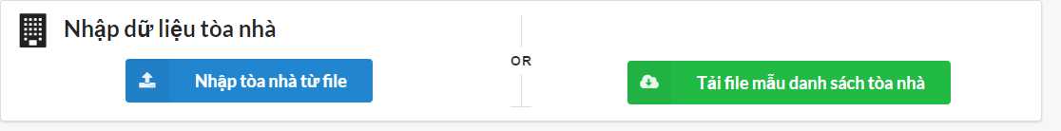

|  |  |  |
| --- | --- | --- |
| **Element** | **Type** | **Description** |
| Nhập toàn nhà từ file | Button | Button to import file |
| Tải file mẫu danh sách tòa nhà | button | Button to download template |

#### Class Diagram

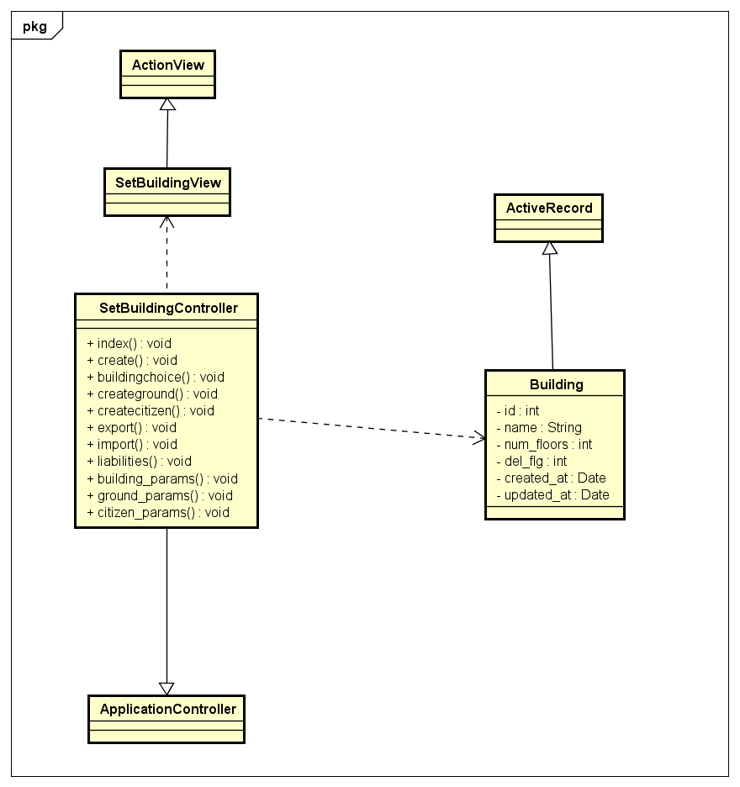

#### Class Specifications

##### Function

|  |  |  |  |  |
| --- | --- | --- | --- | --- |
| **Class** | **SetBuildingController** | | | |
| **Description** | Control all action relate to building of a tower | | | |
| **Base Class** | ApplicationController | | | |
| **Source File** | setbuilding_controller.rb | | | |
| **Namespace** | app/controllers/ | | | |
| **Attributes** | **N/A** | | | |
| **Methods** | **Name** | **Input** | **Output** | **Description** |
| index | Information input | void | Render view |
| import | Information | void | Import building information from excel file. |

#### Sequence Diagram

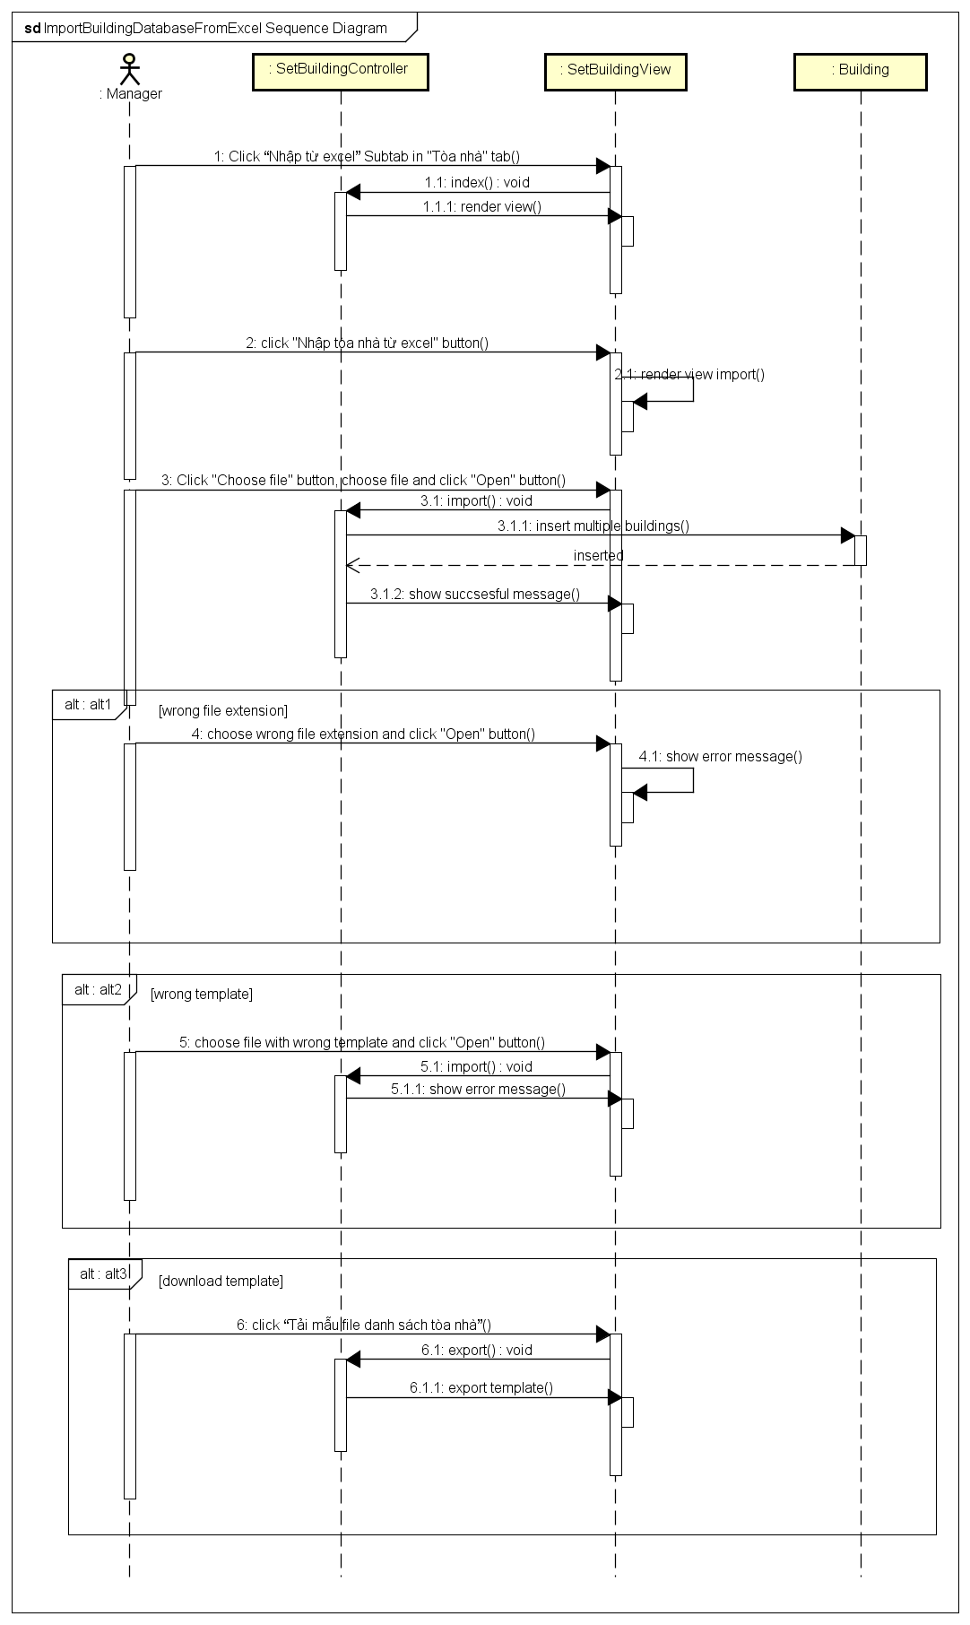

### See building liabilities

#### Description

Manager sees all liabilities of the building.

#### Design

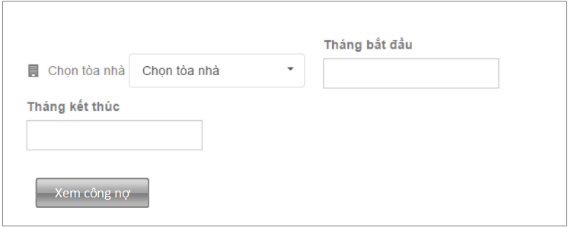

|  |  |  |
| --- | --- | --- |
| **Element** | **Type** | **Description** |
| Chọn tòa nhà | dropbox | Choose building |
| Tháng bắt đầu | Textbox | Start month |
| Tháng kết thúc | Textbox | End month |
| Xem công nợ | Button | Button to see building liabilities |

#### Class Diagram

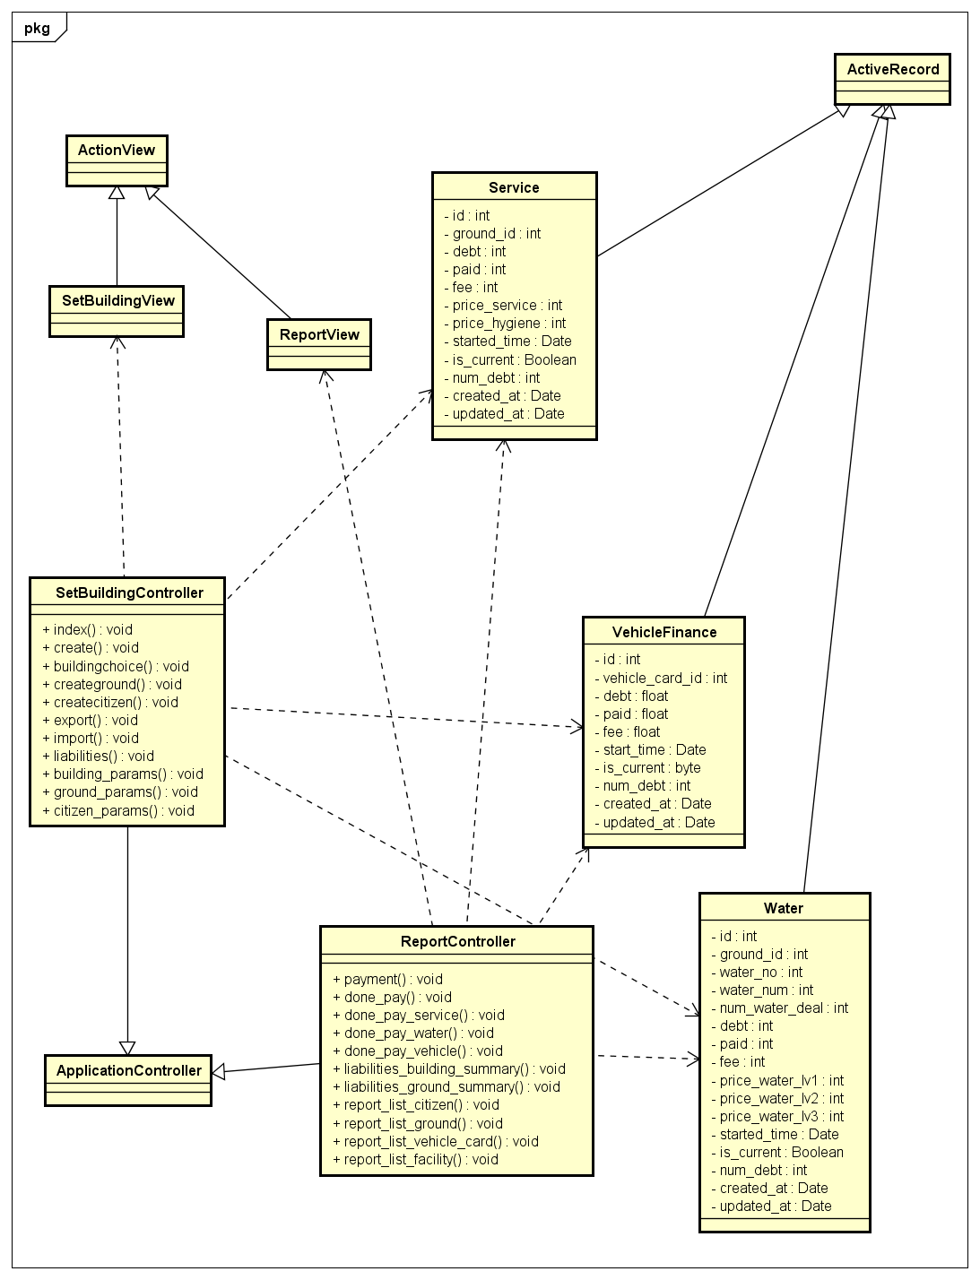

#### Class Specifications

##### Function

|  |  |  |  |  |
| --- | --- | --- | --- | --- |
| **Class** | **SetBuildingController** | | | |
| **Description** | Control all action relate to building of a tower | | | |
| **Base Class** | ApplicationController | | | |
| **Source File** | setbuilding_controller.rb | | | |
| **Namespace** | app/controllers/ | | | |
| **Attributes** | **N/A** | | | |
| **Methods** | **Name** | **Input** | **Output** | **Description** |
| index | Information input | void | Render view |
| libialities | Information input | void | Get all liabilities of the building and render view |
| Libialities_building_summary | Information input | Void | Export report of building liabilities |

#### Sequence Diagram

### Add ground picture

#### Description

Manager adds picture of grounds to verify ground position and area.

#### Design

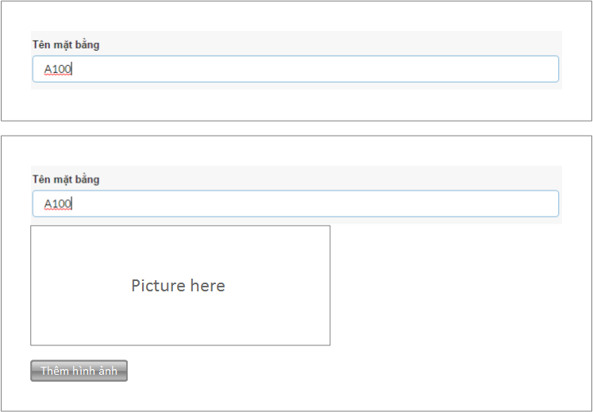

|  |  |  |
| --- | --- | --- |
| **Element** | **Type** | **Description** |
| Tên mặt bằng | Textbox | Ground name |
| Picture here | Image | Display ground picture |
| Thêm hình ảnh | Button | Button to add picture |

#### Class Diagram

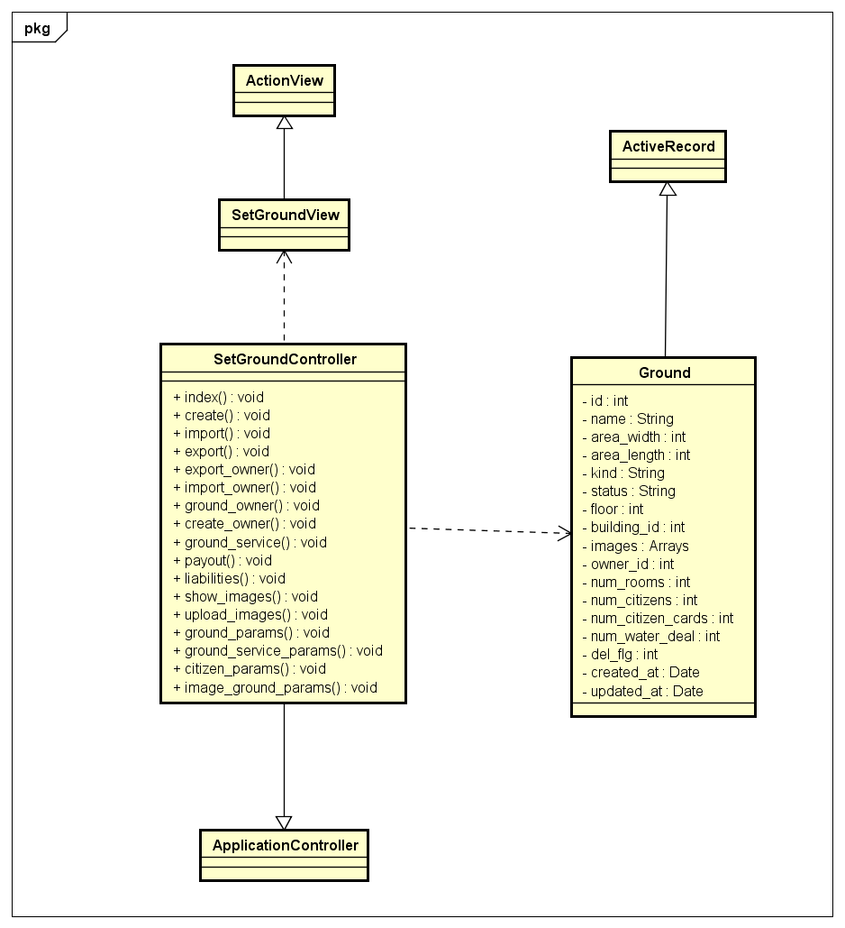

#### Class Specifications

##### Function

|  |  |  |  |  |
| --- | --- | --- | --- | --- |
| **Class** | **SetGroundController** | | | |
| **Description** | Control all action relate to ground of a tower | | | |
| **Base Class** | ApplicationController | | | |
| **Source File** | setground_controller.rb | | | |
| **Namespace** | app/controllers/ | | | |
| **Attributes** | **N/A** | | | |
| **Methods** | **Name** | **Input** | **Output** | **Description** |
| index | Information input | void | Render view |
| Upload_images | Information input | void | Add ground picture to ground in subdomain system |

#### Sequence Diagram

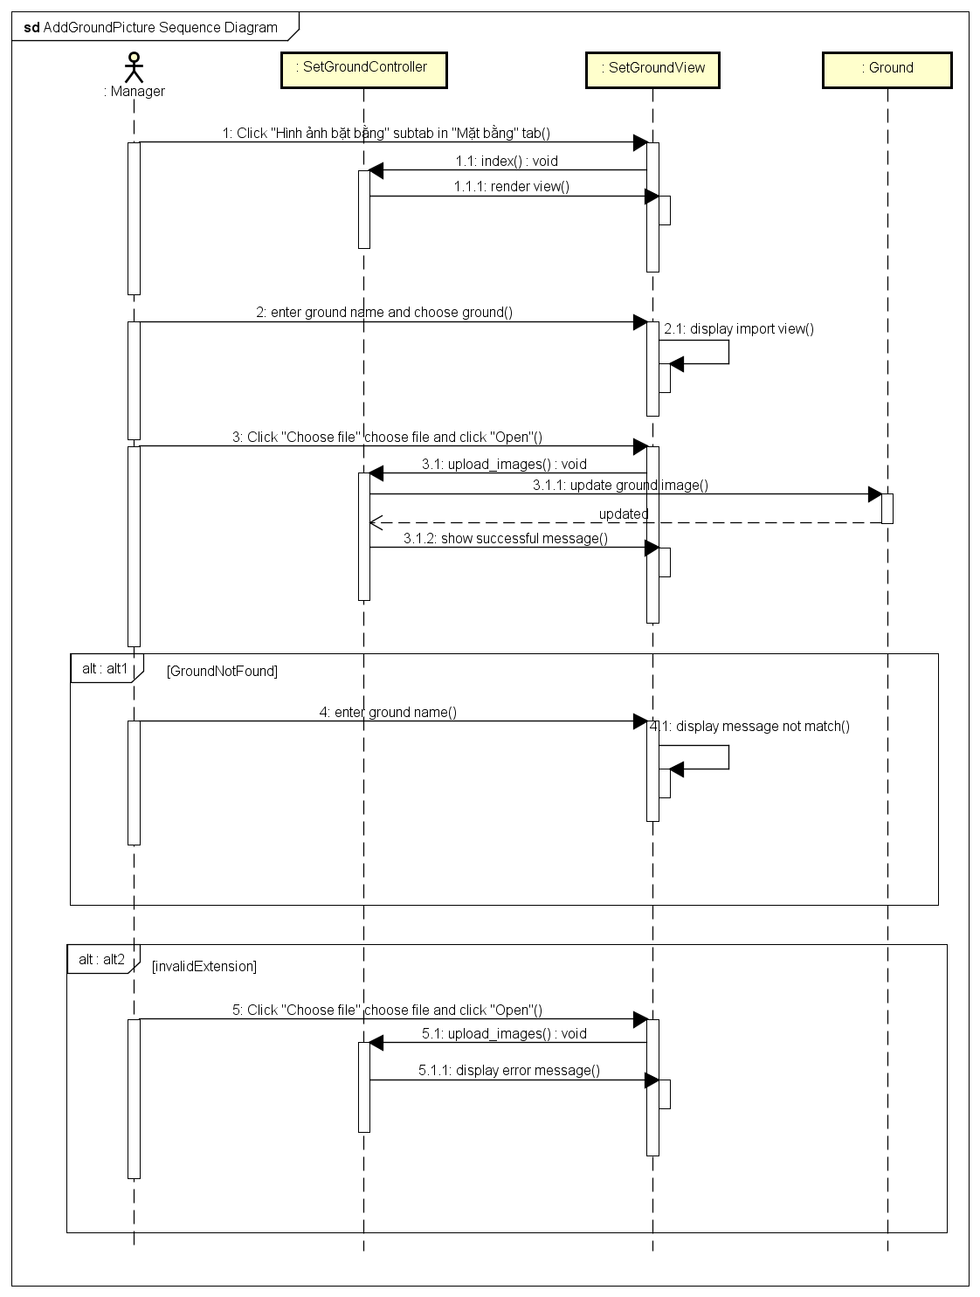

### Import ground database from excel

#### Description

Manager imports multiple grounds from excel file.

#### Design

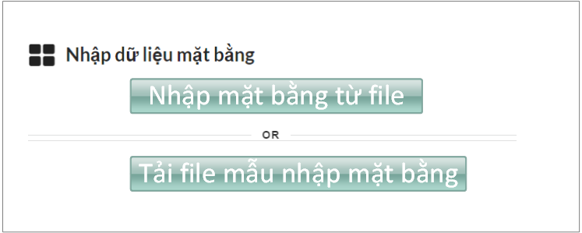

|  |  |  |
| --- | --- | --- |
| **Element** | **Type** | **Description** |
| Nhập mặt bằng từ file | Button | Button to import file |
| Tải file mẫu nhập mặt bằng | button | Button to download template |

#### Class Diagram

*Refer to class diagram of Add ground picture in 1.3.63 Add ground picture*

#### Class Specifications

##### Function

|  |  |  |  |  |
| --- | --- | --- | --- | --- |
| **Class** | **SetGroundController** | | | |
| **Description** | Control all action relate to ground of a tower | | | |
| **Base Class** | ApplicationController | | | |
| **Source File** | setground_controller.rb | | | |
| **Namespace** | app/controllers/ | | | |
| **Attributes** | **N/A** | | | |
| **Methods** | **Name** | **Input** | **Output** | **Description** |
| index | Information input | void | Render view |
| Import | Information input | Void | Insert multiple grounds from excel file to subdomain system |

#### Sequence Diagram

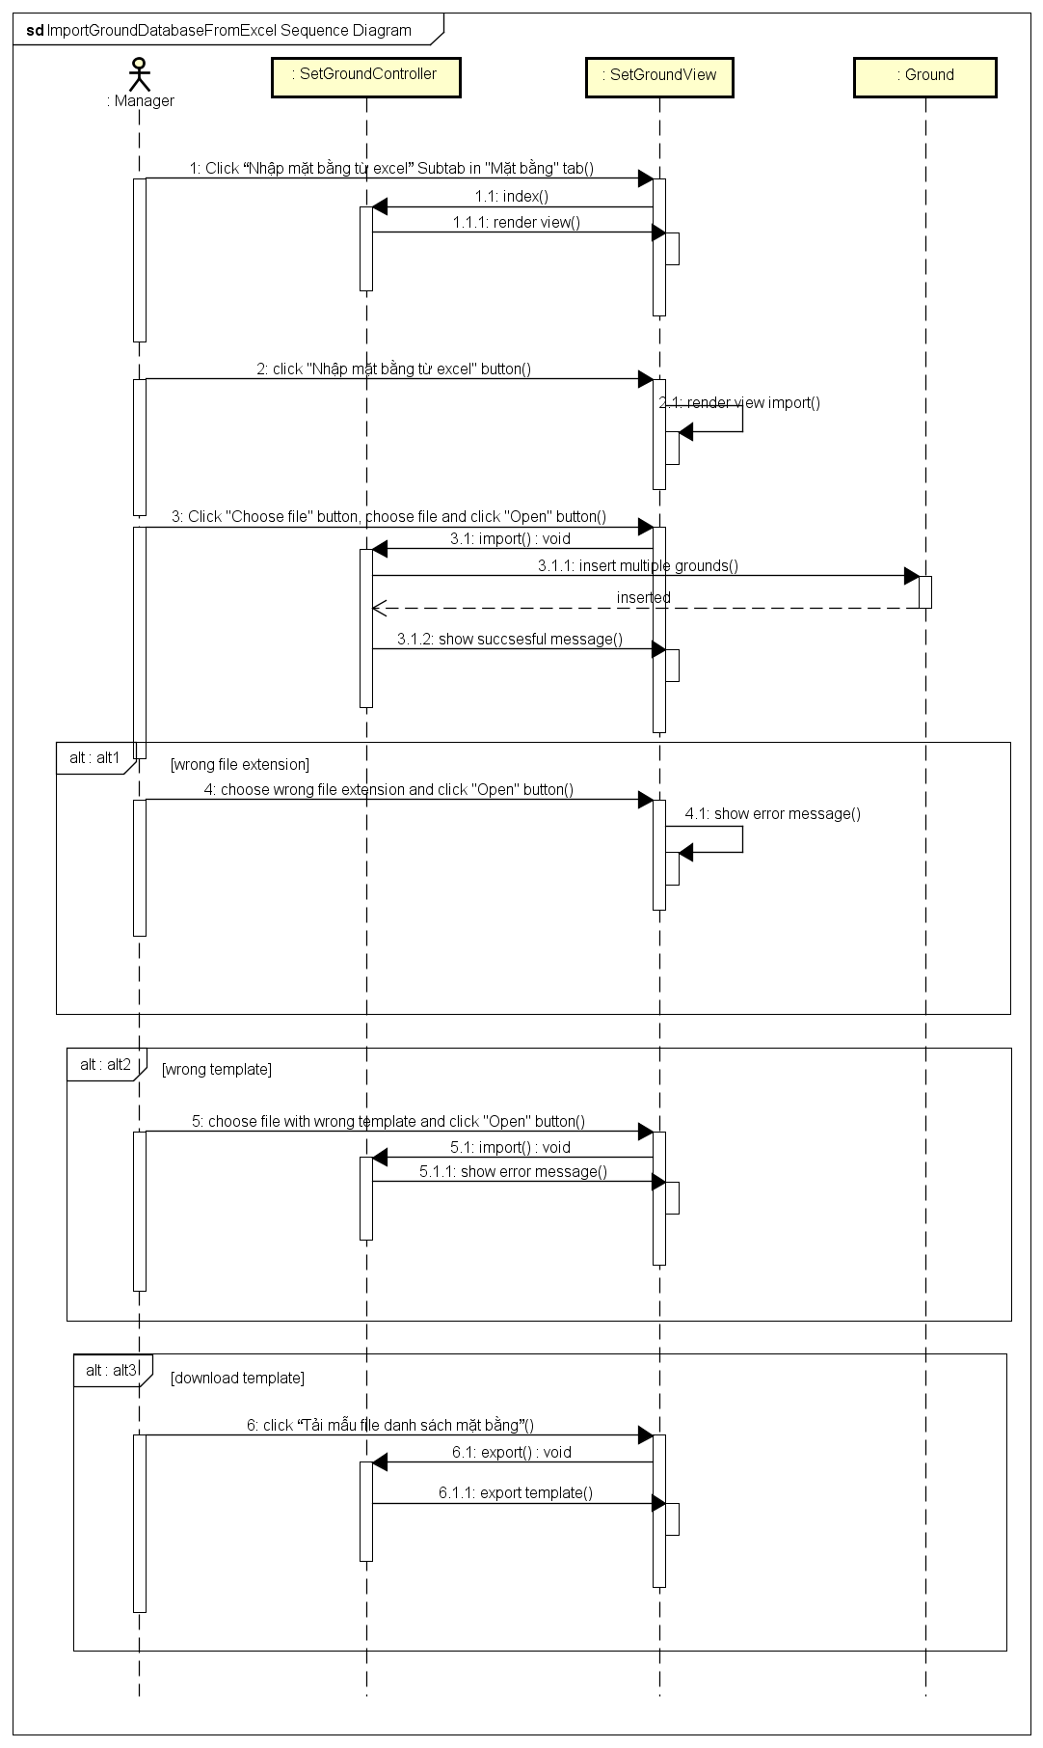

### Change owner

#### Description

Manager changes owner of the ground.

#### Design

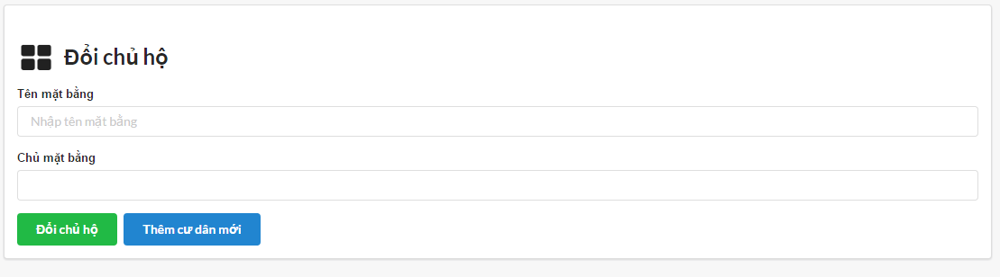

|  |  |  |
| --- | --- | --- |
| **Element** | **Type** | **Description** |
| Tên mặt bằng | Textbox | Ground name |
| Chủ mặt bằng | Textbox | Owner name |
| Đổi chủ hộ | Button | Button to change owner |
| Thêm cư dân mới | Button | Button to add new citizen |

#### Class Specifications

##### Function

|  |  |  |  |  |
| --- | --- | --- | --- | --- |
| **Class** | **SetGroundController** | | | |
| **Description** | Control all action relate to ground of a tower | | | |
| **Base Class** | ApplicationController | | | |
| **Source File** | setground_controller.rb | | | |
| **Namespace** | app/controllers/ | | | |
| **Attributes** | **N/A** | | | |
| **Methods** | **Name** | **Input** | **Output** | **Description** |
| index | Information input | void | Render view |
| Ground_owner | Information input | Void | Change owner of ground |
| payout | Information input | void | Pay finance of ground |

#### Class Diagram

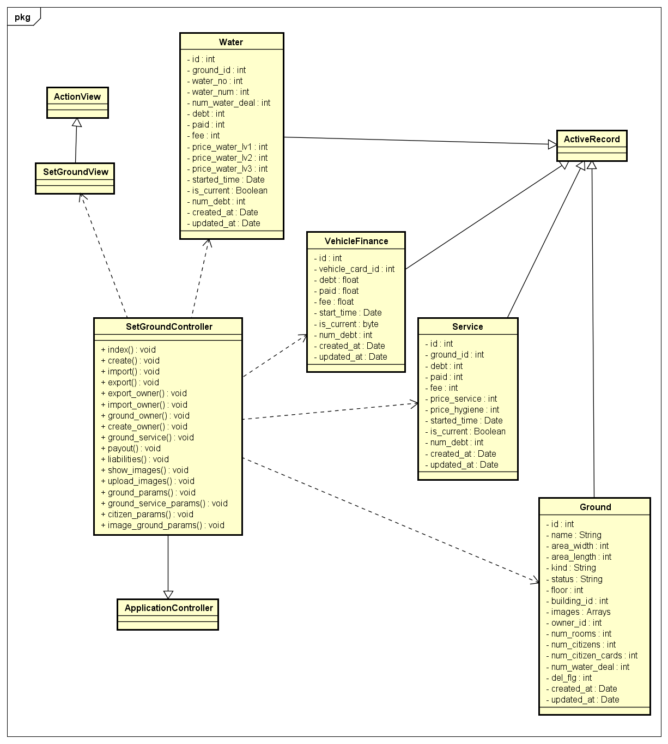

#### Sequence Diagram

### Import owner database from excel

#### Description

Manager imports multiple owners of ground from excel file

#### Design

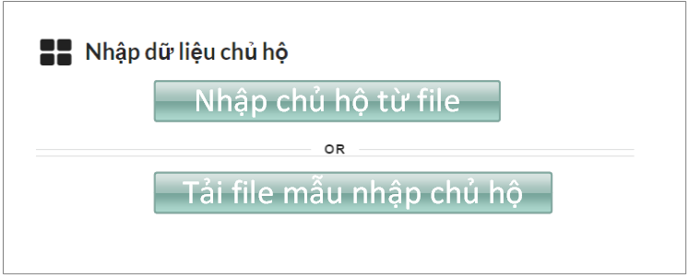

|  |  |  |
| --- | --- | --- |
| **Element** | **Type** | **Description** |
| Nhập chủ hộ từ file | Button | Button to import file |
| Tải file mẫu nhập chủ hộ | button | Button to download template |

#### Class Diagram

*Refer to class diagram of Add ground picture in 1.3.63 Add ground picture*

#### Class Specifications

##### Function

|  |  |  |  |  |
| --- | --- | --- | --- | --- |
| **Class** | **SetGroundController** | | | |
| **Description** | Control all action relate to ground of a tower | | | |
| **Base Class** | ApplicationController | | | |
| **Source File** | setground_controller.rb | | | |
| **Namespace** | app/controllers/ | | | |
| **Attributes** | **N/A** | | | |
| **Methods** | **Name** | **Input** | **Output** | **Description** |
| index | Information input | void | Render view |
| Import_owner | Information input | void | Import multiple owner from excel file |

#### Sequence Diagram

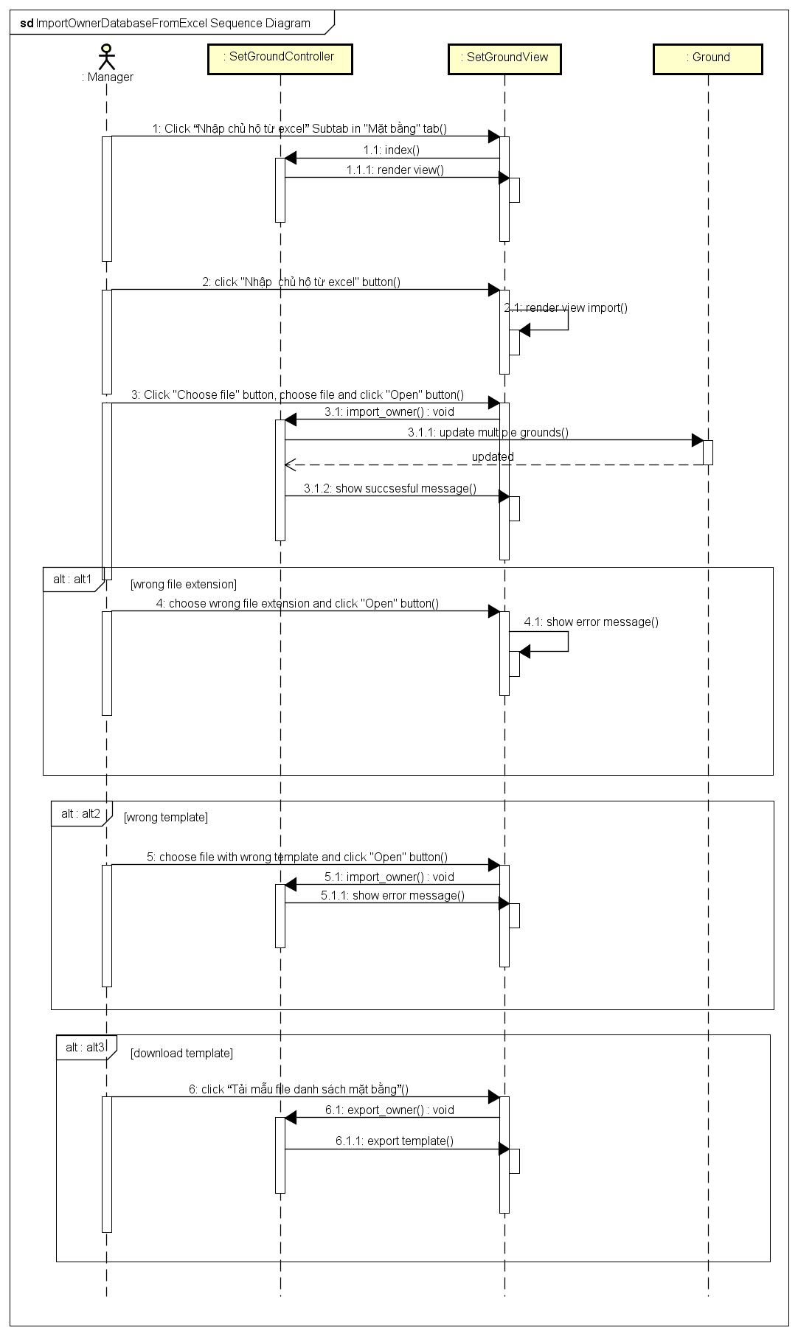

### Open – Close service

#### Description

Open or close service of a ground.

#### Design

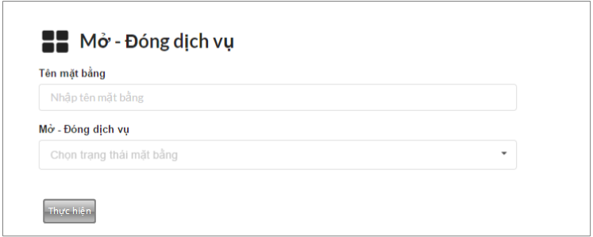

|  |  |  |
| --- | --- | --- |
| **Element** | **Type** | **Description** |
| Tên mặt bằng | Textbox | Ground name |
| Mở - Đóng dịch vụ | Dropbox | Open or close service |
| Thực hiện | button | Button to open-close service |

#### Class Diagram

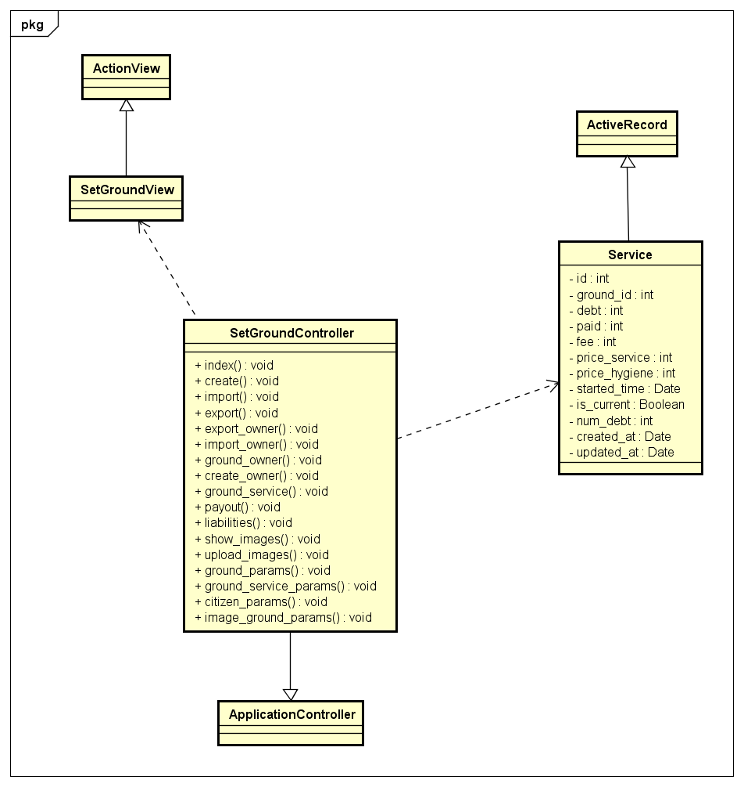

#### Class Specifications

##### Function

|  |  |  |  |  |
| --- | --- | --- | --- | --- |
| **Class** | **SetGroundController** | | | |
| **Description** | Control all action relate to ground of a tower | | | |
| **Base Class** | ApplicationController | | | |
| **Source File** | setground_controller.rb | | | |
| **Namespace** | app/controllers/ | | | |
| **Attributes** | **N/A** | | | |
| **Methods** | **Name** | **Input** | **Output** | **Description** |
| index | Information input | void | Render view |
| Ground_service | Information input | void | Open or close service of ground |

#### Sequence Diagram

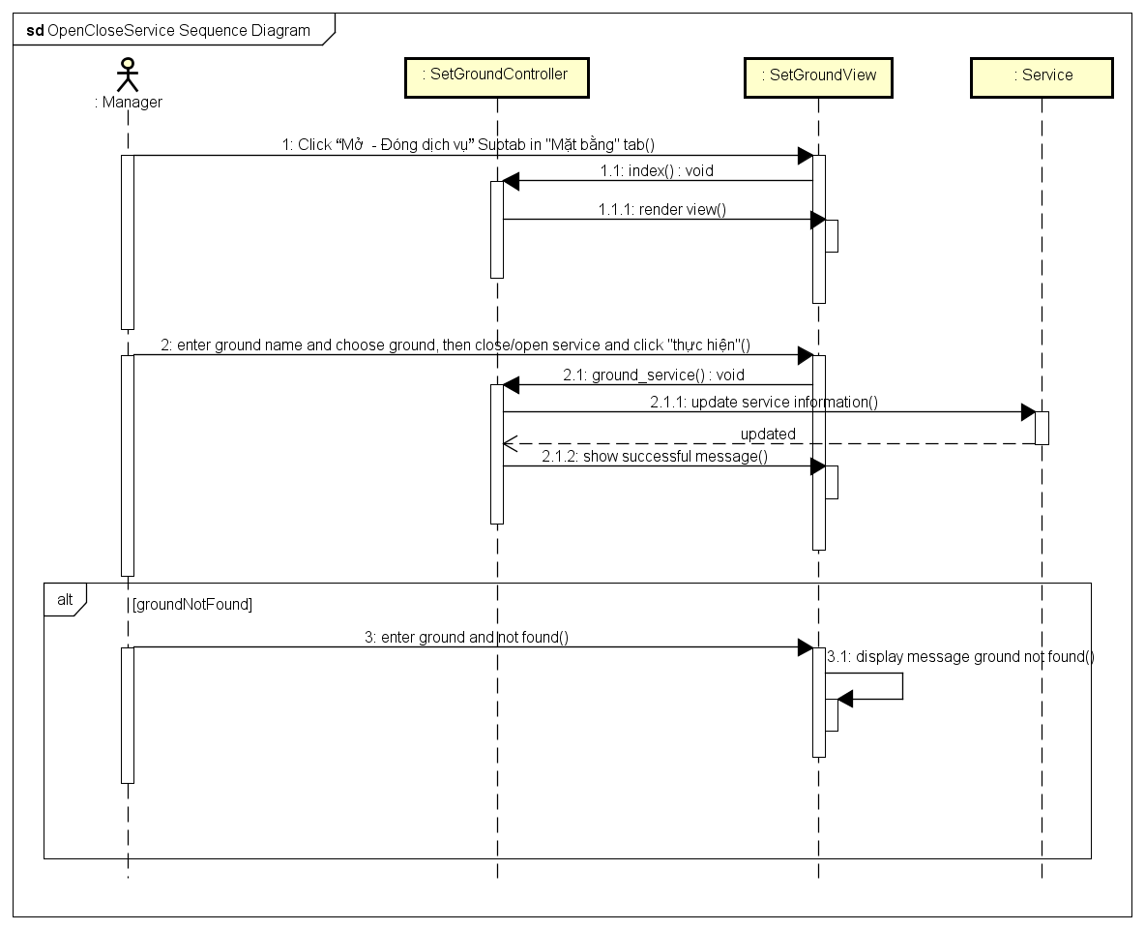

### See ground liabilities

#### Description

Manager sees all liabilities of a ground.

#### Design

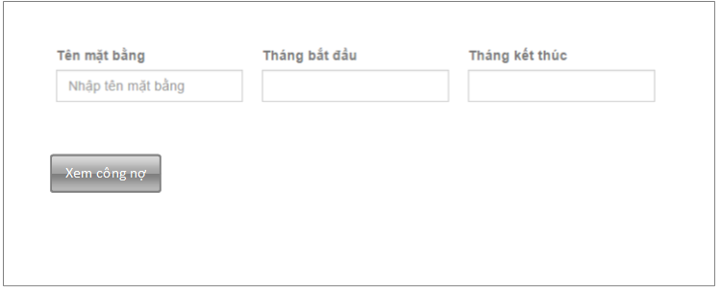

|  |  |  |
| --- | --- | --- |
| **Element** | **Type** | **Description** |
| Tên mặt bằng | Textbox | Ground name |
| Tháng bắt đầu | Textbox | Start month |
| Tháng kết thúc | Textbox | End month |
| Xem công nợ | Button | Button to see building liabilities |

#### Class Specifications

##### Function

|  |  |  |  |  |
| --- | --- | --- | --- | --- |
| **Class** | **SetGroundController** | | | |
| **Description** | Control all action relate to ground of a tower | | | |
| **Base Class** | ApplicationController | | | |
| **Source File** | setground_controller.rb | | | |
| **Namespace** | app/controllers/ | | | |
| **Attributes** | **N/A** | | | |
| **Methods** | **Name** | **Input** | **Output** | **Description** |
| index | Information input | void | Render view |
| libialities | Information input | void | Get all libialities of ground and render view |
| Libialities_ground_summary | Information input | Void | Export liabilities report |

#### Class Diagram

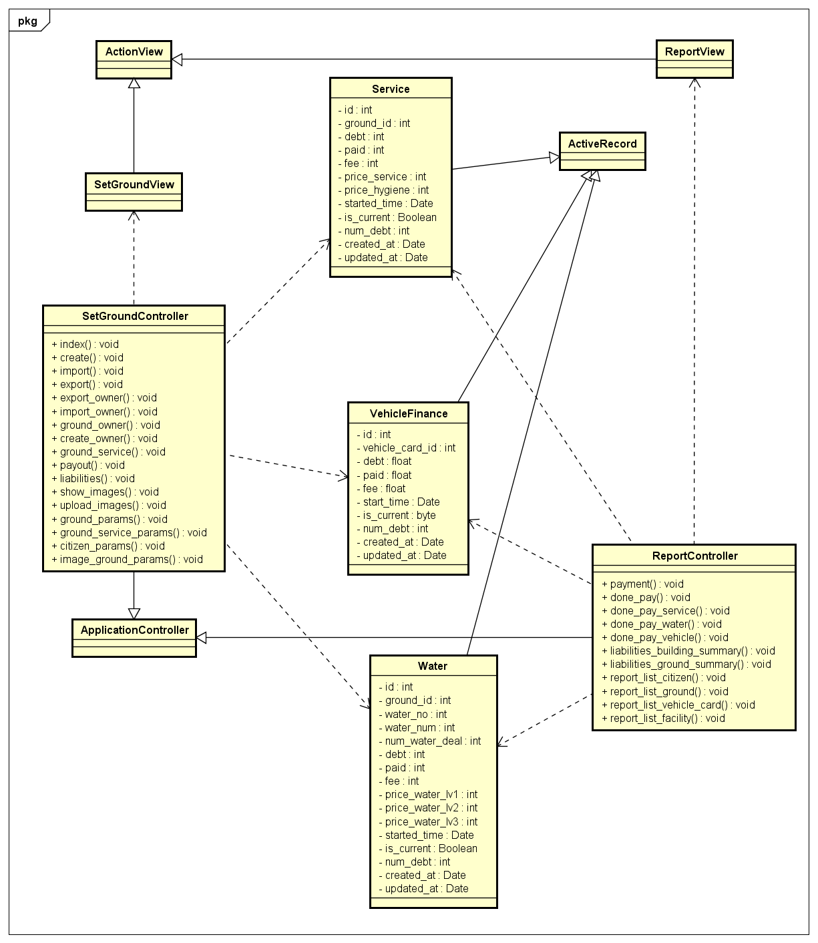

#### Sequence Diagram

### Owner history

#### Description

View all owner history of ground: come or go, time, ground name.

#### Design

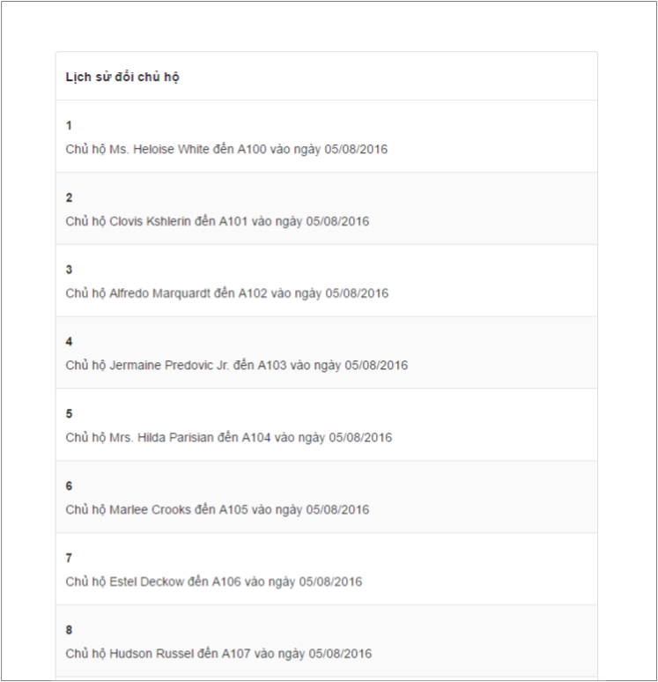

|  |  |  |
| --- | --- | --- |
| **Element** | **Type** | **Description** |
| Table result | Table | Table list owner history |

#### Class Diagram

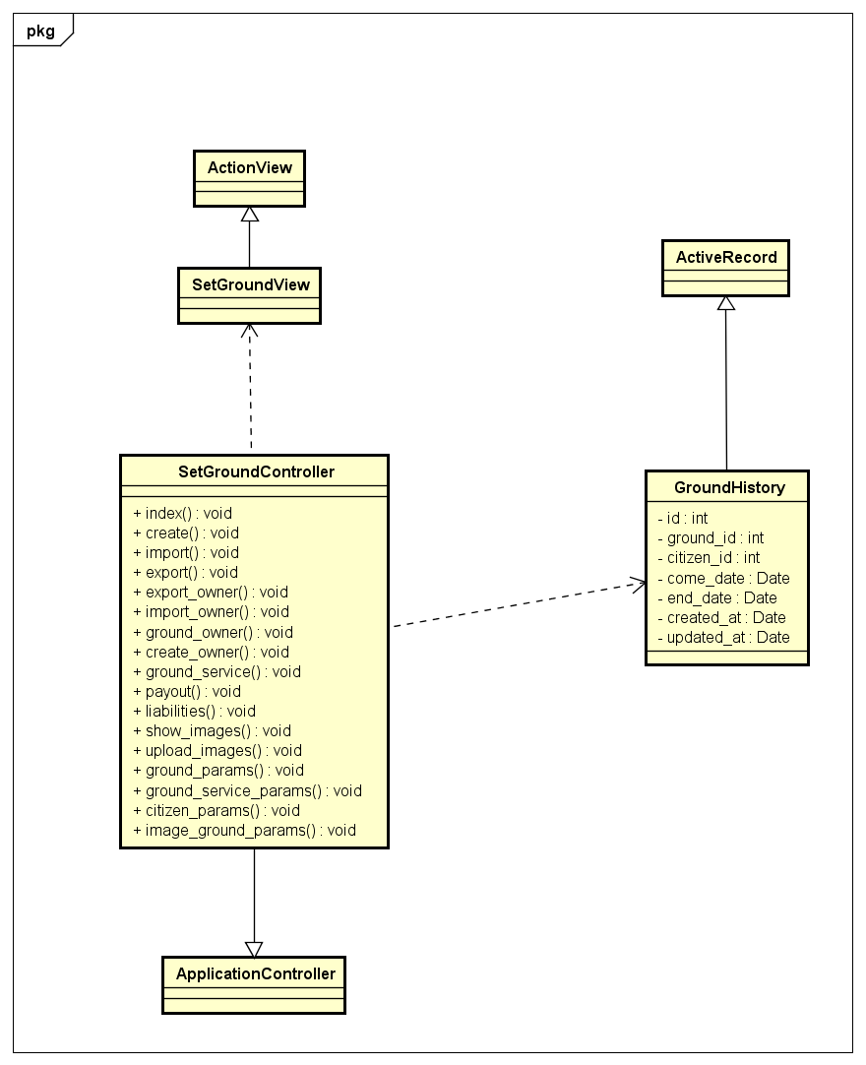

#### Class Specifications

##### Function

|  |  |  |  |  |
| --- | --- | --- | --- | --- |
| **Class** | **SetGroundController** | | | |
| **Description** | Control all action relate to ground of a tower | | | |
| **Base Class** | ApplicationController | | | |
| **Source File** | setground_controller.rb | | | |
| **Namespace** | app/controllers/ | | | |
| **Attributes** | **N/A** | | | |
| **Methods** | **Name** | **Input** | **Output** | **Description** |
| index | Information input | void | Get all owner history and render view |

#### Sequence Diagram

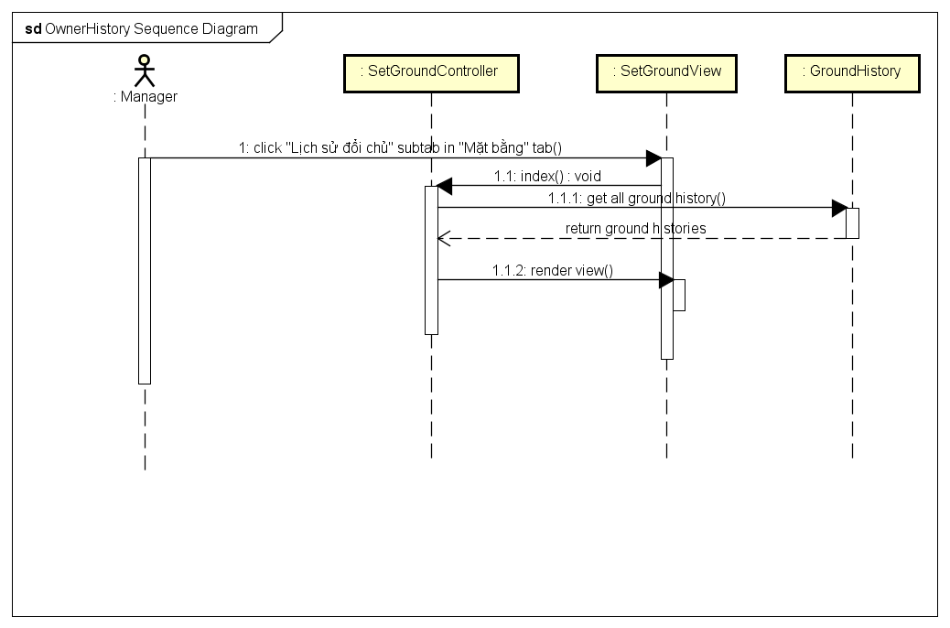

### Owner history detail

#### Description

See owner history record detaily.

#### Design

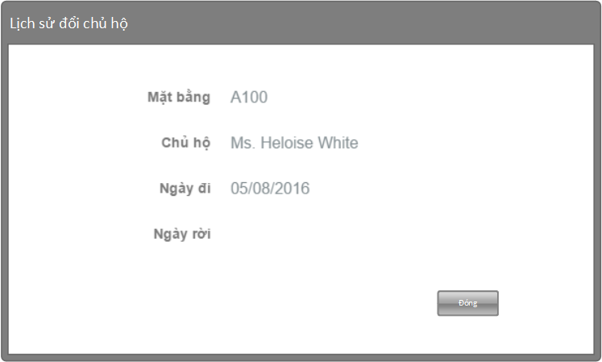

|  |  |  |
| --- | --- | --- |
| **Element** | **Type** | **Description** |
| Mặt bằng | Textbox | Ground name |
| Chủ hộ | Textbox | Owner name |
| Ngày đi | Textbox | Come date |
| Ngày rời | Textbox | End date |
| Đóng | Button | Button to close |

#### Class Diagram

*Refer to class diagram of Owner history in 1.3.69 Owner history*

#### Class Specifications

##### Function

|  |  |  |  |  |
| --- | --- | --- | --- | --- |
| **Class** | **SetGroundController** | | | |
| **Description** | Control all action relate to ground of a tower | | | |
| **Base Class** | ApplicationController | | | |
| **Source File** | setground_controller.rb | | | |
| **Namespace** | app/controllers/ | | | |
| **Attributes** | **N/A** | | | |
| **Methods** | **Name** | **Input** | **Output** | **Description** |
| index | Information input | void | Render view detail owner history |

#### Sequence Diagram

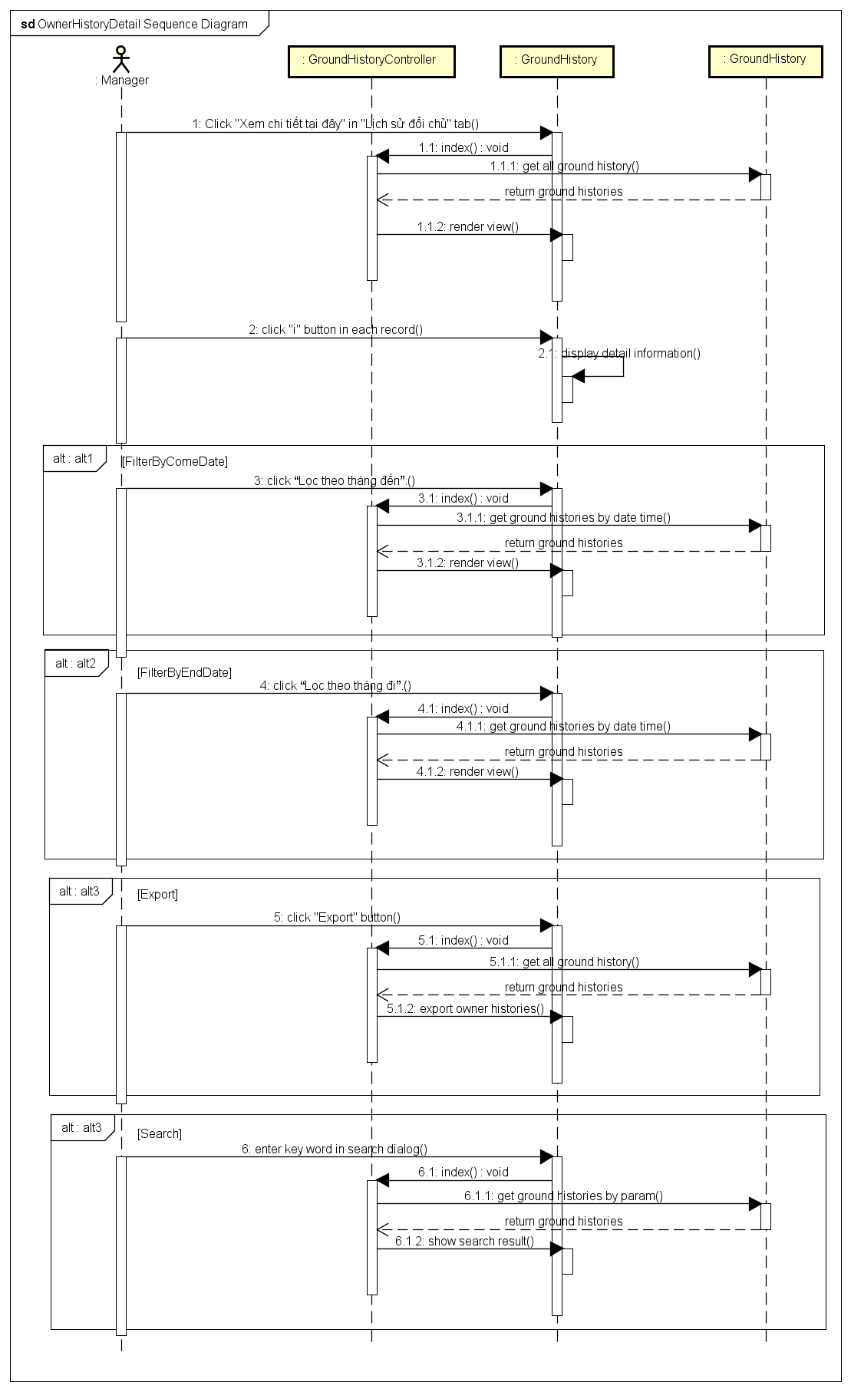

### Import citizen database from excel

#### Description

Manager imports multiple citizens from excel file.

#### Design

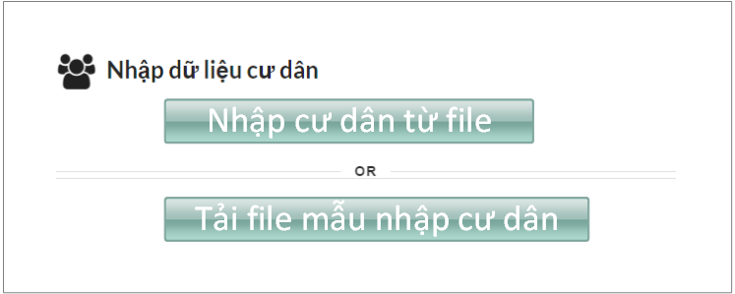

|  |  |  |
| --- | --- | --- |
| **Element** | **Type** | **Description** |
| Nhập cư dân từ file | Button | Button to import file |
| Tải file mẫu nhập cư dân | button | Button to download template |

#### Class Diagram

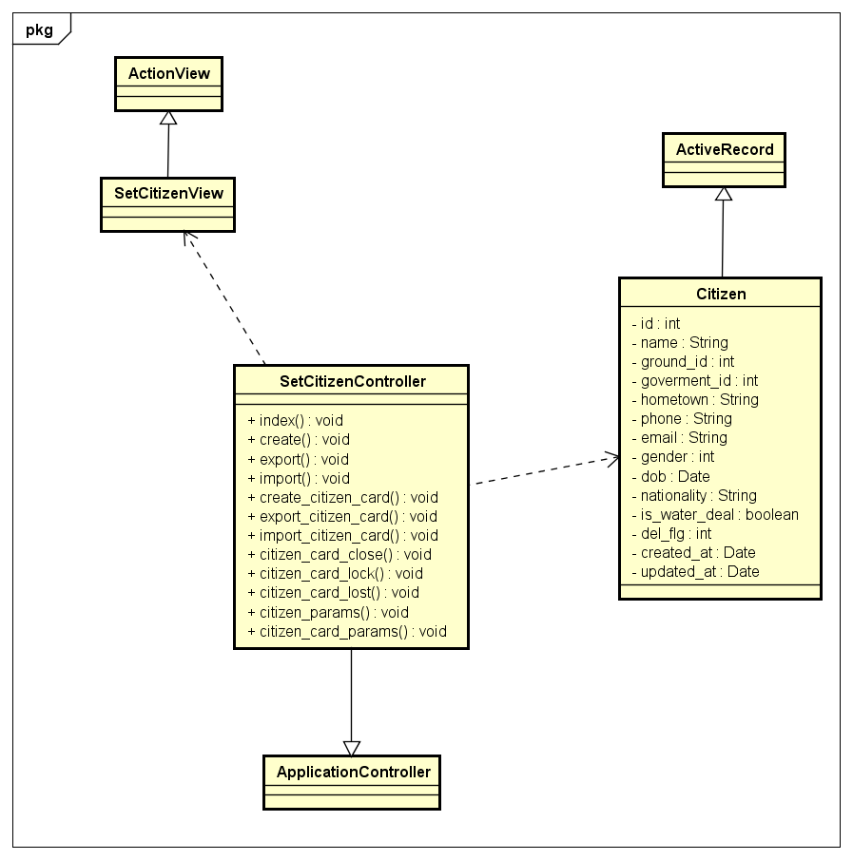

#### Class Specifications

##### Function

|  |  |  |  |  |
| --- | --- | --- | --- | --- |
| **Class** | **SetCitizenController** | | | |
| **Description** | Control all action relate to citizen of a tower | | | |
| **Base Class** | ApplicationController | | | |
| **Source File** | setcitizen_controller.rb | | | |
| **Namespace** | app/controllers/ | | | |
| **Attributes** | **N/A** | | | |
| **Methods** | **Name** | **Input** | **Output** | **Description** |
| index | Information input | void | Render view |
| import | Information input | Void | Import multiple citizen from excel file |

#### Sequence Diagram

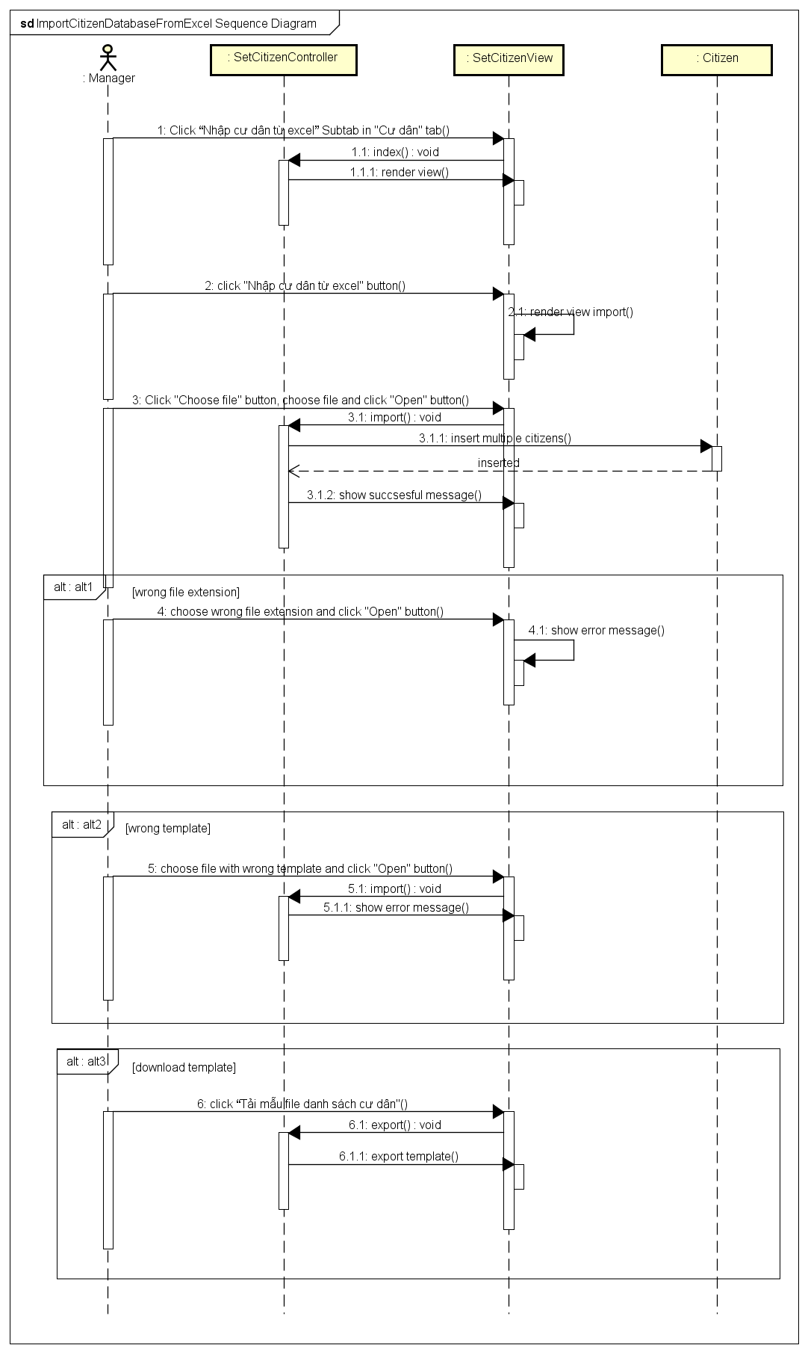

### Import citizen card database from excel

#### Description

Manager imports multiple citizen cards from excel file.

#### Design

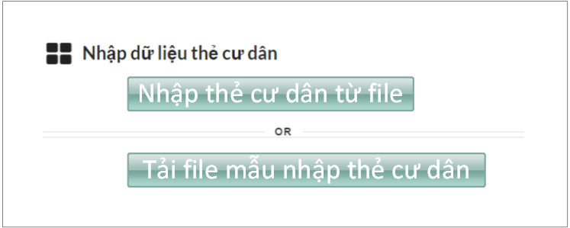

|  |  |  |
| --- | --- | --- |
| **Element** | **Type** | **Description** |
| Nhập thẻ cư dân từ file | Button | Button to import file |
| Tải file mẫu nhập thẻ cư dân | button | Button to download template |

#### Class Diagram

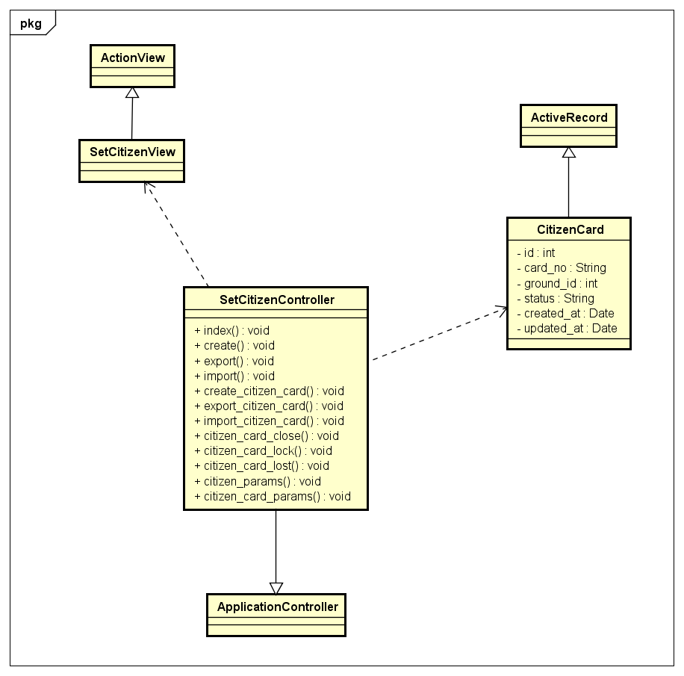

#### Class Specifications

##### Function

|  |  |  |  |  |
| --- | --- | --- | --- | --- |
| **Class** | **SetCitizenController** | | | |
| **Description** | Control all action relate to citizen of a tower | | | |
| **Base Class** | ApplicationController | | | |
| **Source File** | setcitizen_controller.rb | | | |
| **Namespace** | app/controllers/ | | | |
| **Attributes** | **N/A** | | | |
| **Methods** | **Name** | **Input** | **Output** | **Description** |
| index | Information input | void | Render view |
| Import_citizen_card | Information input | void | Import multiple citizen cards from excel file |

#### Sequence Diagram

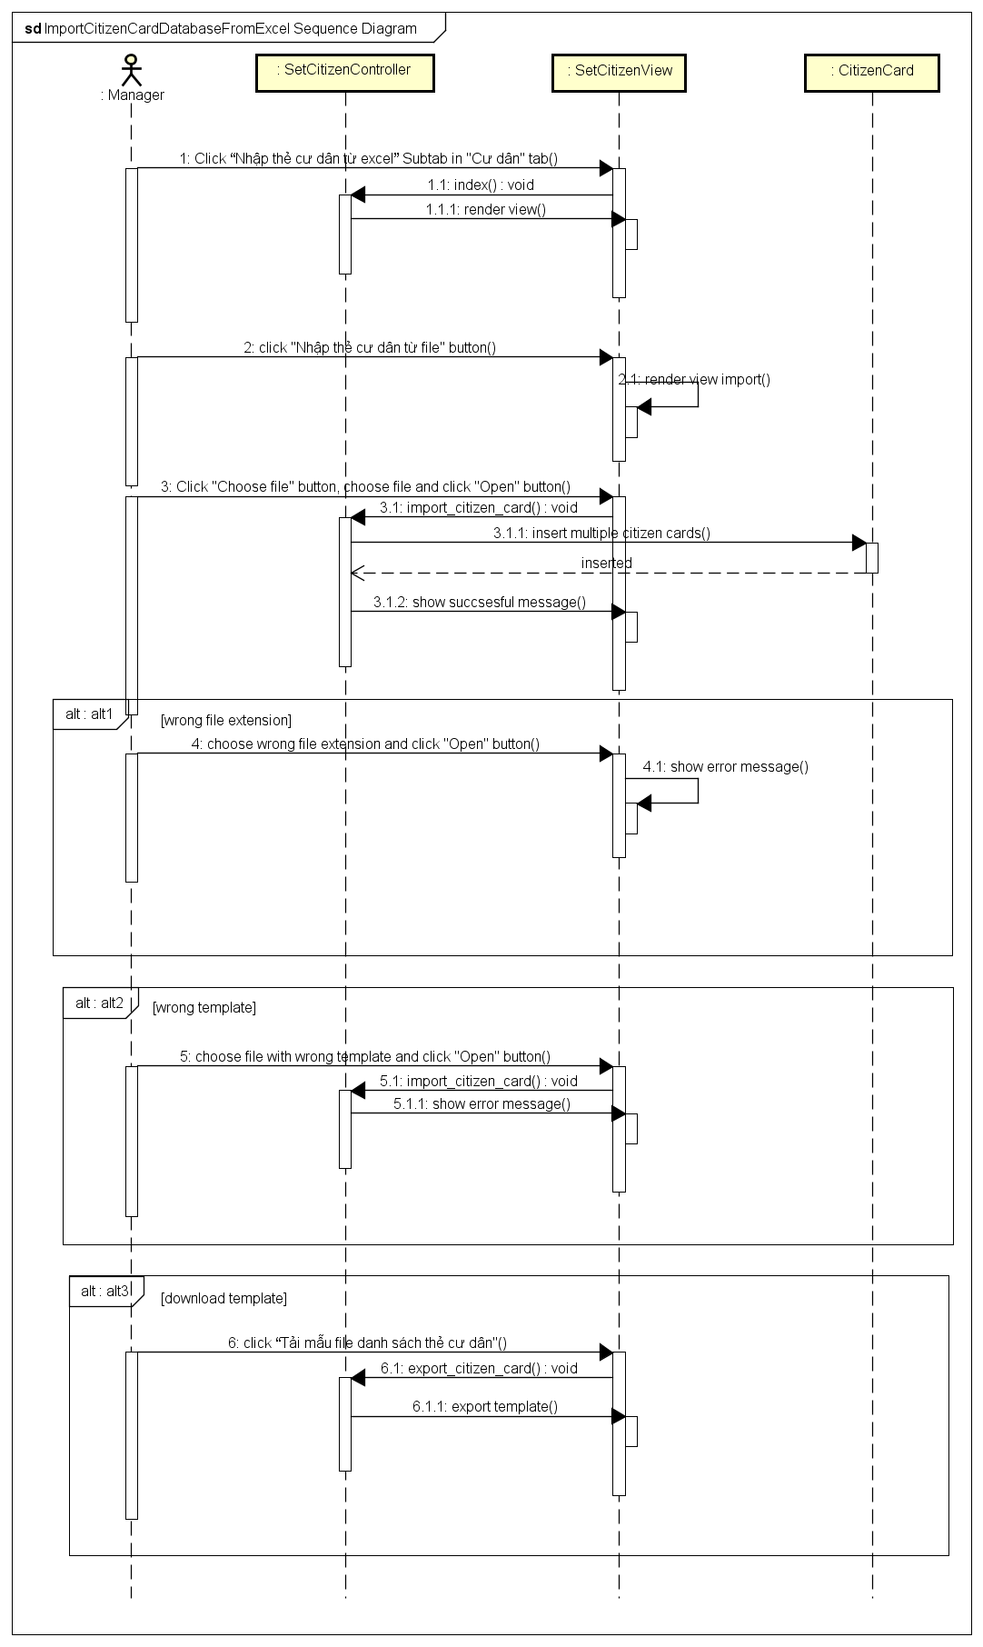

### Lock – Lost citizen card

#### Description

Manager locks or closes a citizen card.

#### Design

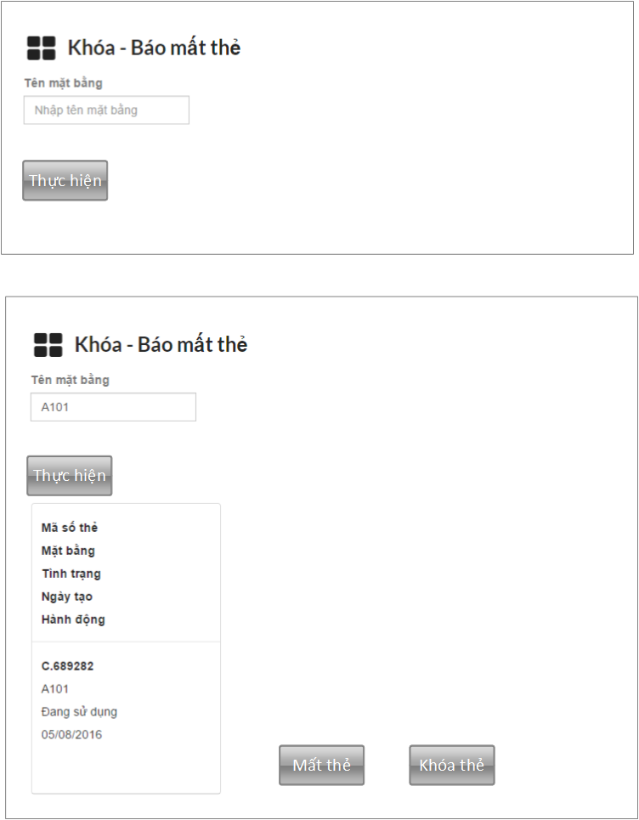

|  |  |  |
| --- | --- | --- |
| **Element** | **Type** | **Description** |
| Tên mặt bằng | Textbox | Ground name |
| Thực hiện | Button | Button to lock or lost |
| Table result | Table | Detail citizen card information |
| Mất thẻ | Button | Button to close citizen card |
| Khóa thẻ | Button | Button to lock citizen card |

#### Class Diagram

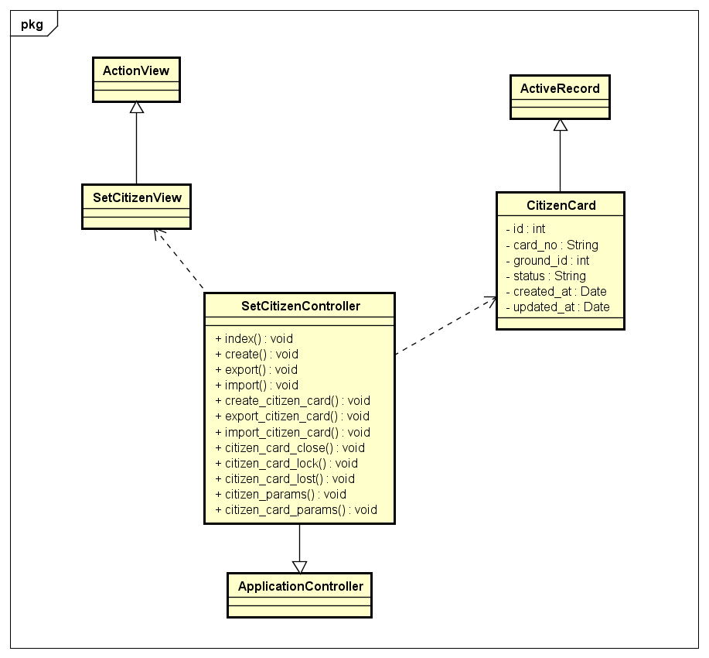

#### Class Specifications

##### Function

|  |  |  |  |  |
| --- | --- | --- | --- | --- |
| **Class** | **SetCitizenCardController** | | | |
| **Description** | Control all action relate to citizen of a tower | | | |
| **Base Class** | ApplicationController | | | |
| **Source File** | setcitizen_controller.rb | | | |
| **Namespace** | app/controllers/ | | | |
| **Attributes** | **N/A** | | | |
| **Methods** | **Name** | **Input** | **Output** | **Description** |
| index | Information input | void | Render view |
| Citizen_card_close | Information input | Void | Get citizen card information and render view |
| Citizen_card_lock | Information input | Void | Close citizen card |
| Citizen_card_lost | Information input | Void | Lock citizen card |

#### Sequence Diagram

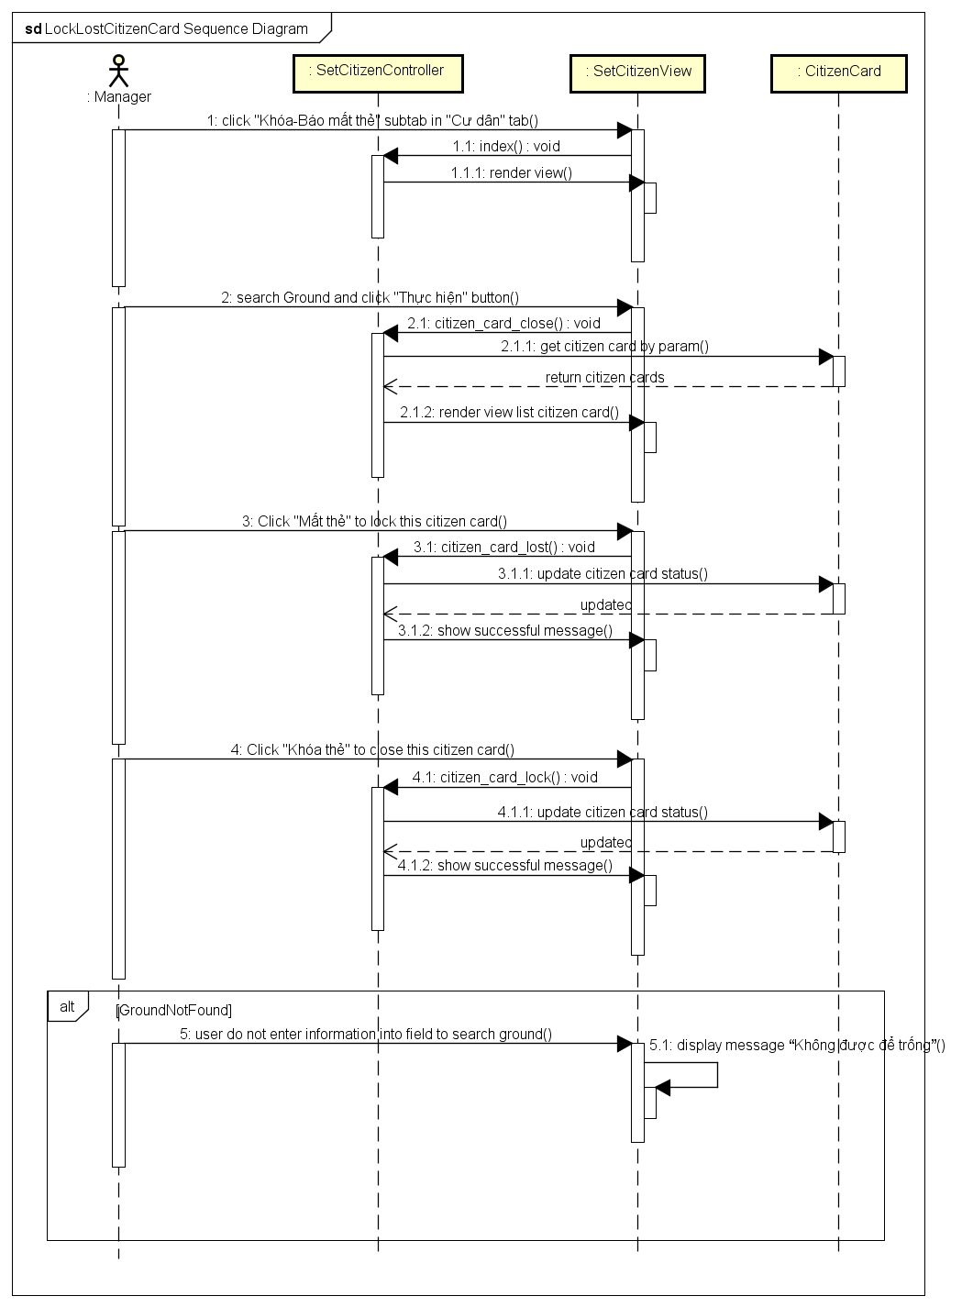

### Import Vehicle Card database from excel

#### Description

Manager imports multiple vehicle cards from excel file.

#### Design

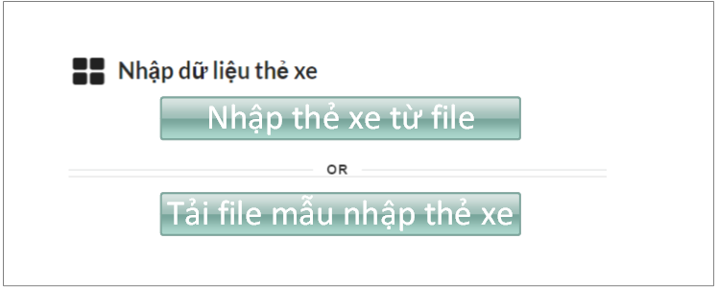

|  |  |  |
| --- | --- | --- |
| **Element** | **Type** | **Description** |
| Nhập thẻ xe từ file | Button | Button to import file |
| Tải file mẫu nhập thẻ xe | button | Button to download template |

#### Class Diagram

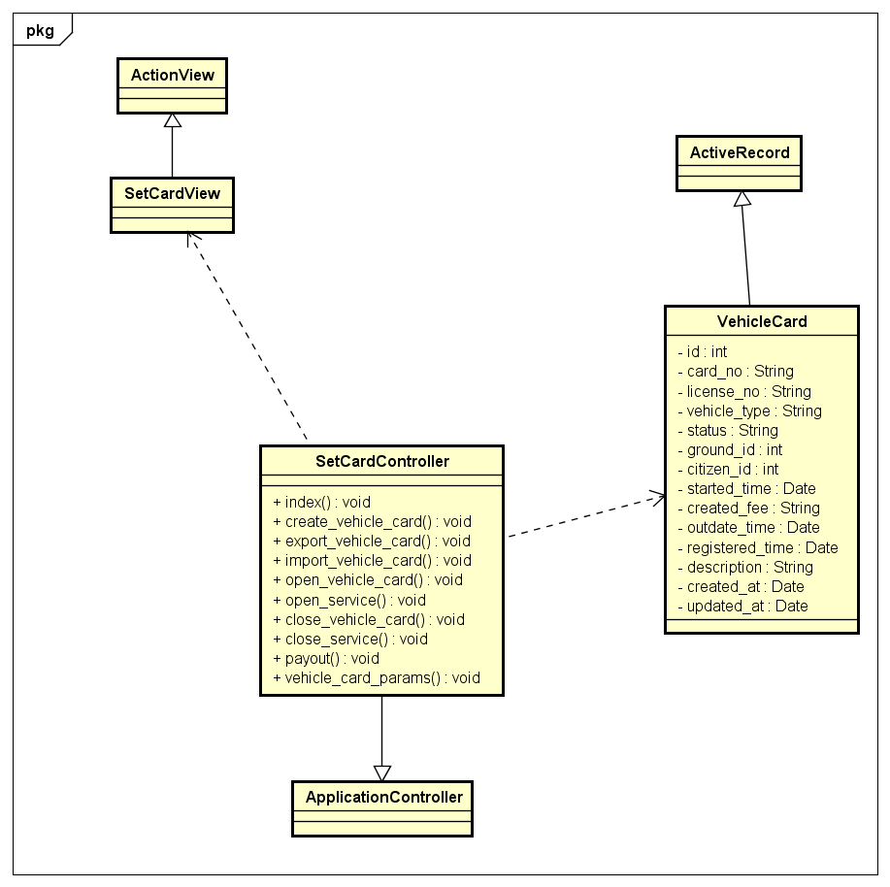

#### Class Specifications

##### Function

|  |  |  |  |  |
| --- | --- | --- | --- | --- |
| **Class** | **SetCardController** | | | |
| **Description** | Control all action relate to vehicle card of a tower | | | |
| **Base Class** | ApplicationController | | | |
| **Source File** | setcard_controller.rb | | | |
| **Namespace** | app/controllers/ | | | |
| **Attributes** | **N/A** | | | |
| **Methods** | **Name** | **Input** | **Output** | **Description** |
| index | Information input | void | Render view |
| Import_vehicle_card | Information input | void | Import multiple vehicle card from excel file. |

#### Sequence Diagram

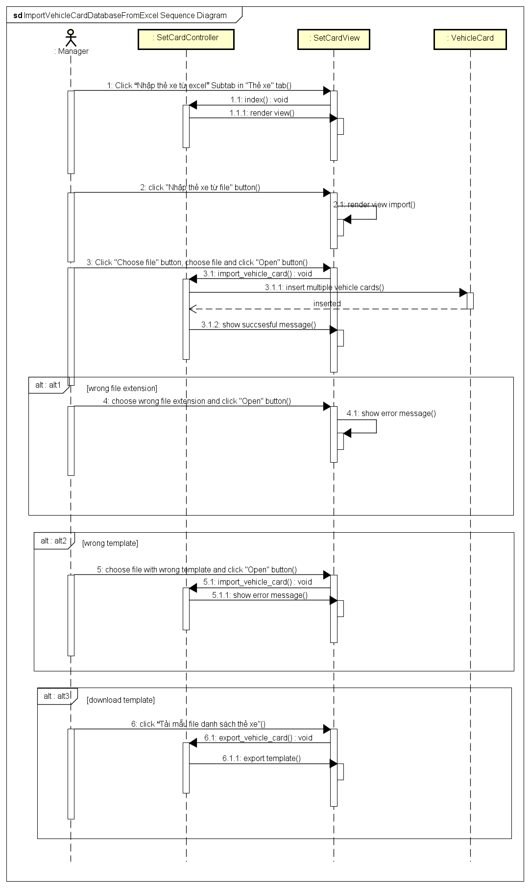

### Open vehicle card service

#### Description

Open vehicle card service for a ground.

#### Design

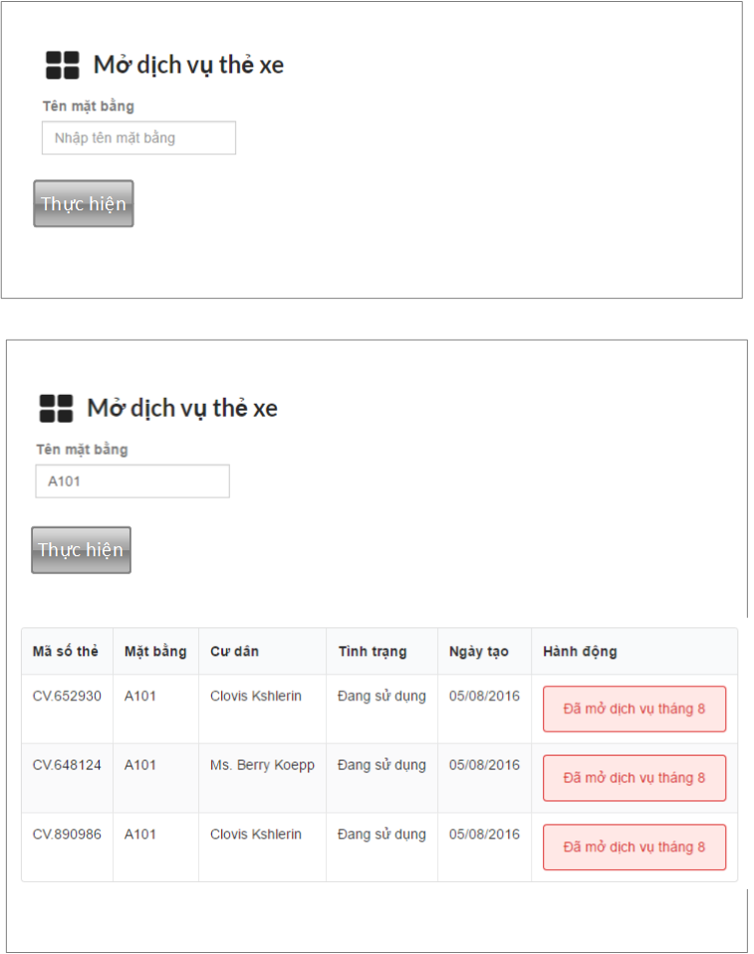

|  |  |  |
| --- | --- | --- |
| **Element** | **Type** | **Description** |
| Tên mặt bằng | Textbox | Ground name |
| Thực hiện | Button | Button to see service of this ground |
| Table result | Table | Display all service of this ground |
| Hành động | Button/textbox | Button to open service/display message |

#### Class Diagram

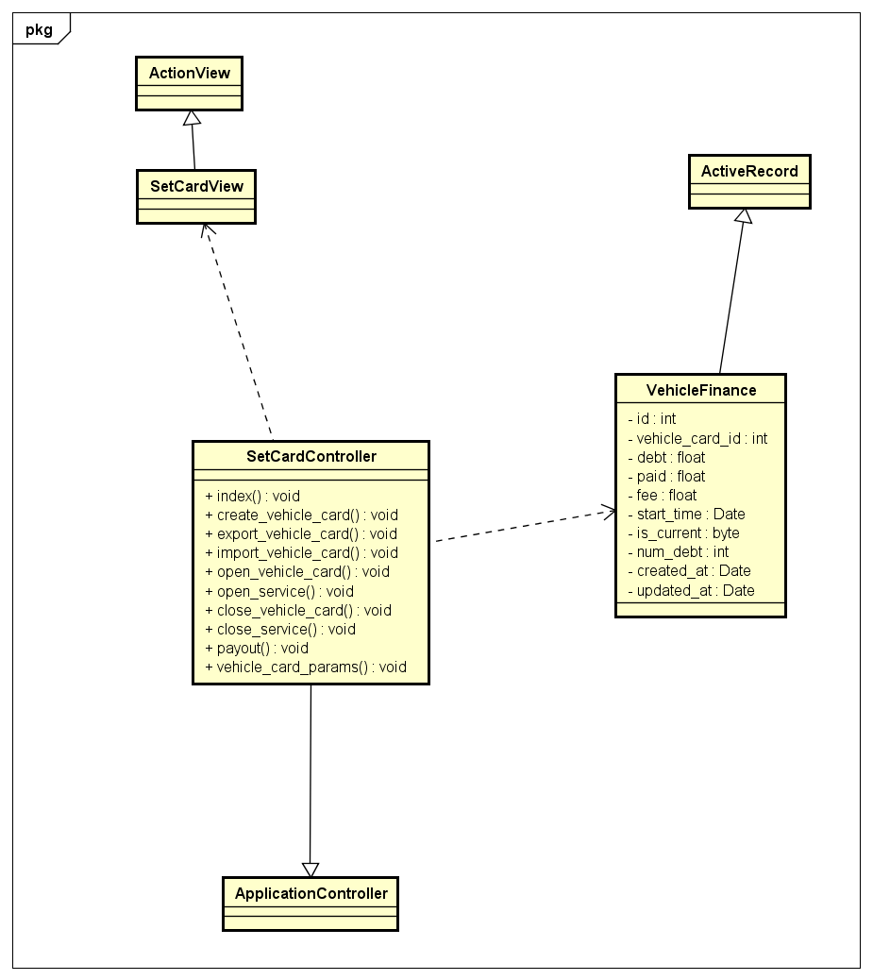

#### Class Specifications

##### Function

|  |  |  |  |  |
| --- | --- | --- | --- | --- |
| **Class** | **SetCardController** | | | |
| **Description** | Control all action relate to vehicle card of a tower | | | |
| **Base Class** | ApplicationController | | | |
| **Source File** | setcard_controller.rb | | | |
| **Namespace** | app/controllers/ | | | |
| **Attributes** | **N/A** | | | |
| **Methods** | **Name** | **Input** | **Output** | **Description** |
| index | Information input | void | Render view |
| Open_service | Information input | void | Open vehicle card service for ground |

#### Sequence Diagram

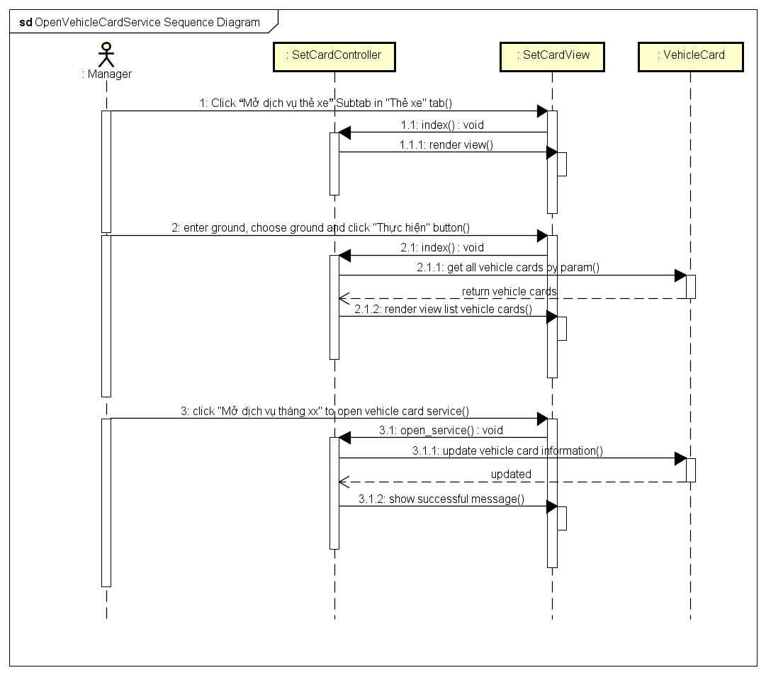

### Lock – Lost vehicle card

#### Description

Lock or close vehicle card of the ground

#### Design

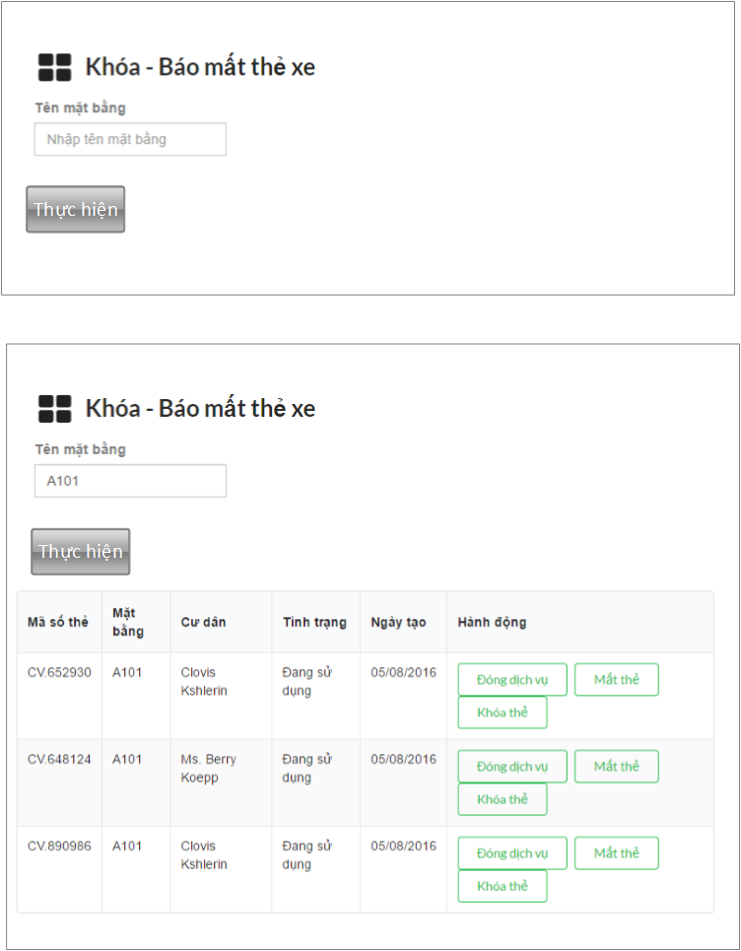

|  |  |  |
| --- | --- | --- |
| **Element** | **Type** | **Description** |
| Tên mặt bằng | Textbox | Ground name |
| Thực hiện | Button | Button to lock or lost |
| Table result | Table | Detail vehicle card information |
| Đóng dịch vụ | Button | Button to close vehicle service |
| Mất thẻ | Button | Button to close vehicle card |
| Khóa thẻ | Button | Button to lock vehicle card |

#### Class Diagram

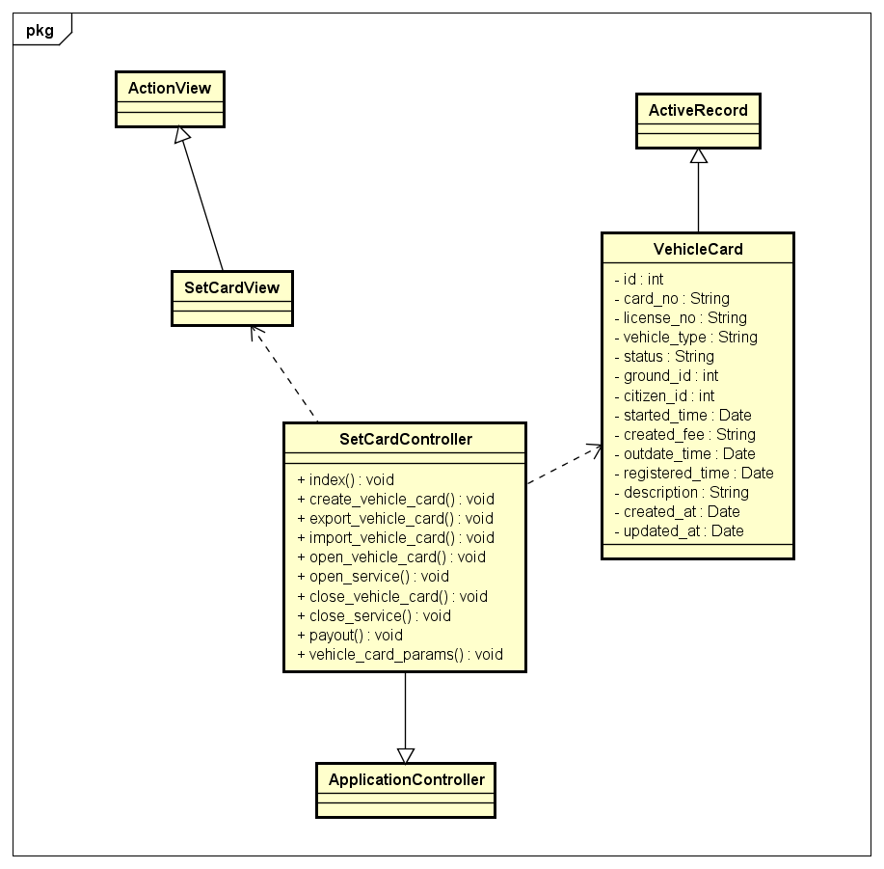

#### Class Specifications

##### Function

|  |  |  |  |  |
| --- | --- | --- | --- | --- |
| **Class** | **SetCardController** | | | |
| **Description** | Control all action relate to vehicle card of a tower | | | |
| **Base Class** | ApplicationController | | | |
| **Source File** | setcard_controller.rb | | | |
| **Namespace** | app/controllers/ | | | |
| **Attributes** | **N/A** | | | |
| **Methods** | **Name** | **Input** | **Output** | **Description** |
| index | Information input | void | Render view |
| Close_service | Information input | Void | Close vehicle card service or lock , close vehicle card. |

#### Sequence Diagram

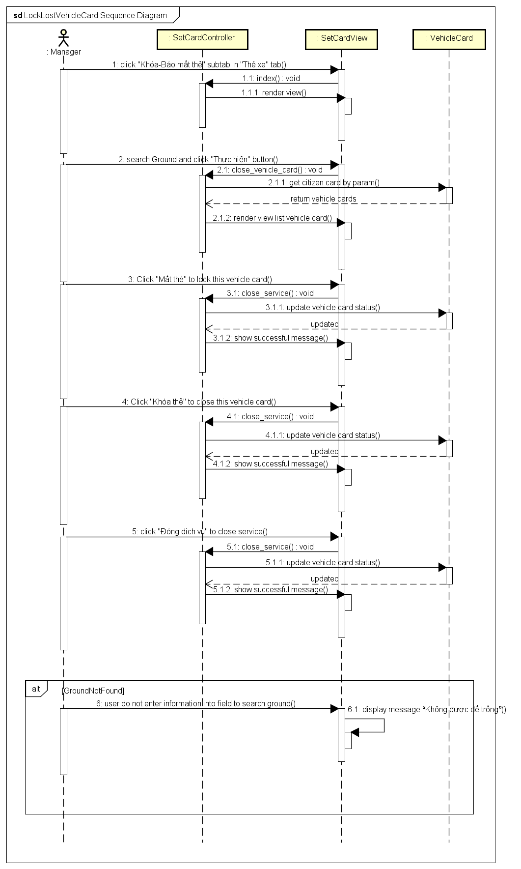

### Send announcement via email

#### Description

Manager sends mail to citizen of tower.

#### Design

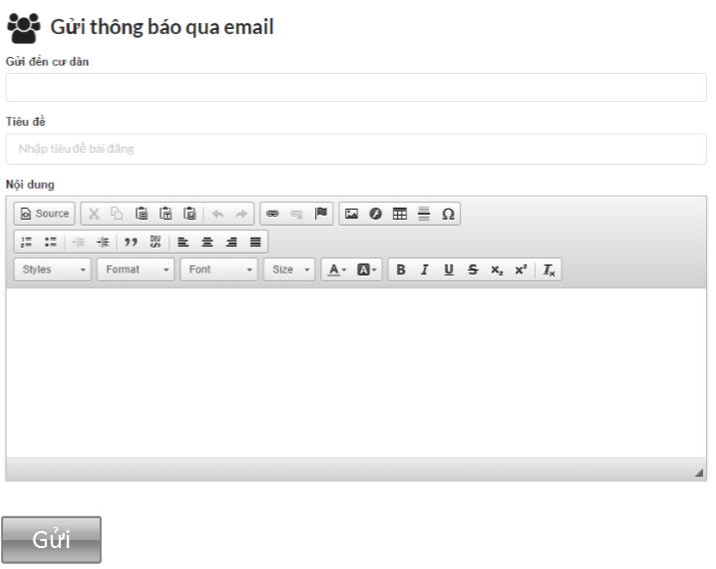

|  |  |  |
| --- | --- | --- |
| **Element** | **Type** | **Description** |
| Gửi đến cư dân | Textbox | Email of citizen |
| Tiêu đề | Textbox | Title of email |
| Nội dung | Textbox | Content of email |
| Gửi | Button | Button to send mail |

#### Class Diagram

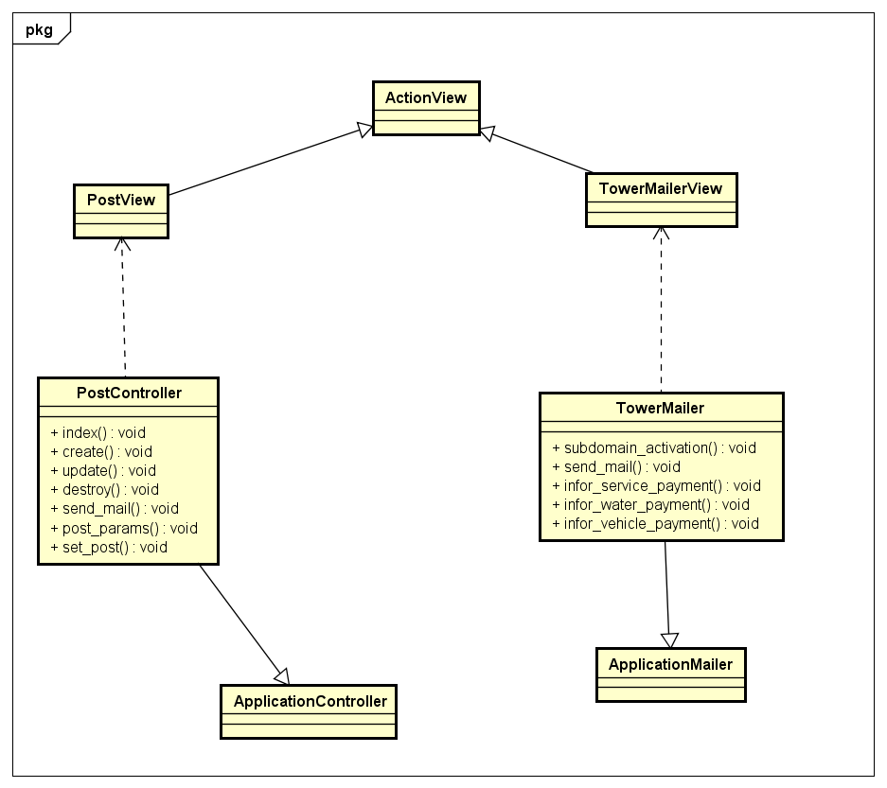

#### Class Specifications

##### Function

|  |  |  |  |  |
| --- | --- | --- | --- | --- |
| **Class** | **TowerMailer** | | | |
| **Description** | Control all action relate to email | | | |
| **Base Class** | ApplicationMailer | | | |
| **Source File** | tower_mailer.rb | | | |
| **Namespace** | app/mailers/ | | | |
| **Attributes** | **N/A** | | | |
| **Methods** | **Name** | **Input** | **Output** | **Description** |
| index | Information input | void | Render view |
| Send_mail | Information input | Void | Send mail |

#### Sequence Diagram

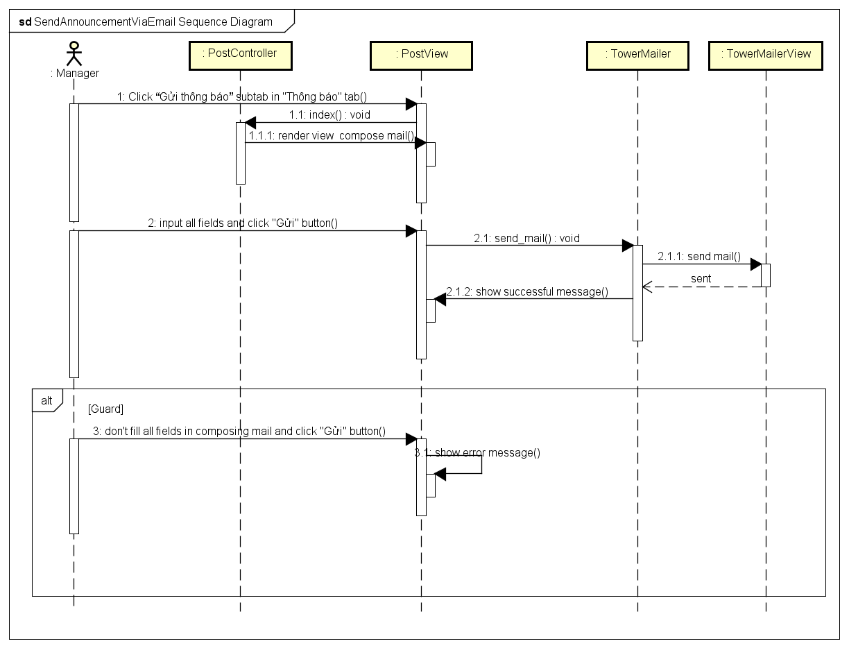

### Financial Setting

#### Description

Configure all financial parameter.

#### Design

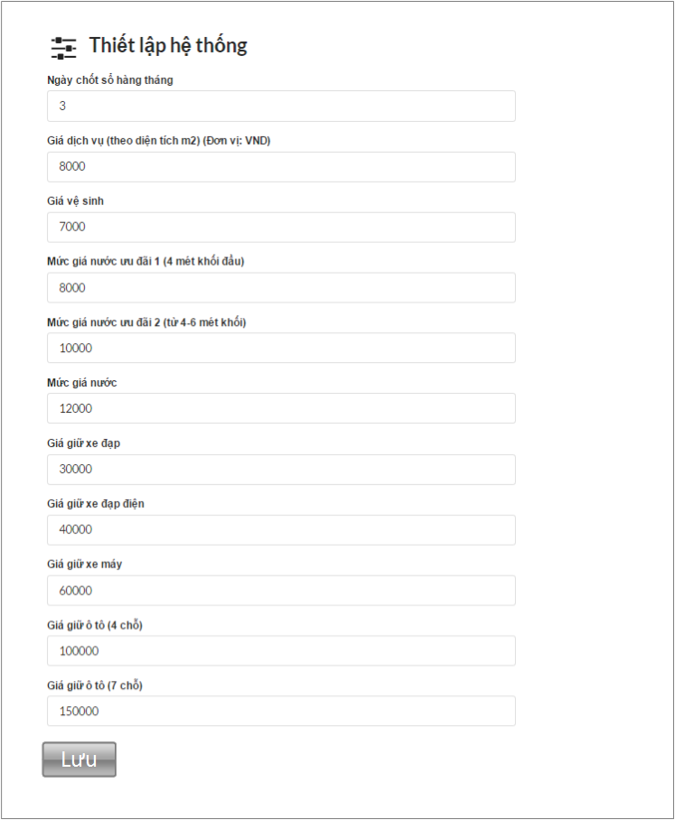

|  |  |  |
| --- | --- | --- |
| **Element** | **Type** | **Description** |
| Ngày chốt sổ hàng tháng | Textbox | Date closing |
| Giá dịch vụ | Textbox | Service price |
| Giá vệ sinh | Textbox | Sanitary price |
| Mức giá nước ưu đãi 1 | Textbox | Type 1 water deal price |
| Mức giá nước ưu đãi 2 | Textbox | Type 2 water deal price |
| Mức giá nước | Textbox | Water price |
| Giá giữ xe đạp | Textbox | Bicycle holder price |
| Giá giữ xe đạp điện | Textbox | Electic bicycle holder price |
| Giá giữ xe máy | Textbox | Motorbike holder price |
| Giá giữ ô tô (4 chỗ) | Textbox | 4 seats car holder price |
| Giá giữ ô tô (7 chỗ) | Textbox | 7 seats car holder price |
| Lưu | Button | Button to save setting |

#### Class Diagram

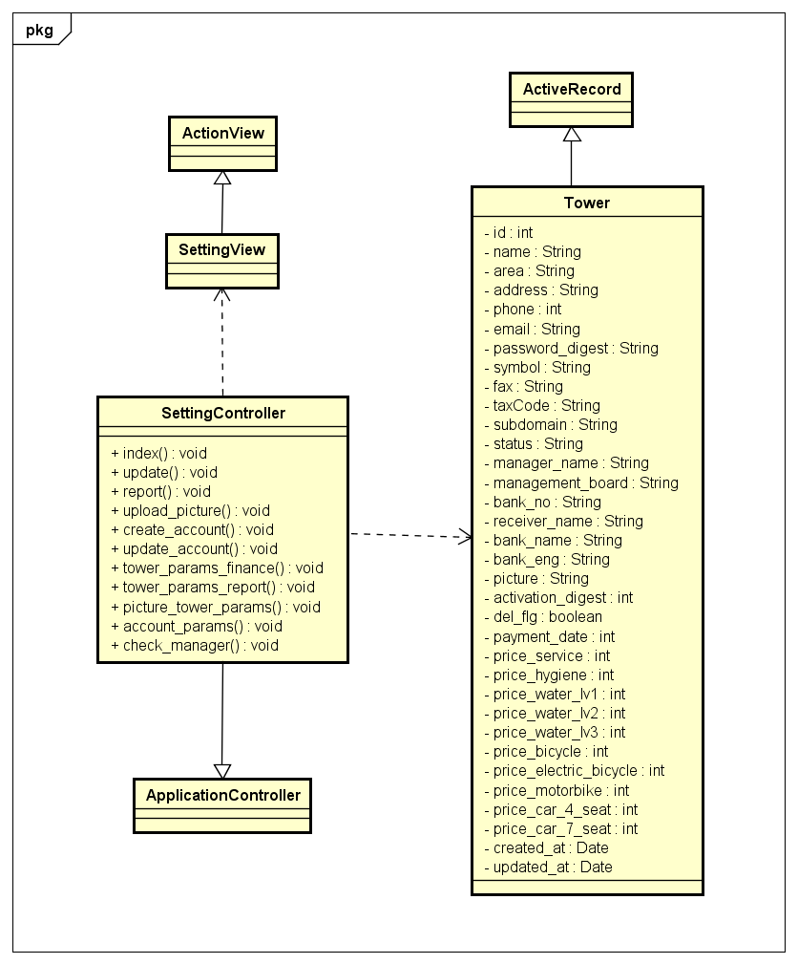

#### Class Specifications

##### Function

|  |  |  |  |  |
| --- | --- | --- | --- | --- |
| **Class** | **SettingController** | | | |
| **Description** | Configure setting relate to tower | | | |
| **Base Class** | ApplicationController | | | |
| **Source File** | setting_controller.rb | | | |
| **Namespace** | app/controllers/ | | | |
| **Attributes** | **N/A** | | | |
| **Methods** | **Name** | **Input** | **Output** | **Description** |
| Index | Information input | void | Render view |
| create | Information input | void | Configure financial setting for tower |

#### Sequence Diagram

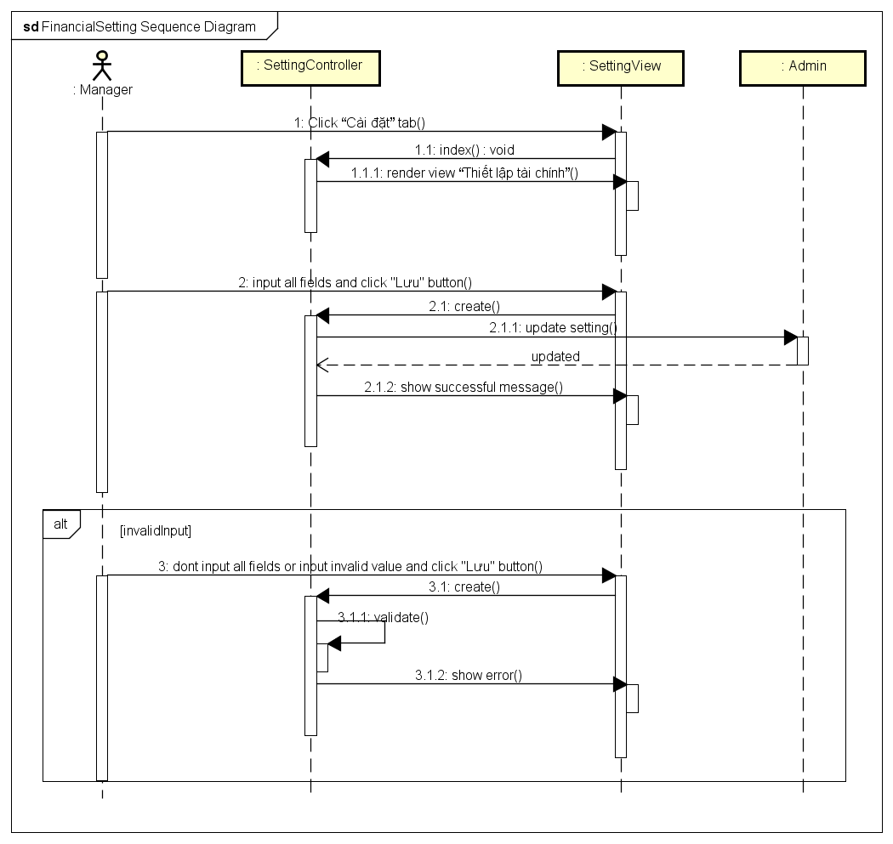

### Report Setting

#### Description

Configure all report setting for tower.

#### Design

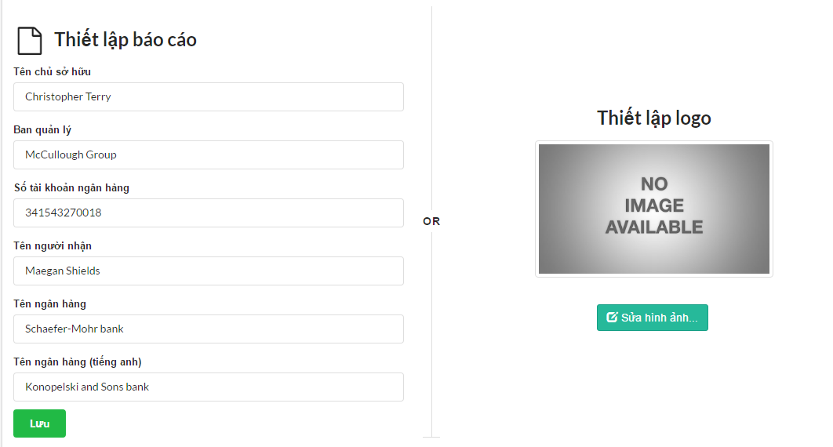

|  |  |  |
| --- | --- | --- |
| **Element** | **Type** | **Description** |
| Tên chủ sở hữu | Textbox | Owner name |
| Ban quản lý | Textbox | Manager board |
| Số tài khoản ngân hàng | Textbox | Bank number |
| Tên người nhận | Textbox | Receiver name |
| Tên ngân hang | Textbox | Bank name |
| Tên ngân hang (Tiếng anh) | Textbox | English bank name |
| Lưu | Button | Button to save setting |
| Picture | Image | Display image |
| Sửa hình ảnh | Button | Button to choose picture |

#### Class Diagram

*Refer to class diagram of Financial Setting in 1.3.78 Financial Setting*

#### Class Specifications

##### Function

|  |  |  |  |  |
| --- | --- | --- | --- | --- |
| **Class** | **SettingController** | | | |
| **Description** | Configure setting relate to tower | | | |
| **Base Class** | ApplicationController | | | |
| **Source File** | setting_controller.rb | | | |
| **Namespace** | app/controllers/ | | | |
| **Attributes** | **N/A** | | | |
| **Methods** | **Name** | **Input** | **Output** | **Description** |
| index | Information input | void | Render view |
| report | Information input | Void | Configure all report setting |

#### Sequence Diagram

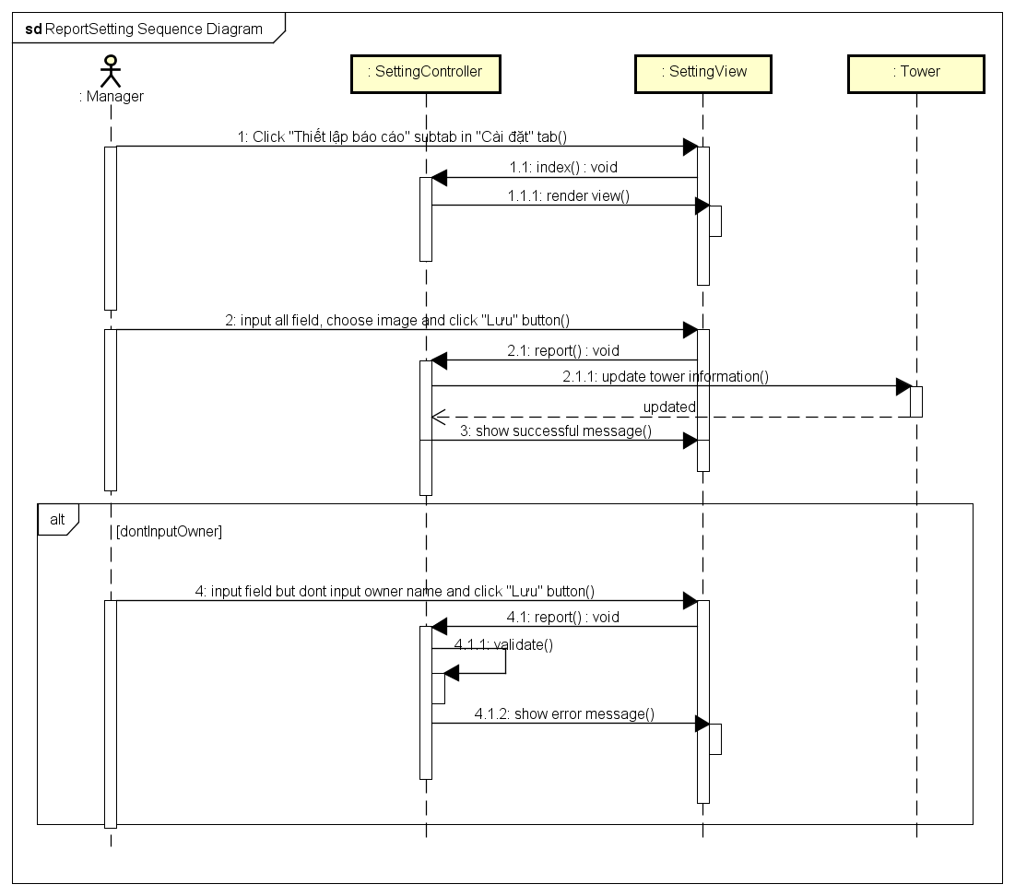

### View vehicle finance

#### Description

Manager views all vehicle finance of tower.

#### Design

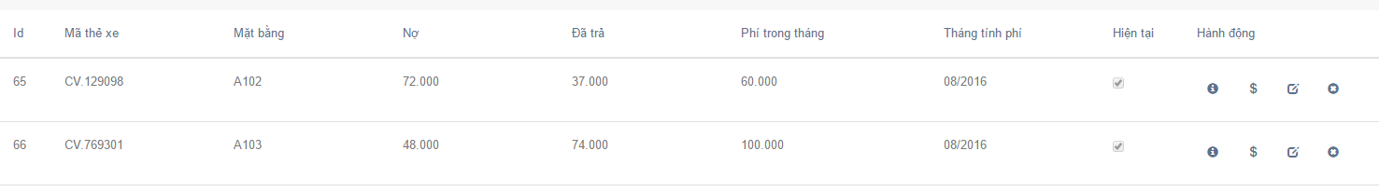

|  |  |  |
| --- | --- | --- |
| **Element** | **Type** | **Description** |
| Id | Textbox | Id of vehicle card |
| Mã thẻ xe | Textbox | Vehicle card number |
| Mặt bằng | Textbox | Ground name |
| Nợ | Textbox | Vehicle finance debt |
| Đã trả | Textbox | Vehicle finance paid |
| Phí trong tháng | Textbox | Fee in month |
| Tháng tính phí | Textbox | Month that charge |
| Hiện tại | checkbox | Is current or not |
| Hành động | Many Button | Action that manager can do |

#### Class Diagram

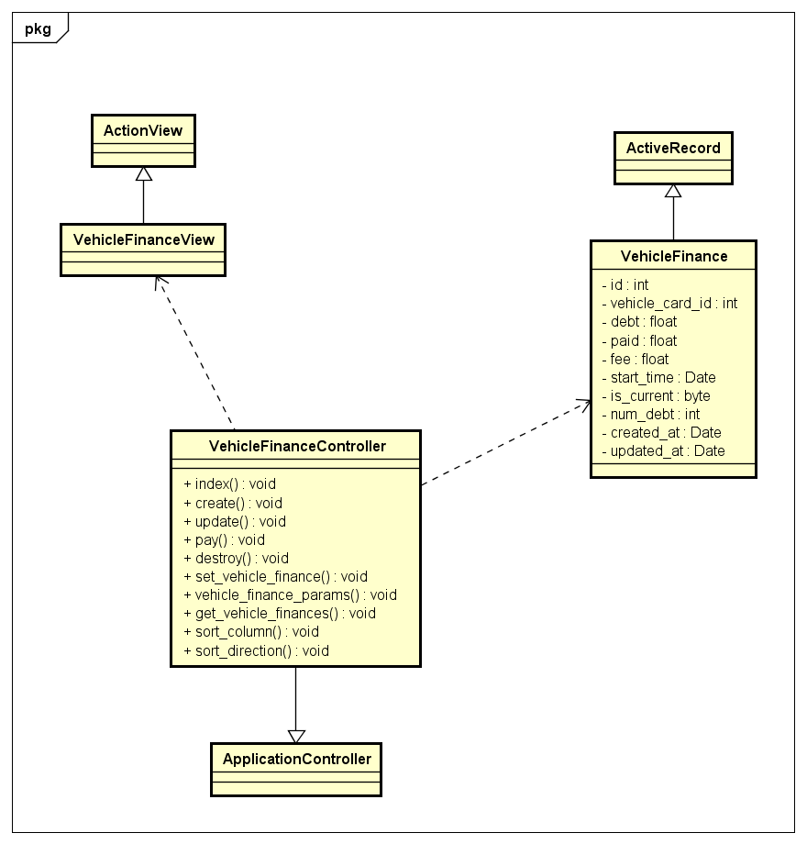

#### Class Specifications

##### Function

|  |  |  |  |  |
| --- | --- | --- | --- | --- |
| **Class** | **VehicleFinanceController** | | | |
| **Description** | Control and do business relate to vehicle finance of tower | | | |
| **Base Class** | ApplicationController | | | |
| **Source File** | Vehicle_fianances_controller.rb | | | |
| **Namespace** | app/controllers/ | | | |
| **Attributes** | **N/A** | | | |
| **Methods** | **Name** | **Input** | **Output** | **Description** |
| index | Information input | void | Get all vehicle finances information and render view |

#### Sequence Diagram

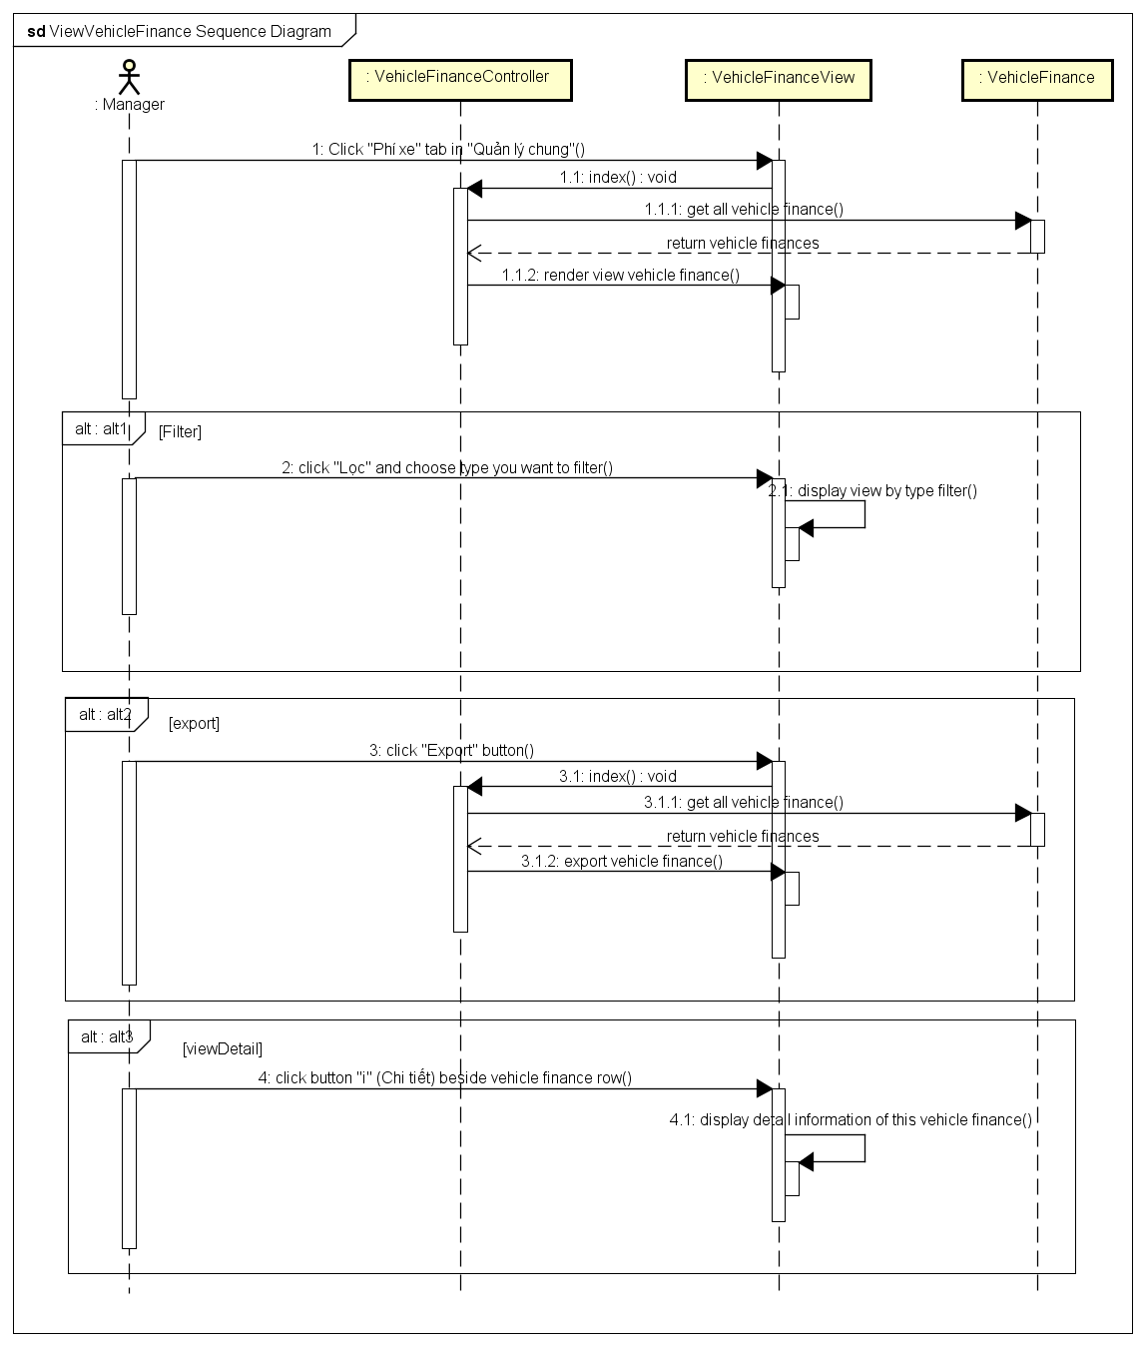

### Add vehicle finance

#### Description

Manager adds new vehicle finance of a ground

#### Design

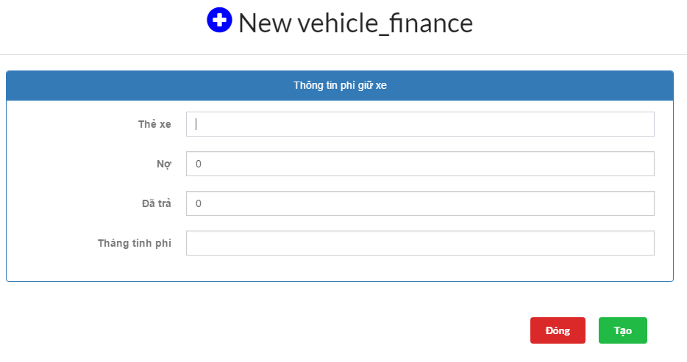

|  |  |  |
| --- | --- | --- |
| **Element** | **Type** | **Description** |
| Thẻ xe | Textbox | Vehicle card number |
| Nợ | Textbox | vehicle Debt of ground |
| Đã trả | Textbox | vehicle Paid of ground |
| Tháng tính phí | Textbox | Month that charge |
| Đóng | Button | Button to dismiss form |
| Tạo | Button | Button to submit form |

#### Class Diagram

*Refer to class diagram of View vehicle finance in 1.3.80 View vehicle finance*

#### Class Specifications

##### Function

|  |  |  |  |  |
| --- | --- | --- | --- | --- |
| **Class** | **VehicleFinanceController** | | | |
| **Description** | Control and do business relate to vehicle finance of tower | | | |
| **Base Class** | ApplicationController | | | |
| **Source File** | Vehicle_finances_controller.rb | | | |
| **Namespace** | app/controllers/ | | | |
| **Attributes** | **N/A** | | | |
| **Methods** | **Name** | **Input** | **Output** | **Description** |
| create | Information input | void | Create a new vehicle finance and add to the subdomain system |

#### Sequence Diagram

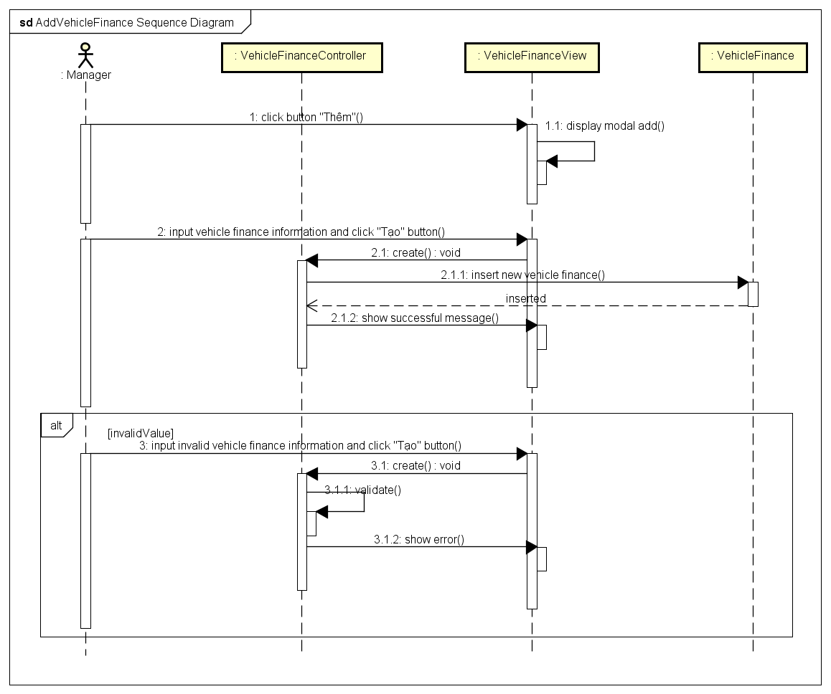

### Update vehicle finance

#### Description

Manager updates vehicle finance information of a ground

#### Design

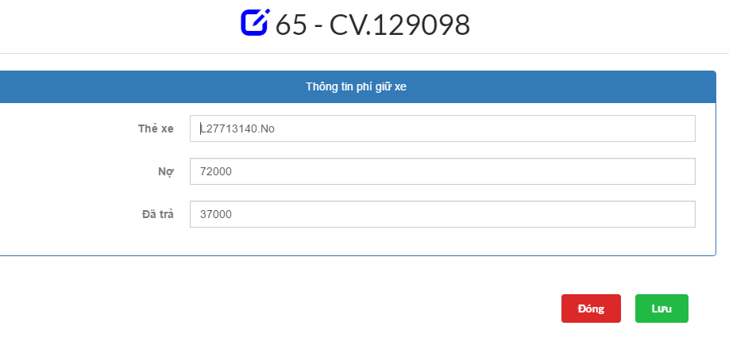

|  |  |  |
| --- | --- | --- |
| **Element** | **Type** | **Description** |
| Thẻ xe | Textbox | Vehicle card number |
| Nợ | Textbox | vehicle Debt of ground |
| Đã trả | Textbox | vehicle Paid of ground |
| Đóng | Button | Button to dismiss form |
| Lưu | Button | Button to submit form |

#### Class Diagram

*Refer to class diagram of View vehicle finance in 1.3.80 View vehicle finance*

#### Class Specifications

##### Function

|  |  |  |  |  |
| --- | --- | --- | --- | --- |
| **Class** | **VehicleFinanceController** | | | |
| **Description** | Control and do business relate to vehicle finance of tower | | | |
| **Base Class** | ApplicationController | | | |
| **Source File** | Vehicle_finances_controller.rb | | | |
| **Namespace** | app/controllers/ | | | |
| **Attributes** | **N/A** | | | |
| **Methods** | **Name** | **Input** | **Output** | **Description** |
| update | Information input | void | Update vehicle finance information |

#### Sequence Diagram

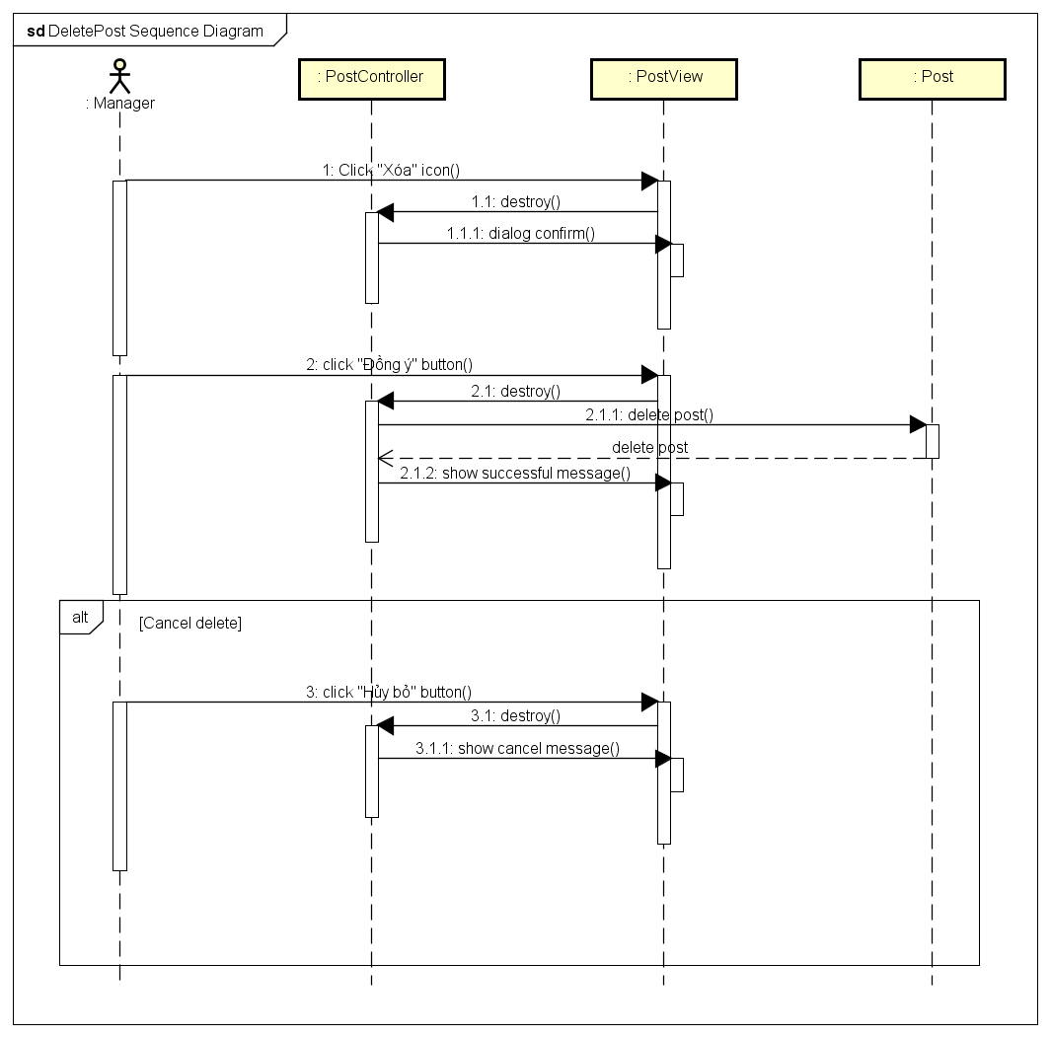

### Delete vehicle finance

#### Description

Manager deletes a vehicle finance of a ground

#### Design

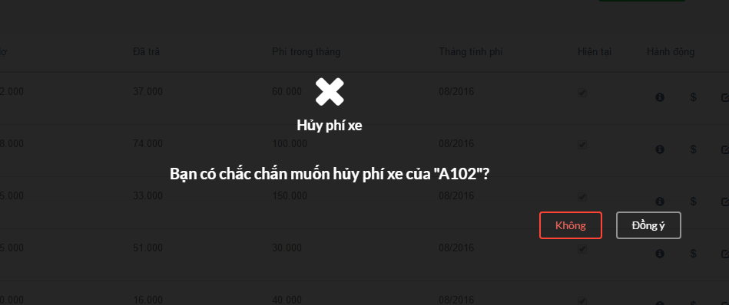

|  |  |  |
| --- | --- | --- |
| **Element** | **Type** | **Description** |
| Không | Button | Button to cancel delete |
| có | Button | Button to submit delete |

#### Class Diagram

*Refer to class diagram of View vehicle finance in 1.3.80 View vehicle finance*

#### Class Specifications

##### Function

|  |  |  |  |  |
| --- | --- | --- | --- | --- |
| **Class** | **VehicleFinanceController** | | | |
| **Description** | Control and do business relate to vehicle finance of tower | | | |
| **Base Class** | ApplicationController | | | |
| **Source File** | Vehicle_finances_controller.rb | | | |
| **Namespace** | app/controllers/ | | | |
| **Attributes** | **N/A** | | | |
| **Methods** | **Name** | **Input** | **Output** | **Description** |
| destroy | Information input | void | Delete vehicle finance of a ground |

#### Sequence Diagram

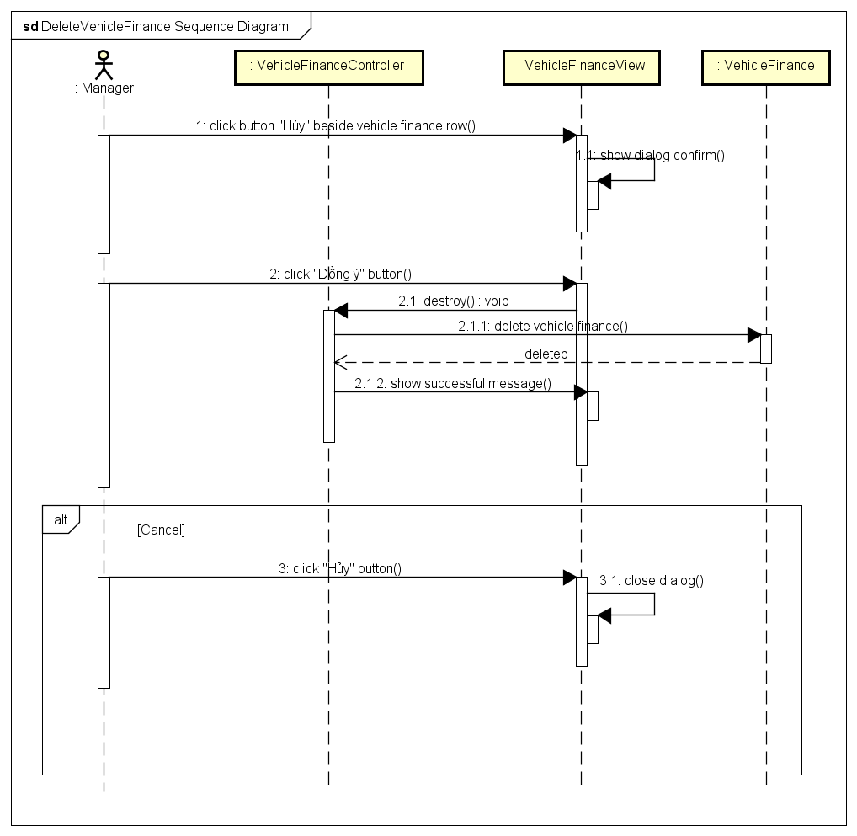

# SOFTWARE TEST DOCUMENTATION

## Introduction

### System Overview

This chapter is comprehensive test plan of the Apartment Management project. It describes scopes of test and activities, which need to be taken during test process of project. It contains the following sections:

* Scope of Testing
* Test Plan
* Resources and responsibilities
* Test strategy: Test approach, test stages
* Test schedule
* Feature to be tested
* Feature not to be tested
* Defect log
* Test Report

### Scope of testing:

#### Stage of testing:

There are 4 phases in testing process: Integration Testing, System Testing, and Acceptance Testing.

|  |  |  |  |
| --- | --- | --- | --- |
| No. | Test Stage | Description | Implementation |
| 1 | Integration testing | Integration testing will be performed by tester. Requirement of the system will be tested in functional flow. Integration test should be performed to ensure all components incorporate well | Hồ Việt Tuấn |
| 2 | System testing | System testing will be performed by the tester and the development team leader with assistance from the individual developers as required. No specific test tools are available for this project. Programs will enter into System/Integration test after all critical defects have been corrected | All members |
| 3 | Acceptance testing | Acceptance testing consist of Alpha Test and Beta Test, will be executed by all team members, stand at end-user point of view. Determine whether a system, satisfies the requirement specified in the requirement analysis phase. Finding defect is not the main focus in this stage. Acceptance test will access the system’s readiness for deployment and using. | All member and people with Internet (build on host with project domain) |

**Table 5.1. Stages of testing**

#### Type of testing:

Legendary5 team will test the following type on Google Chrome with resolution (1366x768 and 1024x768)

* GUI test
* Function test
* Performance test
* Regression test
* Acceptance test

#### Scope of testing:

Team performs all functions defined in the SRS based on the approved version

## Test Plan:

### Testing tools and environment:

#### Testing tools:

* Google Chrome v51.0[2]: Used to test size of web page and size of component on page



**Figure 5.1 Google Chrome**

* Color Picker v43.0[3]: A tool from Google Chrome to read color ID on web page



**Figure 5.2 Color Picker**

* Trello[4]: Log Bug



**Figure 5.4 Trello**

#### Testing environment:

* Software:
* Google Chrome v51.0
* Microsoft Excel 2013
* Microsoft Word 2013
* Windows 10 Professional (64bits)
* Hardware:
* Personal computer for developing with the minimum configuration:
  + Windows 10 Professional, Ubuntu 16.04 LTS
  + Intel Core i5
  + Install Memory (RAM): 4.00GB

### Resources and responsibilities:

|  |  |  |
| --- | --- | --- |
| No. | Resources | Responsibilities |
| 1 | Project Manager | * Responsible for Project Schedules and overall success of the project * Review test case and report |
| 2 | Tester | * Perform the actual system testing * Manage test resource and assign test tasks * Create document of Test Plan, Test Case, Test Report * Execute test * Test log report |
| 3 | Developer | * Fix bugs |

**Table 5.2 Resources and responsibilities**

### Test strategy:

#### Test Model:

This project follows V-Model process to implement testing. V- Model means Verification and Validation model. In software development, the V-Modelrepresents a development process that may be considered an extension of the waterfall model, and is an example of the more general V-model. Instead of moving down in a linear way, the process steps are bent upwards after the coding phase, to form the typical V shape. The V-Model demonstrates the relationships between each phase of the development life cycle and its associated phase of testing. The horizontal and vertical axes represents time or project completeness (left-to-right) and level of abstraction (coarsest-grain abstraction uppermost), respectively.

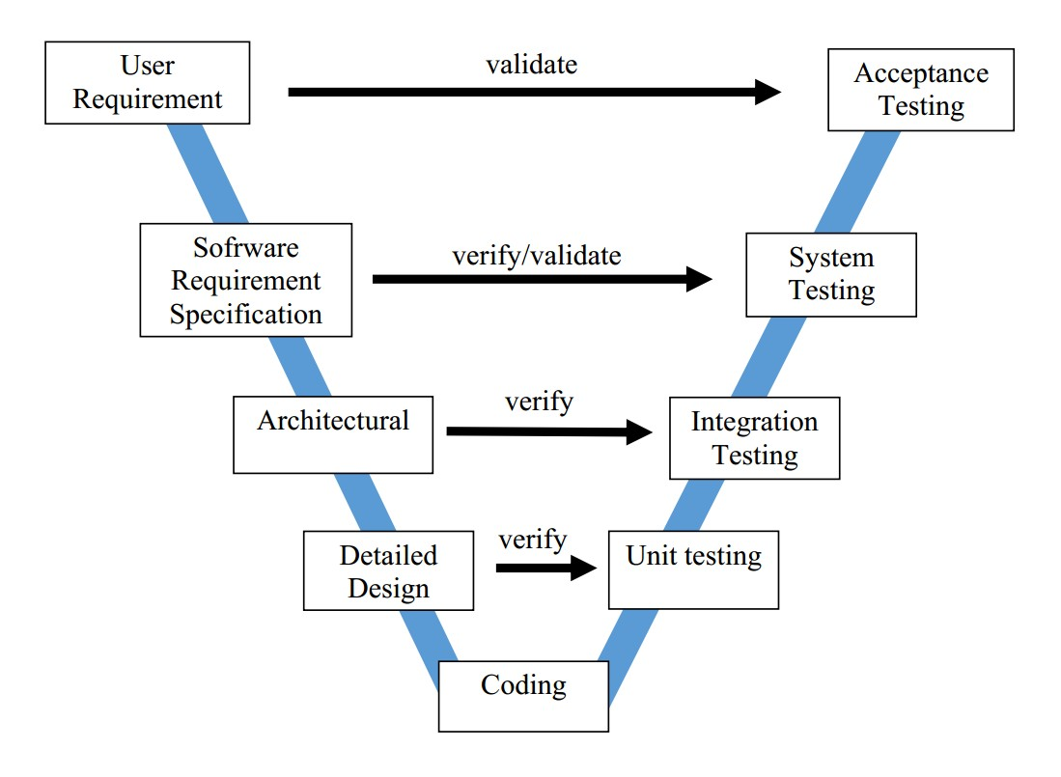

Figure 5.4 V- Model[5]

We choose V-Model because:

* The V-shaped model should be used for small to medium sized projects where requirements are clearly defined and fixed.
* The V-Shaped model should be chosen when ample technical resources are available with needed technical expertise.
* Simple and easy to use.
* Testing activities like planning, test designing happens well before coding. This saves a lot of time. Hence higher chance of success over the waterfall model.
* Proactive defect tracking – that is defects are found at early stage.
* Avoids the downward flow of the defects.
* Works well for small projects where requirements are easy to understand.

#### Test type:

Apartment Management project will be carry out each time release package as defined in project plan and depends on internal delivery by development team. The different types of testing that will be carry out this project are:

|  |  |  |
| --- | --- | --- |
| No. | Test Type | Description |
| 1 | Function Test | * Test all implemented functions on MANAPART system * The testing will be covered for those functions in Function Test is verification the validation of the behavior according to the requirement * Test case will have to be designed to cover all of the above and executed * Implemented function’s error message will be included under this test |
| 2 | GUI Test | * GUI (Graphical User Interface) Testing verifies a user’s interaction with the software. The goal of GUI testing is to ensure that the GUI provides the user with the appropriate access and navigation through the functions of the target-of-test. GUI testing also to ensure that the objects on the GUI function as expected and fit the requirement * GUI test will be performed fully on screens * This test target on the overall look of the management website and mobile app include initial position, font, text size, color, label, button, screen size, etc. * Test all GUI elements and acceptance of characters or numbers. * Error messages, warning messages are display correct and not making confuse. * Font is used correct and readable * Alignment of text and photo on page is display correct and clarity enough |
| 3 | Performance Test | * The testing will be covered for response time for MANAPART system |
| 4 | Regression Test | * This test is to confirm whether the bug is removed including the extent of the impact * This test is to confirm that the new functions and components added to the system doesn’t make change to existing components. |
| 5 | Acceptance Test | * This test is to conduct to determine whether the requirement of a specification or contract are meet. * It involves alpha testing and beta testing. Alpha testing takes place at developer’s environment, involving the operational system by internal member, before it is related to external users. Beta testing is take place at user’s environment, involving testing by a group of user who use the system independence and give feedback before the system is released. |

**Table 5.3 Test type**

#### Test Stage:

Table below are the stages in which common test are executed:

|  |  |  |
| --- | --- | --- |
| Type of Test | Stage of Test | |
| **Integration** | **System** |
| Function Test | 🗸 | 🗸 |
| GUI Test | 🗸 | 🗸 |
| Regression Test | 🗸 | 🗸 |
| Acceptance Test |  | 🗸 |

**Table 5.4 Test Stage**

#### Test Schedule:

|  |  |  |
| --- | --- | --- |
| Test Schedule | Start Date | End Date |
| **Phase 1: Main features** | **02/08/2016** | **10/08/2016** |
| User Interface Testing | 02/08/2016 | 05/08/2016 |
| Functional Testing | 06/08/2016 | 08/08/2016 |
| Performance Tests | 09/08/2016 | 09/08/2016 |
| Regression Tests | 10/08/2016 | 10/08/2016 |
| **Phase 2: Other features and optimization** | **11/08/2016** | **26/08/2016** |
| User Interface Testing | 11/08/2016 | 16/08/2016 |
| Functional Testing | 17/08/2016 | 23/08/2016 |
| Performance Tests | 22/08/2016 | 24/08/2016 |
| Scenario Tests | 23/08/2016 | 25/08/2016 |
| Regression Tests | 26/08/2016 | 26/08/2016 |
| **Phase 3: Deployment** | **27/08/2016** | **27/08/2016** |
| Acceptance testing | 27/08/2016 | 27/08/2016 |

**Table 5.5 Test Schedule**

#### Deliverables:

#### Table below are the Deliverables for MANAPART Project:

|  |  |  |
| --- | --- | --- |
| Deliverables | Responsibilities | Completion Date |
| Test Plan | Test leader | 01/08/2016 |
| Test Cases | Tester | 03/08/2016 |
| Test case review | Tester + PM | 04/08/2016 |
| Test Data (Data Set) | Tester | 05/08/2016 |
| Defect report | All members | 24/08/2016 |
| Final test Summary report | PM | 24/08/2016 |

**Table 5.6 Deliverable responsibilities**

### Feature to be tested:

* All features represented by use cases will be tested

### Feature not to be tested:

* Out of scope features will not be tested

## Test Approach:

### Integration and System Test:

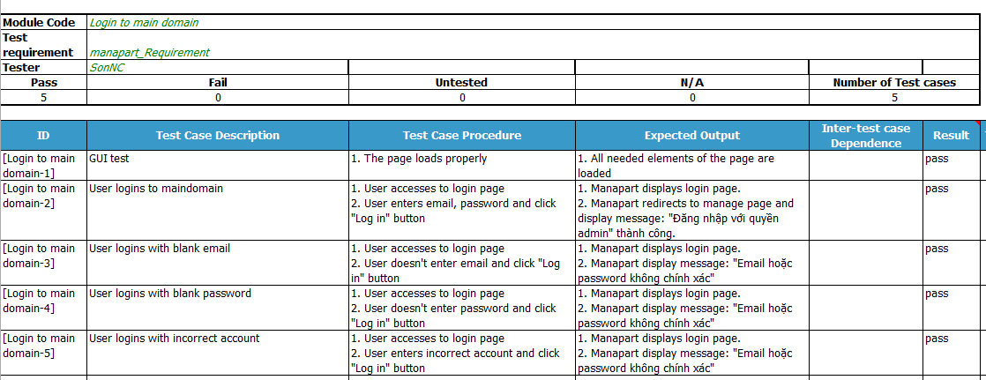

Figure 5-5: Login to main domain

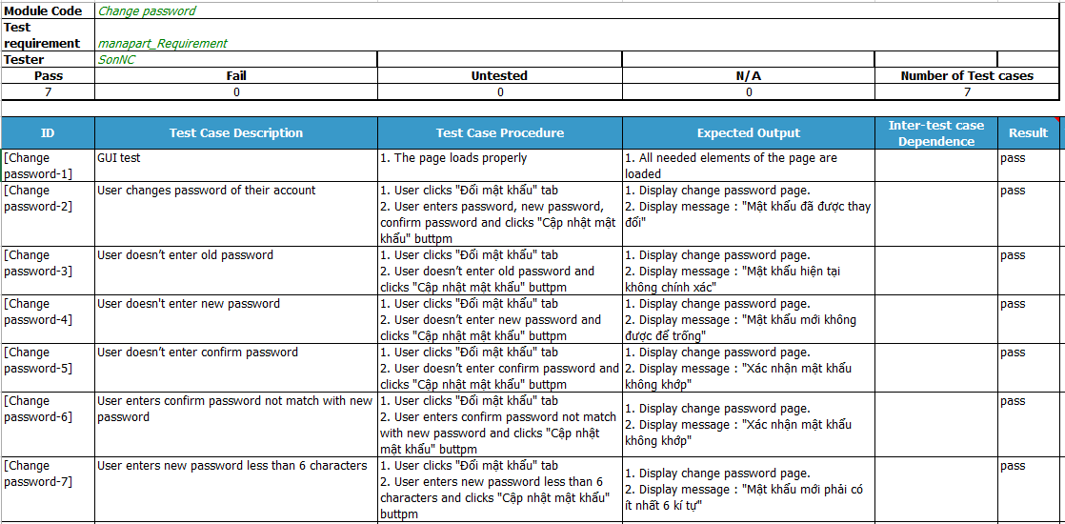

Figure 5-6: Change password

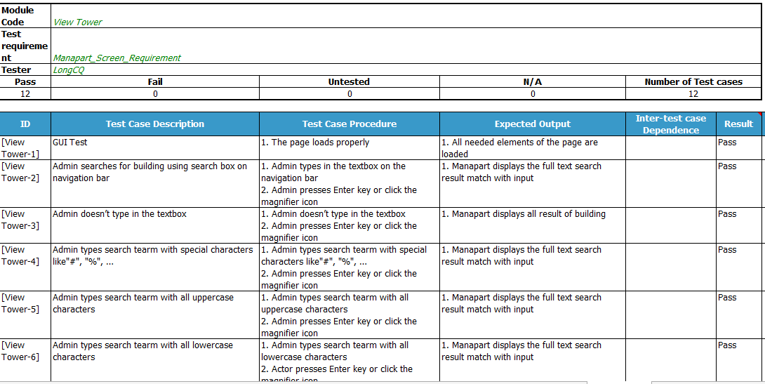

Figure 5-7: View Tower

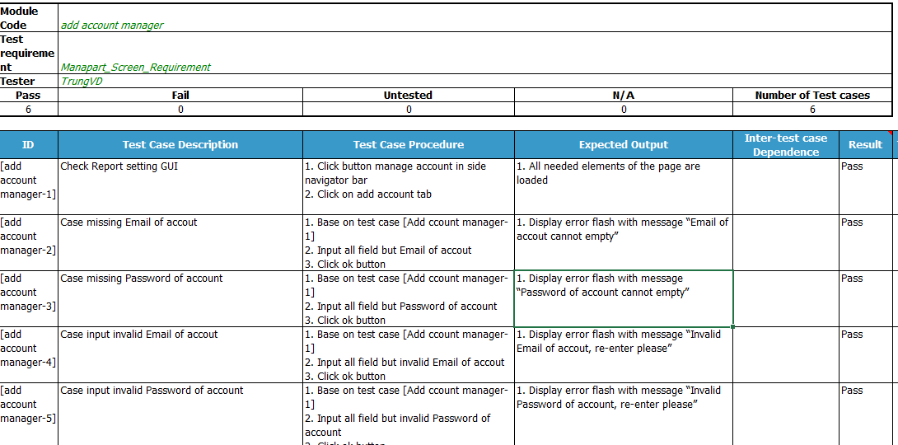

Figure 5-8: Add Account Manager

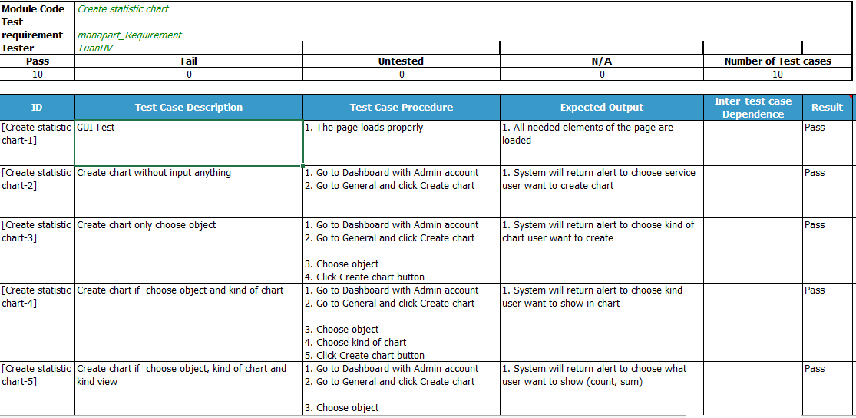

Figure 5-9: Create statistic chart

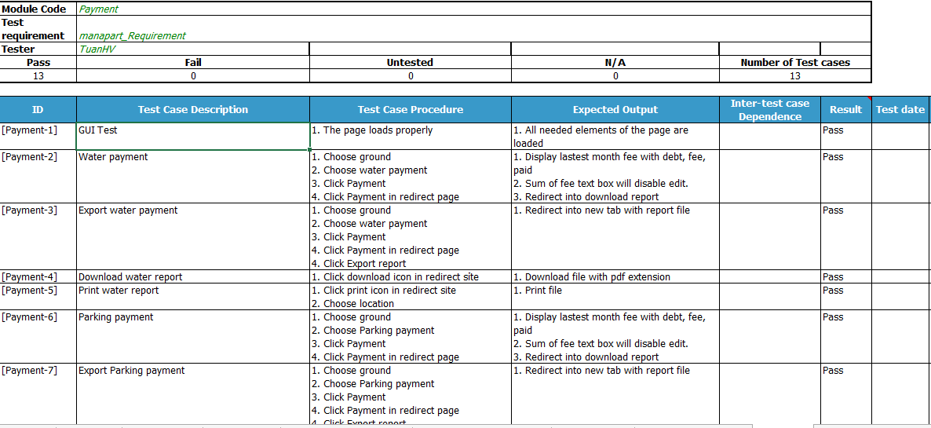

Figure 5-10: Payment

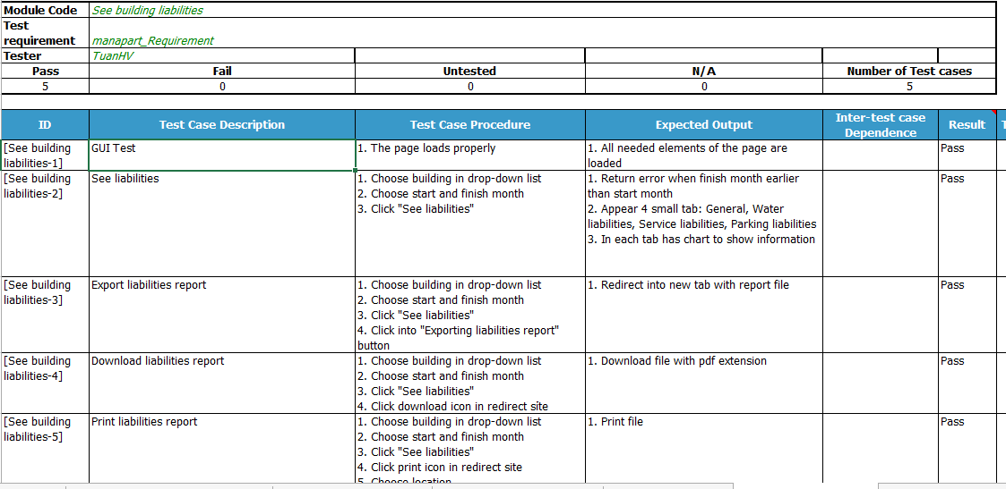

Figure 5-11: See building liabilities

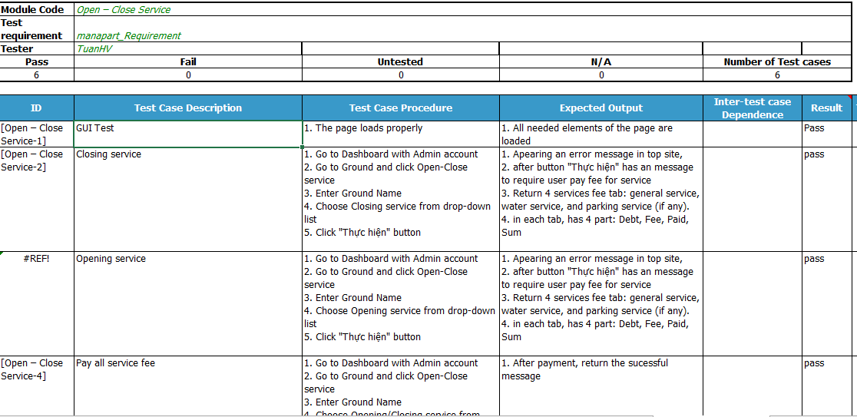

Figure 5-12: Open-Close Service

Detail of this test will be describe in Test Case file **TestCase_Manapart.xlsx**

### Acceptance Test:

* Acceptance test is a level of software test where a system will be tested for acceptability. The purpose of this test is to evaluate the system’s compliance with the business requirement and assess whether it is acceptable to release or to delivery.
* MANAPART project uses Check Lists as a substitute for Acceptance test.
* The contents of the Checklist are shown in the table below

|  |  |  |  |
| --- | --- | --- | --- |
| **ID** | **Checklists** | **Yes** | **No** |
|  | **General** |  |  |
| CL-001 | Text on all pages for spelling and grammatical errors. | ✓ |  |
| CL-002 | Functionality of buttons available on all pages. | ✓ |  |
| CL-003 | All mandatory fields are validated and indicated by asterisk (*) symbol. | ✓ |  |
| CL-004 | All error messages are displayed in same CSS style, using red color. | ✓ |  |
| CL-005 | Delete functionality for any record on page are asked for confirmation. | ✓ |  |
| CL-006 | All numeric values are formatted properly. | ✓ |  |
| CL-007 | Application crash or unavailable pages are redirected to error page. | ✓ |  |
|  | **GUI and Usability** |  |  |
| CL-08 | Screens are designed follow project standards. | ✓ |  |
| CL-09 | The screen well organized and easy to use. | ✓ |  |
| CL-010 | All fields on page (e.g. text box, radio options, dropdown lists) should be aligned properly. | ✓ |  |
| CL-011 | The most important fields are located where they are easy to see. | ✓ |  |
| CL-012 | Information is presented in the order that the user needs it. | ✓ |  |
| CL-013 | The static text is clear, concise, and meaningful. | ✓ |  |
| CL-014 | All static text words are spelled out (correctly!) and abbreviations used only when space is limited. | ✓ |  |
| CL-015 | All icons and elements are flat | ✓ |  |
| CL-016 | Pop-up menus are provided for the user to access information about an object's properties or perform specific tasks on the object. | ✓ |  |
| CL-017 | Command buttons are used to trigger application processes. | ✓ |  |
| CL-018 | Checkboxes are used to show independent on/off choices. Can tick on more different answer. | ✓ |  |
| CL-019 | Radio buttons are used to show sets of two or more mutually exclusive choices. Only allow tick on 1 answer. | ✓ |  |
| CL-020 | System display notification message when meet trouble, error. | ✓ |  |
|  | **Database** |  |  |
| CL-021 | Correct data is getting saved in database upon successful page submits. | ✓ |  |
| CL-022 | Values columns are not accepting null values. | ✓ |  |
| CL-023 | Radio button options are saved correctly in database. | ✓ |  |
| CL-024 | Database fields are designed with correct data type and data length. | ✓ |  |
| CL-025 | Null values are not allowed for Primary key column. | ✓ |  |
|  | **Performance** |  |  |
| CL-026 | Page load time is within 10 seconds. | ✓ |  |
| CL-027 | Database query execution time is within 1 second. | ✓ |  |
| CL-028 | CPU and memory usage at most 500 connection. | ✓ |  |
|  | **Security** |  |  |
| CL-029 | Check application logout functionality. | ✓ |  |
| CL-030 | Password information should be stored in encrypted format only. | ✓ |  |

**Table 5.7 Check list**

### Defect Log:

* MANAPART project used Trello to manage bug list
* Every member will have an account in a team account of Trello to get bug assigned and to fix bug
* Process of defect log:
* Tester log bug to Trello with status “Assigned” and assign developer who is in charge of the function that have bug
* Developer fix that bug and change status to “Resolved” and assign tester who log this bug
* Tester will check this bug again:
* If this bug is fixed and there’s no error, tester check test case and change percent of completeness to 100% and the status of this bug to “Closed”
* If the bug is still got any problem, tester change the status to “Open” and assigned to developer again.

## Test Report:

### Test case

|  |  |  |  |  |  |  |
| --- | --- | --- | --- | --- | --- | --- |
| **No** | **Module code** | **Pass** | **Fail** | **Untested** | **N/A** | **Number of   test cases** |
|  | | | | | | |
| 1 | Login to maindomain | 5 | 0 | 0 | 0 | 5 |
| 2 | Logout of maindomain | 2 | 0 | 0 | 0 | 2 |
| 3 | Change password | 7 | 0 | 0 | 0 | 7 |
| 4 | View all tower | 12 | 0 | 0 | 0 | 12 |
| 5 | Update tower | 8 | 0 | 0 | 0 | 8 |
| 6 | Delete tower | 3 | 0 | 0 | 0 | 3 |
| 7 | Register tower | 12 | 0 | 0 | 0 | 12 |
| 8 | Login to subdomain | 5 | 0 | 0 | 0 | 5 |
| 9 | Logout of subdomain | 2 | 0 | 0 | 0 | 2 |
| 10 | View account manager | 5 | 0 | 0 | 0 | 5 |
| 11 | Add account manager | 6 | 0 | 0 | 0 | 6 |
| 12 | Update account manager | 6 | 0 | 0 | 0 | 6 |
| 13 | De-active account manager | 3 | 0 | 0 | 0 | 3 |
| 14 | View building | 12 | 0 | 0 | 0 | 12 |
| 15 | Add building | 11 | 0 | 0 | 0 | 11 |
| 16 | Update building | 8 | 0 | 0 | 0 | 8 |
| 17 | Delete building | 3 | 0 | 0 | 0 | 3 |
| 18 | View ground | 12 | 0 | 0 | 0 | 12 |
| 19 | Add ground | 11 | 0 | 0 | 0 | 11 |
| 20 | Update ground | 8 | 0 | 0 | 0 | 8 |
| 21 | Delete ground | 4 | 0 | 0 | 0 | 4 |
| 22 | View citizen card | 12 | 0 | 0 | 0 | 12 |
| 23 | Add citizen card | 10 | 0 | 0 | 0 | 10 |
| 24 | Update citizen card | 8 | 0 | 0 | 0 | 8 |
| 25 | Delete citizen card | 3 | 0 | 0 | 0 | 3 |
| 26 | View citizen | 12 | 0 | 0 | 0 | 12 |
| 27 | Add citizen | 11 | 0 | 0 | 0 | 11 |
| 28 | Update citizen | 8 | 0 | 0 | 0 | 8 |
| 29 | Delete citizen | 4 | 0 | 0 | 0 | 4 |
| 30 | View facility | 10 | 0 | 0 | 0 | 10 |
| 31 | Add facility | 7 | 0 | 0 | 0 | 7 |
| 32 | Update facility | 6 | 0 | 0 | 0 | 6 |
| 33 | Delete facility | 3 | 0 | 0 | 0 | 3 |
| 34 | View maintenance schedule | 10 | 0 | 0 | 0 | 10 |
| 35 | Add maintenance schedule | 6 | 0 | 0 | 0 | 6 |
| 36 | Update maintenance schedule | 6 | 0 | 0 | 0 | 6 |
| 37 | Delete maintenance schedule | 3 | 0 | 0 | 0 | 3 |
| 38 | View water finance | 6 | 0 | 0 | 0 | 6 |
| 39 | Update water finance | 7 | 0 | 0 | 0 | 7 |
| 40 | View vehicle card | 10 | 0 | 0 | 0 | 10 |
| 41 | Update vehicle card | 7 | 0 | 0 | 0 | 7 |
| 42 | View service finance | 6 | 0 | 0 | 0 | 6 |
| 43 | Update service finance | 6 | 0 | 0 | 0 | 6 |
| 44 | View history | 6 | 0 | 0 | 0 | 6 |
| 45 | View post | 3 | 0 | 0 | 0 | 3 |
| 46 | Add post | 3 | 0 | 0 | 0 | 3 |
| 47 | Update post | 3 | 0 | 0 | 0 | 3 |
| 48 | Delete post | 3 | 0 | 0 | 0 | 3 |
| 49 | View grounds map | 4 | 0 | 0 | 0 | 4 |
| 50 | View statistic and report | 2 | 0 | 0 | 0 | 2 |
| 51 | Export report | 13 | 0 | 0 | 0 | 13 |
| 52 | Create statistic chart | 10 | 0 | 0 | 0 | 10 |
| 53 | Payment | 13 | 0 | 0 | 0 | 13 |
| 54 | Enter water consumption | 2 | 0 | 0 | 0 | 2 |
| 55 | Enter water consumption from excel | 3 | 0 | 0 | 0 | 3 |
| 56 | Closing monthly statistic | 2 | 0 | 0 | 0 | 2 |
| 57 | Import building database from excel | 3 | 0 | 0 | 0 | 3 |
| 58 | See building liabilities | 5 | 0 | 0 | 0 | 5 |
| 59 | Add ground picture | 2 | 0 | 0 | 0 | 2 |
| 60 | Import ground database from excel | 3 | 0 | 0 | 0 | 3 |
| 61 | Change owner | 6 | 0 | 0 | 0 | 6 |
| 62 | Import owner database from excel | 3 | 0 | 0 | 0 | 3 |
| 63 | Open - close service | 6 | 0 | 0 | 0 | 6 |
| 64 | See ground liabilities | 5 | 0 | 0 | 0 | 5 |
| 65 | Owner history | 3 | 0 | 0 | 0 | 3 |
| 66 | Owner history detail | 5 | 0 | 0 | 0 | 5 |
| 67 | Import citizen database from excel | 16 | 0 | 0 | 0 | 16 |
| 68 | Import citizen card database from excel | 13 | 0 | 0 | 0 | 13 |
| 69 | Lock - lost citizen card | 7 | 0 | 0 | 0 | 7 |
| 70 | Import vehicle card database from excel | 16 | 0 | 0 | 0 | 16 |
| 71 | Open vehicle card service | 8 | 0 | 0 | 0 | 8 |
| 72 | Lock - lost vehicle card | 10 | 0 | 0 | 0 | 10 |
| 73 | Send announcement via email | 6 | 0 | 0 | 0 | 6 |
| 74 | Financial setting | 35 | 0 | 0 | 0 | 35 |
| 75 | Report setting | 14 | 0 | 0 | 0 | 14 |
| 76 | Add service finance | 14 | 0 | 0 | 0 | 14 |
| 77 | Delete service finance | 4 | 0 | 0 | 0 | 4 |
| 78 | Add vehicle finance | 14 | 0 | 0 | 0 | 14 |
| 79 | Delete vehicle finance | 4 | 0 | 0 | 0 | 4 |
| 80 | Update vehicle finance | 10 | 0 | 0 | 0 | 10 |
| 81 | View vehicle finance | 7 | 0 | 0 | 0 | 7 |
| 82 | Delete water finance | 4 | 0 | 0 | 0 | 4 |
| 83 | Add water finance | 17 | 0 | 0 | 0 | 17 |
| **Sub total** | | 613 | 0 | 0 | 0 | 613 |
|  |  |  |  |  |  |  |
|  |  |  |  |  |  |  |
|  | **Test coverage** |  | **100.00** | % |  |  |
|  | **Test successful coverage** |  | **100.00** | % |  |  |
|  | **Fixed** |  | **96** | bugs |  |  |

### Bug list report:

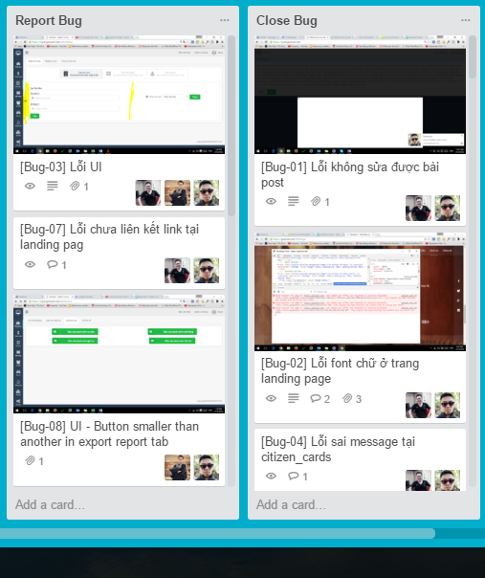

*Figure 5-13 Bug List Report*

# USER MANUAL

## User Guidelines

### Register

1. Goto <https://gotower.net>, click on "Đăng Ký" button.

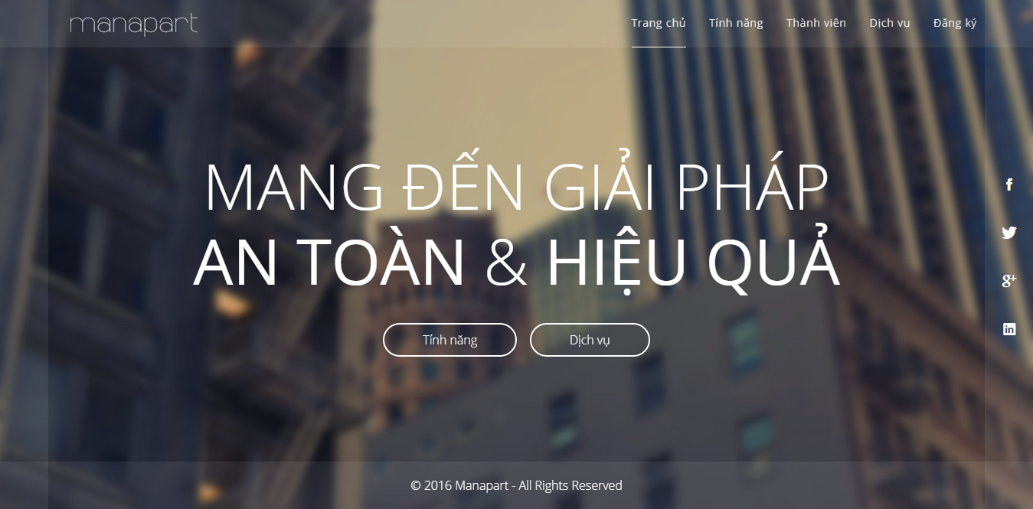

1. Manapart register screen

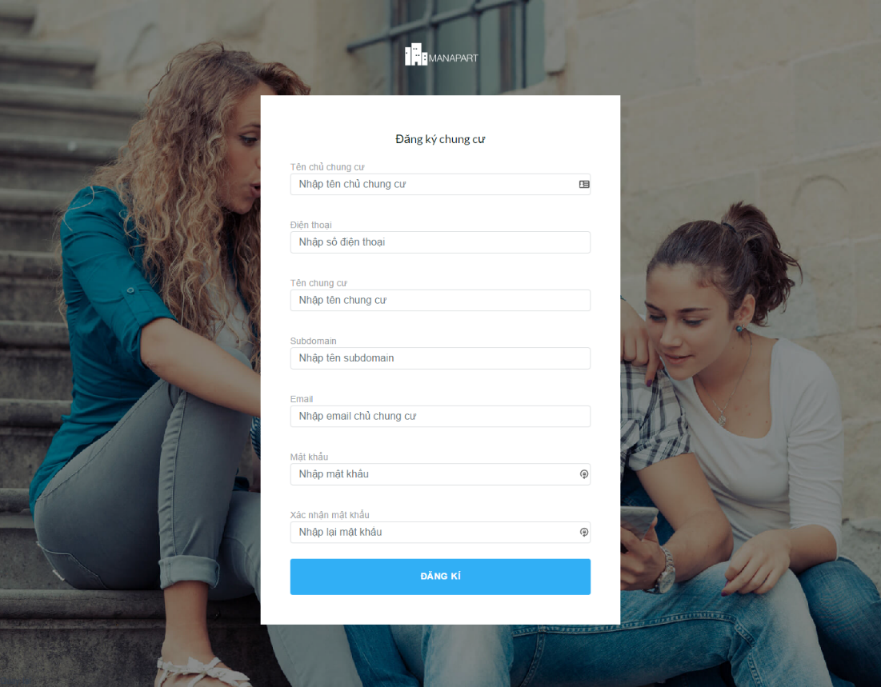

1. Fill required information in asterisk field.
2. Click on "Đăng kí" button.

### Login

1. Go to you subdomain login pages and fill login details into login form

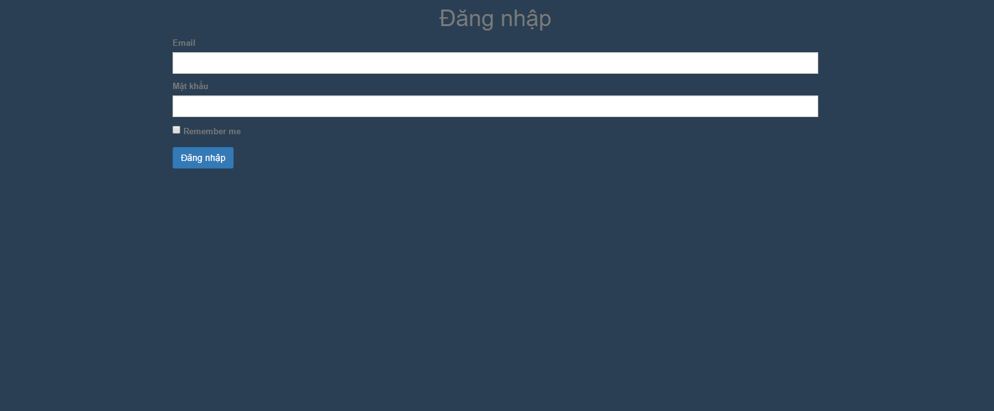

1. If this is your first time login, manapart will guide you to walk through the import data process

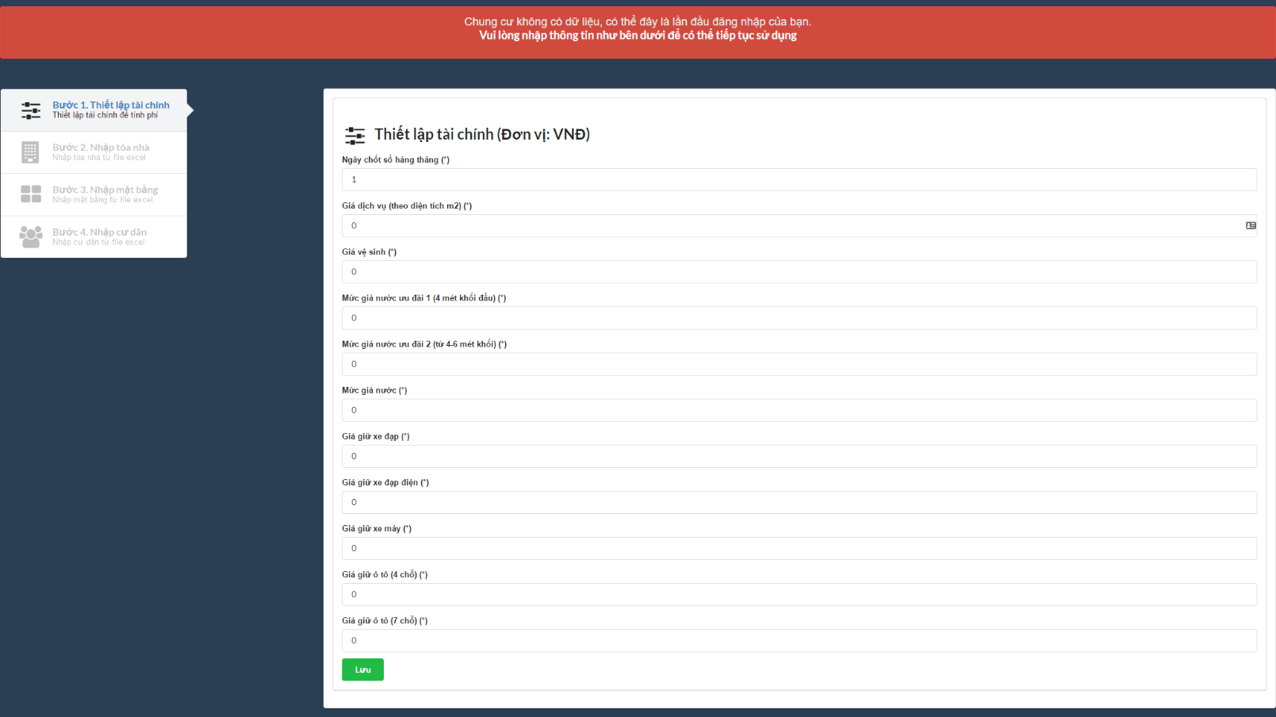

1. In the first step, you will able to configure financial fee. When done, click on "lưu" button.
2. In the second step, you will able to import all your building from file. At fisrt, click "Tải file mẫu danh sách tòa nhà". The import template will be downloaded into your local machine. You have to fill your buildings name into template file. After that, click on "Nhập tòa nhà từ file" button to upload your buildings data.

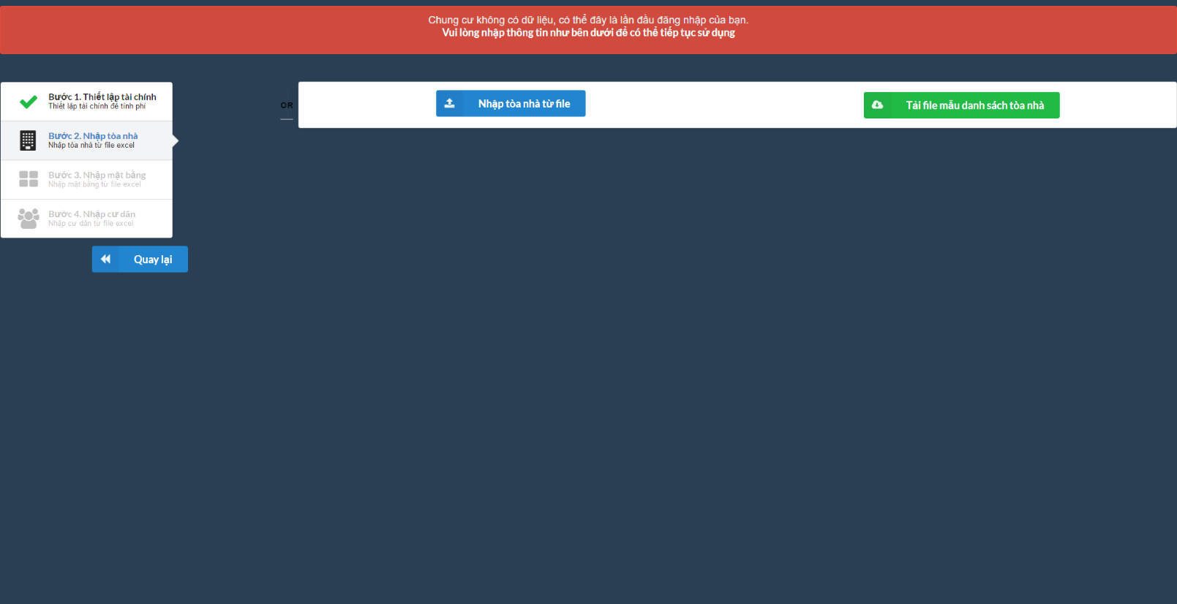

1. In the third step, you will able to import your tower's gound data from excel file. Click "Tải file mẫu danh sách mặt bằng" button. Fill downloaded file then upload it by click "Nhập mặt bằng từ file" button.

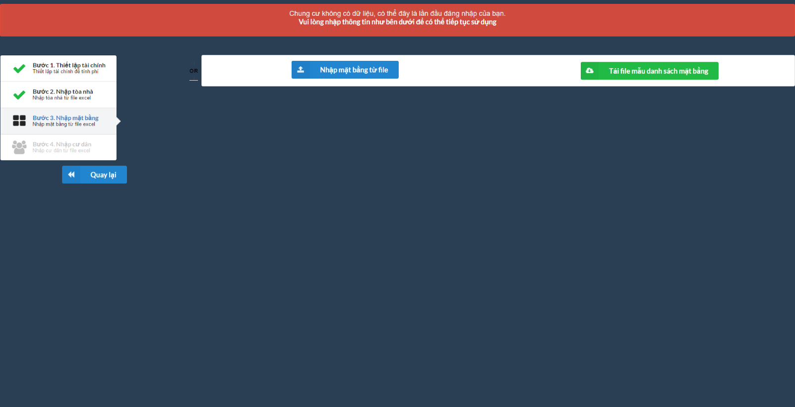

1. In the fourth step, you will be asked to import citizens data like these step before. If everything correct, you good to go.

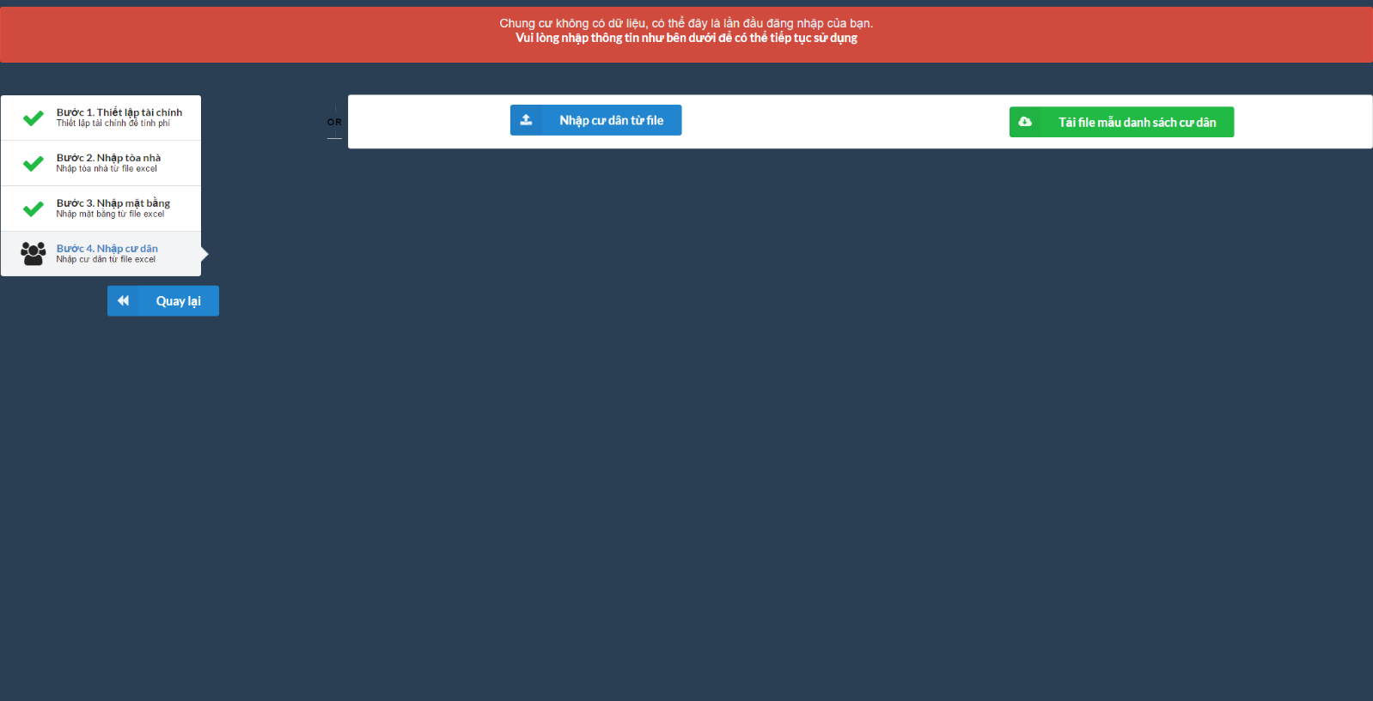

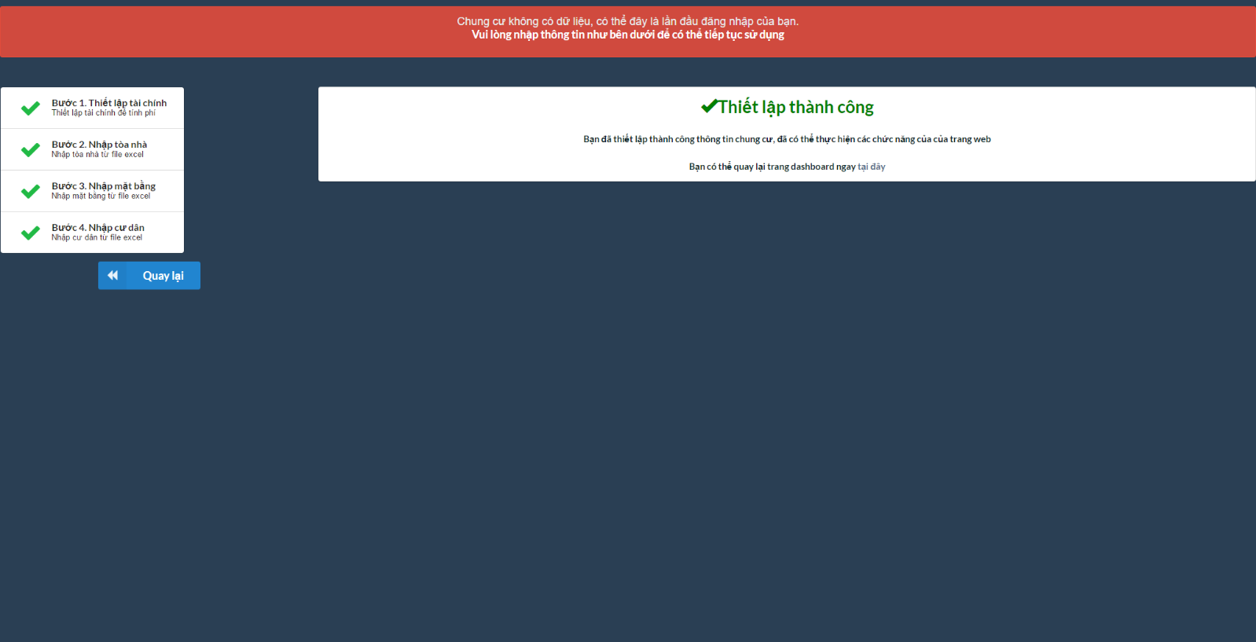

1. If this is not your first login, then after login click on "Bàn làm việc" button to go to our dashboard

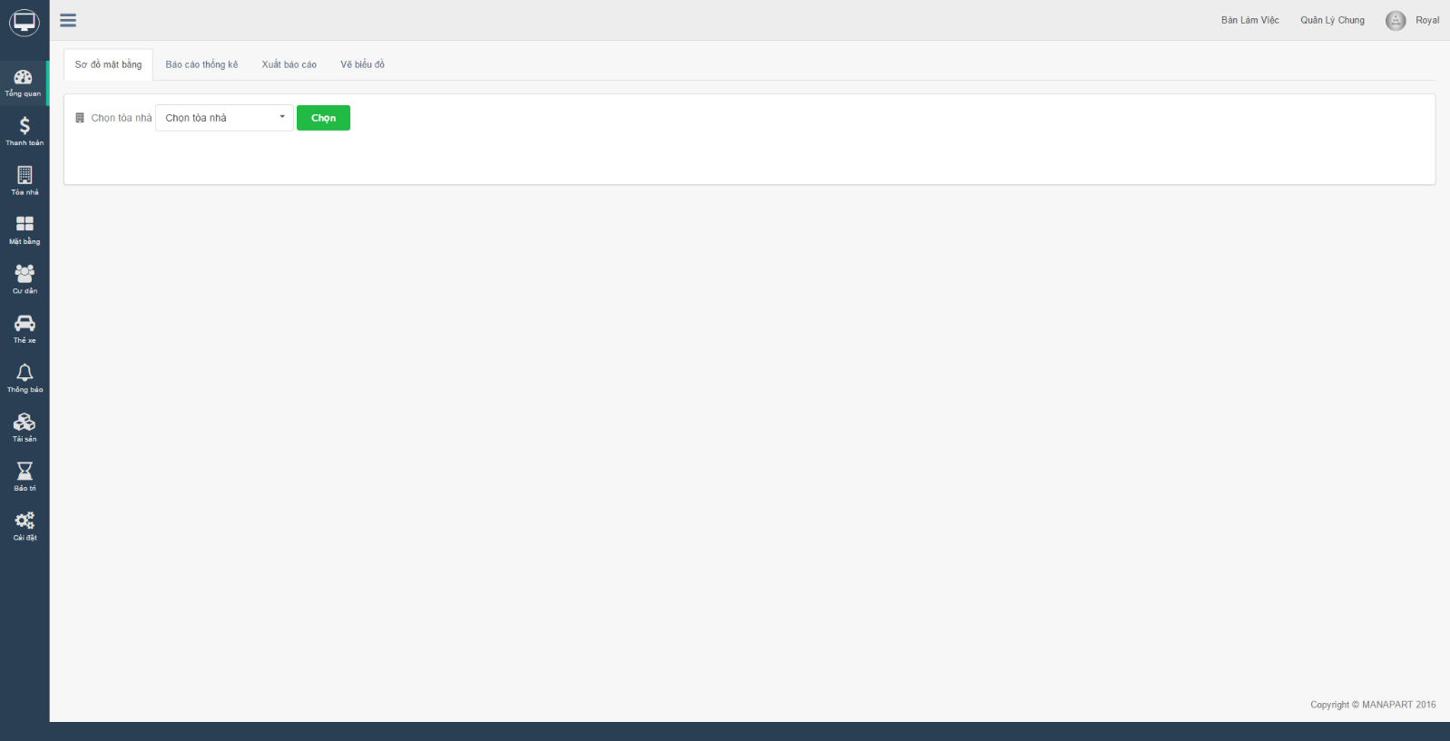

### Dashboard

#### Overview

1. In "Tổng quan" -> "Sơ đồ mặt bằng" choose building that you want to have an overview then click "chọn" button.

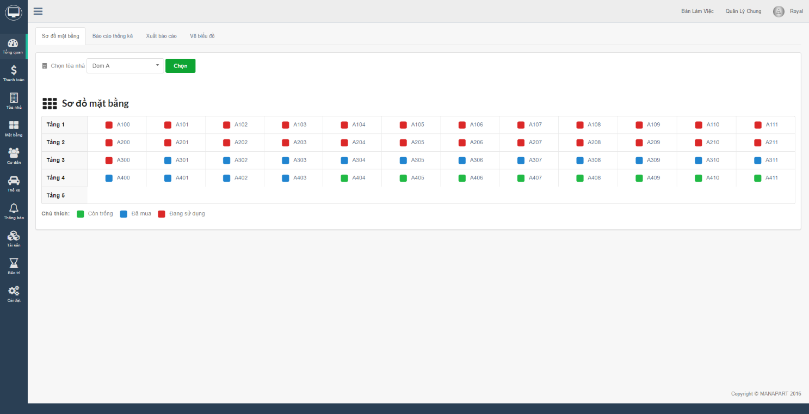

1. Click on "Báo cáo thống kê" will give you the overview of your Tower using different kind of chart.

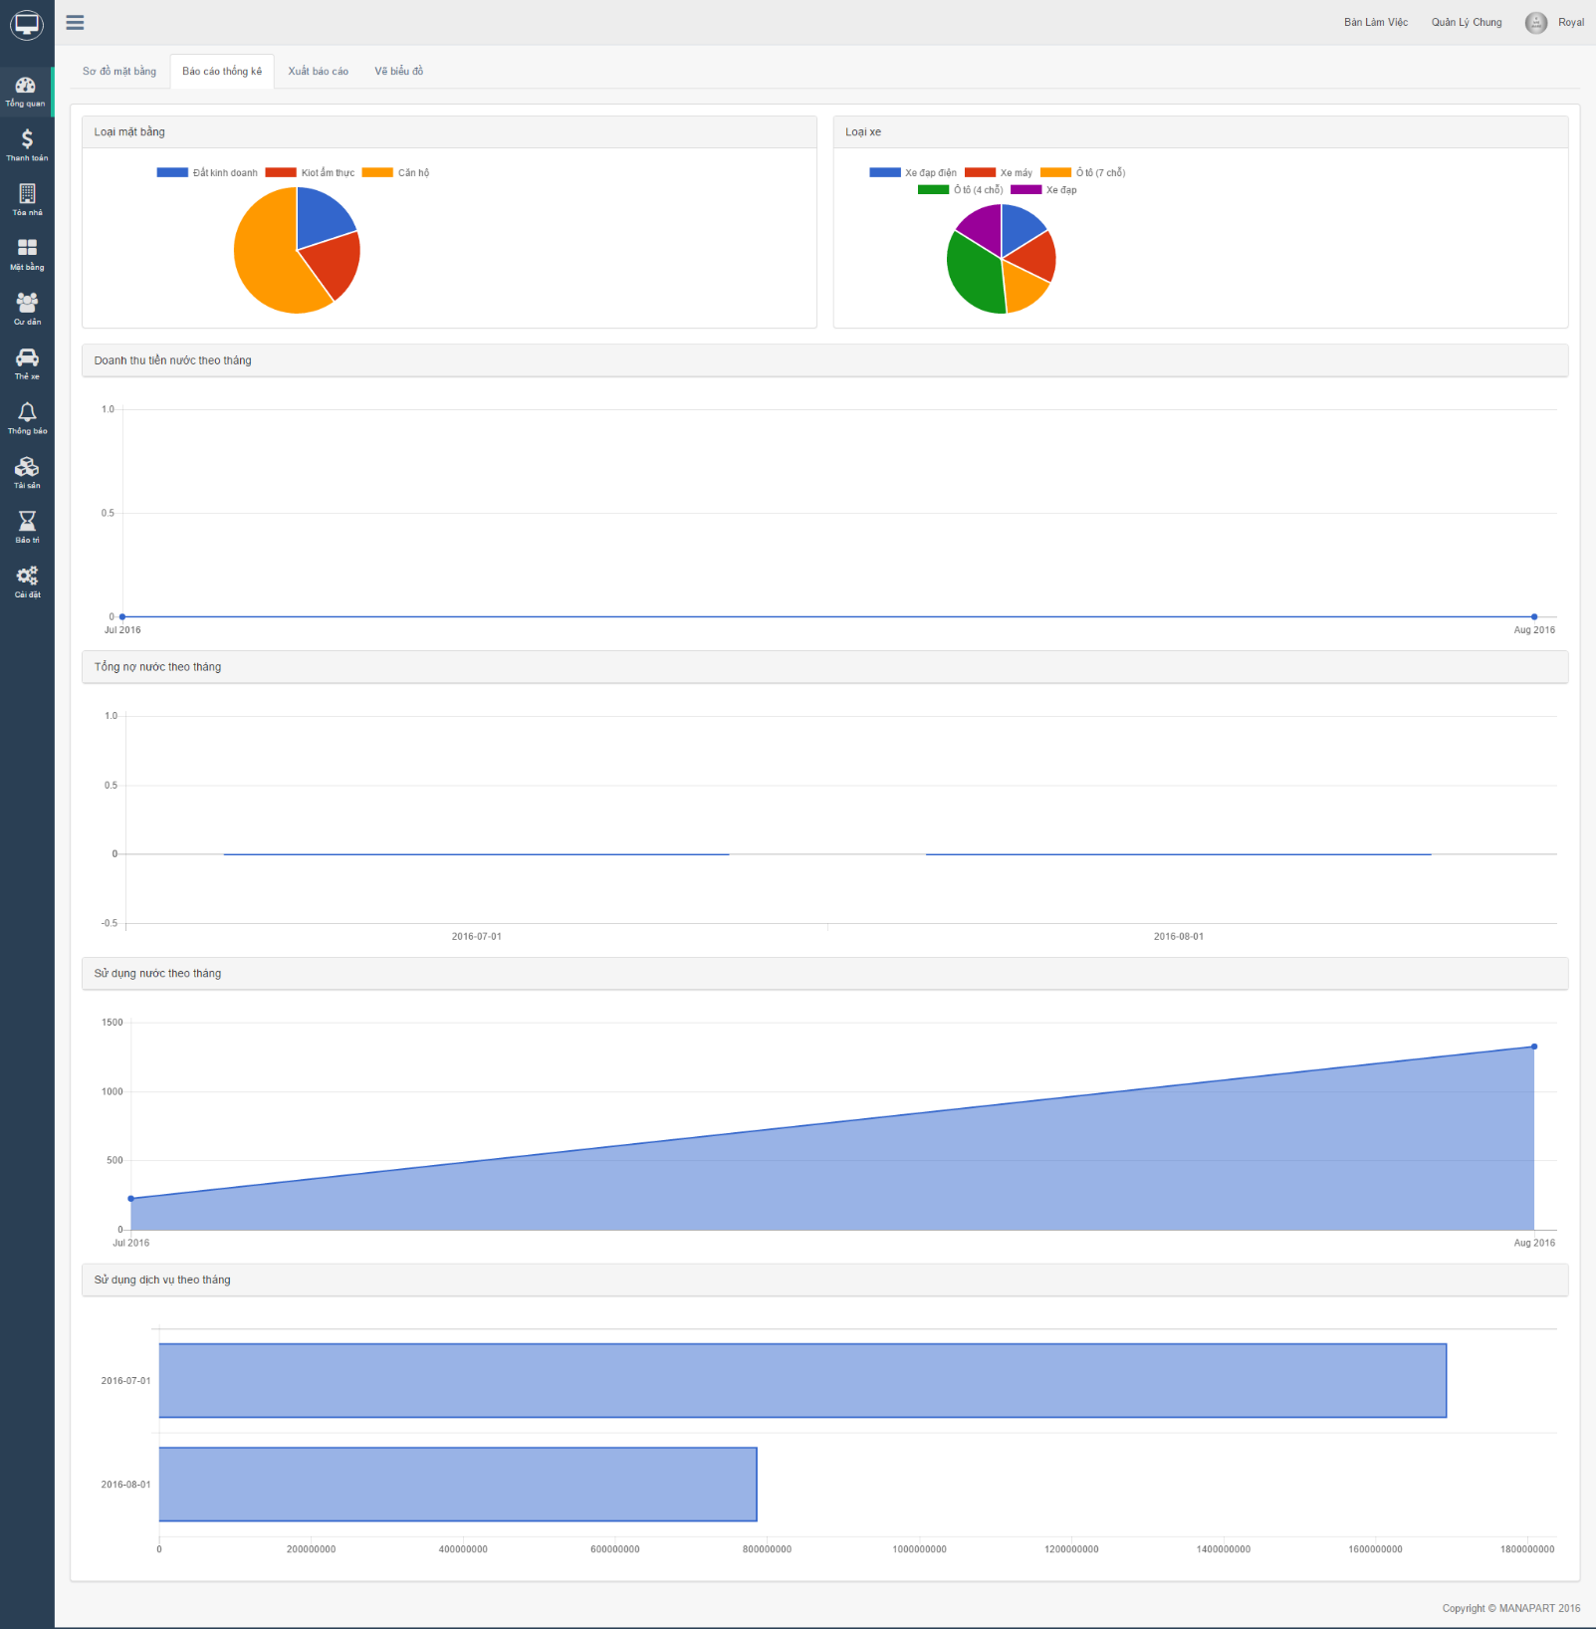

1. Click on "Xuất báo cáo" tab, you will be able to export your building data

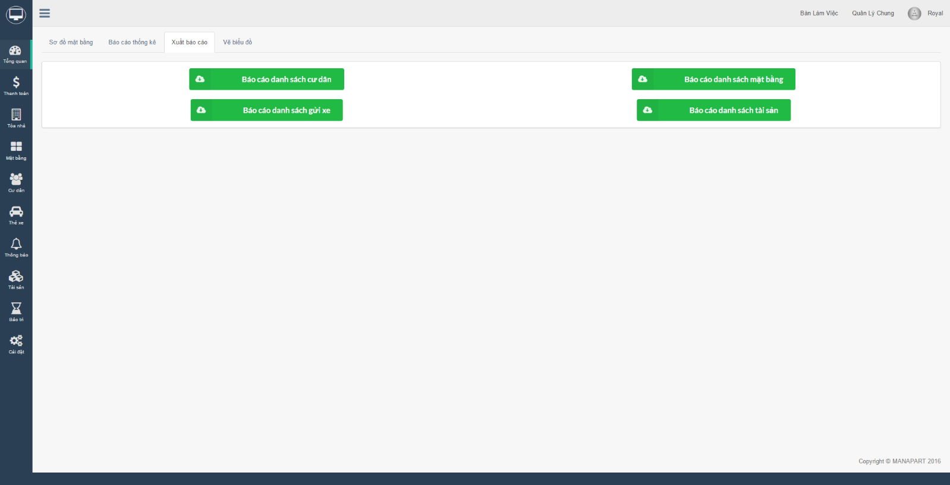

1. Click on "Vẽ biểu đồ" tab, you will be able to draw your own chart by select the information then choose type of chart you want to see.

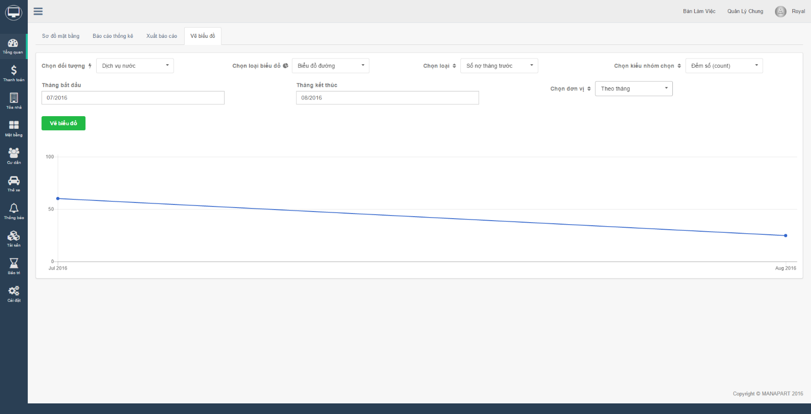

#### Payment

1. In "Thanh toán", Input name of ground into "Tên mặt bằng" input box. After that,choose which kind of bill you want to paid then click on "Thanh toán" button.

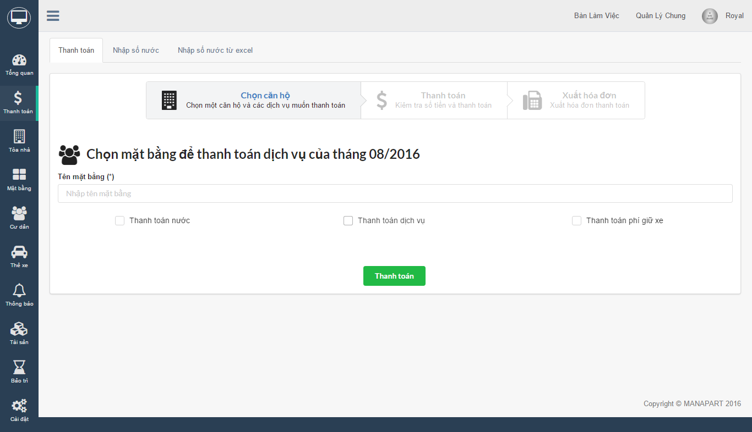

1. In "Thanh toán" tab, you will be able to see all your payment. Click button "Thanh toán" to continue the process.

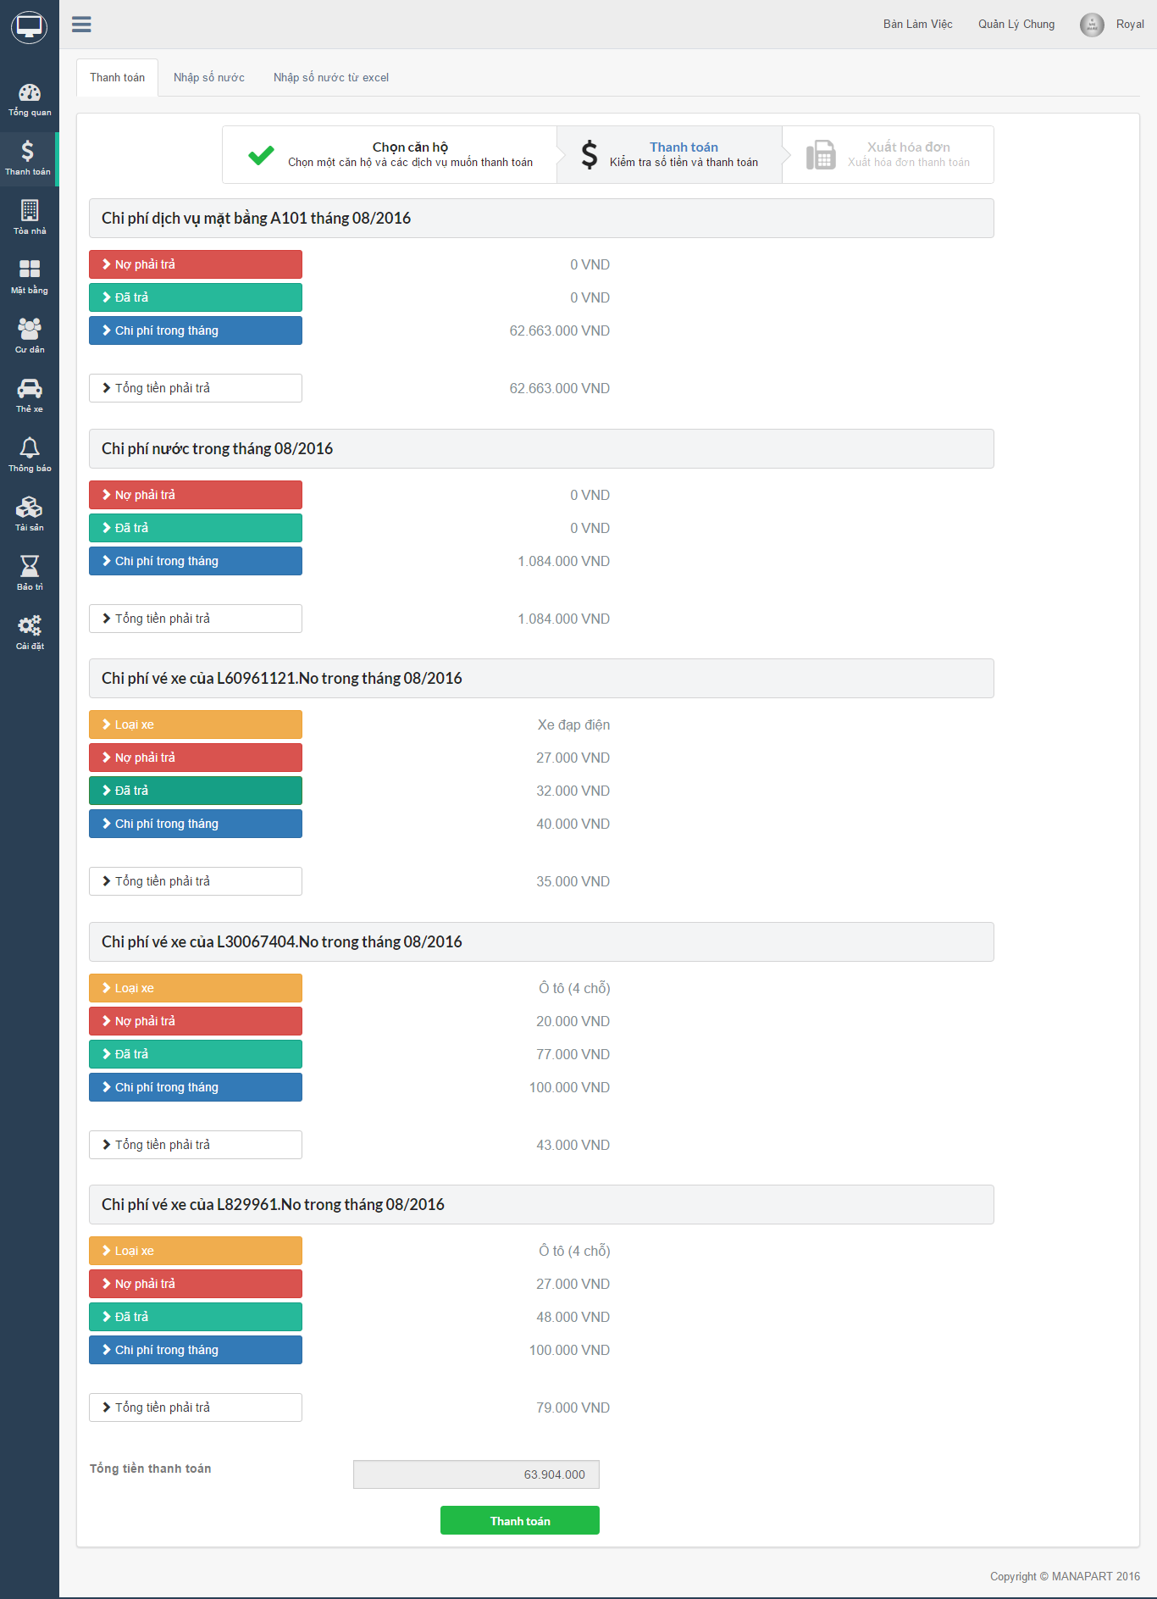

1. At the final step, you can export these bills if you want to.

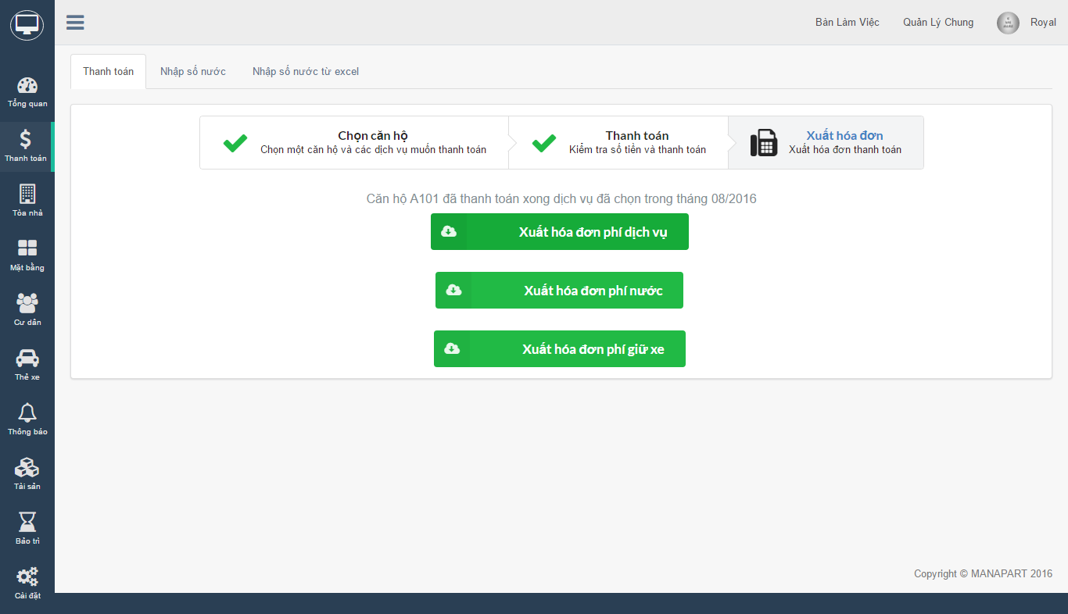

#### Building

1. In "Tòa nhà", you can import new building from file or manually. If you want to import building manualy, fill building input and number of floors input then click "Tạo" button.

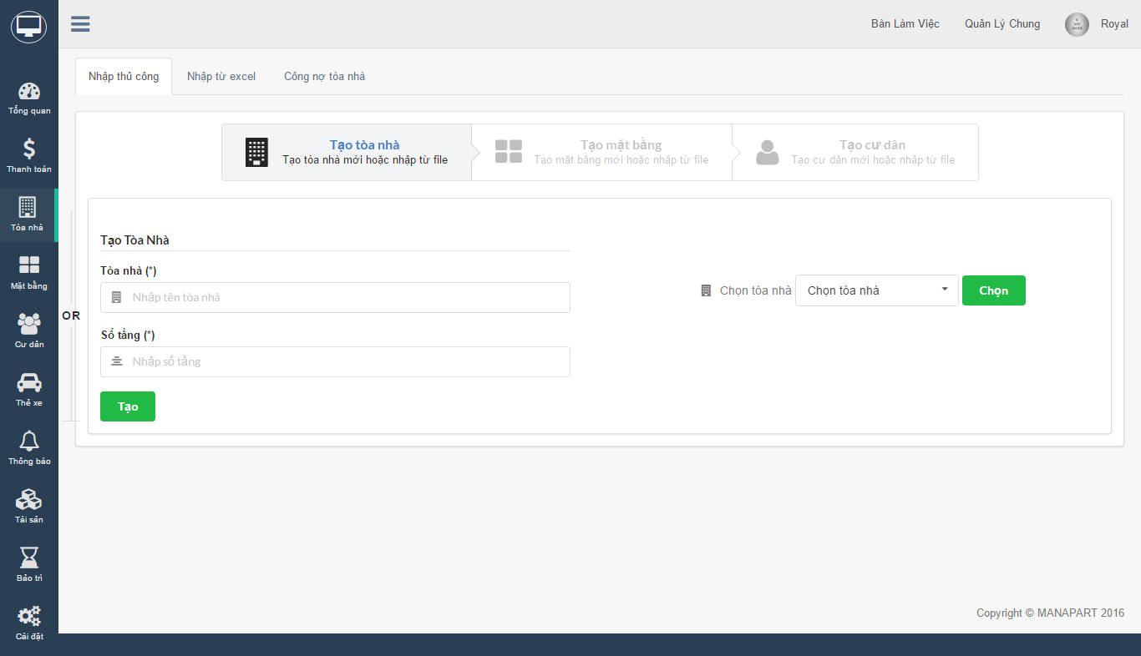

1. If you want to import multiple building, click on "Nhập từ excel" tab. Download and fill "Danh sách tòa nhà" file, then upload it by click "Nhập tòa nhà từ file" button.

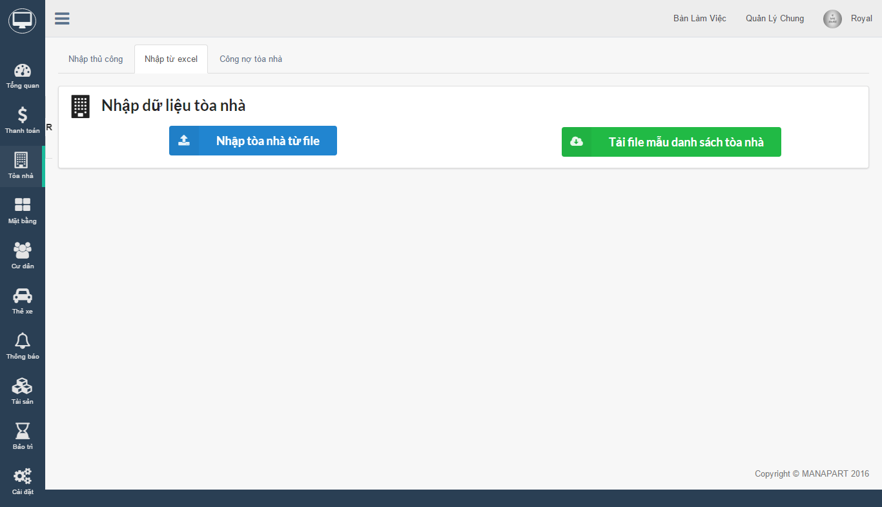

1. "Công nợ tòa nhà" tab shows you liabilities of specific building

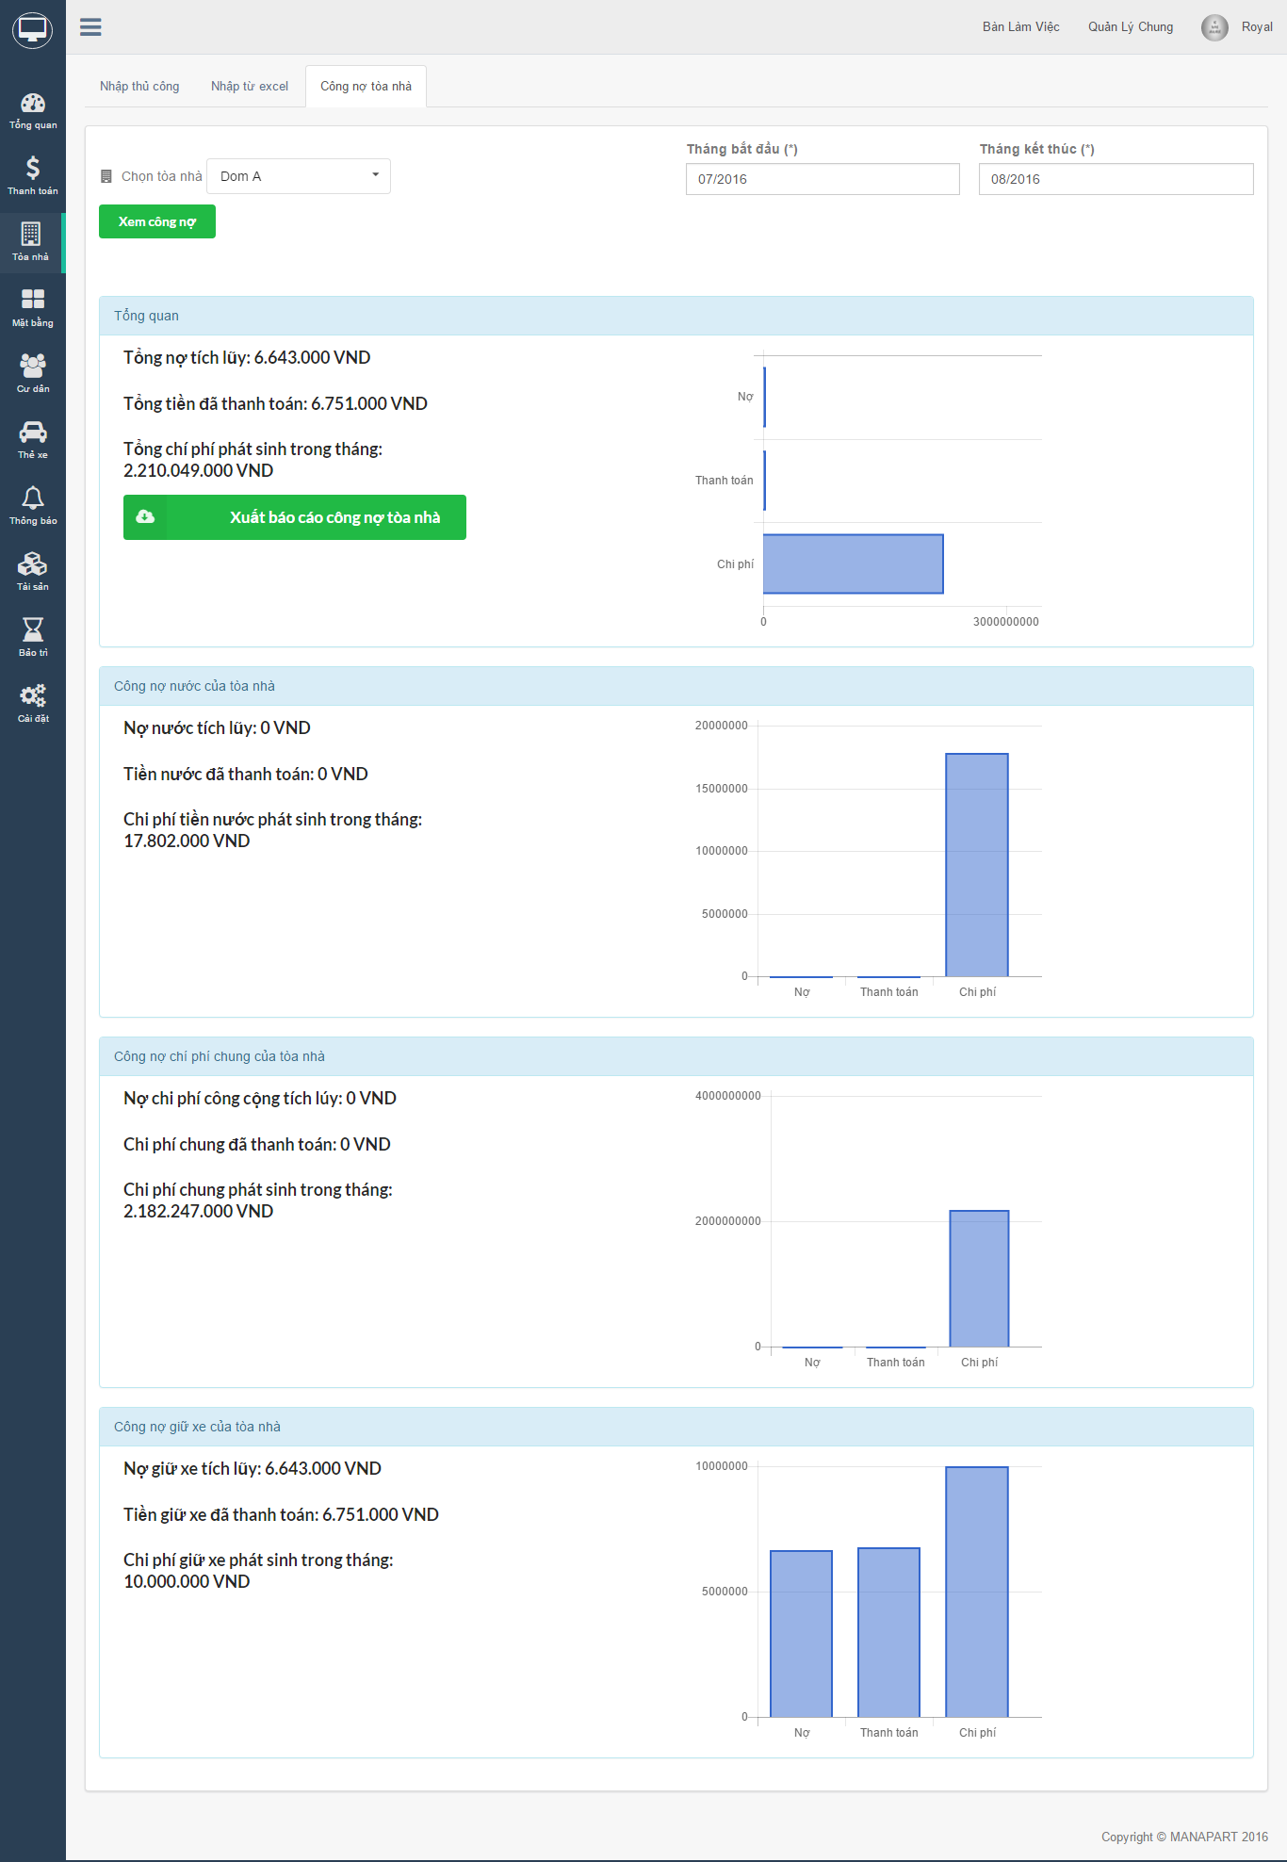

#### Ground

1. In "Mặt bằng", Click on "Nhập thủ công" tab to import ground manualy. Fill all require field then click "Tạo" button.

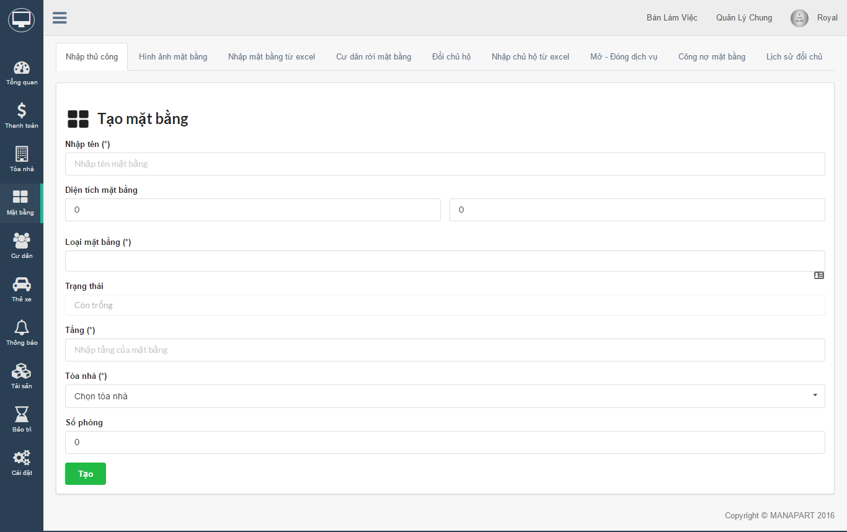

1. You can import grounds from excel by click on tab "Nhập mặt bằng từ excel"

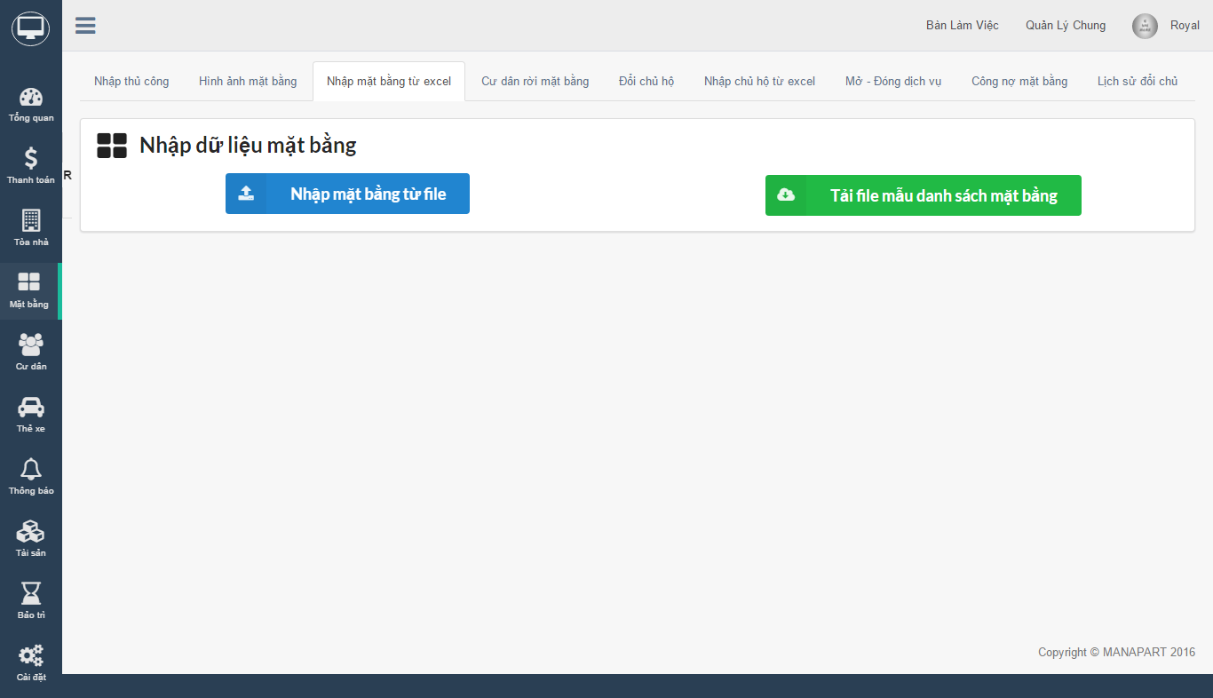

1. Adds images for ground by click on "Hình ảnh mặt bằng" button

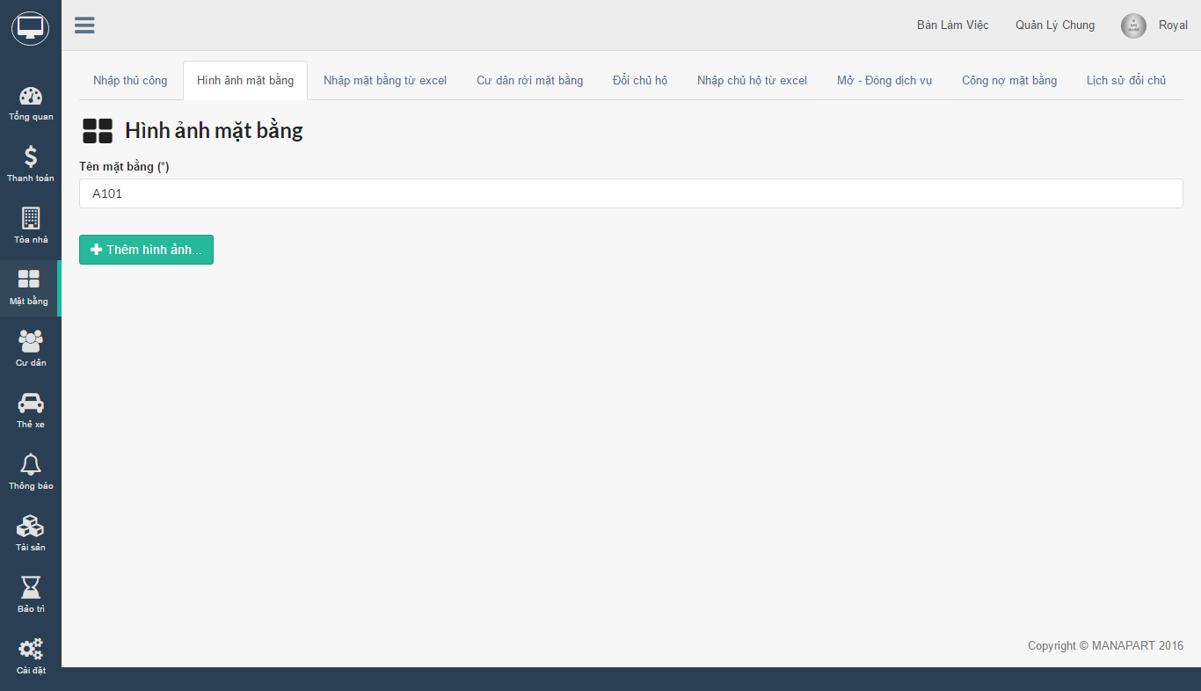

1. When an citizen leave ground, you can remove he(she) from ground by click on "Cư dân rời mặt bằng" tab. In this screen, input citizen name then click "Rời đi" button to process.

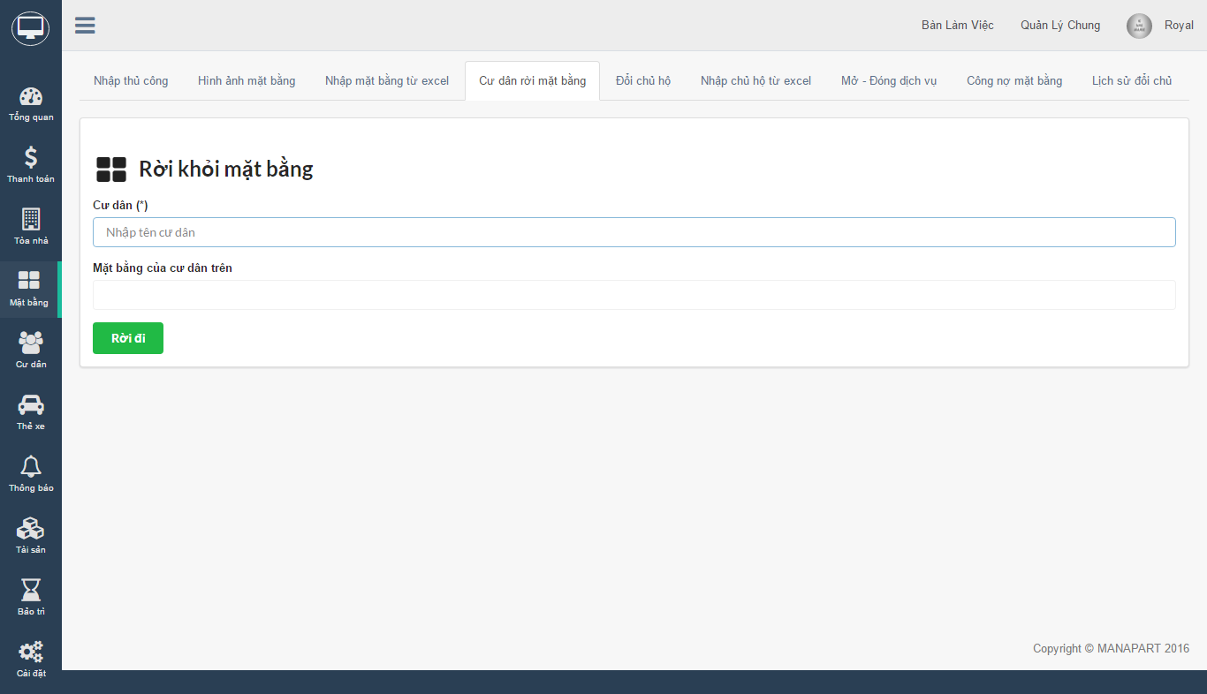

1. If you want to change ground owner, click on "Đổi chủ hộ" tab. If new owner isn't building's citizen then you have to add he (she) first by click on "Thêm cư dân mới".

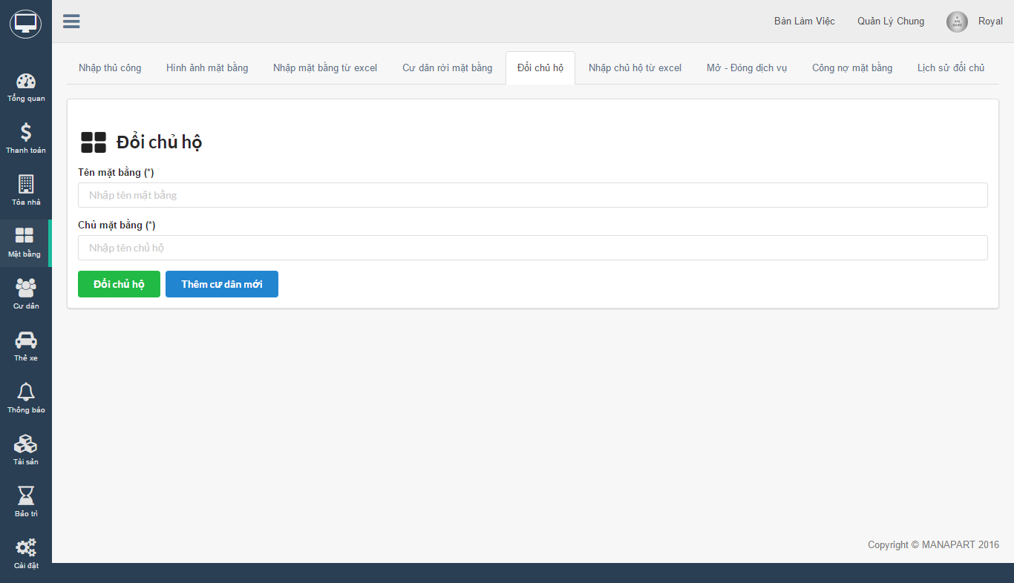

1. You also can import ground owner from excel by click on "Nhập chủ hộ từ excel" tab

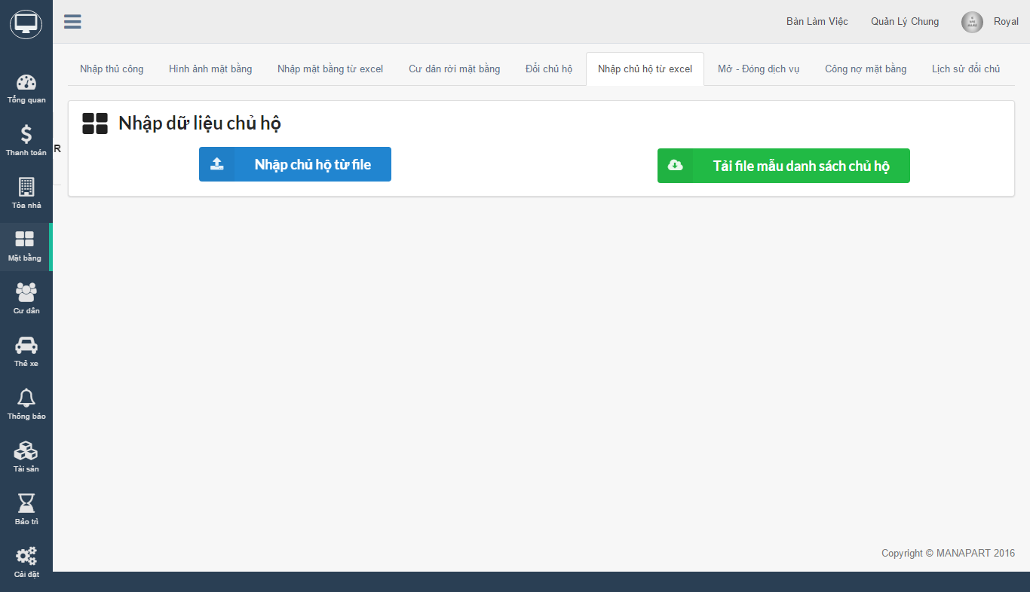

1. Go with each ground is service, You can open or close service of a ground by click on "Mở - Đóng dịch vụ" tab.

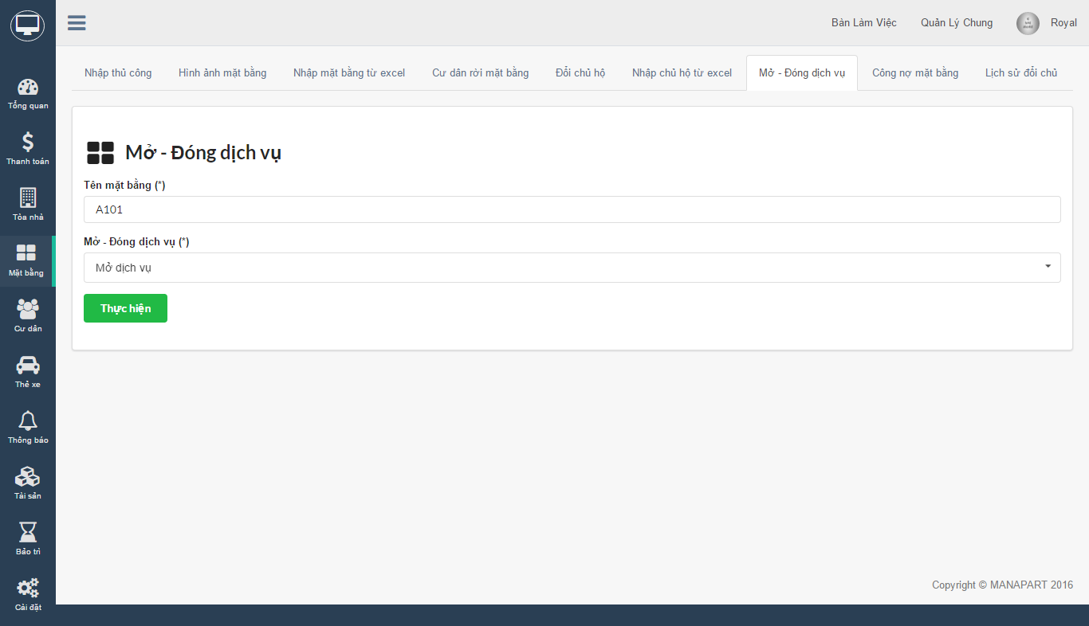

1. To view liabilities of a ground, go to "Công nợ mặt bằng" tab. Choose ground name, start date, end date then click "Xem công nợ" button. After that you can export detail report by click "Xuất báo cáo công nợ tòa nhà" button.

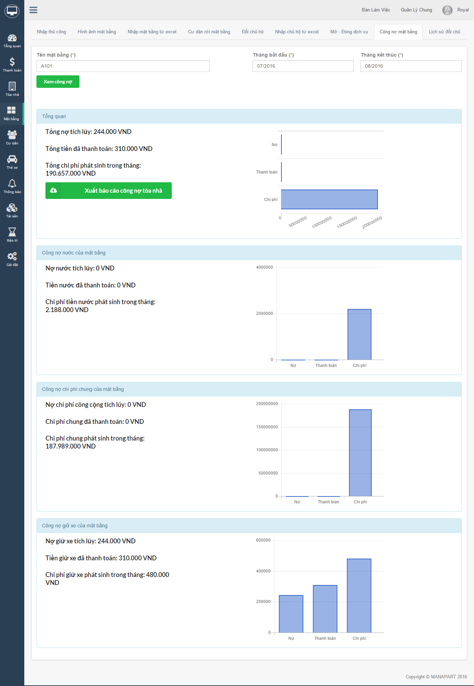

1. If you want to view ground owner changed history, click on "Lịch sử đổi chủ" tab

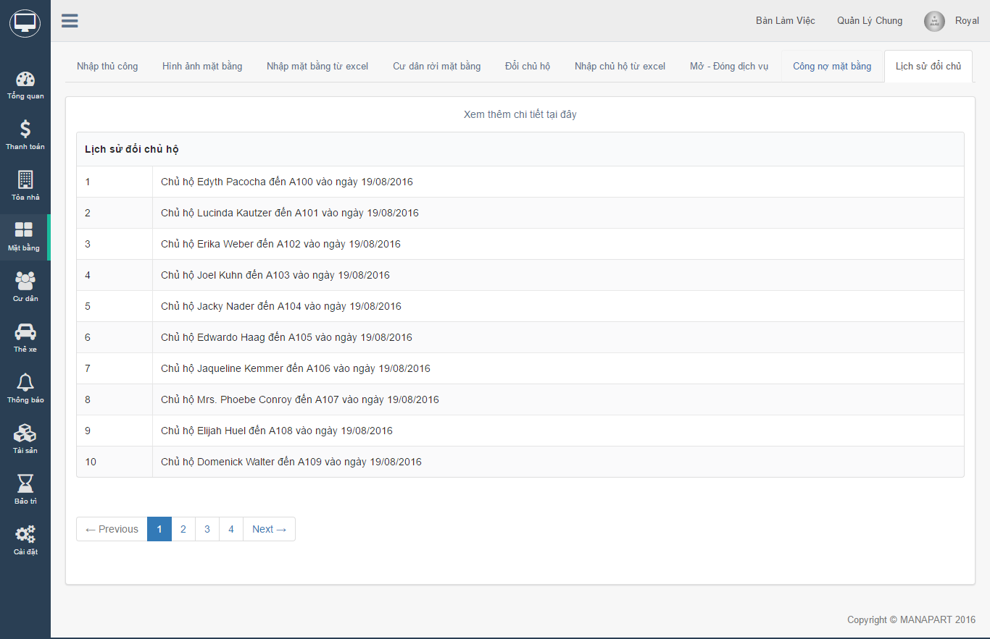

#### Citizen

1. In "Cư dân", Click on "Tạo cư dân" tab to import new citizen manualy.

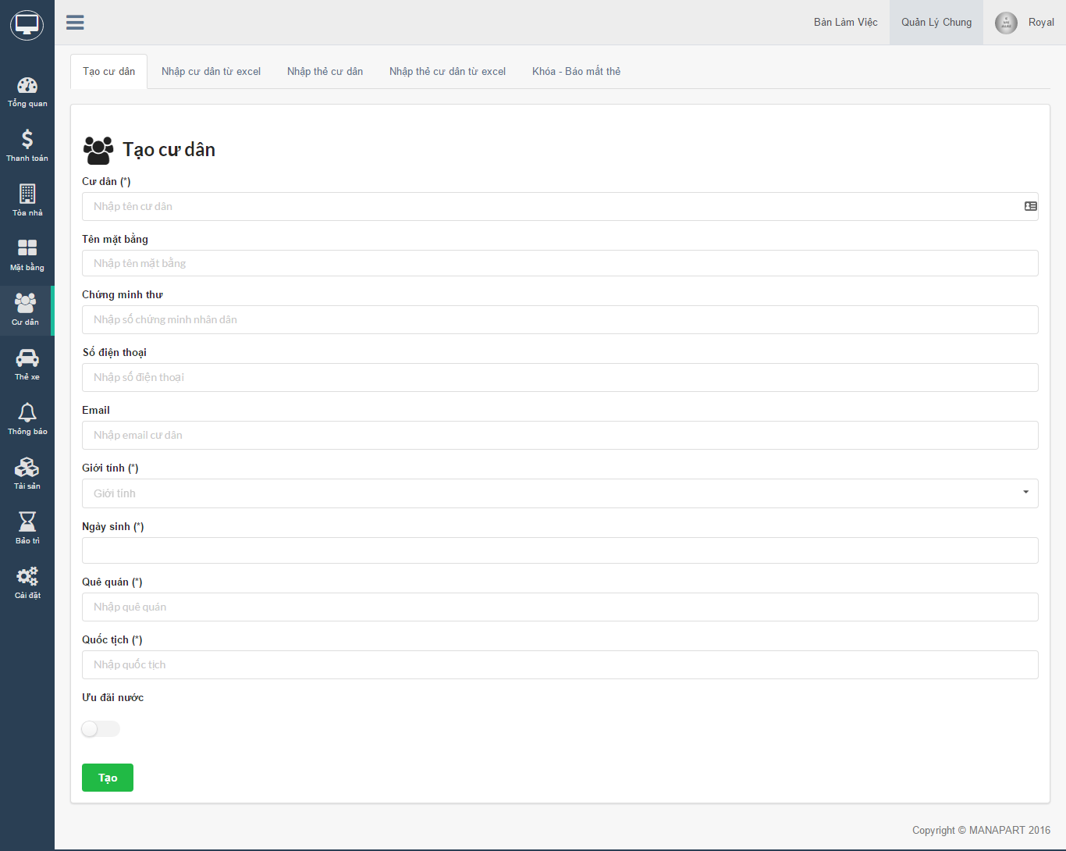

1. To import citizen from excel, click on "Nhập cư dân từ excel" tab. Click on "Tải mẫu danh sách cư dân" button to download template file, fill all required information then upload to website by click on "Nhập cư dân từ file" button.

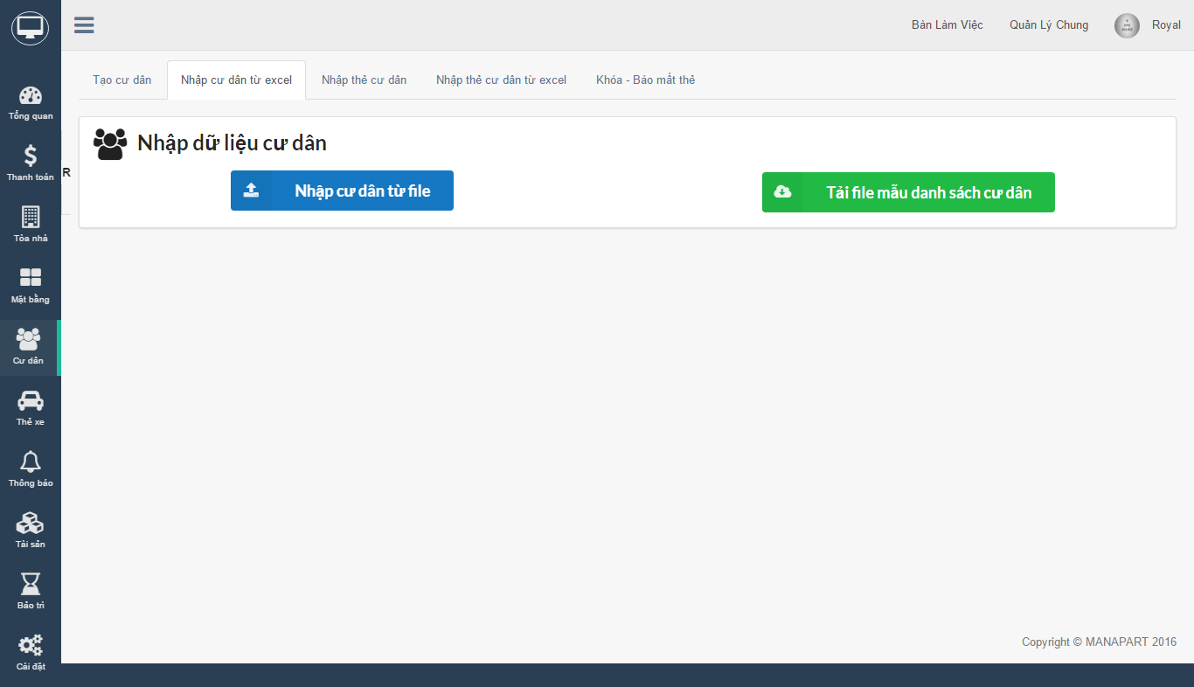

1. To import citizen card, you need to go to "Nhập thẻ cư dân" tab. Fill all field then click "Tạo" button.

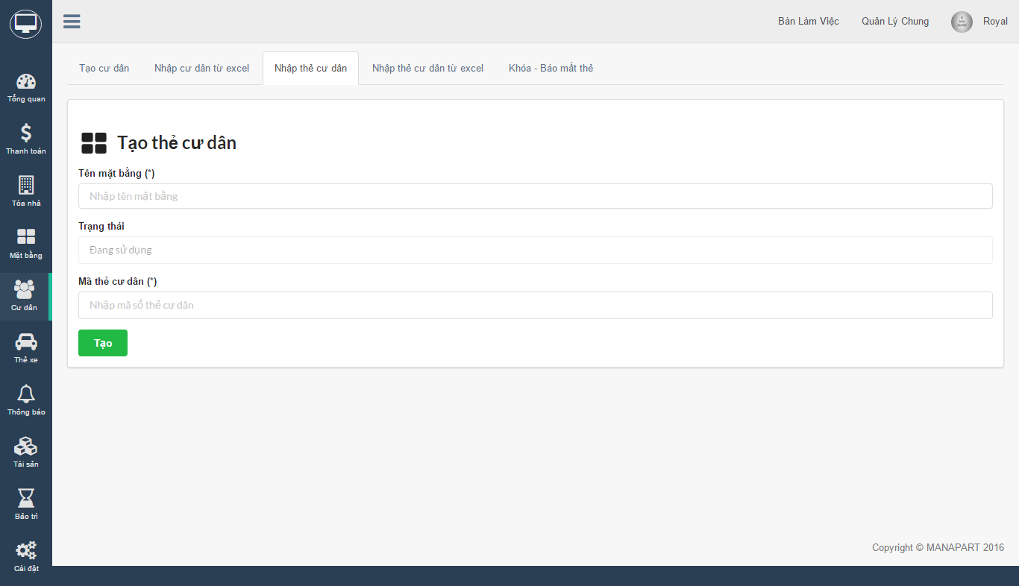

1. Import citizen card from excel by click on "Nhập thẻ cư dân từ excel" tab.

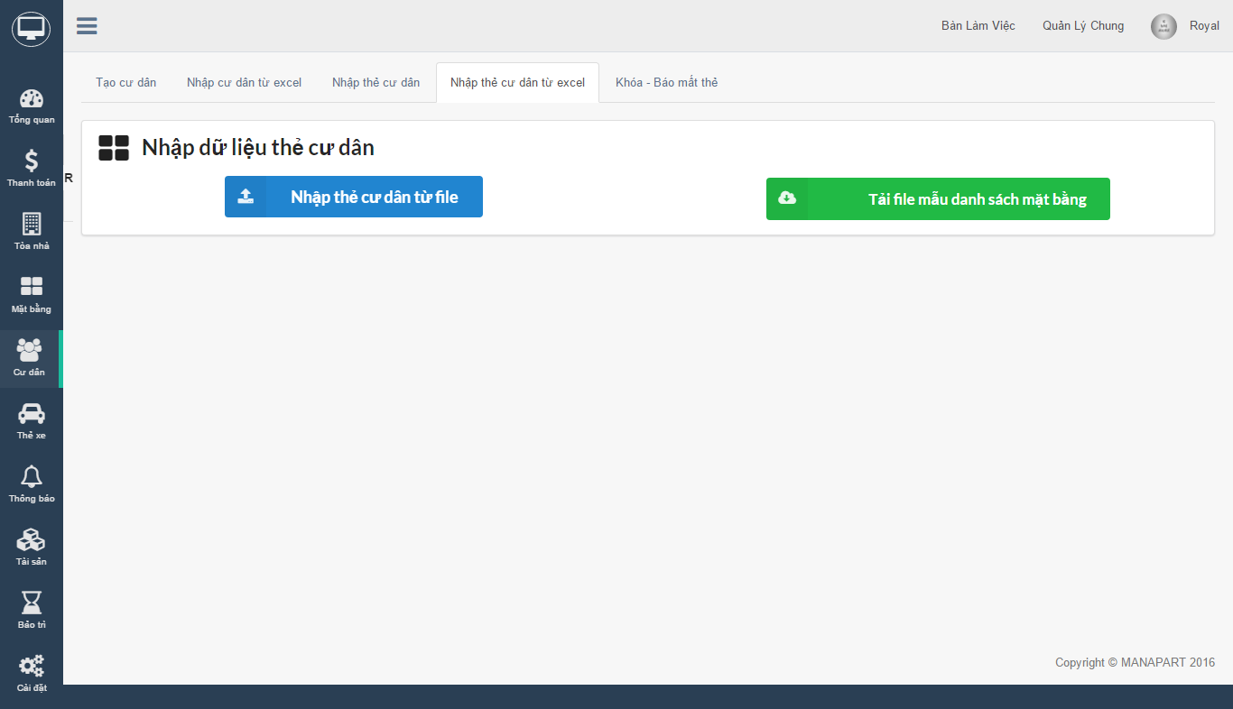

1. If an citizen lost their card or they want to lock citizen card. Click on "Khóa - Báo mất thẻ". Import ground name, then click "Thực hiện" button then choose card you want to lock.

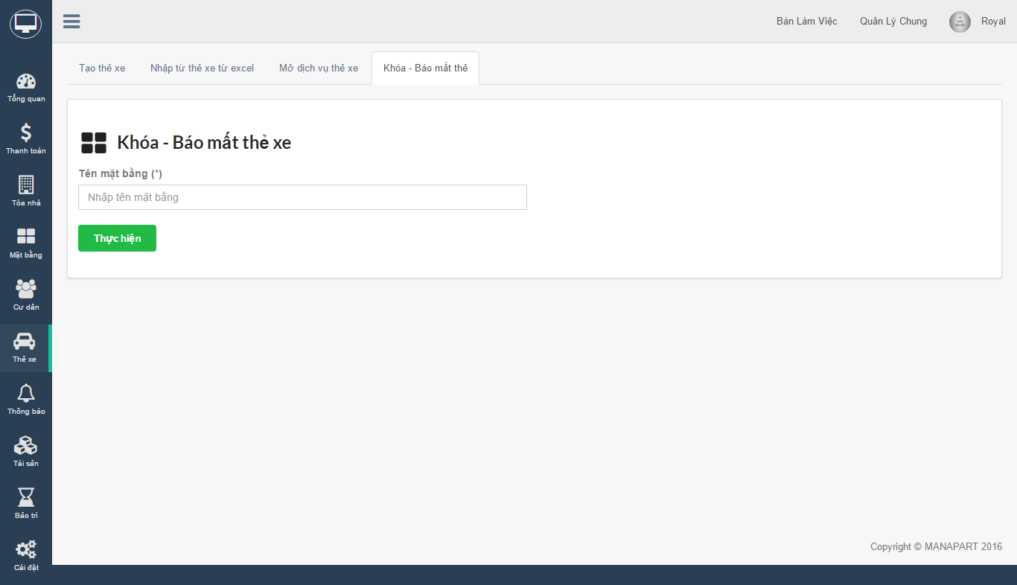

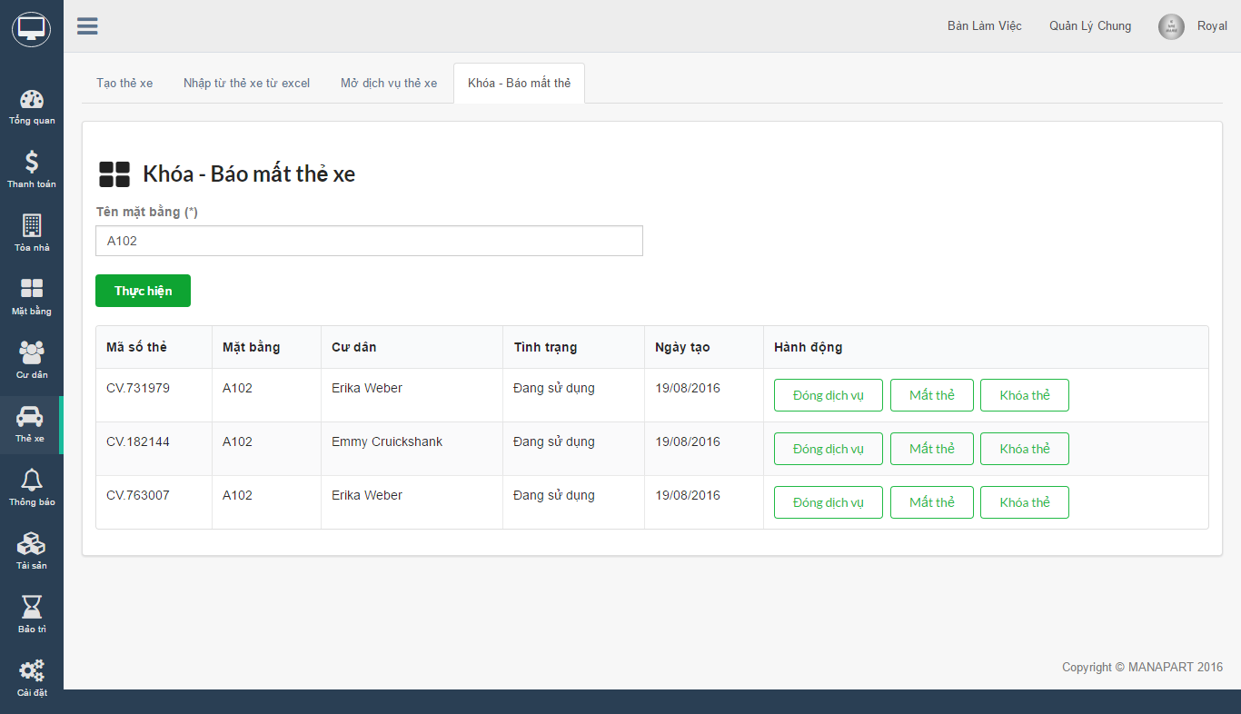

#### Announcement

1. In "Thông báo" -> "Tạo thông báo toàn bộ" tab, you can create a announcement for your citizens on your building's page.

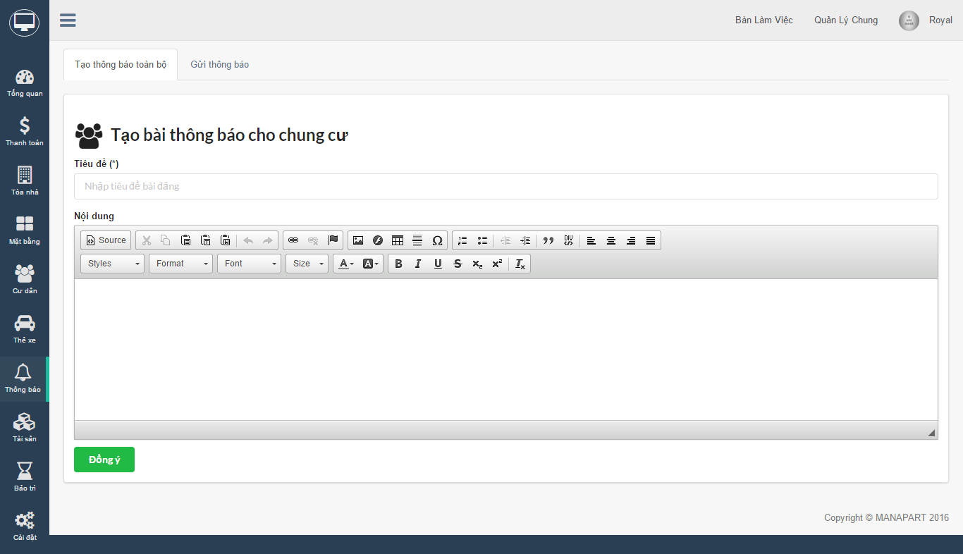

1. If you want to send announcement to specific citizens then click on "Gửi thông báo" tab. Input citizen name and other field then click "Gửi" button. Announcement will be send to citizen's email.

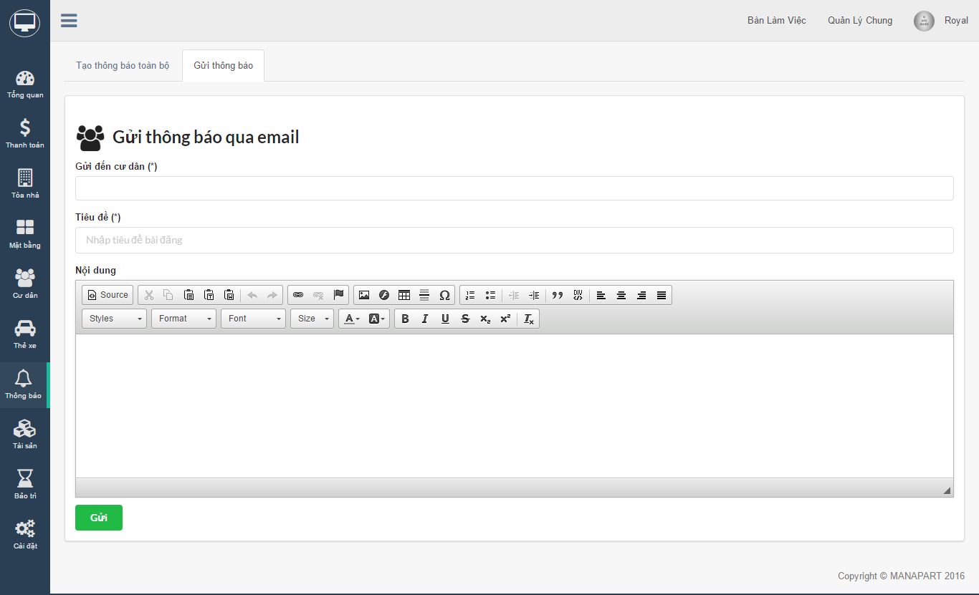

#### Facility

1. Goto "Tài sản" -> "Nhập thủ công" to import facility manualy

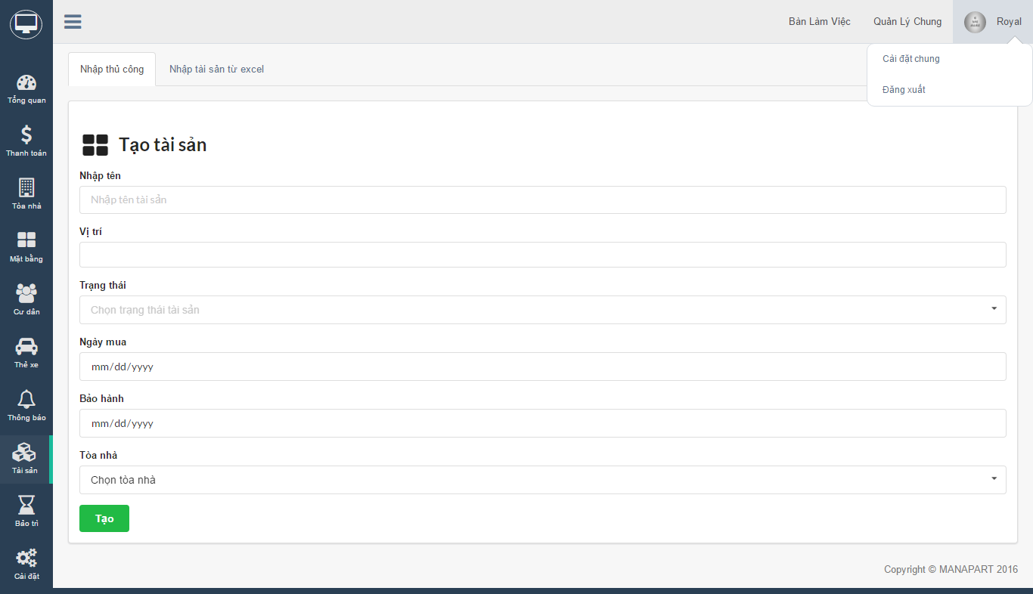

1. You can import facilities from excel file by click on "Nhập tài sản từ excel" tab.

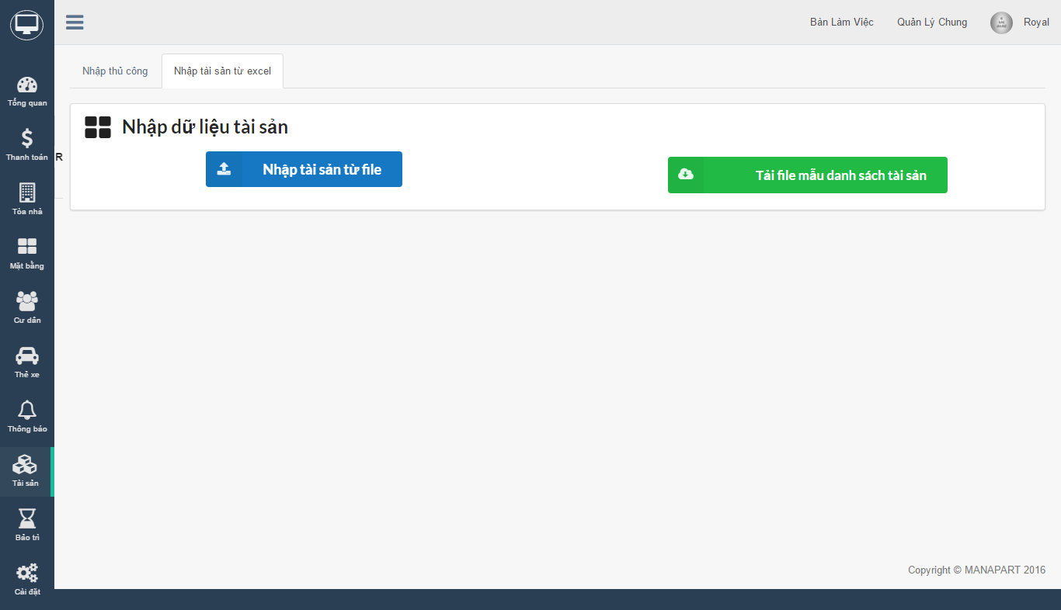

#### Maintain

1. When a facility need to maintain, goto "Bảo trì" -> "Nhập thủ công" tab to create maintain ticket for facility

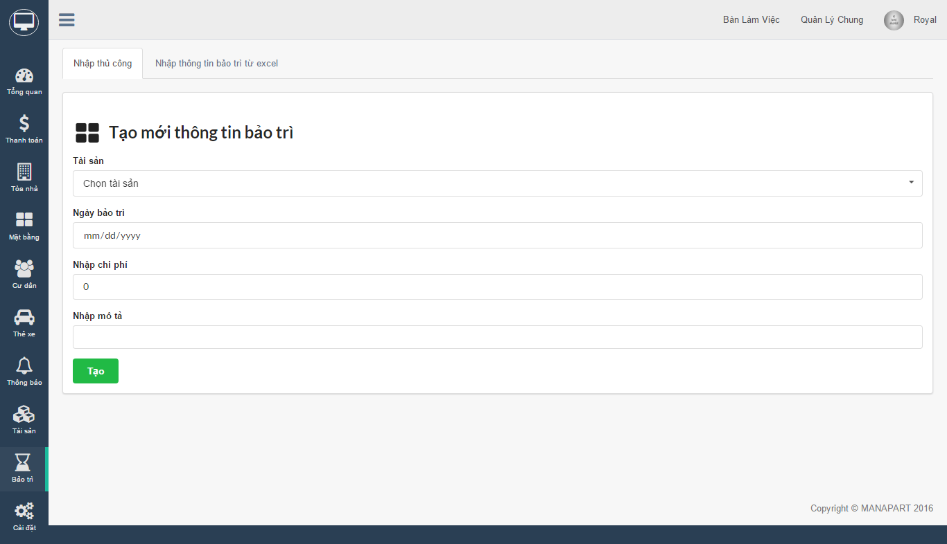

1. You can import maintain plan for facilities by click on tab "Nhập thông tin bảo trì từ excel"

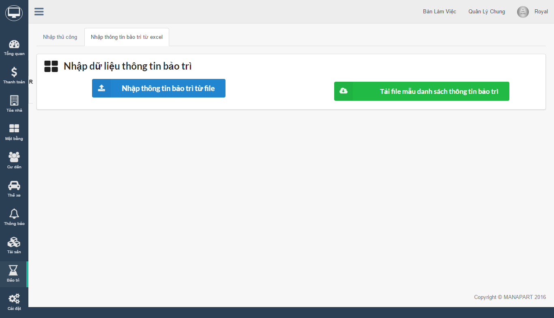

#### Setting

1. System setting

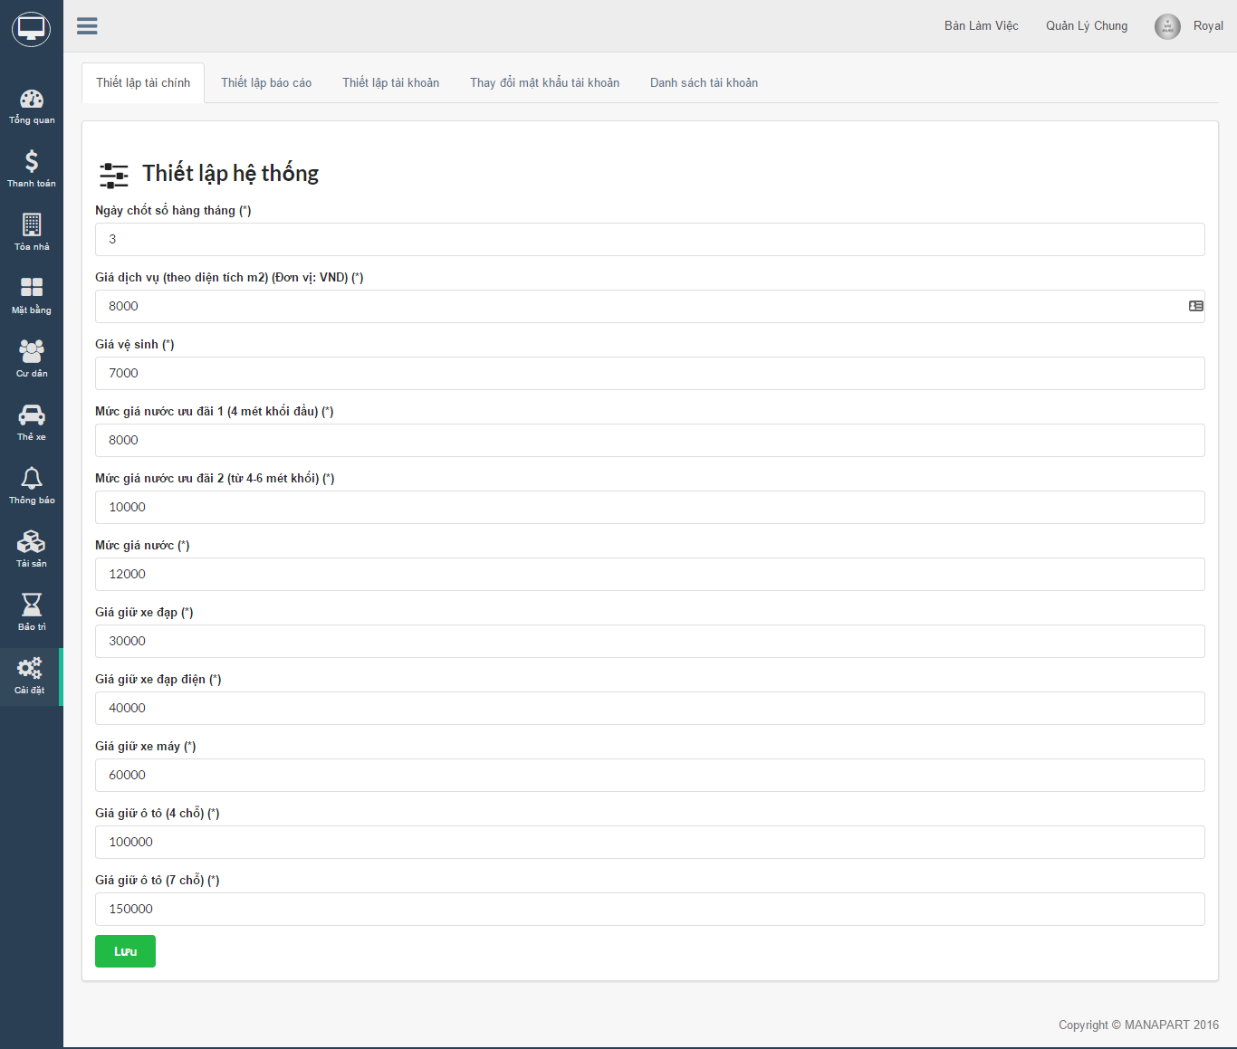

1. Report setting

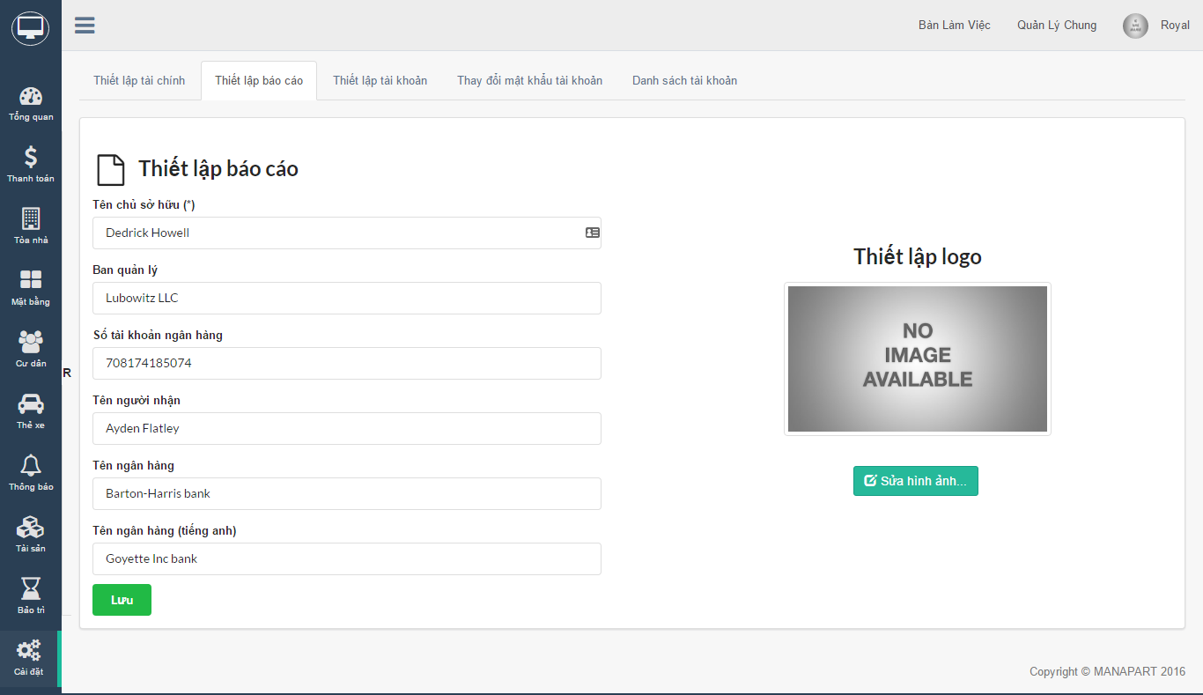

1. Account setting

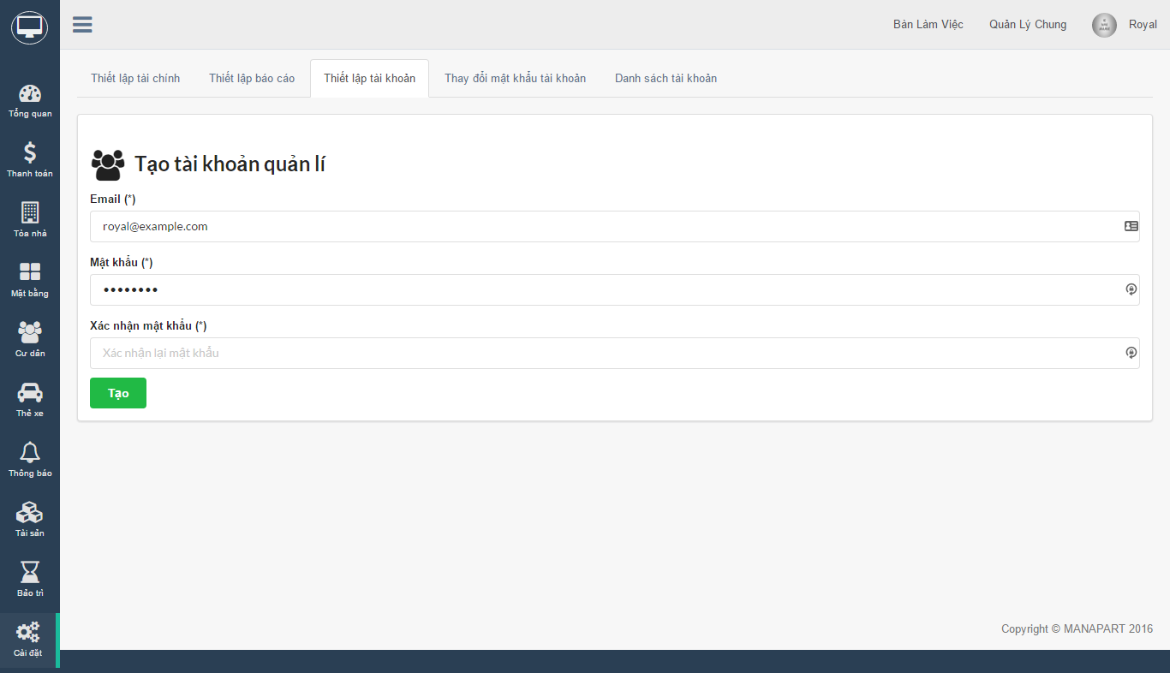

1. Change Account password

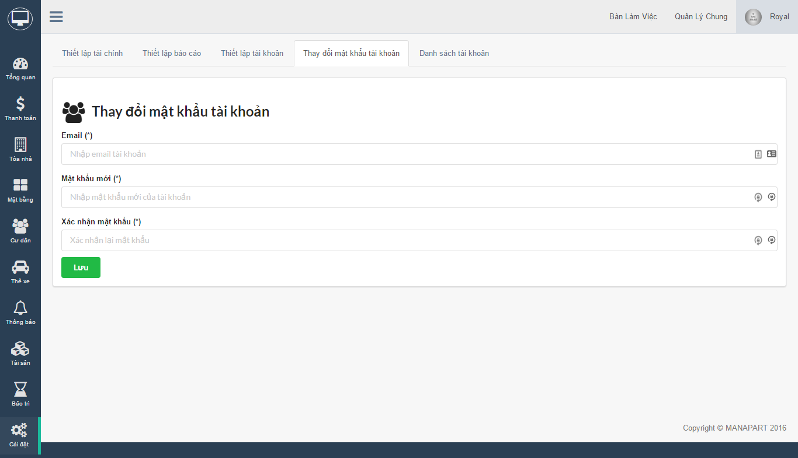

1. List Account

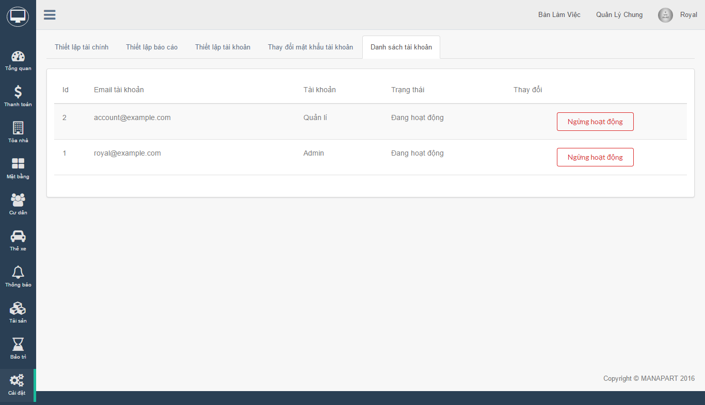

1. https://en.wikipedia.org/wiki/Bcrypt
2. https://www.google.com/chrome/browser/desktop/
3. https://chrome.google.com/webstore/detail/colorpicker/jcmgligingjhdnhdhgepemlckgcgmgaj?hl=en
4. https://trello.com/b/w95Kw2Yq/capstone-project-manapart
5. Software Quality Assurance and Testing (SWQ391) teacher slide